Real estate sales in 2025
In 2025, 561.7 thousand notarial deeds of real estate trading were signed (a year-on-year increase
of 2.9%). The rise in the number of notarial deeds applied to almost all types of real estate. Adecrease was recorded only in the number of notarial deeds concerning the sale of premises (by 0.6%).
2.9%
The increase in the number
of notarial deeds of real estate sales compared to 2024

Table 1. Notarial deeds related to real estate sales concluded in 2025
In 2025, compared to the
previous year, the highest
increase in the number
of notarial deeds was recorded in granting perpetual usufruct by the State Treasury or local government units along with the sale of the building
(by 26.0%)
Specification | 2025 | 2024=100
Total | 561 718 | 102.9
Sale of premises | 218 680 | 99.4
Sale of undeveloped plots | 126 665 | 105.6
Sale of agricultural real estate | 65 684 | 110.7
Sale of plots with a residential building | 59 398 | 102.3
Sale of cooperative ownership right to premises | 42 895 | 100.5
Sale of other properties | 21 661 | 104.4
Sale of plots with a building for other purposes | 17 976 | 108.3
Sale of perpetual usufruct rights | 5 072 | 102.6
Sale of real estate to the State Treasury or local government units | 3 532 | 104.6
Granting perpetual usufruct by the State Treasury or local government units along with the sale of the building | 155 | 126.0
Source: the Ministry of Justice data.
According to data from the Real Estate Price Register (RCN), 586.6 thousand real estate sale and purchase transactions with a total value of PLN 270.0 billion were concluded in 2025.

Table 2. Volume of real estate sale
In 2025, the structure of both the number and value of real estate sale and purchase transactions was dominated by the sale of premises whose shares amounted to 49.3% and 51.8%, respectively
Specification | Number of transactions |  |  | Value of transactions
Specification | 2024 | 2025ª |  | 2024 | 2025ª
Specification | in units |  | 2024=100 | in million PLN |  | 2024=100
Total | 573 289 | 586 608 | 102.3 | 260 349 | 270 019 | 103.7
Premises | 293 025 | 289 290 | 98.7 | 137 964 | 139 830 | 101.4
Built-up land properties | 90 201 | 93 561 | 103.7 | 70 188 | 75 733 | 107.9
Undeveloped land  properties | 190 063 | 203 757 | 107.2 | 52 197 | 54 456 | 104.3
a Preliminary data.

In 2025, in the structure of the number of real estate purchase and sale transactions by type, in most voivodeships, transactions involving residential properties predominated. They accounted for more than a half of all registered contracts in the following voivodeships: dolnośląskie (62.7%), pomorskie (61.8%), zachodniopomorskie (54.8%), mazowieckie (54.7%) and śląskie (54.1%). The highest share of transactions involving another type of property, namely undeveloped land, was observed only in four voivodeships: podkarpackie (53.8%), lubelskie (51.2%), świętokrzyskie (50.9%) i podlaskie (45.1%).
Chart 1. Structure of the number of real estate sale and purchase transactions by type
in 2025
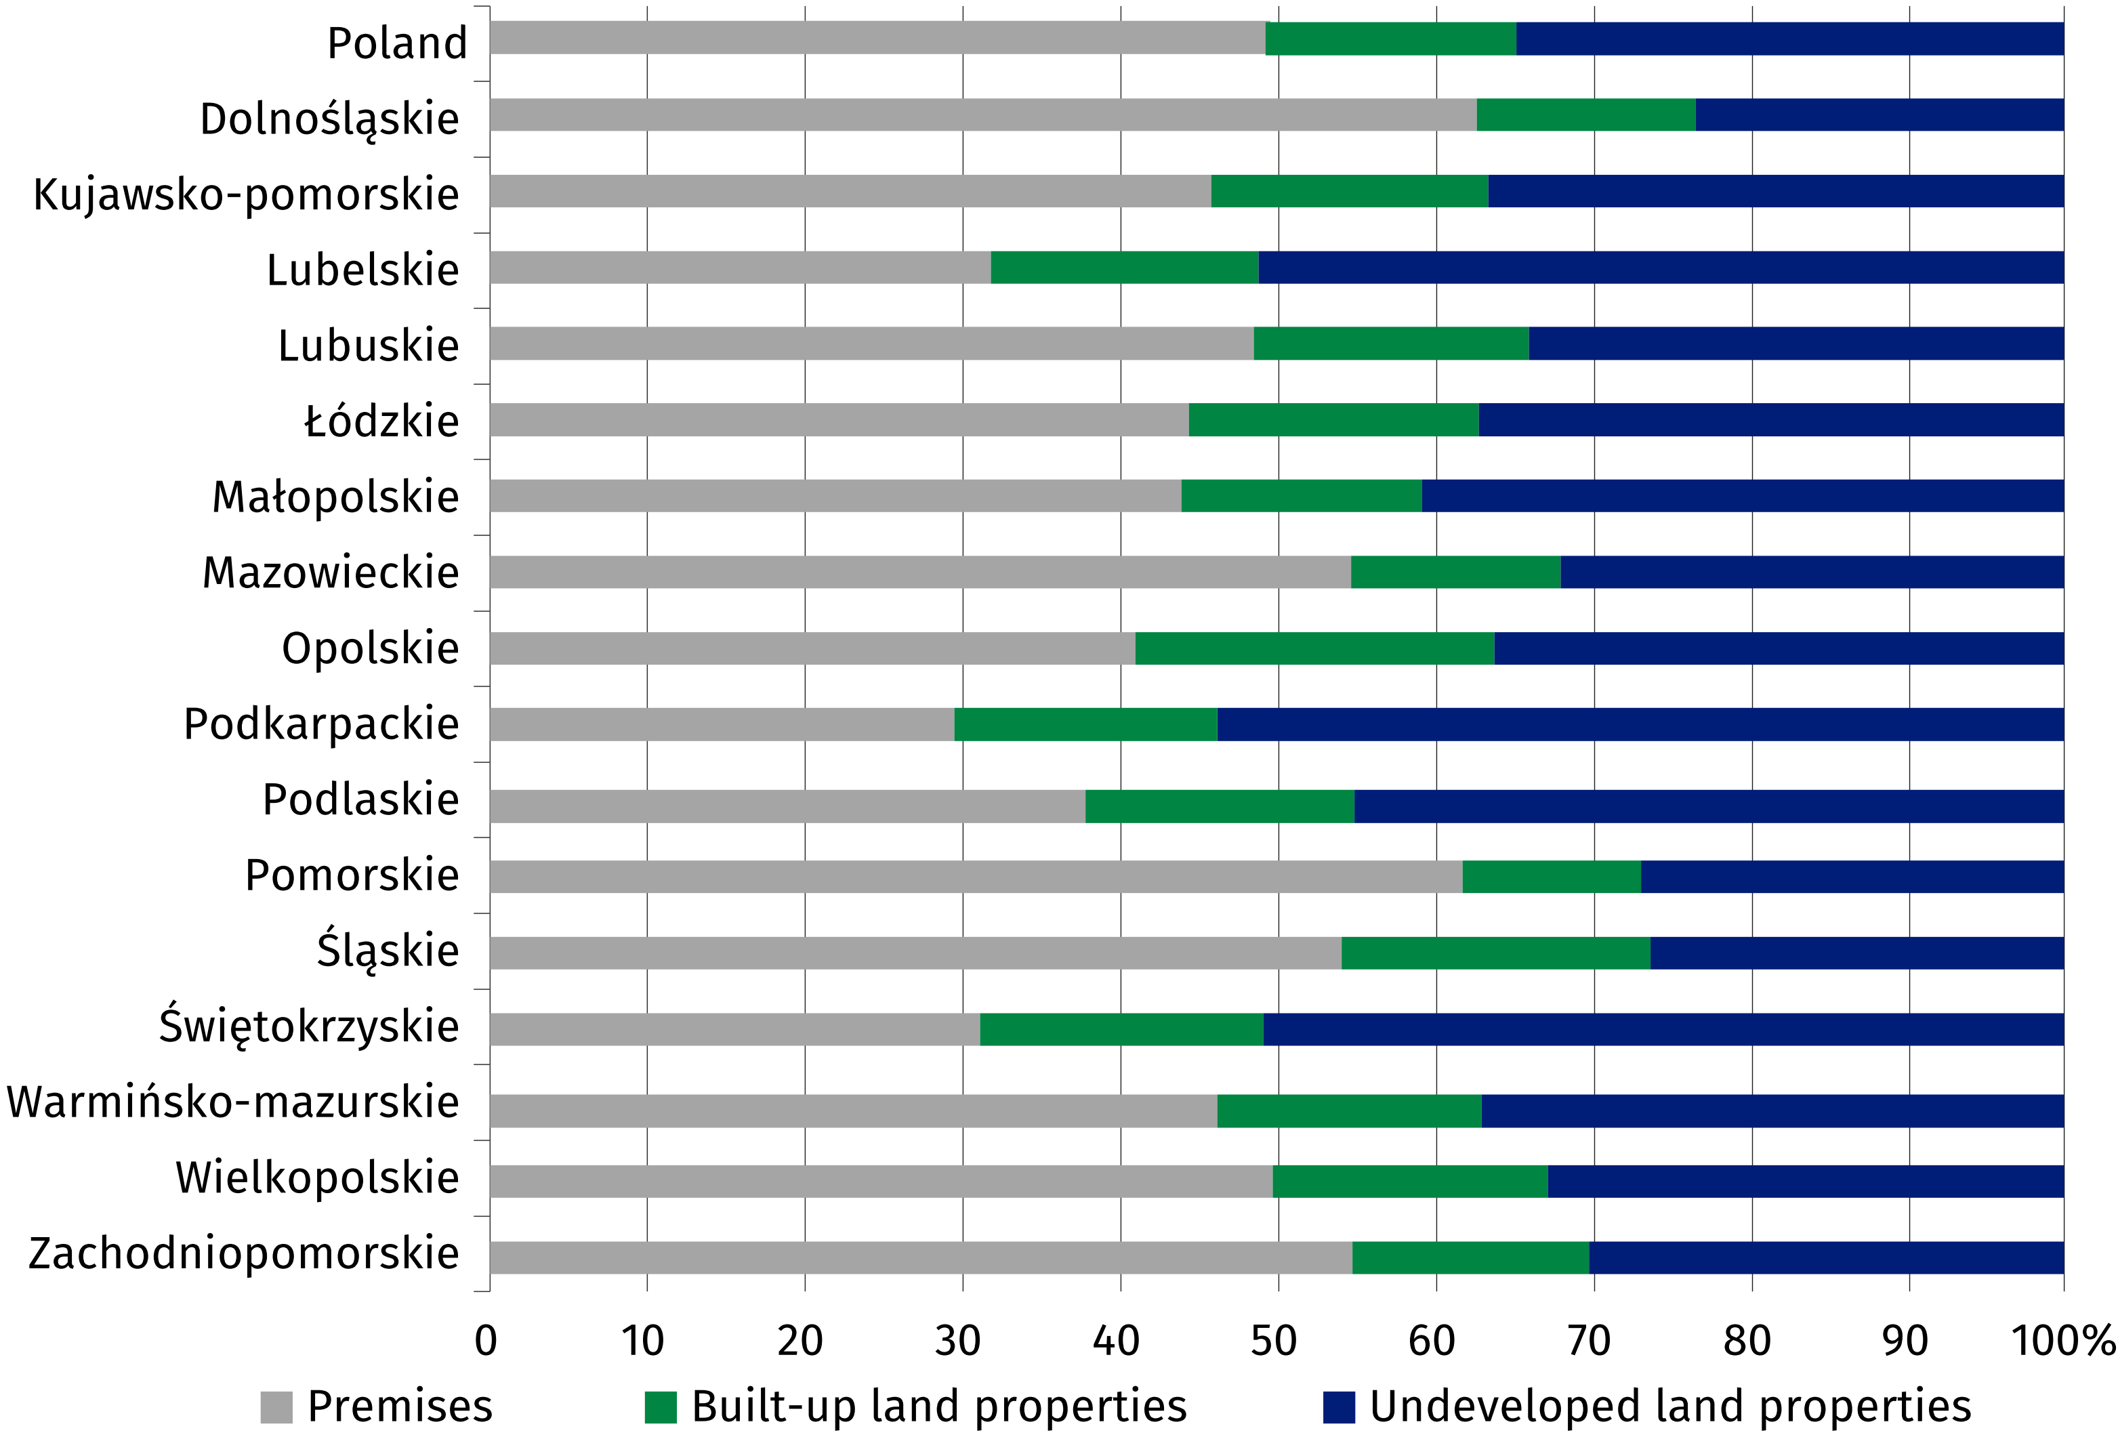

Table 3. Price indices of residential premises in 2025
Specification | 2025
Specification | 2024=100 | 2015=100
Total | 104.9 | 216.8
Primary market | 105.7 | 206.8
Secondary market | 104.2 | 224.0
Chart 2. Changes in prices of residential premises compared to the previous year
Prices of residential premises
in 2025, compared to 2024,
increased by 4.9% (of which 5.7% on the primary market and 4.2% on the secondary market)
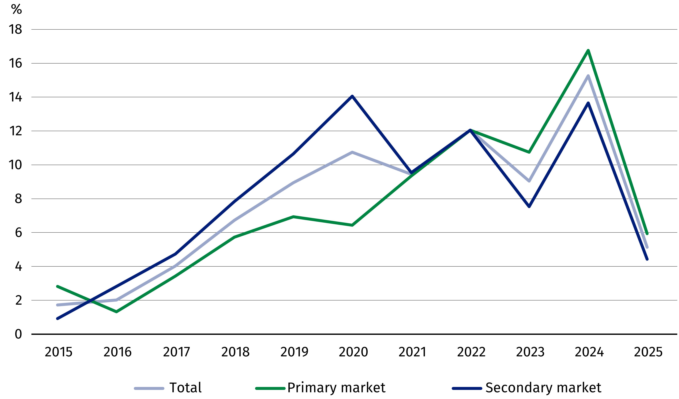
Chart 3. Changes in prices of residential premises compared to 2015
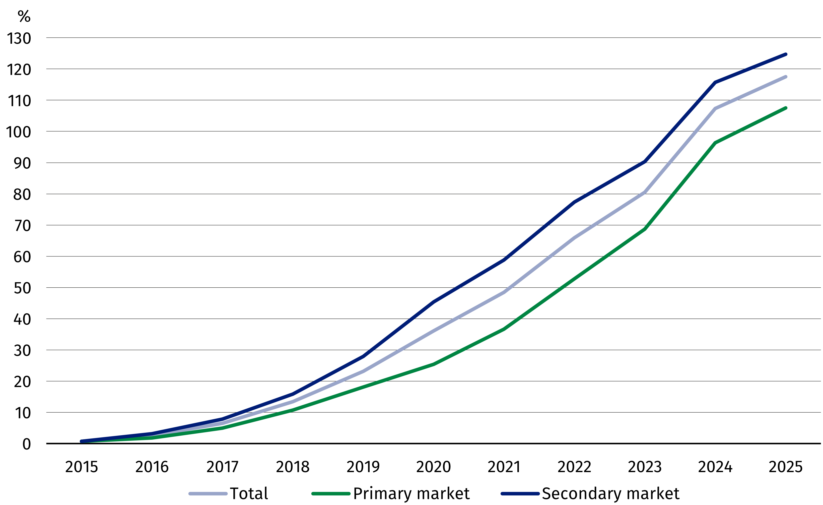
When quoting Statistics Poland data, please provide the information: “Source of data: Statistics Poland”, and when publishing calculations made on data published by Statistics Poland, please include the following disclaimer: “Own study based on figures from Statistics Poland”.

Prepared by:  Prices and Services Department  Director Ewa Adach-Stankiewicz  Phone: (+48 22) 608 31 24 | Issued by:  Press Office  Mobile: (+48) 695 255 032  Phone: (+48 22) 608 38 04, (+48 22) 449 41 45,  (+48 22) 608 30 09  e-mail: obslugaprasowa@stat.gov.pl

stat.gov.pl/en/

@StatPoland

@GlownyUrzadStatystyczny

@gus_stat

@GłównyUrządStatystycznyGUS

@Glówny Urząd Statystyczny
Related information
Price indices of residential premises by voivodships
Price of one square meter of usable floor space of a residential building
Real estate sales in 2024
Data available in databases
Knowledge Databases (DBW) – Economy – Prices – Real estate prices
Local Data Bank – Real Estate Market
Terms used in official statistics
Real estate turnover
Real estate Price Register
Premises
Price indices of residential premises
Real estate transaction

