Average paid employment and wages and salaries
in the national economy in 2025 – preliminary data
11.0 million
full-time equivalents
Average paid employment in the national economy in 2025
According to preliminary data, the average paid employment in the national economy in 2025 was 11 040.9 thousand full-time equivalents and remained at a similar level compared with the previous year.

Average paid employment in the national economy
Average paid employment includes full-time employees and part-time employees converted into full-time equivalent employees
In 2025, the most full-time equivalents (22.5%) were in the Manufacturing section. Compared with 2024, the average paid employment increased in most sections, and the highest increase occurred in the Other service activities section (by 3.0%), Education section (by 2.1%) and Real estate activities section (by 2.0%). A decrease in the average paid employment was recorded in seven sections, where the largest decrease was in the Mining and quarrying section (by 3.0%) and Trade; repair of motor vehicles∆ section (by 1.6%).
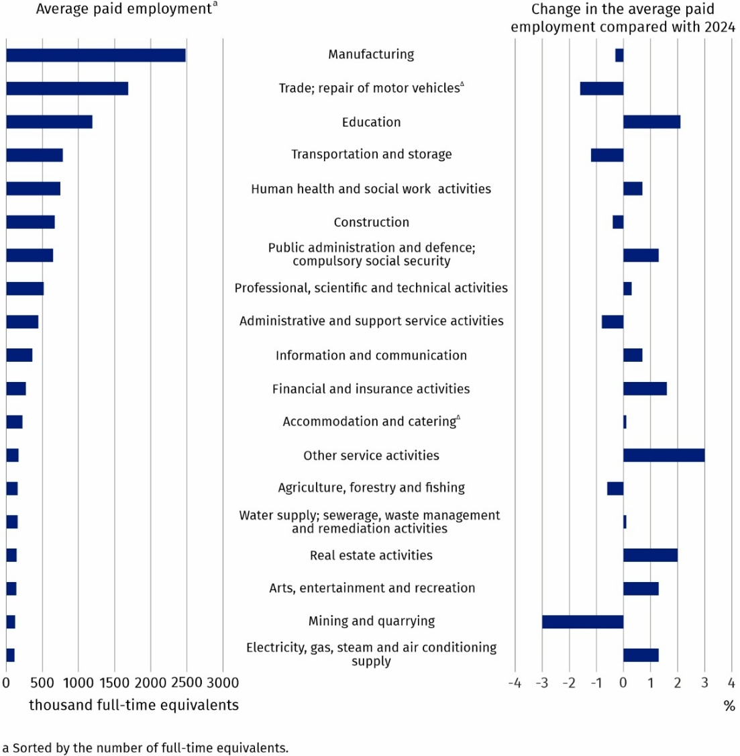
Chart 1. Average paid employment in the national economy by PKD 2007/NACE Rev. 2 section in 2025 – preliminary data

Average monthly gross wages and salaries in the national economy
In 2025, the average monthly nominal gross wage and salary in the national economy increased by 9.1% compared with 2024
According to preliminary data, the average monthly gross wage and salary in the national economy in Poland in 2025 was PLN 8 903.56. Compared with 2024, it increased nominally by 9.1%. The average monthly gross wage and salary by PKD 2007/NACE Rev. 2 section remained differentiated and ranged from PLN 5 990.92 in the Accommodation and catering∆ section to PLN 14 689.70 in the Information and communication section. These values were respectively 32.7% lower and 65.0% higher than the total average monthly gross wage and salary.
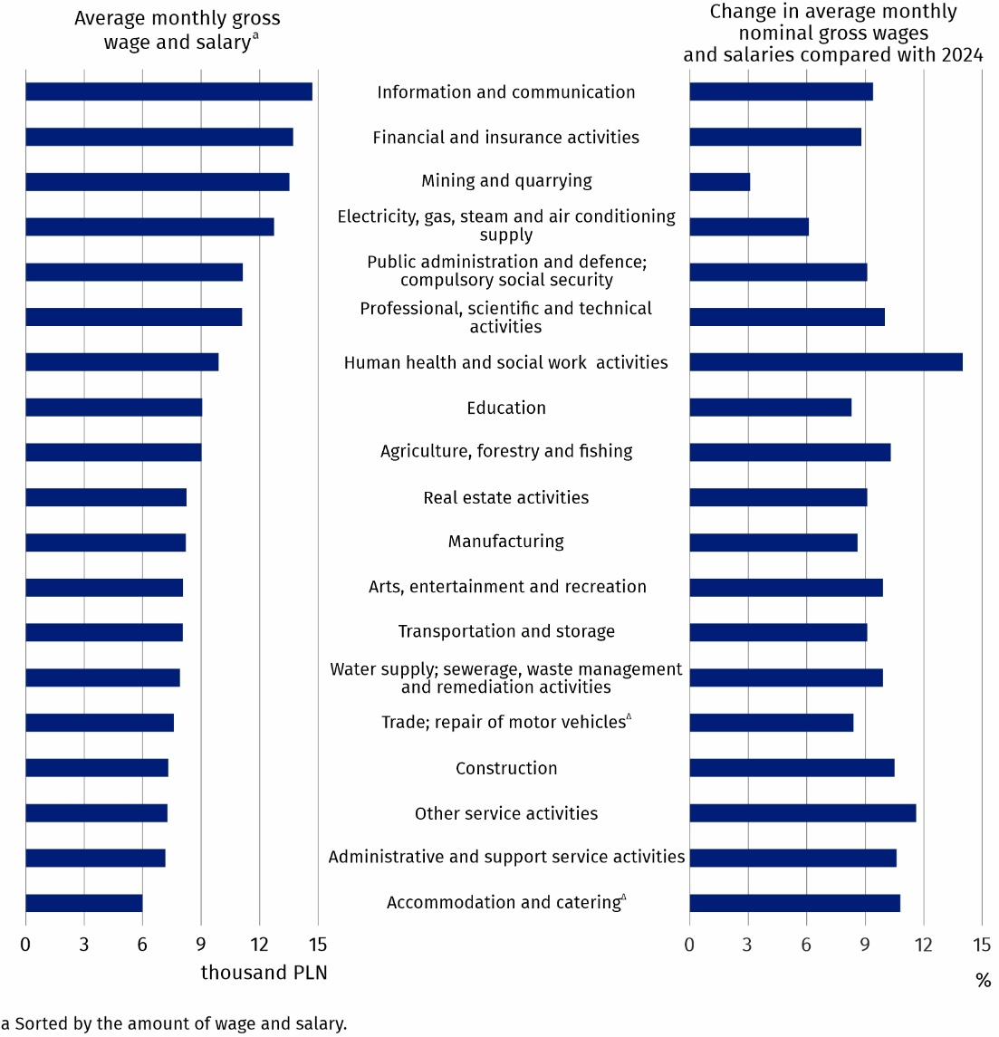
Chart 2. Average monthly gross wages and salaries in the national economy by PKD 2007/NACE Rev. 2 section in 2025 – preliminary data
In all PKD 2007/NACE Rev. 2 sections, an increase in the average monthly nominal gross wage and salary compared with 2024 was recorded. The increase ranged from 3.1% in the Mining and quarrying section to 14.0% in the Human health and social work activities section.
Symbol (∆) — means that abbreviated names of NACE Rev. 2 sections were used. Full names are available on the Eurostat website at: https://ec.europa.eu/eurostat/web/metadata/classifications
When quoting Statistics Poland data, please provide the information: ‘Source of data: Statistics Poland’, and when publishing calculations made on data published by Statistics Poland, please include the following disclaimer: ‘Own study based on figures from Statistics Poland’.
Prepared by:  Statistical Office in Bydgoszcz  Acting Director Katarzyna Klamrowska  Phone: (+48 52) 366 93 90 | Issued by:  Press Office  Mobile phone: +48 695 255 032  Landline phones: +48 22 608 38 04, +48 22 449 41 45, +48 22 608 30 09  e-mail: obslugaprasowa@stat.gov.pl

stat.gov.pl/en/

@StatPoland

@GlownyUrzadStatystyczny

@gus_stat

@GłównyUrządStatystycznyGUS

@Glówny Urząd Statystyczny
Related information
Methodological report Wages and salaries in the national economy
Yearbook of Labour Statistics 2025
Other publications related to the labour market
Data available in databases
Local Data Bank -> Labour market
Strateg -> Find indicator by theme -> Labour market
Knowledge Databases -> Labour market
Terms used in official statistics
Average paid employment
Average monthly gross wages and salaries

