Persons performing work only under contracts
of mandate and related contracts in Poland in December 2025
On the last day of December 2025,
1 497.7 thousand persons in Poland were performing work only under contracts of mandate and related contracts, i.e. 4.8% more than on 31 December 2024. Compared with 30 September 2025, their number decreased by 0.3%.
1.5 million
number of persons performing work only under contracts of mandate and related contracts in Poland as at 31 December 2025
Among persons performing work only under contracts of mandate and related contracts, men constituted the majority. At the end of December 2025, their share stood at 51.3%, which was 0.3 percentage points (pp) higher than a year earlier. Compared with 30 September 2025, their share remained unchanged.
On the last day of December 2025, men accounted for 51.3% of all persons performing work only under contracts of mandate and related contracts

Compared with 31 December 2024, both the number of women and the number of men performing work only under contracts of mandate and related contracts increased by 4.2% and 5.4%, respectively. By contrast, compared with 30 September 2025, their numbers decreased by 0.5% and 0.1%, respectively.
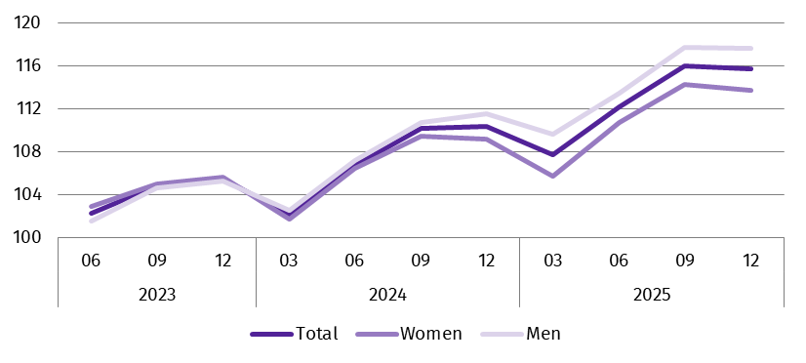
Chart 1. Indices of the number of persons performing work only under contracts of mandate and related contracts
(03 2023 = 100)
At the end of December 2025, the median age of persons performing work only under contracts of mandate and related contracts was 42.0 years, the same as at 31 December 2024.
On the last day of December 2025, as in previous months, the most persons performing work only under contracts of mandate and related contracts were in the Administrative and support service activities section, which includes, inter alia, the activities of employment agencies providing placement services. As at 31 December 2025, the number of such persons was 326.2 thousand, i.e. 21.8% of the total number of persons performing work only under such contracts. This share was 0.7 pp lower than at the end of December 2024, but 0.1 pp higher than at the end of September 2025.
In the second largest section in terms of the number of persons – Trade; repair of motor vehicles^{Δ} – work based only on contracts of mandate and related contracts – was performed by 159.8 thousand persons. They accounted for 10.7% of all contractors (0.2 pp fewer than a year earlier, but 0.2 pp more than on 30 September 2025).
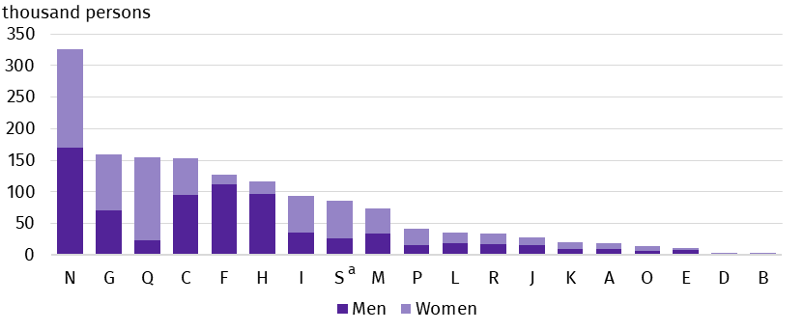
Chart 2. Persons performing work only under contracts of mandate and related contracts by sex and PKD 2007/NACE Rev. 2 section in December 2025
As at the end of the month
One in five persons performing work only under contracts of mandate or related contracts was working for an entity classified under the Administrative and support service activities section
a Data for the Other service activities (S) section also cover persons performing work only under contracts of mandate and related contracts in the Activities of households as employers; undifferentiated goods- and services-producing activities of households for own use (T) and Activities of extraterritorial organisations and bodies (U) sections.
On the last day of December 2025, the most persons performing work only under contracts of mandate and related contracts lived in the Warszawski stołeczny region and the Śląskie region – 201.2 thousand and 174.8 thousand persons, respectively, accounting for 13.4% and 11.7% of the total number of persons performing work only under such contracts. The regions with the smallest numbers of contractors were Świętokrzyskie and Opolskie, where 30.4 thousand and 31.4 thousand contractors lived respectively (representing 2.0% and 2.1% of the total number of persons performing work only under contracts of mandate and related contracts). Compared with 31 December 2024, these shares remained at a similar level.
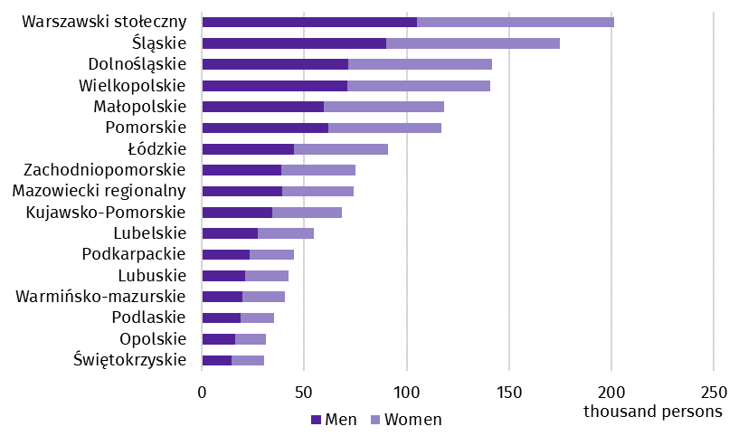
Chart 3. Persons performing work only under contracts of mandate and related contracts by place of residenceª and sex in December 2025
As at the end of the month
As at 31 December 2025, 16.6 thousand persons performing work only under contracts of mandate and related contracts lived abroad
a Data by statistical NUTS 2 region; excluding persons performing work only under contracts of mandate and related contracts who live abroad.
Methodological notes
The source of the presented data is administrative registers. The population under study includes persons performing work only under contracts of mandate, together with contracts of a related nature, to which the provisions of the Civil Code apply and which entail an obligation to be covered by social and/or health insurance with the Social Insurance Institution (ZUS), i.e. agency agreements, service contracts, nanny agreements, appointment letters and contracts with members of supervisory boards. According to the provisions of the Civil Code, in Poland, contracts of mandate and related contracts can be concluded by persons aged 13 or over. The population under study does not include persons working under contracts to perform a specified task or persons performing harvest assistance contracts (farmer's helpers). It also does not include persons performing work under contracts of mandate and related contracts who have concluded such a contract with their own employer or with another entity but to the benefit of their own employer, or who are secondary school pupils or students under the age of 26.
In this publication symbols and abbreviated names of PKD 2007/NACE Rev. 2 sections were used marking abbreviations with a ‘Δ’ symbol. The full names can be found in the list of PKD 2007/NACE Rev. 2 sections below.
Full names of PKD 2007/NACE Rev. 2 sections:
A – Agriculture, forestry and fishing;
B – Mining and quarrying;
C – Manufacturing;
D – Electricity, gas, steam and air conditioning supply;
E – Water supply; sewerage, waste management and remediation activities;
F – Construction;
G – Wholesale and retail trade; repair of motor vehicles and motorcycles;
H – Transportation and storage;
I – Accommodation and food service activities;
J – Information and communication;
K – Financial and insurance activities;
L – Real estate activities;
M – Professional, scientific and technical activities;
N – Administrative and support service activities;
O – Public administration and defence; compulsory social security;
P – Education;
Q – Human health and social work activities;
R – Arts, entertainment and recreation;
S – Other service activities;
T – Activities of households as employers; undifferentiated goods- and services-producing activities of households for own use;
U – Extraterritorial organisations and bodies.
Data for the Other service activities (S) section also cover persons performing work under contracts of mandate and related contracts in the Activities of households as employers; undifferentiated goods- and services-producing activities of households for own use (T) and Activities of extraterritorial organisations and bodies (U) sections.
When quoting Statistics Poland data, please provide the information: ‘Source of data: Statistics Poland’, and when publishing calculations made on data published by Statistics Poland, please include the following disclaimer: ‘Own study based on figures from Statistics Poland’.
Prepared by:  Statistical Office in Bydgoszcz  Acting Director Katarzyna Klamrowska  Phone: (+48 52) 366 93 90 | Issued by:  Press Office  Mobile phone: +48 695 255 032  Landline phones: +48 22 608 38 04, +48 22 449 41 45, +48 22 608 30 09  e-mail: obslugaprasowa@stat.gov.pl

stat.gov.pl/en/

@StatPoland

@GlownyUrzadStatystyczny

@gus_stat

@GłównyUrządStatystycznyGUS

@Glówny Urząd Statystyczny
Related information
Methodological report Employment in the national economy
Employed persons in the national economy in Poland in December 2025
Persons performing work only under contracts of mandate and related contracts in Poland in September 2025
Persons performing work under contracts of mandate and related contracts in Poland in December 2024
Terms used in official statistics
Employed persons in the national economy

The Act of 23 April 1964 – Civil Code (Journal of Laws of 2025, item 1071, as amended).

