Producer price indices for business services in the first quarter of 2026

In the first quarter of 2026, the producer prices for business services increased compared to the previous quarter by 1.1% and compared to the first quarter of 2025 - by 2.7%.
1.1%
Increase in producer prices for business services compared to the fourth quarter of 2025

Table 1. Producer price indices for business services
SPECIFICATION | 1 quarter 2026
SPECIFICATION | 4 quarter 2025=100 | 1 quarter 2025=100
Total | 101.1 | 102.7
Publishing activities | 101.0 | 101.2
Motion picture, video and television programme production, sound recording and music publishing activities | 100.9 | 102.3
Programming and broadcasting activities | 92.9 | 97.7
Computer programming, consultancy and related activities | 100.8 | 101.6
Information service activities | 101.1 | 104.1
Real estate activities | 101.9 | 103.6
Legal and accounting activities | 101.2 | 103.1
Management consultancy activities | 101.1 | 103.1
Architectural and engineering activities; technical testing and analysis | 101.0 | 101.9
Advertising and market research | 100.2 | 103.2
Other professional, scientific and technical activities | 101.6 | 104.0
SPECIFICATION | 1 quarter 2026
SPECIFICATION | 4 quarter 2025=100 | 1 quarter 2025=100
Rental and leasing activities | 100.9 | 101.2
Employment activities | 102.1 | 104.4
Travel agency, tour operator and other reservation service and related activities | 98.8 | 99.3
Security and investigation activities | 101.8 | 103.6
Services to buildings and landscape activities | 102.2 | 103.2
Office administrative, office support and other business support activities | 101.3 | 102.2

In the 1st quarter of 2026, the highest increase of prices compared to the previous quarter was recorded in services to buildings and landscape activities
In the first quarter of 2026 the highest increase of prices compared to the previous quarter was recorded in services to buildings and landscape activities (by 2.2%). Next, there was noticed the rise of prices in employment activities (by 2.1%), real estate activities (by 1.9%), as well as security and investigation activities (by 1.8%). The lowest growth in service prices was noticed in the case of advertising and market research services (by 0.2%).
Price decrease compared to the previous quarter were recorded in programming and broadcasting activities (by 7.1%), travel agency and in tour operator and other reservation service and related activities (by 1.2%).
Compared to the first quarter of 2025, the highest increase of service prices occurred in employment activities (by 4.4%), information service activities (by 4.1%) and other professional, scientific and technical activities (by 4.0%). The lowest increase of service prices were noticed in the case of publishing activities and rental and leasing activities (by 1.2% each).
Price decerase compared to the first quarter of 2025 occurred in programming and broadcasting activities (by 2.3%) and in travel agency, tour operator and other reservation service and related activities (by 0.7%).

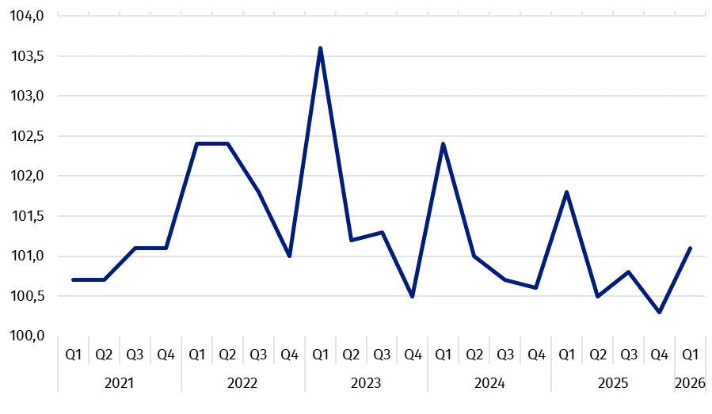
Chart 1. Producer price changes of business services in 2021-2026 (the previous quarter = 100)

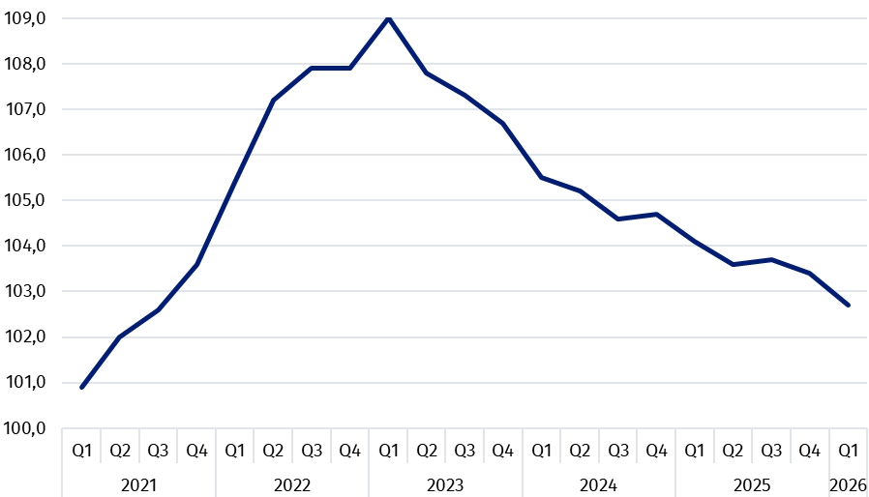
Chart 2. Producer price changes of business services in 2021-2026 (corresponding period of the previous year = 100)

In case of quoting Statistics Poland data, please provide information: “Source of data: Statistics Poland”, and in case of publishing calculations made on data published by Statistics Poland, please include the following disclaimer: “Own study based on figures from Statistics Poland”.

Prepared by:  Prices and Services Statistics Department  Director Ewa Adach-Stankiewicz  Phone: (+48 22) 608 31 24 | Issued by:  Press Office  Mobile +48 695 255 032  Phone +48 22 608 38 04, +48 22 449 41 45,  +48 22 608 30 09  e-mail: obslugaprasowa@stat.gov.pl

www.stat.gov.pl/en/

@StatPoland

@GlownyUrzadStatystyczny

gus_stat

glownyurzadstatystycznygus

glownyurzadstatystyczny
Related information
News releases

Prices in the national economy

Data available in databases
Knowledge Databases
Prices indices (Topics: Prices, Trade)

Terms used inn official statistics
Producer price indices for business services

,² Producer price indices for business services are presented using a weighting system prepared based on turnover in 2021.

