Transport of goods and passengers in 2025
In 2025, both freight and passenger transport increased. Growth was recorded in most modes
of transport, except for rail and inland waterway transport for freight and road and inland waterway transport for passengers.
7.6%
Increase in freight transport compared to 2024

4.2%
Increase in passenger transport compared to 2024

Transport of goods
Compared with 2024, the
highest increase in freight transported was recorded
in air transport (17.5%)

In 2025, compared to the previous year, an increase in the volume of freight transported was recorded in most modes of transport. A decrease occurred only in rail and inland waterway transport. A similar trend was observed in transport performance – it was higher in most modes of transport than the previous year, while a decrease in transport performance
occurred only in rail and inland waterway transport.

Table 1. Transport of goods by mode of transport
Specification | 2024 |  | 2025
Specification | in thousand tonnes |  |  | 2024=100 | 2023=100
Total | 2 138 473 | 2 300 253 |  | 107.6 | 103.3
Railway transport ª | 222 028 | 216 050 |  | 97.3 | 94.0
Road transport ^{b} | 1 861 777 | 2 026 352 |  | 108.8 | 104.3
of which hire or reward | 1 160 548 | 1 268 898 |  | 109.3 | 104.4
of which road transport  entities ^{c} | 868 108 | 928 569 |  | 107.0 | 105.0
Pipeline transport | 46 217 | 48 967 |  | 105.9 | 110.2
Maritime transport ^{d} | 6 684 | 7 104 |  | 106.3 | 96.5
Inland waterway transport | 1 674 | 1 674 |  | 99.9 | 99.0
Air transport ^{e} | 93 | 109 |  | 117.5 | 121.6
a Excluding shunting. b Data partially estimated. c Classified according to the Polish Classification of Activities 2007 into the section H „Transport and storage”, excluding division “Postal and Courier Activities”.
d Owned and rented ships e Scheduled and non-scheduled (Polish carriers).
Table 1. Transport of goods by mode of transport (cont.)
Specification | 2024 |  | 2025
Specification | in million  tonne-kilometres |  |  | 2024=100 | 2023=100
Total | 483 001 | 500 418 |  | 103.6 | 101.2
Railway transport ª | 57 818 | 55 572 |  | 96.6 | 91.5
Road transport ^{b} | 392 501 | 408 192 |  | 104.0 | 101.9
of which hire or reward | 338 328 | 350 844 |  | 103.7 | 100.5
of which road transport  entities ^{c} | 297 631 | 304 377 |  | 102.3 | 99.5
Pipeline transport | 13 186 | 14 522 |  | 110.1 | 117.7
Maritime transport ^{d} | 18 676 | 20 989 |  | 112.4 | 106.6
Inland waterway transport | 385 | 364 |  | 94.7 | 89.3
Air transport ^{e} | 435 | 479 |  | 110.2 | 113.1
a Excluding shunting. b Data partially estimated. c Classified according to the Polish Classification of Activities 2007 into the section H „Transport and storage”, excluding division “Postal and Courier Activities”.
d Owned and rented ships e Scheduled and non-scheduled (Polish carriers).

In 2025 goods from the group of “metal ores and other mining and quarrying products; peat; uranium and thorium” had the biggest share (22.9%) in transport structure.
Chart 1. Structure of goods transport by groups of goods in 2025 and year-over-year
fluctuations ª

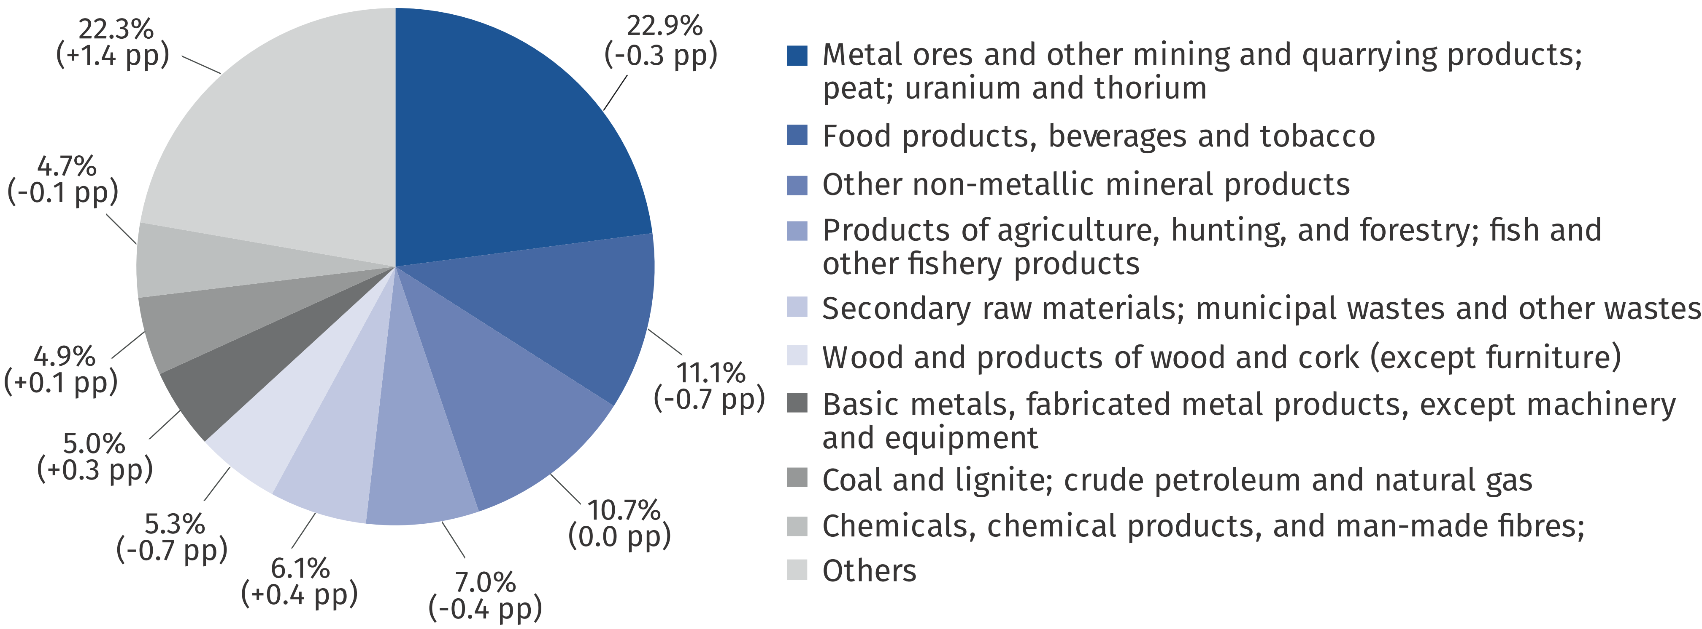

a Applies to railway transport, road transport and inland waterway transport.
Chart 2. Structure of maritime transport of cargo by cargo categories in 2025 and changes compared to the previous year
In 2025 self-propelled ro-ro units dominated in the structure of maritime cargo transport by cargo categories (55.3%)

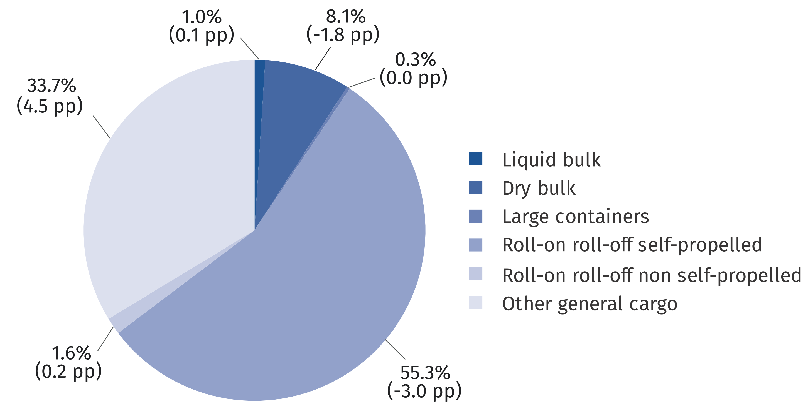

Considering transport directions, in 2025 most of goods transported by road (83.0%) and rail (69.9%) were carried in national traffic, whereas international conveyance prevailed in other modes of transport.
Table 2. Transport of goods by direction of transport
Specification  a – 2024  b – 2025 |  | Total  in thousand  tonnes | National transport | International transport
 |  | Total  in thousand  tonnes | National transport | export | import | transit | between foreign countries
 |  | Total  in thousand  tonnes | in percent
Railway transport ª | a | 222 028 | 64.7 | 13.0 | 18.5 | 3.8 | .
Railway transport ª | b | 216 050 | 69.9 | 12.1 | 16.0 | 2.0 | .
Road transport ^{b} | a | 1 464 166 | 81.1 | 5.9 | 5.2 | 0.3 | 7.5
Road transport ^{b} | b | 1 588 360 | 83.0 | 5.6 | 5.0 | 0.3 | 6.2
Maritime transport ^{c} | a | 6 684 | 0.9 | 43.7 | 39.5 | . | 15.9
Maritime transport ^{c} | b | 7 104 | 1.0 | 40.2 | 44.3 | . | 14.5
Inland waterway transport | a | 1 674 | 28.4 | 12.4 | 1.8 | 0.1 | 57.3
Inland waterway transport | b | 1 672 | 35.8 | 7.6 | 1.6 | 0.0 | 55.0
Air transport ^{d} | a | 93 | 0.3 | 99.7
Air transport ^{d} | b | 109 | 0.3 | 99.7
a Excluding shunting b Data on the basis of results a sample survey (excluding cabotage) c Owned and rented ships. d Scheduled and non-scheduled (Polish carriers).

Table 2. Transport of goods by direction of transport (cont.)
Specification  a – 2024  b – 2025 |  | Total  in million tonne-  -kilometres | National transport | International transport
 |  | Total  in million tonne-  -kilometres | National transport | export | import |  | transit |  | between foreign countries
 |  | Total  in million tonne-  -kilometres | in percent
Railway transport ª | a | 57 818 | 56.1 | 15.1 |  | 19.6 |  | 9.2 |  | .
Railway transport ª | b | 55 872 | 64.3 | 13.9 |  | 17.3 |  | 4.5 |  | .
Road transport ^{b} | a | 352 182 | 37.5 | 19.4 |  | 18.4 |  | 1.9 |  | 22.8
Road transport ^{b} | b | 365 068 | 41.7 | 19.6 |  | 17.6 |  | 1.6 |  | 19.5
Inland waterway transport | a | 385 | 4.1 | 16.3 |  | 2.4 |  | 0.1 |  | 77.1
Inland waterway transport | b | 364 | 6.6 | 12.0 |  | 2.3 |  | 0.0 |  | 79.1
Air transport ^{d} | a | 435 | 0.0 | 99.9
Air transport ^{d} | b | 479 | 0.0 | 99.9
a Excluding shunting b Data on the basis of results a sample survey (excluding cabotage) c Owned and rented ships. d Scheduled and non-scheduled (Polish carriers).

Taking into account national traffic by distance classes, one can note that in 2025 the most goods was transported by rail over distances of 150 – 299 km and up to 50 km, by road – up to 50 km, and by inland waterway transport – in the 50 – 149 km zone.
Table 3. National transport of goods by distance classes
Specification  a – 2024  b – 2025 |  | Total  in thousand tonnes | Distance classes
 |  | Total  in thousand tonnes | 49 km  and less | 50-149 | 150-299 | 300-499 | 500 km  and more
 |  | Total  in thousand tonnes | in percent
Railway  transport ^{ab} | a | 143 590 | 24.6 | 20.3 | 30.9 | 13.2 | 11.0
Railway  transport ^{ab} | b | 150 870 | 25.2 | 19.6 | 25.7 | 16.1 | 13.4
Road transport ^{c} | a | 1 187 229 | 45.0 | 27.1 | 25.4 |  | 2.5
Road transport ^{c} | b | 1 317 892 | 43.5 | 27.1 | 26.3 |  | 2.5
Inland waterway transport | a | 475 | 54.0 | 45.9 | – | 0.0 | 0.1
Inland waterway transport | b | 599 | 45.8 | 53.5 | 0.1 | 0.2 | 0.4
a Excluding shunting. b Excluding official consignments. c Data on the basis of results a sample survey.

Table 3. National transport of goods by distance classes (cont.)
Specification  a – 2024  b – 2025 |  | Total  in million tonne-  -kilometres | Distance classes
 |  | Total  in million tonne-  -kilometres | 49 km  and less | 50-149 | 150-299 | 300-499 | 500 km  and more
 |  | Total  in million tonne-  -kilometres | in percent
Railway  transport ^{ab} | a | 32 414 | 1.5 | 9.1 | 35.9 | 24.4 | 29.1
Railway  transport ^{ab} | b | 35 927 | 1.3 | 8.4 | 28.4 | 27.8 | 34.1
Road transport ^{c} | a | 131 995 | 8.0 | 20.5 | 58.5 |  | 13.0
Road transport ^{c} | b | 152 239 | 7.3 | 20.8 | 59.3 |  | 12.6
Inland waterway transport | a | 16 | 10.5 | 87.2 | – | 0.2 | 2.1
Inland waterway transport | b | 24 | 7.7 | 83.6 | 0.6 | 1.9 | 6.2
a Excluding shunting. b Excluding official consignments. c Data on the basis of results a sample survey.

Transport of passengers
In 2025, 7.7% more passengers were transported by rail than
a year ago
In 2025, 4.2% more passenger were transported than in the previous year. Passenger transport increased in air transport (by 9.5%), rail transport (by 7.7%), and maritime transport (by 3.4%), while a decrease was recorded in inland waterway transport (by 8.1%) and road transport (by 1.4%).
Table 4. Transport of passengers
In 2025, 60.1% of all passengers were carried by railway transport
Specification | 2024 | 2025
Specification | in thousand passengers |  | 2024=100
Total | 698 879 | 728.364 | 104.2
Railway transport | 406 614 | 437 983 | 107.7
Road transport ª | 272 455 | 268 876 | 98.6
Maritime transport ^{bcd} | 1 429 | 1 478 | 103.4
Inland waterway transport | 1 097 | 1 008 | 91.9
Air transport ^{e} | 17 375 | 19 019 | 109.5
a Excluding urban transport and provided by entities employing up to 9 persons. b Owned and rented ships. c Excluding truck drivers on board ferries. d Including coastal shipping. e Scheduled and non-scheduled (Polish carriers).

Table 4. Transport of passengers (cont.)
Specification | 2024 |  | 2025
Specification | in million  passenger-kilometres |  |  | 2024=100
Total |  | 79 200 | 82 081 | 103.6
Railway transport |  | 28 388 | 30 572 | 107.7
Road transport ª |  | 13 743 | 11 497 | 83.7
Maritime transport ^{bcd} |  | 145 | 150 | 103.5
Inland waterway transport |  | 12 | 13 | 106.2
Air transport ^{e} |  | 36 912 | 39 849 | 108.0
a Excluding urban transport and provided by entities employing up to 9 persons. b Owned and rented ships. c Excluding truck drivers on board ferries. d Including coastal shipping. e Scheduled and non-scheduled (Polish carriers).

When quoting Statistics Poland data, please provide the information: “Source of data: Statistics Poland”, and when publishing calculations made on data published by Statistics
Poland, please include the following disclaimer: “Own study based on figures from Statistics Poland”.
.

Prepared by:  Statistical Office in Szczecin  Director Magdalena Wegner  Phone: (+48 91) 459 77 00 | Issued by:  Press Office  Mobile: (+48) 695 255 032  Phone: (+48 22) 608 38 04, (+48 22) 449 41 45,  (+48 22) 608 30 09  e-mail: obslugaprasowa@stat.gov.pl

stat.gov.pl/en/

@StatPoland

@GlownyUrzadStatystyczny

@gus_stat

@GłównyUrządStatystycznyGUS

@Glówny Urząd Statystyczny
Related information
Transport – activity results in 2024
Data available in databases
Knowledge Databases – Database – Transport
Terms used inn official statistics
Transport of goods
Transport of passengers
Tonne-kilometres
Passenger-kilometres

