Spring assessment of the condition of agricultural and horticultural crops in 2026
29.05.2026
It is initially estimated that this year the sown area of basic cereals with cereal mixtures is larger than last year (after taking into account the area ploughed due to winter damage) and amounts to approx. 5.6 million hectares (an increase of about 2.9%). According to initial estimates, the total cultivation area of rape and turnip rape is expected to decrease by around 0.4%. Winter and spring losses in the area of winter cereal crops were higher this year than in the previous year and amounted to about 1.1% for winter cereal mixtures and about 1.0% for winter barley. On plantations of winter wheat, rye, and triticale, winter losses amounted to approx. 0.2%.
2.9%
increase in the sown area of basic cereals with cereal mixtures compared to the 2025 sown area

The beginning of the growing season was observed in the second decade of March. However, agrometeorological conditions during spring were generally unfavorable for plant growth and development. Spring cold spells slowed vegetation progress, while severe frosts occurring in the third decade of April, locally reaching even -9°C and taking the form of frost, caused damage to some crops, particularly flowering fruit trees and bushes as well as berry plantations. The extent of the damage varied and depended mainly on the location of the plantation and the cultivated variety. At the same time, the continuing shortage of rainfall limited soil water resources. In most parts of the country, significant drying of the topsoil layer was recorded, which negatively affected the growth and development of crops.
The weather conditions in spring were generally unfavorable for plant growth and development

The overwintering of orchard crops was generally assessed as good, despite the occurrence of severe frosts during winter. However, strong frosts recorded at the end of April, locally taking the form of frost, contributed to losses in orchard crops. In many regions of the country, significant damage to flowers and fruit sets was recorded on plantations of both fruit trees and fruit bushes. An additional factor weakening the condition of trees during spring was the increasing shortage of rainfall, which led to significant soil drying.
Preliminary estimates of the area of certain crops for harvest in 2026
The area of winter basic cereals with cereal mixtures was estimated at about 4.5 million hectares
The area of winter basic cereals with cereal mixtures was estimated at about 4.5 million hectares, about 0.9% larger than the sown area in the previous year, including:
- winter wheat more than 2.3 million hectares,
- rye about 0.6 million hectares,
- winter barley about 0.4 million hectares,
- winter triticale about 1.1 million hectares.

The area of spring basic cereals with cereal mixtures was estimated at about 1.2 million hectares
Compared with the previous year, an increase in the cultivation area was recorded for all species of spring cereals except oats. Preliminary estimates indicate that the sown area of spring basic cereals with cereal mixtures, amounted to approx. 1.2 million hectares, i.e. about 11.7% more than in the previous growing season. The sown area of individual species was as follows:
- spring wheat about 0.1 million ha,
- spring barley about 0.2 million ha,
- oats about 0.5 million ha,
- spring triticale about 0.1 million ha,
- spring cereal mixtures about 0.2 million ha.
The course of agrometeorological conditions from autumn 2025 to spring 2026
Agrometeorological conditions in November were highly variable. Frequent rainfall hindered autumn field work and the harvesting of root and fodder crops. At the same time, in regions with a more even distribution of precipitation, adequate soil moisture and positive air temperatures supported the growth and development of winter crops. Cooling in the third decade of the month, combined with diurnal temperature fluctuations, promoted plant hardening.
In December, weather conditions generally did not pose a threat to overwintering crops, despite the continued variability of agrometeorological conditions. Significant drops in air temperature near the ground surface were recorded in the third decade of the month, locally reaching -15°C or lower. Despite the lack of snow cover or its minimal thickness, these conditions did not lead to excessive cooling of the soil at the tillering node depth.
The course of weather conditions during the winter period increased the risk of crop damage
In January and during the first and second decades of February, very large drops in near-ground air temperature were recorded, locally reaching -25°C or lower, which increased the risk of frost damage. In many regions of the country, insufficient snow cover did not provide adequate protection for crops against excessive cooling. In the third decade of February, a warming period occurred, accompanied by rainfall. Locally, waterlogging was observed in fields, which could have negatively affected the overwintering condition of plants.
Weather conditions in March were generally favorable for agriculture. In the second decade of the month, vegetation of winter crops and permanent grasslands resumed. Favorable agrometeorological conditions allowed for the continuation of spring fieldwork, including the sowing of oats, spring wheat, and spring barley over a large part of the country. At the same time, the persistent precipitation deficit contributed to a reduction in soil water resources.
Agrometeorological conditions in April were generally unfavorable for agriculture. Cool days and nights occurring throughout the month slowed down the growth and development of plants. In addition, frosts occurring in the third decade of April, reaching even -9°C in some places, caused damage to certain crops, especially flowering fruit trees and bushes as well as berry plantations. The continuing lack of rainfall contributed to the deterioration of soil moisture conditions. In most parts of the country, significant drying of the topsoil layer was observed, which negatively affected the growth and development of crops.
In May, cool days and nights continued and were accompanied by a shortage of rainfall, locally significant. These conditions adversely affected the rate of plant growth and development. The growth of winter and spring cereals during their period of highest water demand took place over a large part of Poland under conditions of insufficient soil moisture. In many regions of the country, the topsoil layer became excessively dry. Local rainfall improved soil moisture conditions; however, the persistently low temperatures continued to slow down crop vegetation.
Table 1. Air temperature and precipitation from autumn 2025 to spring 2026
Specification | National average air temperature |  | National average rainfall totals
Specification | ºC | deviation from the norm ^{a)} | mm | % norm ^{a)}
AUTUMN ^{b)} 2025
September | 15.5 | 1.7 | 62.9 | 109.6
October | 8.7 | -0.1 | 60.5 | 129.8
November | 4.1 | 0.1 | 45.0 | 113.4
WINTER ^{b)} 2025/2026
December | 2.3 | 2.0 | 14.5 | 37.3
January | -4.1 | -3.0 | 17.2 | 47.4
February | -1.6 | -1.5 | 22.3 | 70.6
SPRING ^{b)} 2026
March | 6.4 | 3.3 | 10.8 | 28.6
April | 7.6 | -1.1 | 11.0 | 30.2
a) From 2021 IMiGW adopts as the average norm from years 1991-2020.
b) Monthly averages /Statistics Poland calculations based on IMiGW data/.

Assessment of the condition of agricultural crops

Winter crops
Table 2. Spring assessment of winter crops
Years | Wheat | Rye | Barley | Triticale | Rape and turnip rape
Years | in qualifying grades ^{a)}
2006-2010^{b)} | 3.7 | 3.5 | 3.5 | 3.6 | 3.6
2011-2015^{b)} | 3.7 | 3.5 | 3.5 | 3.6 | 3.5
2016-2020^{b)} | 3.7 | 3.6 | 3.6 | 3.6 | 3.5
2021 | 3.7 | 3.7 | 3.7 | 3.7 | 3.7
2022 | 3.8 | 3.8 | 3.8 | 3.8 | 3.8
2023 | 3.9 | 3.9 | 3.9 | 3.9 | 3.9
2024 | 4.0 | 3.9 | 3.9 | 4.0 | 3.8
2025 | 4.0 | 4.1 | 4.0 | 4.1 | 3.8
2026 | 3.7 | 3.7 | 3.7 | 3.8 | 3.5
a) A grade of „5” indicates very good condition, „4”– good, „3”– sufficient, „2” – poor, „1”– bad, disaster.
b) Annual average.
An assessment carried out in the first decade of May 2026 by Statistics Poland field appraisers shows that the state of winter cereal sowings is worse than last year. It was assessed at 3.7 – 3.8 qualification degrees, while the condition of winter rape and turnip rape was assessed at 3.5 qualification degrees, i.e. lower than last year's assessment.

Spring crops
Spring cereals were sown in most voivodeships on time or with a slight delay. Due to the cold spring with a deepening shortage of rainfall, sowing spring cereals was difficult, and plant emergence was delayed and uneven. Considerable drying of the soil in April and the first half of May inhibited the growth and development of spring crops. The condition of spring crop sowings was assessed as worse than last year.
Table 3. Spring condition assessment for spring crops
Years | Wheat | Barley | Oats | Triticale | Cereals mixtures | Rape and turnip rape
Years | in qualifying grades ^{a)}
2006-2010^{b)} | 3.4 | 3.4 | 3.4 | 3.4 | 3.4 | 3.3
2011-2015 ^{b)} | 3.5 | 3.5 | 3.5 | 3.5 | 3.5 | 3.4
2016-2020 ^{b)} | 3.4 | 3.5 | 3.5 | 3.4 | 3.4 | 3.4
2021 | 3.4 | 3.4 | 3.5 | 3.4 | 3.4 | 3.5
2022 | 3.5 | 3.5 | 3.5 | 3.5 | 3.5 | 3.5
2023 | 3.7 | 3.6 | 3.7 | 3.6 | 3.6 | 3.6
2024 | 3.7 | 3.7 | 3.7 | 3.7 | 3.7 | 3.6
2025 | 3.7 | 3.6 | 3.7 | 3.6 | 3.6 | 3.6
2026 | 3.3 | 3.3 | 3.5 | 3.4 | 3.3 | 3.2
a) A grade of „5” indicates very good condition, „4”– good, „3”– sufficient, „2” – poor, „1”– bad, disaster.
b) Annual average.
Permanent grassland and clover plantations
The condition of permanent grasslands after winter was generally assessed as worse than in the previous year. Vegetation conditions for meadow and pasture plants during late winter and early spring were mostly unfavorable, mainly due to low temperatures and insufficient soil moisture. These factors limited grass tillering and also slowed down plant growth and green biomass production.
Assessments of the condition of permanent meadows by voivodeship ranged from 4.4 degrees in the Zachodniopomorskie Voivodeship to 2.5 points in the Opolskie Voivodeship.
Pasture condition were estimated to range from 4.1 degrees in the Lubelskie and Zachodniopomorskie Voivodeships to 2.5 degrees in the Opolskie Voivodeship.
Assessments of the condition of red clover in pure sowing and in mixtures with grasses ranged from 4.1 degrees in the Lubelskie and Zachodniopomorskie Voivodeships to 2.3 degrees in the Opolskie Voivodeship.

Table 4. Condition assessment of permanent grassland and red clover
Years | Meadows | Pastures | Clover ^{a)}
Years | in qualifying grades ^{b)}
2006 – 2010^{c)} | 3.4 | 3.3 | 3.6
2011 – 2015^{c)} | 3.6 | 3.5 | 3.6
2016-2020 ^{c)} | 3.6 | 3.5 | 3.5
2021 | 3.6 | 3.6 | 3.6
2022 | 3.6 | 3.6 | 3.7
2023 | 3.8 | 3.8 | 3.8
2024 | 3.9 | 3.9 | 3.9
2025 | 3.9 | 3.9 | 3.8
2026 | 3.6 | 3.5 | 3.6
a) Red clover in pure sowing and in mixtures with grasses.
b) A grade of „5” indicates very good condition, „4”– good, „3”– sufficient, „2” – poor, „1”– bad, disaster.
c) Annual average.
Assessment of the extent of winter crop losses
This year, losses in the sown area of winter crops were higher than in the previous year.
A total of about 12.2 thou-sand hectares of winter cereals sown in autumn 2025 were qualified for ploughing
It is estimated that by mid-May a total of approximately 12.2 thousand hectares sown with winter cereals, i.e. 0.3% of the winter cereal area, had been ploughed up or qualified for ploughing, of which:
- winter wheat about 3.9 thousand ha (in 2025 – 1.2 thousand ha),
- rye about 1.5 thousand ha (in 2025 - 0.5 thousand ha),
- winter barley about 4.1 thousand ha (in 2025 – 0.7 thousand ha),
- winter triticale about 2.3 thousand ha (in 2025 – 0.6 thousand ha),
- winter cereal mixtures about 0.4 thousand ha (in 2025 – less than 0.3 thousand ha).
The area of winter rape and turnip rape ploughed up and qualified for ploughing amounted to approximately 9.1 thousand ha, i.e. 0.8% of the area sown in autumn (compared with approximately 1.8 thousand hectares ploughed up in 2025).
According to the assessment of the field experts of the Statistics Poland, the main reasons for ploughing up winter crop plantations this year were frost damage, low plant density per 1 m², and damage caused by wild animals. The highest winter and spring losses in winter cereal crops were recorded in the Dolnośląskie Voivodeship (due to low plant density per 1 m²), while in rape and turnip rape the highest losses were recorded in the Kujawsko-Pomorskie Voivodeship (due to frost damage).
Losses in stored agricultural and horticultural crops
Approximately 3.9 million tonnes of potatoes were intended for storage during the winter of 2025/2026, i.e. around 56% of the 2025 harvest. Losses in stored potatoes are estimated to be similar to those in the previous year, at around 11% of the total quantity intended for storage. The highest losses in stored potatoes were reported in the Zachodniopomorskie Voivodeship – approx. 15% and the Łódzkie Voivodeship – approx. 14%, while the lowest losses were recorded in the Podlaskie and Kujawsko-Pomorskie Voivodeships – approx. 8%.
Table 5. Losses in stored crops
Years | Potatos | Cabbage | Onion | Carrots | Beetroot | Parsley | Celery | Leeks
Years | as a % of the total quantity of stored crops
2006- 2010^{a)} | 12 | 17 | 13 | 15 | 11 | 16 | 15 | 12
2011- 2015^{a)} | 11 | 17 | 14 | 14 | 12 | 15 | 15 | 12
2016-2020 ^{a)} | 11 | 13 | 12 | 12 | 11 | 13 | 13 | 12
2021 | 11 | 11 | 11 | 13 | 10 | 12 | 11 | 10
2022 | 12 | 11 | 11 | 12 | 10 | 11 | 11 | 10
2023 | 11 | 11 | 12 | 13 | 10 | 11 | 11 | 11
2024 | 11 | 10 | 11 | 13 | 11 | 12 | 11 | 12
2025 | 11 | 11 | 12 | 13 | 11 | 12 | 11 | 11
2026 | 11 | 11 | 11 | 13 | 11 | 12 | 10 | 10
a) Annual average
In the 2025/26 season, the share of vegetables intended for storage was slightly lower than in the previous season. The largest decrease was recorded for leeks, celeriac and parsley. Losses occurring during vegetable storage did not differ significantly from the levels observed in previous years. As in earlier storage seasons, significant differences in the level of losses were observed depending on the region of the country. The highest losses were recorded in the Dolnośląskie, Lubelskie, Wielkopolskie and Zachodniopomorskie voivodships, while the lowest were reported in the Mazowieckie and Świętokrzyskie voivodships.
In the current season, the share of apples intended for storage was slightly higher than in the previous season. Storage losses at the national level amounted to approximately 12% and remained at a level similar to that recorded in the previous season. The highest storage losses were recorded in the Warmińsko-Mazurskie voivodship, while the lowest were reported in the Mazowieckie voivodship.
Assessment of overwintering of trees, fruit bushes and berry plantations and the condition of horticultural crops
Frosts occurring at the end of April caused damage to flowers and fruit set in orchard crops. The extent of losses varied across regions and depended, among other factors, on plantation location
Winter 2025/2026 did not cause significant damage to crops across most of the country, despite periods of severe frost. Overwintering conditions for orchard crops were generally assessed as good. However, subsequent weather conditions proved unfavorable for crop development. Cool temperatures in April slowed vegetation processes, while the persistent precipitation deficit led to progressive soil drying. Water shortages hindered nutrient uptake and reduced fertilizer efficiency. The greatest impact on the condition of fruit crops had the frosts occurring at the end of April. In many regions of the country, several consecutive days of low temperatures, locally reaching as low as –9°C, coincided with the flowering period or the early stage of fruit set. As a result, damage occurred to flowers, pistils and young fruitlets. The scale of losses varied across regions and depended, among other factors, on plantation location, terrain characteristics, flowering dynamics and the frost protection methods applied. Damage was reported both in fruit tree orchards and in fruit bushes plantations.
Strawberry plantations and other berry crops overwintered well, and their subsequent development depended largely on spring weather conditions. Low spring temperatures and insufficient precipitation limited plant growth. Frosts occurring in April caused plant damage and adversely affected fruit set. The use of protective covers had a beneficial effect, although it also increased the risk of fungal diseases. The continuing water deficit forced some farms to start irrigation systems earlier than usual.
Weather conditions observed to date were also unfavorable for field vegetable production. Insufficient precipitation, low soil moisture and persistent cool temperatures caused delays in spring field operations. As a consequence, delayed and uneven emergence, as well as slower plant development, were observed, particularly in thermophilic species.
The availability of seed material, fertilizers and other agricultural inputs generally remained good. However, producers reported increasing purchase costs and reduced availability of certain previously used plant protection products as a result of their withdrawal from the market.
Agricultural and horticultural crop area forecasting using satellite remote sensing
Map 1. Estimation of sown area with winter crops
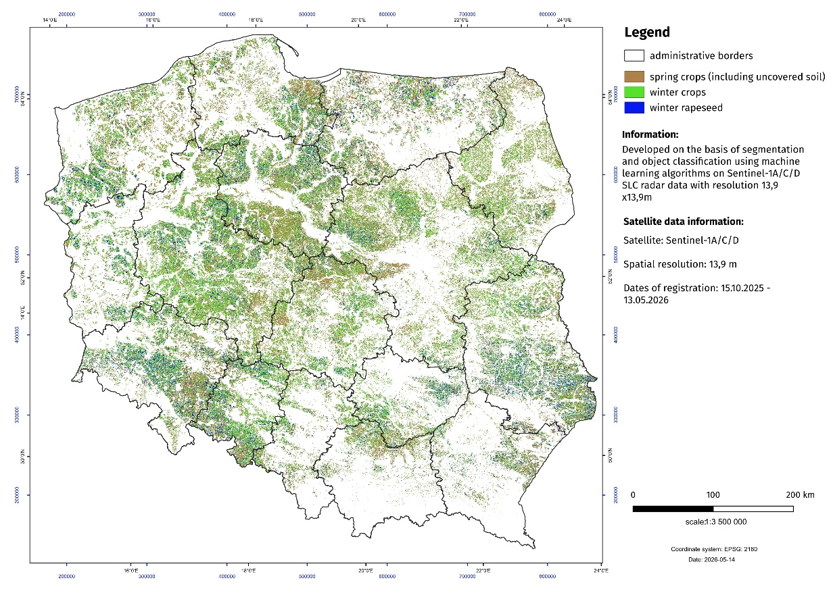

In the field of work on forecasting the area of agricultural and horticultural crops, activities are carried out aimed at using satellite imagery. The new data acquisition system is the basis of a new methodology for agricultural research.
Within the framework of the "Spring assessment of the condition of agricultural and horticultural crops", an estimation of the sown area of winter crops (without distinguishing between crop species) and winter rape and turnip rape was made using satellite remote sensing methods.
Sentinel-1A/C/D radar images (observation period from 15.10.2025 to 13.05.2026) formed the basis for the estimation. The estimation was based on segmentation and object based classification of the T2 coherence matrix and the parameters of the polarymetric H/α decomposition using machine learning algorithms (Random Forest). Classification accuracy was validated using photointerpretation data. A total of 735 satellite scenes of 250 km wide SLC (Single Look Complex) radar data were used. A crop database developed using photointerpretation methods based on Sentinel-2 data was used to teach the system and perform the classification.

In case of quoting Statistics Poland data, please provide information: “Source of data: Statistics Poland”, and in case of publishing calculations made on data published by Statistics Poland, please include the following disclaimer: “Own study based on figures from Statistics Poland”.
Prepared by:  Agriculture and Environment Department  Director Marta Wojciechowska  Phone: (+48 22) 608 31 28 | Issued by:  Press Office  Mobile (+48) 695 255 032  Phone: (+48 22) 608 38 04, (+48 22) 449 41 45,  (+48 22) 608 30 09  e-mail: obslugaprasowa@stat.gov.pl

stat.gov.pl/en/

@StatPoland

@GlownyUrzadStatystyczny

@gus_stat

@GłównyUrządStatystycznyGUS

@Glówny Urząd Statystyczny
Related information
Production of agricultural and horticultural crops in 2025

Data available in databases
BDL: Sown area

Terms used inn official statistics

BDL: Agricultural crops

The information includes the results of the spring crop condition assessment carried out in the first half of May 2026. The assessment was based on expert opinions of Statistics Poland's field appraisers prepared on the basis of vetting of fields, meadows and orchards. The spring crop condition assessment also includes an estimate of the sown area of main agricultural crops using satellite remote sensing methods and an estimate of winter and spring losses.

