The situation of households in 2025 on the basis of results of the Household Budget Survey
In 2025, the income situation of households improved. Average monthly income and, to lesser extent, average monthly expenditure per capita in households increased both in nominal and in real terms. The share of expenditure in available income decreased from 59.3% in 2024 to 57.6% in 2025
In 2025 the financial situation of households improved in comparison with 2024. Households attained in nominal terms higher income, but they also had higher expenditure. The level of average monthly available income per capita in 2025 amounted to PLN 3500 and was higher by 10.5% in nominal terms, and by 6.7% in real terms than the income in 2024. The average monthly expenditure per capita in households in 2025 reached the value of PLN 2015, and were higher on a yearly basis – by 7.3% in nominal terms, and by 3.6% in real terms than expenditure in 2024. The share of expenditure in available income decreased from 59.3% in 2024 to 57.6% in 2025.
6.7%
The increase of the average monthly available income per capita in households in 2025 in real terms

Income and expenditure
Households of self-employed outside farming had the highest average monthly available income per capita – PLN 4198, as well as average monthly expenditure per capita – PLN 2270
In 2025, there were still a relatively large differences in average monthly income and expenditure between various socio-economic groups of households. Similarly to the previous years, the highest average monthly available income per capita in households (PLN 4198) and the highest average monthly expenditure per capita (PLN 2270) were recorded in households of self-employed outside farming. In this group of households – in comparison with the average for the total of households in Poland – both income and expenditure were higher by 19.9% and 12.6% respectively (in 2024, by 19.7% and 14.5% respectively).
In 2025 households of pensioners had the lowest average monthly available income per capita, which is a continuation of observations from previous years. Their average monthly available income per capita amounted to PLN 2541, and was by 27.4% lower than average for households in total (in 2024 lower by 22.7%). The lowest average monthly expenditure per capita was noted in the households of farmers (PLN 1359) and it was by 32.6% lower than average for households in total (in 2024 – lower by 30.2%).
The highest share of expenditure in available income was observed in households of pensioners and the lowest in households of farmers

As in previous years, in 2025, households of pensioners were characterized by the highest share of expenditure in income (72.1%) and the lowest amount of average monthly excess of available income per capita over expenditure per capita (PLN 709). The lowest share of expenditure in income (32.7%) similarly to the previous year had the households of farmers, and in these households the highest average excess of income over expenditure (PLN 2800) was also noted.
In 2025 in comparison with 2024 the share of expenditure in income for total households decreased by 1.7 percentage points to 57.6%, which indicates on average a higher possibility of accumulating savings. The share of average monthly expenditure in average monthly income decreased the most in the households of farmers (by 6.9 percentage points) and it increased slightly only in the households of retirees (by 0.4 percentage points).
Similarly to the previous year, the average monthly available income indicator was the highest in the households of self-employed – 119.9% of the national average (119.7% in 2024), while the lowest was in the households of pensioners – 72.6% of the national average (77.3% in 2024). On the other hand the average monthly expenditure indicator was the highest in the households of self-employed – 112.6% of the national average (114.5% in 2024), and the lowest in the households of farmers – 67.4% of the national average (69.8% in 2024) – similarly to 2024.

In 2025, there was a growth in average monthly available income per capita in real terms in total – by 6.7%. Growth in real terms occurred in all socio-economic groups of households except pensioners - the highest was recorded in the households of farmers (by 21.4%), and the lowest in the households of retirees (by 3.8%).
Income sources structure
The highest share of income from characteristic for given socio-economic group, main source of income occurred in the households of retirees (81.1% against 81.0% in 2024) and employees (81.0% against 81.1% in 2024), whereas the lowest – in the households of self-employed (66.8% against 66.6% in 2024) and pensioners (72.6% against 76.4% in 2024).
In 2025 in the structure of the households’ total income, similarly to the previous years, income from hired work (53.5% against 54.7% in 2024) as well as income from social security benefits (24.0% against 23.7% in 2024) dominated.

In 2025, in comparison with 2024, differences in the structure of the average monthly available income per capita in households ranged from -1.2 percentage points in the case of income from hired work to +1.1 percentage points for income from private farm in agriculture.

Income diversity
The Gini coefficient for residents of rural areas increased in 2025 to the level of 0.307, which was equal to the country average and higher than the Gini coefficient for households living in urban areas, which was 0.299
The diversity of income per capita in households, measured by the Gini coefficient, declined in 2012-2017, increased in 2018-2021, and declined again in 2022-2024. In 2025 there was an increase of the Gini coefficient to the level of 0.307 on a country scale. Gini coefficient value for households living in urban areas was noticeably lower than for residents of rural areas in analysed period.
The percentage of households with income below PLN 2000 per capita decreased to 15.7% (by 3.2 percentage points). The percentage of households with income above PLN 6000 per capita increased to 11.8% (by 3.2 percentage points)
In 2025, significantly lower percentage of households had an average monthly available income per capita below PLN 2000 (15.7% compared to 18.9% in 2024). 48.9% of households had an income between PLN 2000 and PLN 4000 per capita (52.6% in 2024) and 23.6% of households had an income from PLN 4000 to PLN 6000 per capita (19.9% in 2024). More households than in 2024 had income of PLN 6000 or more per capita – 11.8% of them (8.6% in 2024). In 2025, the percentage of households with an average monthly income of at least PLN 2000 per capita amounted to 84.3% (in 2024 – 81.1%).
In real terms – the average monthly expenditure per capita in households in 2025 increased by 3.6% in comparison with the previous year

In 2025, the average monthly expenditure per capita increased in real terms by 3.6% in comparison with 2024. This real increase occurred in almost all socio-economic groups of households (except for pensioners), the highest in the group of retirees (by 4.4%) and employees (by 4.3%), while the lowest among farmers (by 0.3%).
Expenditure structure
Expenditure on food and non-alcoholic beverages, similarly to the previous years, had the highest share in the structure of expenditure for households in total – 25.1% (in 2024 – 25.3). In individual socio-economic groups this share ranged from 21.8% in households of self-employed outside farming to 33.0% in households of farmers.
Another important item in households expenditure was expenditure on housing, water, electricity, gas and other fuels. Its share in total expenditure was on average 19.4% and in 2025 increased by 0.6 percentage points in comparison with the previous year. Among the socio-economic groups, the lowest share of expenditure on housing, water, electricity, gas and other fuels was recorded in the households of farmers (16.6%) and the highest in the households of pensioners (24.9%).

Between 2024 and 2025, changes in the share of individual expenditure groups in expenditure structure for households in total ranged from -0.9 percentage points (transport) to +0.6 percentage points (housing, water, electricity, gas and other fuels).

Income and expenditure in quintile groups
The average monthly available income per capita in the group of the 20% of persons with the highest income (5th quintile group) amounted to PLN 6910, and it was 5.8 times higher (in 2024 – PLN 6071 and 5.3 times higher) than the respective income of the 20% of persons with the lowest income (1st quintile group).
In the households of 20% of persons in the most favourable financial situation was accumulated 39.4% of income of entire surveyed population of households, while in the households of 20% of the persons in the worst situation
– 6.8%
In the households of 20% of persons in the most favourable income situation, there was accumulated 39.4% of income of entire surveyed population of households (in 2024 – 38.2%), while in the households of 20% of persons in the worst income situation – 6.8% (in 2024 – 7.2%).

The average monthly expenditure per capita in the 5th quintile group were 2.3 times higher than in the 1st quintile group (similar to 2024). The share of expenditure in available income in the highest quintile group amounted to 46.5% (in 2024 – 49.6%), and in the lowest – 117.9% (in 2024 – 1113.2%), which means that the poorest households to some extent were forced to use their savings, or loans, or credits.

Territorial approach
The place of residence is another factor that substantially diversified dynamics and structure of income and expenditure of households.
The average monthly available income per capita in urban households was by 18.7% higher than in rural households
The average monthly expenditure per capita in urban households was by 33.4% higher than in rural households
The average monthly available income per capita in urban households was by 18.7% higher than in households in rural areas (in 2024 by 25.0%), which resulted from the amount of income obtained by households, but were also connected with the larger number of persons living in rural households. Similar situation was observed in the case of expenditure of households. Average monthly expenditure per capita in households in urban areas was by 33.4% higher than in households in rural areas (in 2024 by 36.6%).
In territorial terms average monthly available income per capita higher than the national average appeared in voivodships: Mazowieckie, Podlaskie, Wielkopolskie, Lubuskie and Śląskie. As in the previous year, the highest average monthly income per capita was in households in Mazowieckie Voivodship – PLN 4034 (in 2024 – PLN 3632). The income in Mazowieckie Voivodship was higher than the average monthly income per capita for the country by 15.2% (higher than national average by 28.8% in Warsaw Capital Region and lower by 5.5% in the remaining part of Mazowieckie Voivodship). The lowest average monthly available income per capita obtained households in Opolskie Voivodship (PLN 2890) – by 17.4% below the national average. The next voivodships with the lowest level of average monthly income per capita were voivodships: Podkarpackie (lower by 12.9% than national average), Łódzkie (lower by 11.2%) and Świętokrzyskie (lower by 10.8%).
The difference between the highest and the lowest average monthly income per capita in voivodships in relation to the national average amounted to 32.6 percentage points (decrease by 2.0 percentage points compared to 2024) .
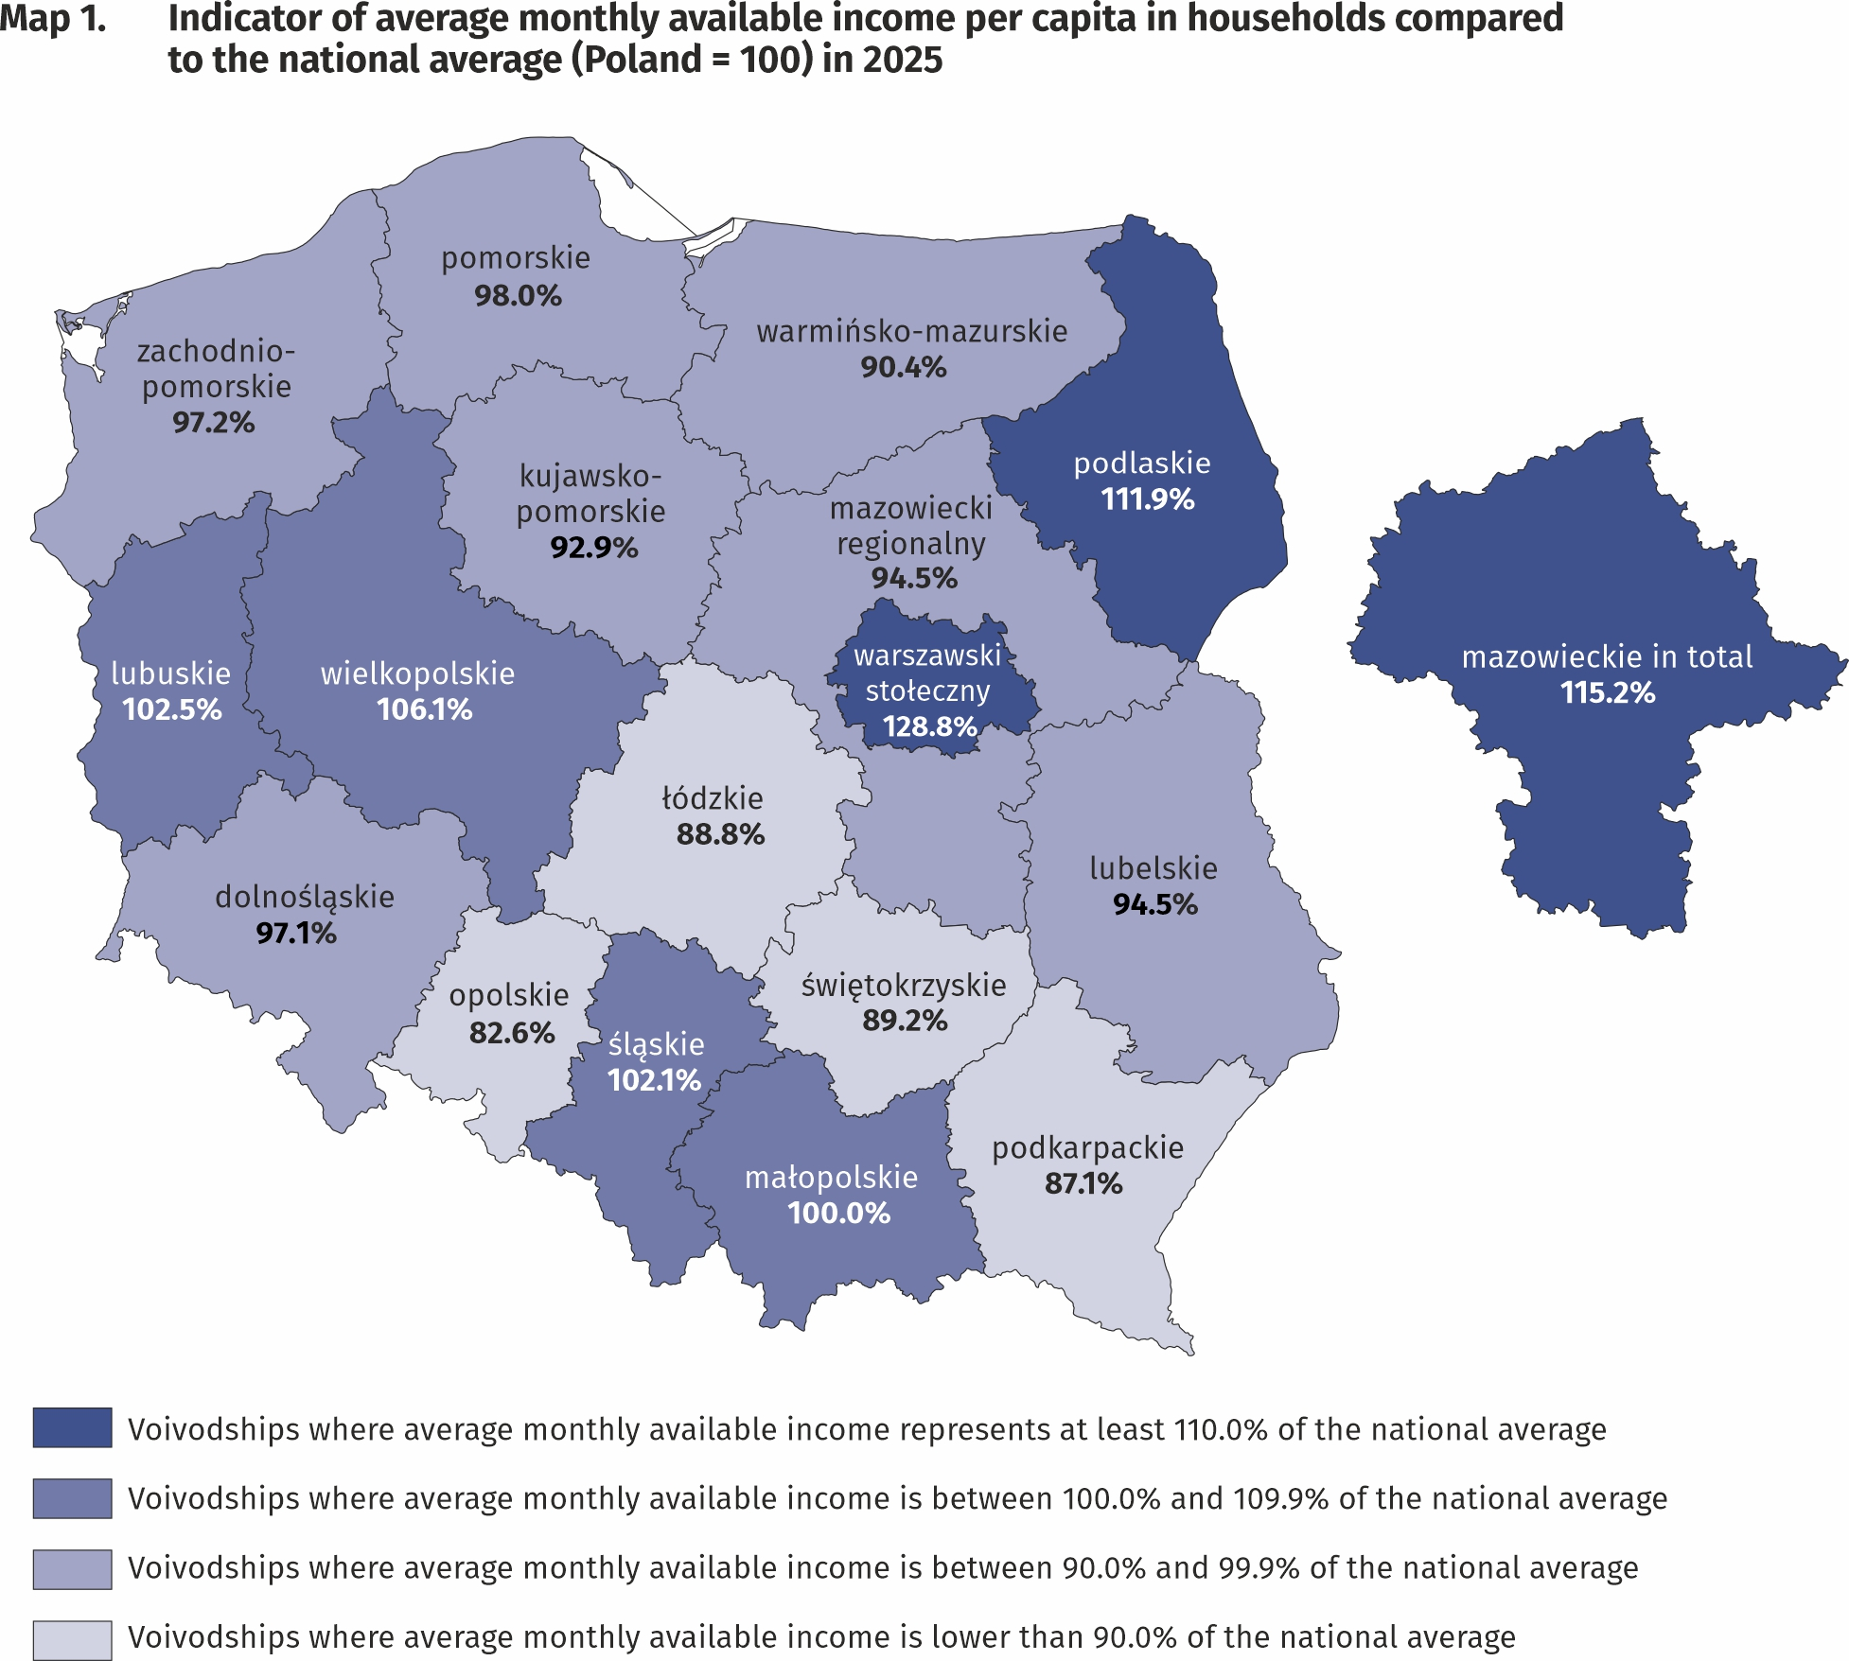
The highest average monthly available income per capita had households in
Mazowieckie Voivodship – PLN 4034 and the lowest
– households living in
Opolskie Voivodship –PLN 2890

In the case of expenditure, average monthly values above average for Poland in 2025 were recorded in voivodships: Dolnośląskie, Mazowieckie, Śląskie, Pomorskie, Kujawsko-Pomorskie, Łódzkie, Lubelskie and Zachodniopomorskie. The highest average monthly expenditure per capita was noted in Dolnośląskie Voivodship – PLN 2303 (in 2024 – PLN 2150), and they were higher than the national average by 14.3%. The lowest average monthly expenditure per capita occurred in Świętokrzyskie Voivodship (PLN 1549 in comparison with PLN 1596 in 2024) and with respect to the average for the whole country was lower by 23.1%, subsequently in Podkarpackie Voivodship (lower by 16.7%), Warmińsko-Mazurskie Voivodship (lower by 15.5%), and Podlaskie Voivodship (lower by 14.0%).
The difference between the highest and the lowest average monthly expenditure per capita in voivodships increased by 5.2 percentage points in comparison with 2024 and amounted to 37.4 percentage points.
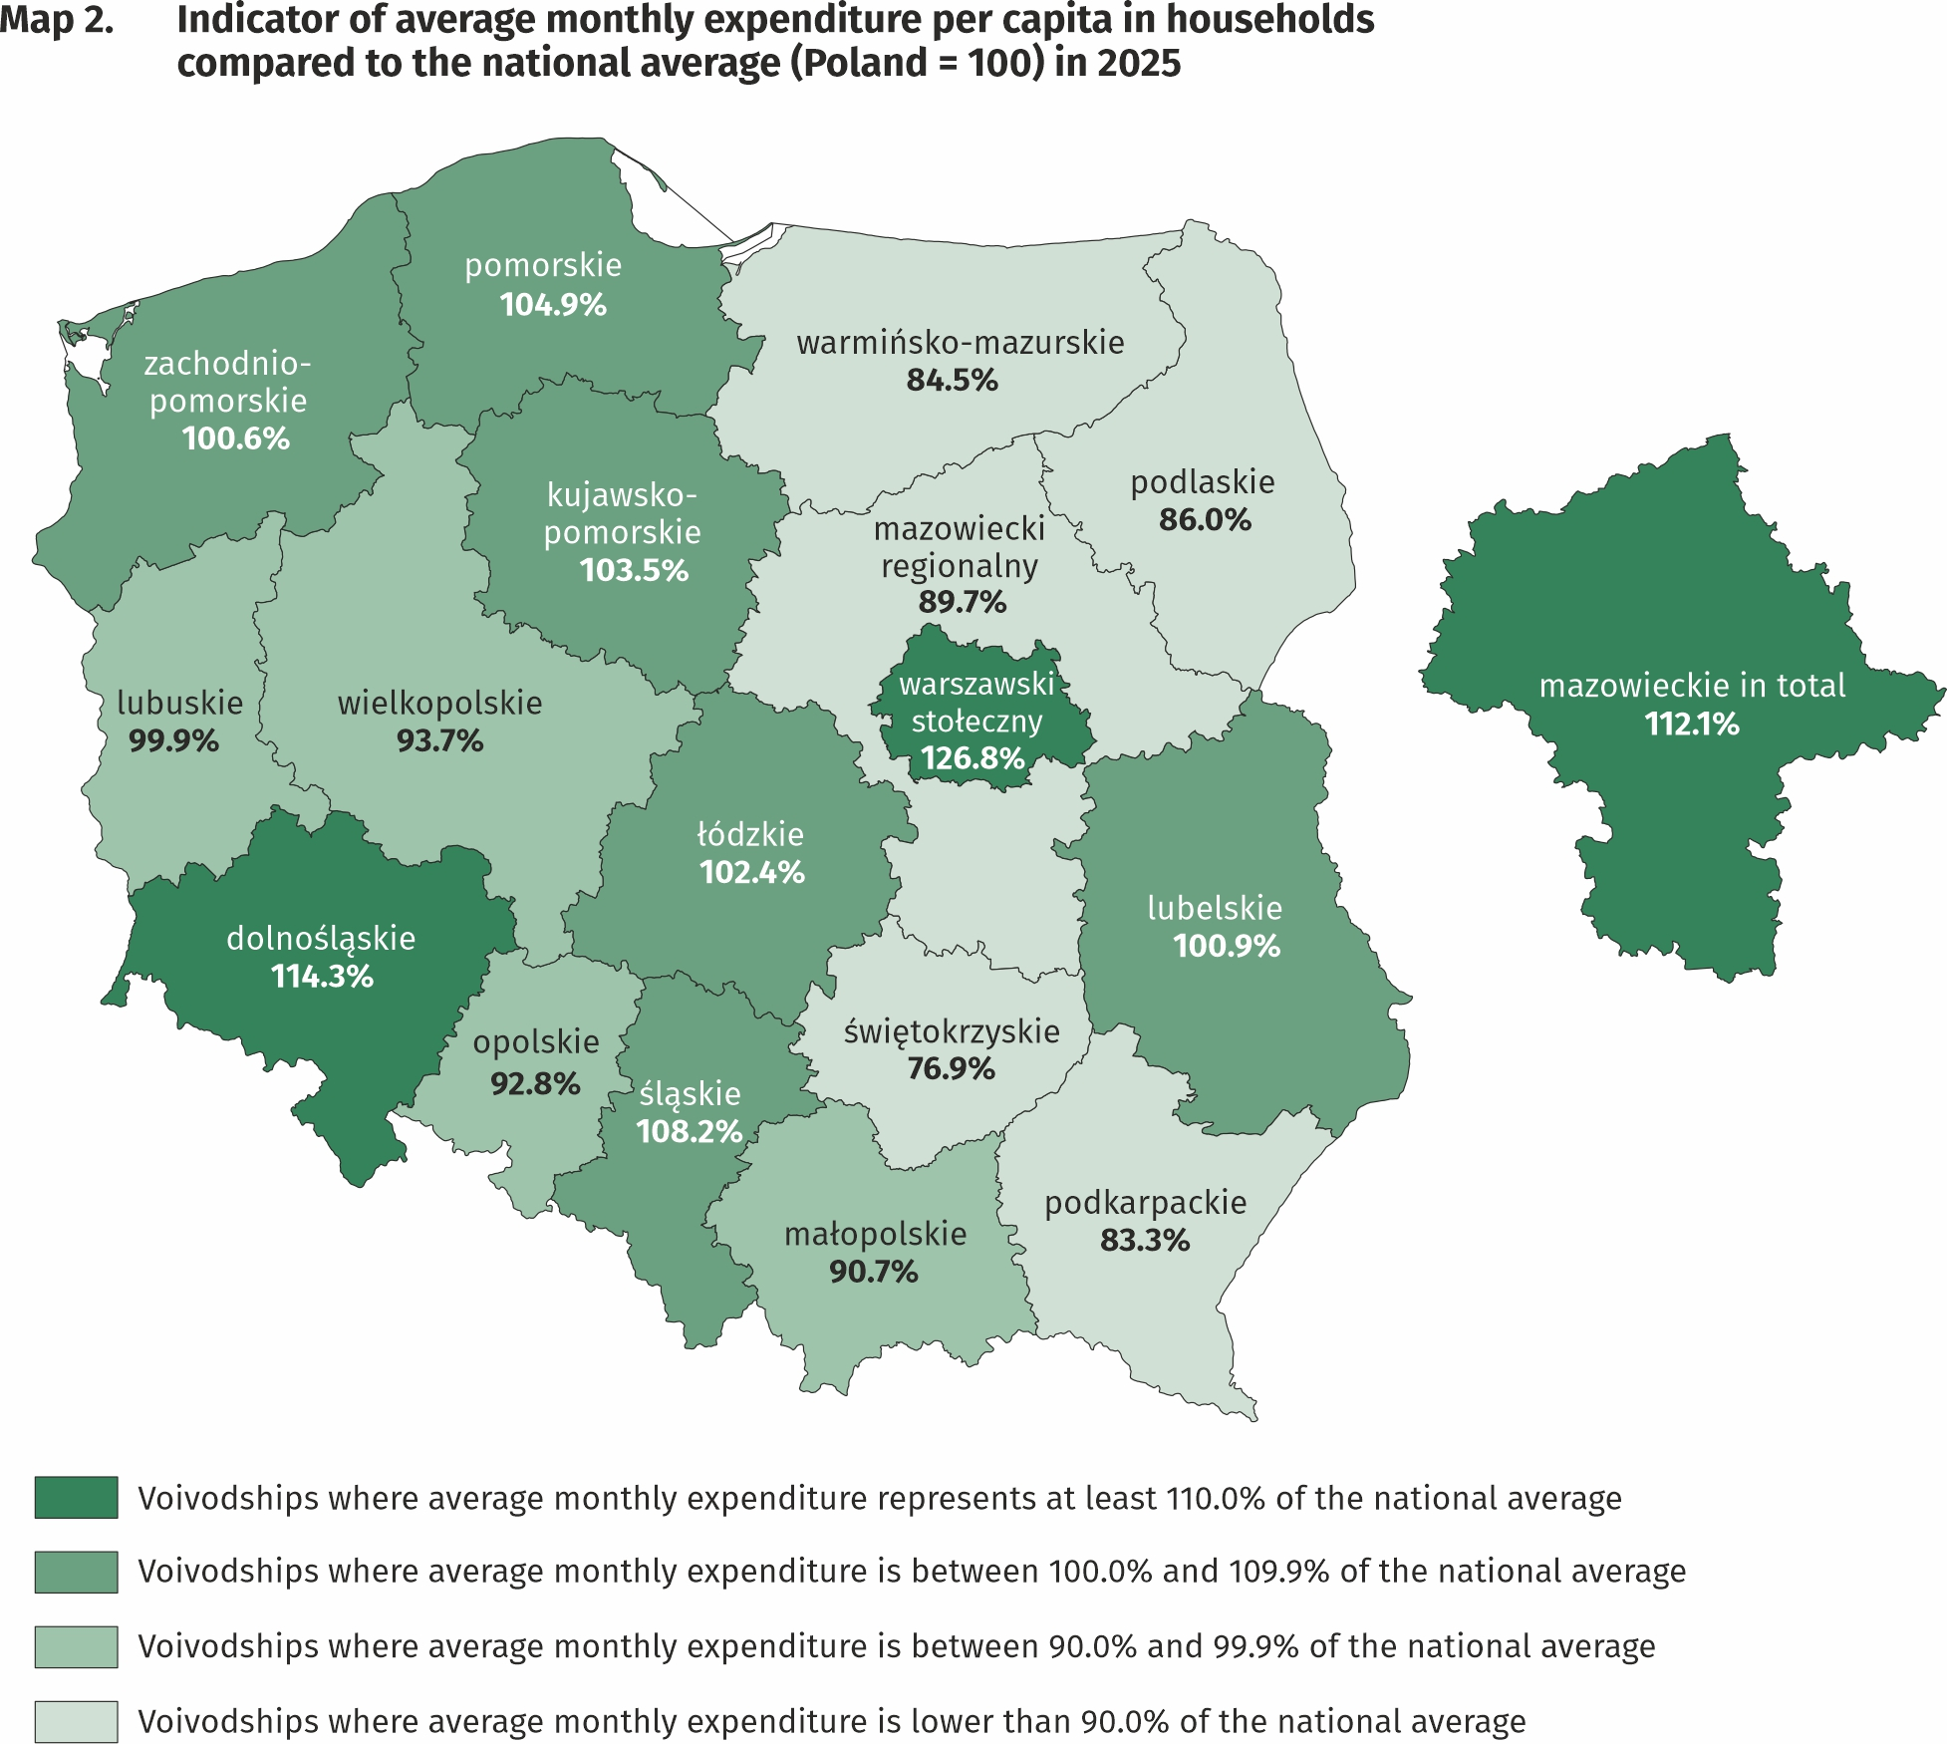
The highest average monthly expenditure per capita in households occurred in Dolnośląskie Voivodship - PLN 2303 and the lowest – in Świętokrzyskie Voivodship – PLN 1549

Quantitative food consumption
In 2025, there was an increase in consumption of some basic foodstuffs, and particularly cheese and curd, animal fats (of which butter), pasta and pasta products
In 2025, there was an increase in consumption of some of basic foodstuffs. The highest growth was recorded for: cheese and curd (by 3.8%), animal fats (by 2.5%, of which butter by 3.0%), pasta and pasta products (by 2.4%). The highest decrease was noted for sugar (by 14.5%), vegetable fats (by 4.8%, of which margarine and other solid fats by 9.5%), poultry meat (by 4.5%), bread (by 2.3%). The level of consumption of eggs, fruit, vegetables, cold cuts and other meat products has changed to a lesser extent, while level of consumption of flour, meat, fish and seafood, milk and cream has not changed compared to 2024.
The level of consumption of foodstuffs is related to household income. As the wealth of households increases, so does the level of consumption of certain foodstuffs, such as bread and cereals, meat, vegetables (except potatoes), fruit, cheese and curd, as well as mineral and spring waters.

The level of food consumption is also affected by dietary habits, prices of foodstuffs and a place of residence. Households in rural areas compared with households in urban areas are characterised by a slightly different model of nutrition. In the rural areas there was, among others, a higher consumption of bread and cereals, meat, potatoes, sugar as well as mineral and spring waters, while in urban areas – vegetables (except potatoes), fruit, and cheese and curd.
Phenomenon observed, both in urban and rural areas, is a decrease in the value of monthly consumption per capita of sugar (by 0.2 kg and 0.1 kg respectively).

The equipment of households with durable goods
In 2025, there was an increase in the number of households equipped with durable goods, and the highest in the case of game console, cable or satellite television, dishwasher, access to the Internet and smartphone
In 2025, an increase in the number of households equipped with durable goods was noted. The highest growth occurred in the case of game console (by 3.0%), cable or satellite television (by 2.0%), dishwasher and access to the Internet (by 1.7%), as well as smartphone (by 1.1%). The largest decrease occurred in the case of equipment for reception, recording and reproduction of sound (by 7.4%), printer, multifunction printer (by 3.4%), passenger car (by 1.2%) and bicycle (by 0.8%). In the case of other goods the differences in the degree of the households equipment between 2024 and 2025 were less significant and did not exceed 0.4 percentage points.
The level of household equipment with durable goods is related to their financial situation. The richest households (5th quintile group) were better equipped with durable goods than the poorest households (1st quintile group). Compared to 2024, there was an increase of percentage of the poorest households equipped with the Internet (by 1.4 percentage points) and smartphone (by 0.2 percentage points), while decreased percentage of those households equipped with passenger car, dishwasher and TV set (by 4.2 percentage points, 1.6 percentage points and 1.3 percentage points respectively). At the same time, there was an increase of percentage of the richest households equipped with dishwasher, passenger car and the Internet (by 4.1 percentage points, 2.6 percentage points and 1.2 percentage points respectively) and percentage of those households equipped with smartphone and TV set maintained at the level of 2024.

In terms of equipping with new generation goods, such as access to the Internet and smartphone, there was a slight difference between households in urban and rural areas, and it was 0.8 percentage points and 1.5 percentage points respectively in favour of urban areas in both cases. A significantly more rural than urban households owned a bicycle (by 26.8 percentage points), a passenger car (by 19.4 percentage points) as well as a motorcycle, scooter, motorbike (by 7.2 percentage points). In comparison with 2024, there was not a significant change of the difference in the level of equipment with new generation devices between households in urban and rural areas.
In rural areas there were more households owning dishwasher, bicycle, passenger car, motorcycle, scooters, motorbikes as well as TV set
Dwelling conditions
In 2025, the average household occupied a dwelling with a floor area of 89.0, and it was slight decrease after systematic increase in the average size of a dwelling continued since 2013

The average household in 2025 occupied a dwelling with a floor area of 89.0 m² (in 2024 – 89.2 m²), which consisted of 3 rooms. There was an average of 31.1 m² of usable floor area and 1 room per capita in the household (in 2024 – 31.3 m² and 1 room).
The largest average usable floor area of dwellings was held by households of farmers
– 147.4 m², while the smallest by households of pensioners – 69.0 m². In comparison with 2024, the increase in the average floor area of the dwellings occupied by households occurred in the households of farmers and self-employed (by 4.6 m² and 0.8 m² respectively), while the decrease in households of employees, pensioners and retirees (by 0.7 m², 0.2 m² and 0.1 m² respectively).
The largest average usable floor area of dwellings per capita was in the households of pensioners (39.3 m²) and retirees (39.0 m²), which is related to a smaller number of persons in the household, while the smallest – in the households of employees (27.9 m²).
The area of dwellings occupied by households was also differentiated according to the level of their income. In the case of the households with the highest income (5th quintile group) average occupied area was smaller (84.6 m²) than households with the lowest income (1st quintile group) – 91.2 m². However, members of households from 5th quintile group had much greater floor area of a dwelling per capita (39.3 m²) than households from 1st quintile group (25.4 m²).
The equipment of dwellings with technical and sanitary installations is systematically improving. Dwellings equipped with water supply accounted for 99.9% of all households, with hot running water – 99.5%, with sewage system and a flushing toilet – 99.4% each, and with a bathroom – 99.2%.
As in the previous years, the best equipped with technical and sanitary installations (except gas and central heating) were the dwellings of self-employed outside farming persons, and the worst – households of pensioners. The differences in the level of equipment in favour of the self-employed were insignificant and did not exceed 1.4 percentage points.
Households in urban areas were slightly better equipped with sanitary and technical installations than households in rural areas, except equipping with gas, which is related to the refusal to equip new multi-family buildings with gas installations.
Households in urban areas were slightly better equipped with sanitary and technical installations (except gas) than households in rural areas
There is clear relationship between household’s income and the equipment of dwellings in sanitary and technical installations, except gas, which was used by the richest households the least (5th quintile group). The most significant difference in this area between 1st and 5th quintile group in favour of the richest households concerned the equipment with central heating (by 5.1 percentage points), bathroom (by 1.9 percentage points) and flushing toilet (by 1.4 percentage points). These differences remain on similar to 2024 level.

A subjective evaluation of the financial situation of households
The subjective evaluation of the financial situation of households improved in all socio-economic groups. Good or rather good assessments prevailed over bad or rather bad
The subjective evaluation of the financial situation of households in 2025 improved in all socio-economic groups. Good or rather good assessments prevailed over bad or rather bad. In 2025, there was an increase in the percentage of households assessing their financial situation as good or rather good (59.2% of households in total compared with 57.7% in 2024) and the slight decrease in the percentage of households perceiving it as bad or rather bad (4.2% compared with 4.3% in 2024). Households of self-employed outside farming, similarly to the previous years, assessed their financial situation the most favourably (78.9% positive assessments compared with 76.2% in 2024), whereas households of pensioners assessed their situation the worst (26.0% positive assessments compared with 24.6% in 2024).

The subjective evaluation of the financial situation of households is related to the place of residence of a household. Members of households in rural areas, similarly to the previous years, assessed their financial situation worse than urban residents, especially those from cities with a population of 500 thousand or more. Among households in cities with population 500 thousand or more the percentage of subjective evaluations good or rather good increased from 69.8% in 2024 to 74.6% in 2025. In households in rural areas, the corresponding percentage was at a much lower level, but also increased from 52.8% in 2024 to 55.0% in 2025 reaching level by 4.0 percentage points higher than in towns below 20 thousand inhabitants.

Support granted by households to the inhabitants of Ukraine (in Poland and Ukraine)
In 2022–2025, households provided aid to inhabitants of Ukraine (in Poland and Ukraine), although the scale of this assistance was systematically decreasing from 69.3% of households in total in the first quarter of 2022 to 3.6% in the fourth quarter of 2025
In 2025 households in Poland continued, although in the smaller scale, providing aid to inhabitants of Ukraine covered by the war, resulting from the Russian invasion. In individual quarters of 2022–2025, the scale of assistance provided by households to inhabitants of Ukraine decreased from 69.3% in the first quarter of 2022 to 3.6% in the fourth quarter of 2025.

The highest share of households granting support to Ukrainian inhabitants in 2025 was among households of employees (4.2%).
In 2025, among the households of employees was recorded the highest percentage of those providing support to inhabitants of Ukraine (in Poland and Ukraine)
In 2025, households from 5th quintile group (covering 20% of the wealthiest persons) were the most engaged in the support to the inhabitants of Ukraine. In this quintile group the percentage of helping households was 4.8% (in 2024 – 10.1%).

Households declaring support to the inhabitants of Ukraine were present in all the classes of locality. In 2025 the highest percentage of households that provided assistance was in cities with 500 thousand or more residents – 6.7% (in 2024 – 12.0%).
In 2025, the highest percentage of households helping residents of Ukraine was in the cities with 500 thousand or more residents
It is worth of emphasizing, that in 2025 support granted to the inhabitants of Ukraine escaping from war to Poland or staying on the territory of covered by war Ukraine, was continued despite the decline in the intensity of this assistance in the following quarters. Among households helping persons from Ukraine, the dominant forms of support in 2022–2025 were: in-kind donations and financial support (directly or through organizations). It is also worth noting that households still provided assistance to refugees from Ukraine in Poland in finding a job, taking care of everyday matters or caring for relatives.
In case of quoting Statistics Poland data, please provide information: “Source of data: Statistics Poland”, and in case of publishing calculations made on data published by Statistics Poland, please include the following disclaimer: “Own study based on figures from Statistics Poland”.

Prepared by:  Social Research Department  Director Izabela Grabowska  Phone: (+48 22) 608 31 22 | Issued by:  Press Office  Mobile: (+48) 695 255 032  Phone: (+48 22) 608 38 04, (+48 22) 449 41 45,  (+48 22) 608 30 09  e-mail: obslugaprasowa@stat.gov.pl

stat.gov.pl/en/

@StatPoland

@GlownyUrzadStatystyczny

@gus_stat

@GłównyUrządStatystycznyGUS

@Glówny Urząd Statystyczny
Related information
Household Budget Survey in 2024
The situation of households in 2024 on the basis of results of the Household Budget Survey
Support granted by households to the inhabitants of Ukraine in the first half of 2022 on the basis of results of the Household Budget Survey

Data available in databases
LOCAL DATA BANK private households
KNOWLEDGE DATABASES Living conditions of the population

Terms used in official statistics
Household's budget
Disposable income
Household's available income
Private household
Net household's receipts
Net household's outgoings
Quantitative consumption of foodstuffs in households per person
Subjective evaluation of material situation
Housing conditions
Expenditures of a household
Expenditures on consumer goods and services
Household's equipment

Values in the news releases are presented rounded up to 1 PLN.
Due to the introduction of a new classification of individual consumption by purpose in 2013, based on harmonized COICOP classification for all surveys of the European Statistical System, the results for 2012–2025 are presented in comparable conditions – each “expenditure” item in 2012 was supplemented by the “life-insurance contributions” item.
The average monthly income indicator is equal to the quotient of the average monthly income per capita in the surveyed group by the average monthly income per capita for the whole Poland in %.
The average monthly expenditure indicator is equal to the quotient of the average monthly expenditure per capita in the surveyed group by the average monthly expenditure per capita for the whole Poland in %.
In 2025 the average number of persons in urban households was 2.56, while in rural households – 3.45.
The category of “new generation goods” includes: access to the Internet, smartphone, plasma or LCD TV set, dishwasher and passenger car.
This category includes access to the Internet, regardless of the type of Internet connection and the type of device (e.g. desktop computer, laptop, tablet, TV set, smartphone).
The average number of persons in 1st quintile group of households was 3.59, and in 5th quintile group – 2.15.
Concerns the provision of assistance due to warfare - regardless of its form and scope (covers both support provided in Poland and directed to persons remaining in Ukraine) at least once in the period from 24th February 2022 to the end of the first quarter or in the quarter, in which the household participated in the survey.

