Retail sales in April 2026
In April 2026 retail sales at constant prices were by 1.3% higher than the year before (against an increase of 7.6% in April 2025). Compared with March 2026, there was a decrease by 0.8% in retail sales. In the period of January-April 2026 sales increased y/y by 3.4% (against an increase by 3.3% in the corresponding period of 2025).
1.3%
An increase compared with
the corresponding month of the previous year

Retail sales seasonally adjusted
In April 2026, an increase of 2.7% in retail sales seasonally adjusted was recorded in comparison with April 2025
After eliminating the seasonal factors, in April 2026 retail sales at constant prices were by 2.7% higher than in the corresponding month of 2025 and by 2.8% lower compared with March 2026.

Chart 1. Retail sales (constant prices, monthly average 2021=100)
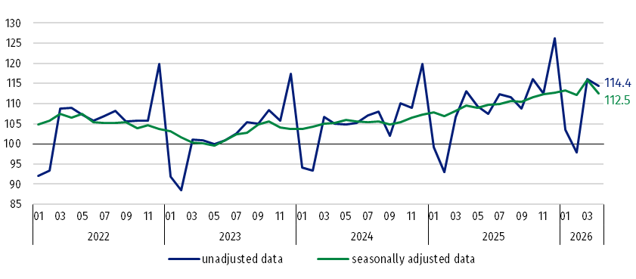

Chart 2. Retail sales (constant prices, corresponding period of previous year=100)
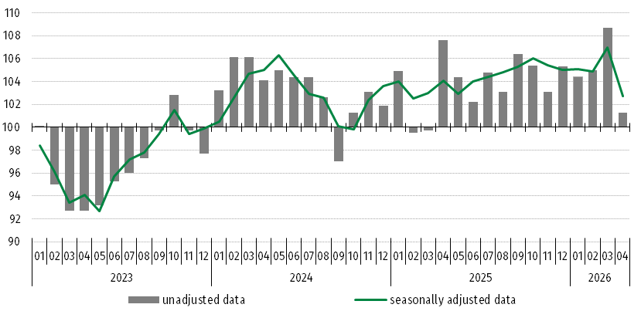

Retail sales of goods by predominant type of enterprise activity
In April 2026, a lower y/y increase in retail sales was recorded than in March this year, which was influenced by i.a. the earlier date of Easter this year and the related lower number of trading days (one trading Sunday) compared to April 2025
In April 2026, the largest increase in retail sales (at constant prices) compared with the corresponding period of 2025 was recorded by entities trading in solid, liquid and gaseous fuels (by 25.6%). An increase in sales was also observed in the following groups: “pharmaceuticals, cosmetics, orthopaedic equipment” (by 9.1%), “others” (by 5.5%), “furniture, radio, TV and household appliances” (by 1.0%) and “motor vehicles, motorcycles, parts (by 0.8%). In the group with the highest share in “total” retail sales - “food, beverages and tobacco products” there was a decrease in sales of 5.8%. Lower sales than in April 2025 were also reported by enterprises classified into the groups: “textiles, clothing, footwear” (by 9.5%), “newspapers, books, other sale in specialized stores” (by 5.9%).
In April 2026, the value of retail sales via Internet at current prices was by 0.5% higher than a year ago, while the share of sales via Internet in “total” sales compared with the corresponding period of 2025 decreased from 8.8% to 8.6%. Among the presented groups with a significant share of sales via Internet a decrease in share was reported by enterprises from the group “textiles, clothing, footwear” (from 25.4% a year ago to 24.4%). However, an increase in share was recorded in the groups: “furniture, radio, TV and household appliances” (respectively from 17.3% to 20.2%), “newspapers, books, other sale in specialized stores” (from 19.5% to 20.4%).

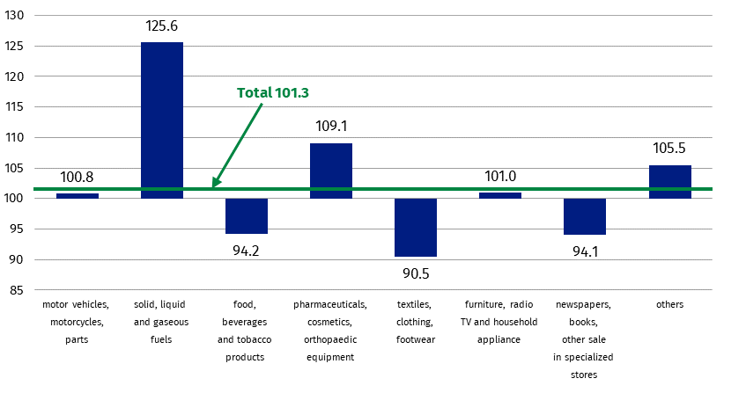
Chart 3. Retail sales of goods in April 2026 by groups (constant prices, corresponding period of previous year=100)

Table 1. Index numbers of retail sales (constant prices)
Specification | 04 2026 |  | 01-04 2026
Specification | 03 2026=100 | 04 2025=100 | 01-04 2025=100
TOTAL | 99.2 | 101.3 | 103.4
of which:
Motor vehicles, motorcycles, parts | 89.1 | 100.8 | 103.0
Solid, liquid and gaseous fuels | 113.4 | 125.6 | 113.4
Food, beverages and tobacco products | 98.5 | 94.2 | 98.5
Other retail sale in non-specialized stores | . | . | .
Pharmaceuticals, cosmetics, orthopaedic equipment | 101.4 | 109.1 | 107.5
Textiles, clothing, footwear | 88.3 | 90.5 | 99.9
Furniture, radio, TV and household appliances | 97.9 | 101.0 | 104.5
Newspapers, books, other sale in specialized stores | 102.7 | 94.1 | 95.9
Others | 98.3 | 105.5 | 106.6
(.) Data not available, classified data (statistical confidentiality) or providing data impossible or purposeless

Table 2. Index numbers and structure of retail sales (current prices)
Specification | 04 2026 |  | 01-04 2026
Specification | 03 2026=100 | 04 2025=100 | 01-04 2025=100 | Structure in %
TOTAL | 99.5 | 102.8 | 103.7 | 100.0
of which:
Motor vehicles, motorcycles, parts | 88.7 | 95.2 | 96.8 | 7.9
Solid, liquid and gaseous fuels | 112.3 | 135.9 | 114.9 | 14.4
Food, beverages and tobacco products | 99.0 | 96.7 | 101.4 | 25.6
Other retail sale in non-specialized stores | . | . | . | .
Pharmaceuticals, cosmetics, orthopaedic equipment | 101.6 | 111.2 | 109.5 | 8.3
Textiles, clothing, footwear | 90.4 | 88.0 | 96.9 | 5.1
Furniture, radio, TV and household appliances | 98.3 | 100.1 | 103.2 | 7.6
Newspapers, books, other sale in specialized stores | 103.0 | 96.0 | 96.7 | 3.4
Others | 99.0 | 106.5 | 107.2 | 9.5
(.) Data not available, classified data (statistical confidentiality) or providing data impossible or purposeless

Methodological notes
The data presented in this news release concerns trade and non-trade enterprises employing more than 9 persons. Groups of enterprises were created on the basis of the Polish Classification of Activities (PKD 2007) and a given enterprise is included to a specific category by predominating kind of activity and according to its present organizational status in mentioned period. The recorded changes of rise or fall of the dynamics of retail sales in particular groups of enterprises activity may result from a change in the predominating kind of activity and organisational changes (e.g. a merger of enterprises). This does not have impact on the dynamics of the total retail sales.
The published monthly information on trade activity, in addition to retail sales, also includes data on the volume of sales by kind-of-activity unit (KAU), which is compiled for the needs of European statistics. The volume of sales (constant prices 2021=100) includes divisions and groups of Section G according to PKD 2007 - "Wholesale and retail trade; repair of motor vehicles and motorcycles”. The data is disseminated on the website of the Statistics Poland: Knowledge Databases - Short-Term Statistics data by KAU

When quoting Statistics Poland data, please provide the information: “Source of data: Statistics Poland”, and when publishing calculations made on data published by Statistics Poland, please include the following disclaimer: “Own study based on figures from Statistics Poland”.

Prepared by:  Prices and Services Statistics Department  Director Ewa Adach-Stankiewicz  Phone: (+48 22) 608 31 24, (+48) 695 255 067 | Issued by:  Press Office  Mobile: (+48) 695 255 032  Phone: (+48 22) 608 38 04, (+48 22) 449 41 45,  (+48 22) 608 30 09  e-mail: obslugaprasowa@stat.gov.pl

stat.gov.pl/en/

@StatPoland

@GlownyUrzadStatystyczny

@gus_stat

@GłównyUrządStatystycznyGUS

@Glówny Urząd Statystyczny
Related information
Internal market in 2024
Socio-economic situation of the country
Statistical Bulletin
Data available in databases
Knowledge Database - Internal market
Local Data Bank
Macroeconomic Data Bank
Terms used in official statistics
Retail sales of goods
Kind-of-activity unit

Corrections made by reporting entities were included in cumulative data.
The volume of sales is defined as turnover in trade deflated by price index i.e. turnover at constant prices (2021=100).

