Participation in sport and recreational activities in 2025
4.9 pp
Increase in the number of persons participating in sport and recreational activities compared to 2021

In the period from 1.10.2024 to 30.09.2025, 43.7% of Poles (41.5% of females and 46.1% of males) participated in sports or recreational activities. Residents of Poland undertook physical activity mainly for pleasure and entertainment, with cycling being the most frequent form of sport and recreational activity. The average cost incurred by a household for sport and recreational activities amounted to PLN 1873, including the purchase of sports equipment – PLN 279.

In the 4th quarter 2025, another survey on the topic of participation in sport and recreational activities was conducted on a sample of households participating in the household budgets survey (the previous edition took place in 2021). It concerned the scope, nature, and degree of household members’ participation in sport and recreational activities, as well as the amount of money households spent on these activities during the period from 1 October 2024 to 30 September 2025. The survey did not take into account participation in mandatory physical education classes for school and university students and in physical rehabilitation.
Assessment of physical fitness and participation of household members in sports or recreational activities
Very good and good physical condition was declared (in a subjective assessment) by 64.3% of people (65.7% in 2021), of which 20.6% of household members rated themselves as very fit (i.e. 1.4 pp less than in 2021). People who rated their physical condition as poor or very poor accounted for 8.8% of the respondents, while in the 60-and-over age group, this percentage was 22.8%. Compared to 2021, this percentage increased by 1.0 pp. Males were more likely than females to rate their physical condition as very good or good (68.4% compared to 60.7% of females). Urban and rural residents declared similarly high physical fitness level (64.4% and 64.3% respectively).
Participation in sports or recreational activities was declared by 43.7% of respondents (41.5% of women and 46.1% of men). Compared to the previous edition of the survey, there was a 4.9 pp increase in the number of physically active people. Participants who took part in sports activities regularly (at least once a week) accounted for 22.9% (in 2021 – 20.6%). Nearly half of urban residents engaged in physical activity (the highest proportion was in large cities with 500,000 or more residents – 59.8%). In contrast, among rural residents, only one in three reported participating in sports or recreational activities.

Chart 1. Participation of household members in sports or recreational activities in 2025
In 2025, nearly 70% of children and young people aged 19 and under participated in sports or recreational activities

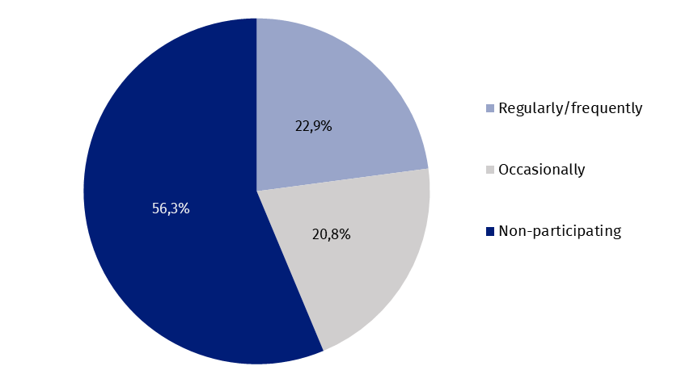

The most popular sporting activity during the study period was cycling, which was practiced by 25.9% of respondents (59.3% of those who reported participating in sports or recreational activities). Swimming was also a popular sport, with 15.1% of respondents participating (34.6% of those who reported participating in activities). A total 9.5% of people (21.8% of those who were physically active) participated in general sports and fitness activities (e.g. recreational walking, skipping on a skipping rope, exercise on a stationary bicycle, link trainer). Among females, in addition to cycling (24.7%) and swimming (13.8%), aerobics, fitness, and gymnastics (12.7%) were also popular. Among males, the third most popular activity after cycling (27.2%) and swimming (16.5%) was football, which was played by 12.3%.
In 2025, 95.7% of people reported being able to ride a bicycle, which was 0.2 pp less than in 2021

Cycling, as the most popular form of activity among Poles, was also the most frequently declared skill, both among females (95.6%) and males (95.8%). Among females, cycling was followed by sledging (71.1%), dancing (64.0%) and swimming (60.1%). In the case of males, skills in football (86.9%), swimming (74,2%) and sledging (73.0%) were often declared, in addition to cycling. More than 50% of them also had skills in other popular team sports, such as volleyball and basketball, as well as in chess, checkers and table tennis. More than half of the females also had skills in volleyball, chess, and checkers, as well as in aerobics, gymnastics, and fitness.

Chart 2. Participation of household members in sports or recreational activities in selected forms of activity in 2025
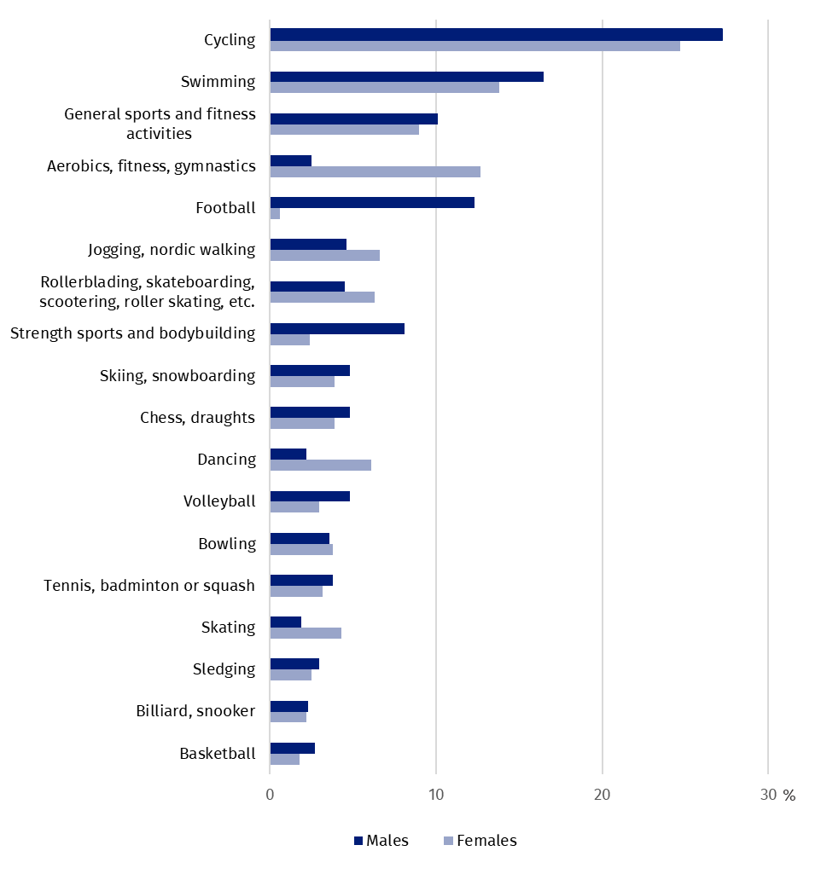

Motives for practising sport or recreational activities by household members
Pleasure and entertainment were the most frequent motive for members of households for practising sport or recreational activities – 63.1% (61.7% of females and 64.4% of males). Keeping fit and maintaining a good body shape were also important. Slightly more females (42.2%) than males (41.4%) indicated this reason. Health and doctor's recommendations were also important motives (females – 32.6%, males – 28.2%). 13.2% of females and 10.2% of males participated in sports to socialize with friends. Other reasons (having participated in sport or recreational activities in the past, and others) did not exceed 10% of the responses. In 2021, pleasure and entertainment, keeping fit and health were also the main motives for undertaking physical activity.

Chart 3. Motives for practising sport or recreational activities by household members
of households in 2025
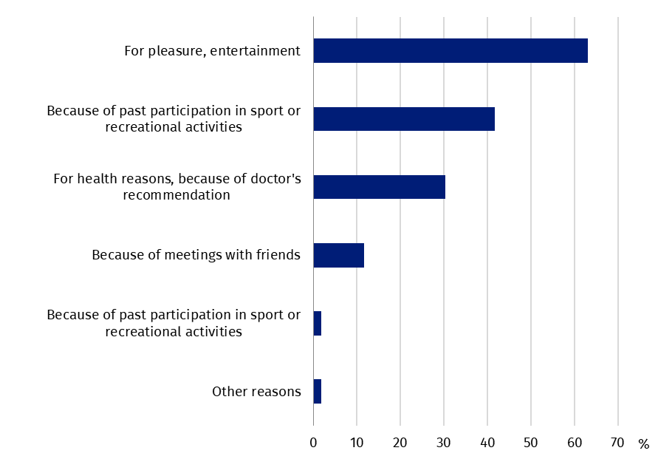

Reasons for non-participation of household members in sports or recreational activities
Every third person not participating in sports or recreational activities indicated lack of free time as the reason, and this was more often the case for males (35.4%) than females (30.3%). The second significant reason was lack of interest or preference for passive recreation (22.6%). This was cited by both males (24.6%) and females (20.8%). Due to health conditions and medical contraindications, 16.3% of Poles did not engage in sports or recreational activities (females – 17.5%, males – 15.0%). Age proved to be an equally significant obstacle, indicated by 14.5% of respondents. Females (16.5%) were more likely than males (12.2%) to mention age as the reason for not participating in sports and recreational activities. In 2021, also ca. 30% of people did not participate in physical activity due to lack of free time. This was followed also by lack of interest (22.9%) and age (17.1%).

Chart 4. Reasons for non-participation of household members in sports or recreational
activities in 2025
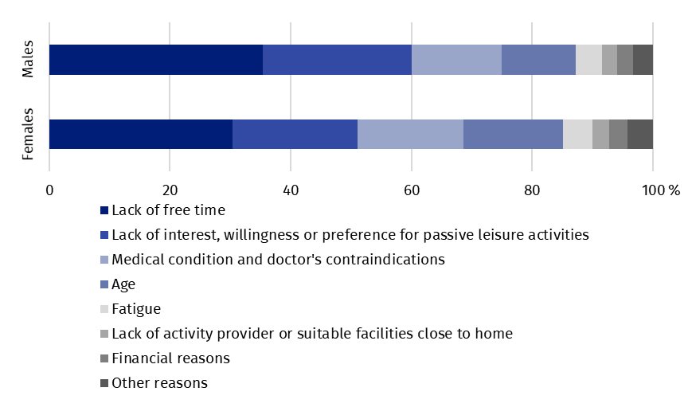
In 2025, residents of rural areas cited a lack of free time as the reason for not participating in sports or recreational activities more often than urban residents (by 2.6 pp)

Household sport equipment and expenditure on sport and recreational activities
According to the results obtained from the survey, 83.7% of households had sports equipment. Compared to 2021, this percentage decreased by 1.3 pp. Most households were equipped with a bicycle – 79.9% (in 2021 – 79.2%), followed by a ball for team games (football, volleyball, basketball, etc.) – 34.4% of households, and a sled – 28.0%. Other popular equipment included in-line skates, skateboard, scooter and roller skates (26.1%) and fitness equipment (22.2%). Households located in rural areas were more often equipped with sports equipment (93.8%) than urban households (78.6%).
In 2025, nearly 7% of households that spent money on a bicycle purchased an electric bicycles
Expenditure on the purchase of sports equipment was incurred by 20.0% of households (in 2021 – 18.6%). It amounted to PLN 279 per household in Poland (including the highest amount for a bicycle – PLN 177). This was 81.2% higher than the corresponding expenditure incurred by households in 2021. The average amount spent on sports equipment per household that incurred such expenditure was PLN 1,392 (PLN 827 in 2021). The largest amount was spent on the purchase of an electric bicycle (PLN 7,479). Over PLN 1,500 was also spent on the purchase of skis or a snowboard, water sports equipment (kayak, rowboat, inflatable boat, sailboat), and a bicycle.
Expenditure on other sports and recreational purposes were incurred by 48.2% of households. Compared to 2021, this percentage was 8.6 pp higher and the amount spent per household increased by 122.6% and amounted to PLN 1594. The highest amount was spent on participation in sports and recreational activities (PLN 1194). Expenditure for this purpose was made by 37.4% of all households. The purchase of sportswear amounted to an average of PLN 264 (36.3% of households spent this amount), maintenance and rental of sports equipment – PLN 50 (11.3% of households), and participation in sports or sports and recreation camps – PLN 86 (3.1% of households). Per household incurring expenditure for the described sports and recreational purposes in 2025, the average amount spent was PLN 3,308. This was over 80% more than in 2021 (PLN 1,807). These expenditures were most often allocated to participation in sports and recreational activities (PLN 3,190). Average fees related to participation in camps amounted to PLN 2,781. A total of PLN 727 was spent on the purchase of sports clothing, and PLN 445 on the rental, maintenance, or upkeep of sports equipment (PLN 397 in 2021).

Chart 5. Expenditure on sport and recreational activities per household
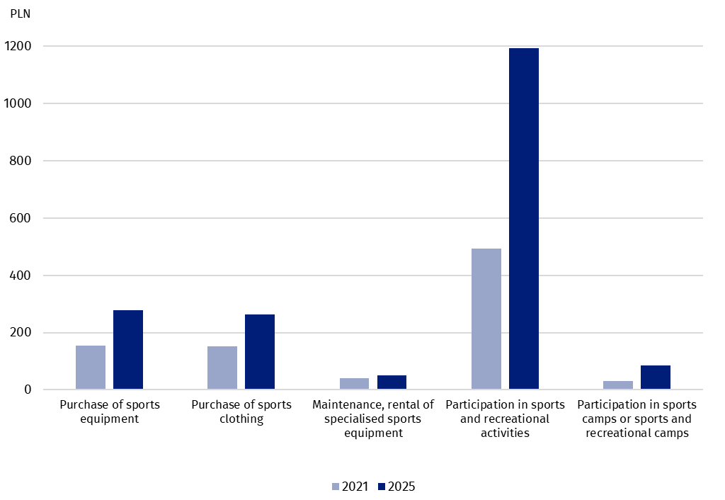

When quoting Statistics Poland data, please provide information: “Source of data: Statistics Poland”, and when publishing calculations made on data published by Statistics Poland, please provide information: “Own study based on Statistics Poland data”.
Prepared by:  Statistical Office in Rzeszów  Acting Director Andżelika Malinowska  Phones: (+48 17) 853 52 10,  (+48 17) 853 52 19 | Issued by:  Press Office  Mobile: (+48) 695 255 032  Phones: (+48 22) 608 38 04, (+48 22) 449 41 45,  (+48 22) 608 30 09  e-mail: obslugaprasowa@stat.gov.pl

stat.gov.pl /en/

@StatPoland

@GlownyUrzadStatystyczny

gus_stat

glownyurzadstatystycznygus

glownyurzadstatystyczny
Related information
Participation in sports and recreational activities in 2021

Terms used in official statistics
Recreational activity
Sport
Sports

When asked about the motives for practising sport or physical recreation, the respondent could indicate up to two answers.
As the reason for not undertaking physical activity, age could be indicated by all surveyed household members, according to their subjective feeling.

