Therapeutic activities of health resort facilities and inpatient rehabilitation facilities in 2025
At the end of 2025, there were operating 263 health resort facilities. 878.1 thousand patients were admitted to health resort facilities during a year, of which 786.7 thousand were inpatients. 91.4 thousand outpatients were treated in health resort facilities (by 7.2% more than in 2024). 79.6 thousand inpatients were treated in 52 inpatient rehabilitation facilities.
1.5%
Decrease in the number of inpatients in health resort facilities compared to 2024

Health resort facilities
45.9 thousand beds were in health resort hospitals and sanatoriums
As of 31 December 2025, there were operating 41 health resort hospitals (of which 3 for children), 191 health resort sanatoriums (of which two for children and one in underground mining excavations), 10 outpatient health resort units and 21 natural healing centres which conduct their treatment in health resort complexes. At the end of the year there were 45.9 thousand health resort beds in health resort hospitals and sanatoriums (by 0.4% less in relation to the previous year). 786.7 thousand inpatients were treated during the year (by 1.5% less than in 2024). Women accounted for 60.7% of the total inpatients being treated, while people aged 65 years and over – 60.5%. Average length of stay of inpatients was 16 days (similarly to previous year).
Health resort facilities located in Zachodniopomorskie voivodship had the largest number of beds (11.1 thousand) and recorded the highest number of inpatients (212.4 thousand persons). A significant number of inpatients was also recorded in Kujawsko-Pomorskie (163.7 thousand), as well as in Dolnośląskie and Małopolskie (91.6 thousand each). In total there were 69.3% of beds in health resort facilities in the above-mentioned four voivodships on which 71.1% of inpatients were admitted.
In Poland 3.4% inpatients treated in health resort facilities were foreigners. The vast majority of foreigners (92.9%) were admitted to health resort facilities in two voivodships: Zachodniopomorskie and Dolnośląskie.
Table 1. Activities of health resort facilities by type of facility in 2025
Average length of stay of inpatients in health resort facilities was 16 days
Specification | Health resort hospitals | Health resort sanatoriums | Outpatient health resort units | Natural healing centres
Health resort facilities (as of 31 December) | 41 | 191 | 10 | 21
Beds in thousands (as of 31 December) | 7.8 | 38.2 | – | –
Inpatients in thousands (during a year) | 108.6 | 678.0 | – | –
Average length of stay of inpatients in days (during a year) | 19.0 | 15.4 | – | –
Outpatients in thousands (during a year) | 3.3 | 29.3 | 17.2 | 41.6
Note: Due to data rounding, in some cases sums of components may slightly differ from the amount given in the item ”total”.

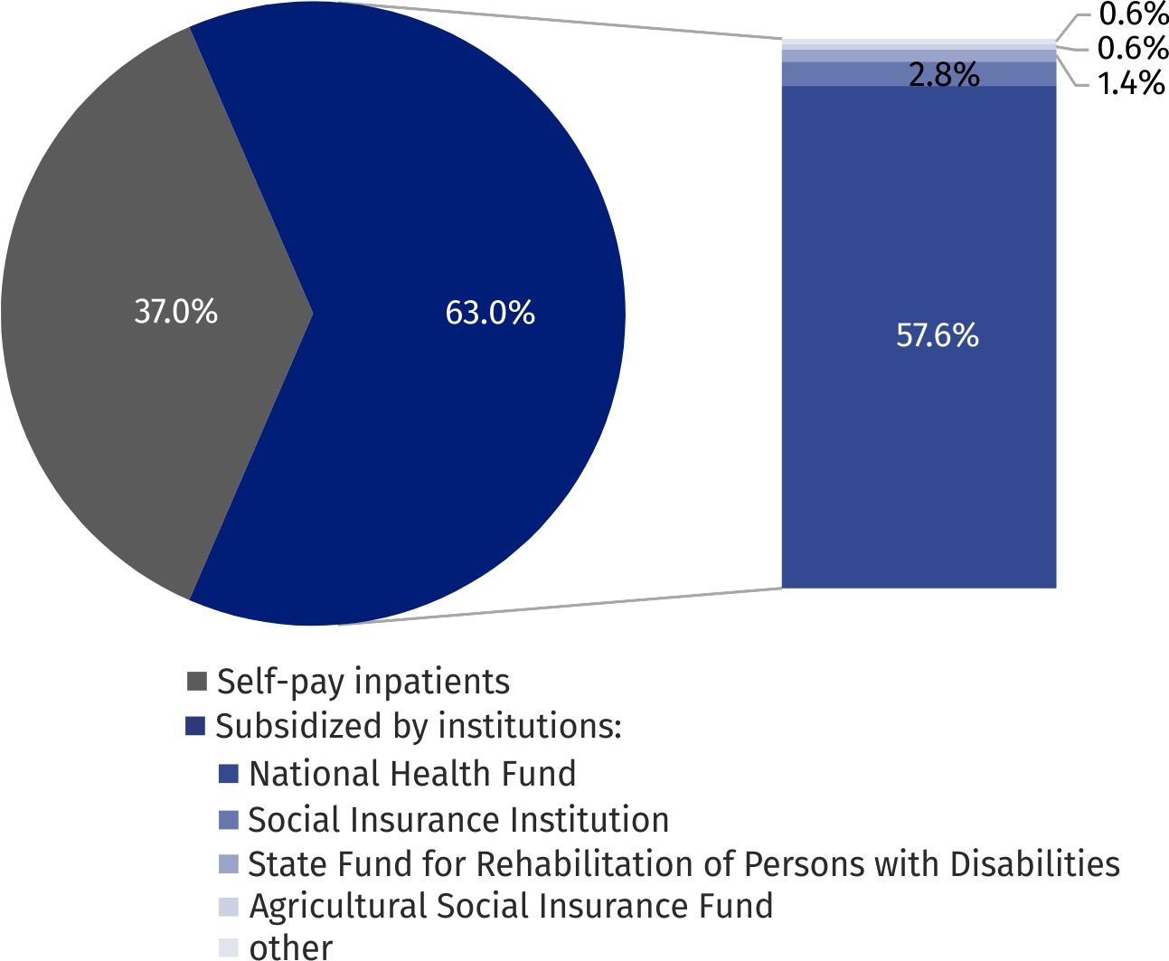
Chart 1. Inpatients treated in health resort facilities by type of financing in 2025
In 2025, 453.4 thousand inpatients were subsidized by the National Health Fund (by 1.2% less than in the previous year), while the number of self-pay inpatients amounted to 290.7 thousand (by 0.5% less). The Social Insurance Institution subsidized inpatient treatment for 21.7 thousand persons (by 17.2% less than in 2024).
91.4 thousand outpatients were treated in health resort facilities (by 7.2% more than in 2024). Almost 78% of them were admitted to outpatient health resort units and natural healing centres. Health resort facilities in Dolnośląskie voivodship recorded the highest number of outpatients (35.2 thousand).
Table 2. Activities of health resort facilities by voivodships in 2025
The most inpatients were treated in health resort facilities in Zachodniopomorskie voivodship (212.4 thousand)
Specification | Beds (as of 31 December) | Inpatients | Outpatients | Average length of stay of inpatients (in days)
Specification | in thousands |  |  | Average length of stay of inpatients (in days)
Poland | 45.9 | 786.7 | 91.4 | 15.9
Dolnośląskie | 6.0 | 91.6 | 35.2 | 16.8
Kujawsko-pomorskie | 8.8 | 163.7 | 13.2 | 15.8
Lubelskie | 1.4 | 22.4 | 3.8 | 17.6
Łódzkie | 0.1 | 1.9 | 0.6 | 17.5
Małopolskie | 5.9 | 91.6 | 15.8 | 17.8
Mazowieckie | 0.2 | 2.4 | 0.6 | 20.9
Podkarpackie | 4.1 | 58.8 | 3.3 | 19.2
Podlaskie | 0.5 | 11.6 | 0.5 | 12.9
Pomorskie | 1.3 | 23.9 | 3.6 | 15.5
Śląskie | 2.4 | 33.9 | 1.5 | 17.3
Świętokrzyskie | 3.5 | 68.7 | 5.7 | 15.4
Warmińsko-mazurskie | 0.5 | 3.8 | – | 21.1
Zachodniopomorskie | 11.1 | 212.4 | 7.6 | 13.7
Note: In three voivodships (Lubuskie, Opolskie, Wielkopolskie) the health resort facilities do not occur. Due to data rounding, in some cases sums of components may slightly differ from the amount given in the item ”total”.
In 2025, 36.4 million treatment services were provided in health resort facilities (by 3.0% less than in the previous year). As in the previous year, the largest number of natural therapy treatments were performed (9.7 million), including mud therapy (4.4 million) and mineral baths (2.5 million). Kinesiotherapy (6.6 million), electrotherapy (4.4 million), massages (4.0 million), other therapeutic treatments and activities (3.4 million), hydrotherapy (3.2 million) and light therapy (2.9 million) were also popular.

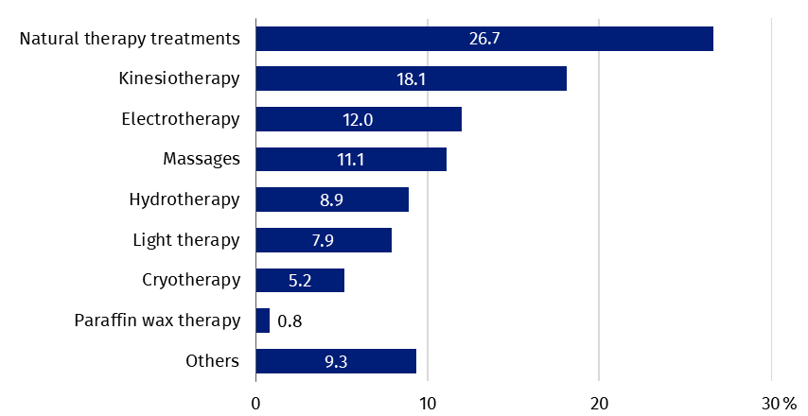
Chart 2. Treatment services provided in health resort facilities by type of service in 2025
36.4 million treatment services were provided in health resort facilities

Inpatient rehabilitation facilities
As of the end of 2025, 52 inpatient rehabilitation facilities were in operation (by 3 more than in the previous year), in which there were 5.7 thousand health resort beds (by 5.4% more than in the previous year). During the year 79.6 thousand patients were admitted (by 8.2% less than in 2024), of whom 69.8 thousand were inpatients and 9.8 thousand outpatients.
Women accounted for 56.6% of the total inpatients being treated, while people aged 65 years and over – 48.5%. Average length of stay of inpatients was 15 days.
In inpatient rehabilitation facilities, most inpatients treated belonged to self-pay inpatients – 41.3 thousand. Among institutions subsidized inpatients, the Agricultural Social Insurance Fund subsidized 9.0 thousand patients, the National Health Fund – 8.1 thousand, the State Fund for Rehabilitation of Persons with Disabilities – 6.3 thousand and the Social Insurance Institution – 3.6 thousand.
3.6 million medical services were provided in inpatient rehabilitation facilities during the year (by 2.7% less than in 2024), most of them belonged to kinesiotherapy (28.9%).

Chart 3. Inpatients treated in inpatient rehabilitation facilities by type of financing in 2025

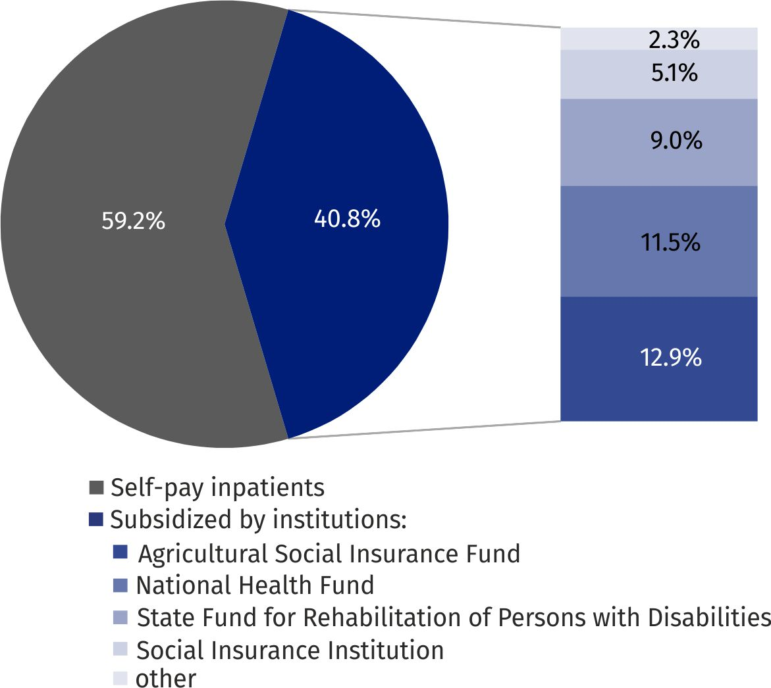
5.7 thousand beds were in inpatient rehabilitation facilities
In the case of quoting data from the Statistics Poland, please provide information: "Statistics Poland data source", and in the case of publishing calculations made on data published by the Statistics Poland, please provide information: "Own study based on Statistics Poland data".

Prepared by:  Statistical Office in Kraków  Director Agnieszka Szlubowska  Phone: (+48 12) 420 40 50 | Issued by:  Press Office  Mobile: (+48) 695 255 032  Phone: (+48 22) 608 38 04, (+48 22) 449 41 45,  (+48 22) 608 30 09  e-mail: obslugaprasowa@stat.gov.pl

stat.gov.pl/en/

@StatPoland

@GlownyUrzadStatystyczny

@gus_stat

@GłównyUrządStatystycznyGUS

@Glówny Urząd Statystyczny
Related information
Health and health care in 2024
Methodological report. Health and health care statistics − Statistics Poland’s reports
Data available in databases
Local Data Bank -> Health care, social welfare and benefits to the family
Knowledge Databases -> Society -> Health and health care
Terms used in official statistics
Patient in health resort
Health resort treatment
Inpatient rehabilitation facility
Health resort facility

Medical services provided in natural healing centres operating as a functional unit of the health resort hospital, sanatorium or outpatient health resort unit, are counted together with the main unit.
Patients cover the entire cost of their stay.
In the case of children and continuation of hospital treatment in health resort facilities by adults (NFZ referrals), as well as in the case of pension prevention (ZUS/KRUS referrals), the stays were fully financed by these institutions.

