General government deficit and debt in the years 2022-2025
1 7.3%
General government deficit in 2025 in relation to GDP
In 2025 the general government deficit was equal 283 969 million PLN (7.3% of GDP), while the general government debt amounted to 2 335 153 million PLN (59.7% of GDP).

Statistics Poland presents the general government deficit and debt data for years 2022-2025 developed as part of April EDP notification.
The data have been developed in accordance with the methodology of the European System of National and Regional Accounts in the European Union introduced by the Regulation (EU) No. 549/2013 of the European Parliament and of the Council of 21 May 2013 (ESA2010) with amendments and the guidelines contained in the Manual on Government Deficit and Debt, Implementation of ESA2010 (MGDD, 2022 edition).

Table 1. General government deficit and debt (million PLN)
The ratios of deficit and debt to GDP in 2024 have changed compared to the data published in October 2025, respectively:

– from -6.5% to -6.4%,
– from 55.1% to 54.8%.
Specification | 2022 | 2023 | 2024 | 2025
Gross domestic product (GDP) | 3 100 850 | 3 415 274 | 3 669 531* | 3 912 673*
General government deficit/surplus | -104 475 | -177 442 | -236 623* | -283 969
% GDP | -3.4% | -5.2% | -6.4%* | -7.3%
Central government deficit/surplus | -92 162 | -138 610 | -243 933* | -280 082
% GDP | -3.0% | -4.1% | -6.6%* | -7.2%
Local government deficit/surplus | -13 274 | -24 811 | 14 105 | 637
% GDP | -0.4% | -0.7% | 0.4% | 0.0%
Social security funds deficit/surplus | 961 | -14 021 | -6 795 | -4 524
% GDP | 0.0% | -0.4% | -0.2% | -0.1%
General government debt | 1 512 812 | 1 691 261 | 2 012 640 | 2 335 153
% GDP | 48.8% | 49.5% | 54.8%* | 59.7%

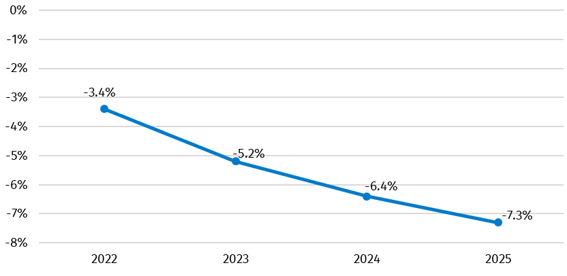
Chart 1. General government deficit in % of GDP

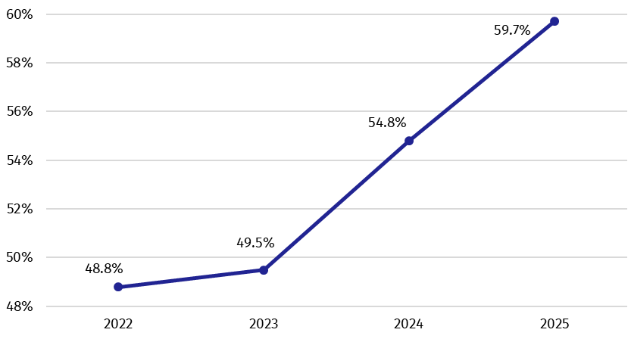
Chart 2. General government debt in % of GDP
Data for 2022-2023 remained unchanged from those previously published (in October 2025). However, the 2024 data were subject to revisions, mainly due to updated data sources for conceptual adjustments and debt write-offs.

Table 2. Total revenues and expenditures of the general government sector according to ESA2010 (million PLN)
Specification | 2022 | 2023 | 2024 | 2025
Total revenues | 1 236 579 | 1 422 920 | 1 569 887* | 1 705 919
% GDP | 39.9% | 41.7% | 42.8%* | 43.6%
Total expenditures | 1 341 054 | 1 600 363 | 1 806 511* | 1 989 889
% GDP | 43.2% | 46.9% | 49.2% | 50.9%

Chart 3. Total revenues and expenditures of the general government sector in % of GDP
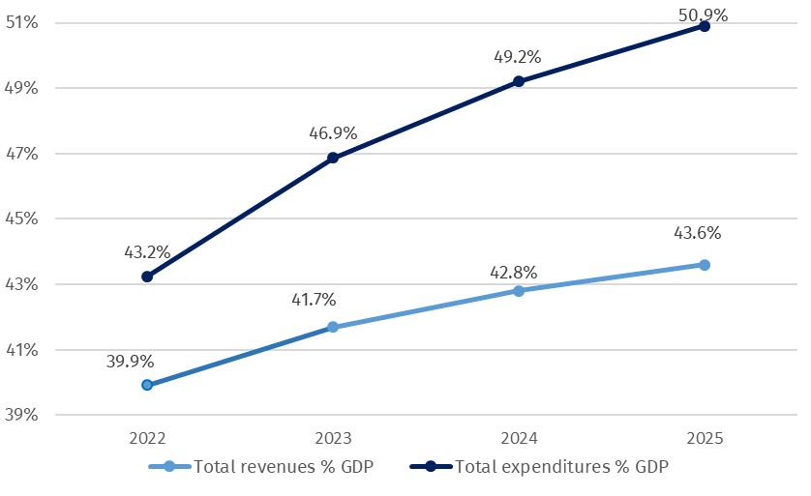

The total values for the general government revenue and expenditure for 2022-2023 remained unchanged compared to those previously published (in October 2025). A minor revision to the revenue structure resulted from the registration of funds received from the European Union and was done in the transaction other current transfers and capital transfers. More significant changes occurred in the expenditure structure due to the reclassification of funds transferred by the sector to other entities. Changes occurred in the transaction capital transfers, which increased by PLN 9,701 million in 2022 and decreased by PLN 8,153 million in 2023. In 2022, there was a drop in the amount of PLN 9,700 million in other current transfers and a growth in the amount of PLN 8,154 million in 2023.
The revision of general government revenue in 2024 resulted in an increase of PLN 129 million. The changes primarily affected capital transfers, other current transfers and output. The revision of expenditure in 2024 resulted in their increase of PLN 191 million and mainly concerned subsidies (an increase of PLN 8,947 million) and capital transfers (a decrease of PLN 9,441 million).

Detailed data on revenues and expenditures of the general government sector divided into ESA2010 transactions are presented in Annex 1.
Information on the general government deficit and debt of all EU Member States will be available on 22 April 2026 at 11 a.m. on the Eurostat website:
https://ec.europa.eu/eurostat/en/web/main/news/euro-indicators
Inventory of the methods, procedures and sources used for the compilation of deficit and debt data and the underlying government sector accounts according to ESA2010 prepared according to the European Commission’s guidelines in English version is available on Eurostat website:
http://ec.europa.eu/eurostat/web/government-finance-statistics/excessive-deficit-procedure/edp-inventories

In case of quoting Statistics Poland data, please provide information: “Source of data: Statistics Poland”, and in case of publishing calculations made on data published by Statistics Poland, please include the following disclaimer: “Own study based on figures from Statistics Poland”.

Prepared by:  National Accounts Department  Director Ewa Soroczyńska  Phone: (+48 22) 608 31 17 | Issued by:  Press Office  Mobile +48 695 255 032  Phone +48 22 608 38 04, +48 22 449 41 45,  +48 22 608 30 09  e-mail: obslugaprasowa@stat.gov.pl

stat.gov.pl/en/

@StatPoland

@GlownyUrzadStatystyczny

@gus_stat

@GłównyUrządStatystycznyGUS

@Glówny Urząd Statystyczny
Related studies
General government deficit and debt in 2024

Subject available in databases
Knowledge Databases – National Accounts

Important concepts available in the dictionary
Gross domestic product

* Data have been revised in relation to the previously published on 21.10.2025. The manual is available on the website: https://ec.europa.eu/eurostat/documents/3859598/16029761/KS-GQ-23-002-EN-N.pdf/77a75b07-61c3-7d34-5243-70d09bc00e44?version=3.0&t=1677163672121

