Labour cost index in the quarters of 2025
In Quarter 4 2025, the labour cost index rose by 5.0% compared with Quarter 1 of the same year, and increased by 2.8% and 1.7% compared with Quarter 2 and Quarter 3 2025, respectively.
170.6
The value of the labour cost index for Quarter 4 2025
In Quarter 4 2025, labour costs per hour worked were 70.6% higher than in the base year, i.e. 2020. By the end of 2025, labour costs in Poland had risen and the number of hours worked had increased slightly. Labour costs in Quarter 4 2025 rose by 7.7% compared with Quarter 4 2024, whilst the number of hours worked was 0.2% higher in that period.
LCI is an indicator of the rate of change relative to the base year. The base year for the data presented is 2020
In 2025, the lowest value of LCI was recorded in Quarter 1 – 162.5. In the following quarters, the index rose: in Quarter 2 it rose by 2.1%, in Quarter 3 by 3.3%, and in Quarter 4 by 5.0% compared with Quarter 1. In the breakdown by PKD 2007/NACE Rev. 2 section, the highest values of LCI throughout the year were recorded in the Human health and social work activities (Q) section. These values amounted to: 185.0 in Quarter 1, 187.9 in Quarter 2, 189.9 in the Quarter 3, and 192.0 in Quarter 4. The lowest values, however, occurred in different sections depending on the quarter: in Quarter 1 and Quarter 3 in the Electricity, gas, steam and air conditioning supply (D) section – 152.2 and 147.2; in Quarter 2 in the Real estate activities (L) section – 155.1; and in Quarter 4 in the Mining and quarrying (B) section – 147.8.
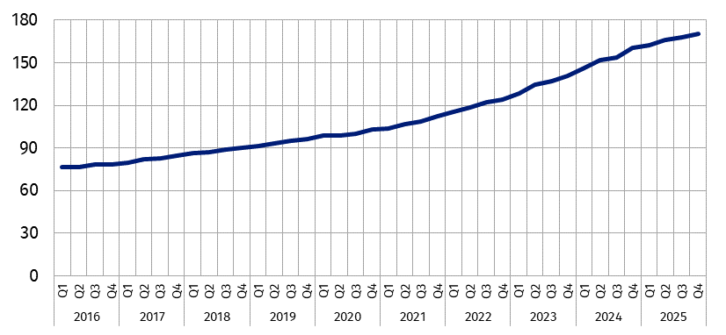
Chart 1. Labour cost index (2020=100)
Poland compared to the European Union
In Quarter 4 2025, Poland was among the EU Member States with the highest values of the labour cost index
The labour cost index makes it possible to compare labour cost dynamics across European Union Member States. Poland is in the group of countries with the highest value of this index, ranking fifth. In Quarter 4 2025, the labour cost index in Poland stood at 170.6. Among the countries, the lowest labour cost index was recorded in Italy – 110.7 – and the highest in Bulgaria – 191.1.
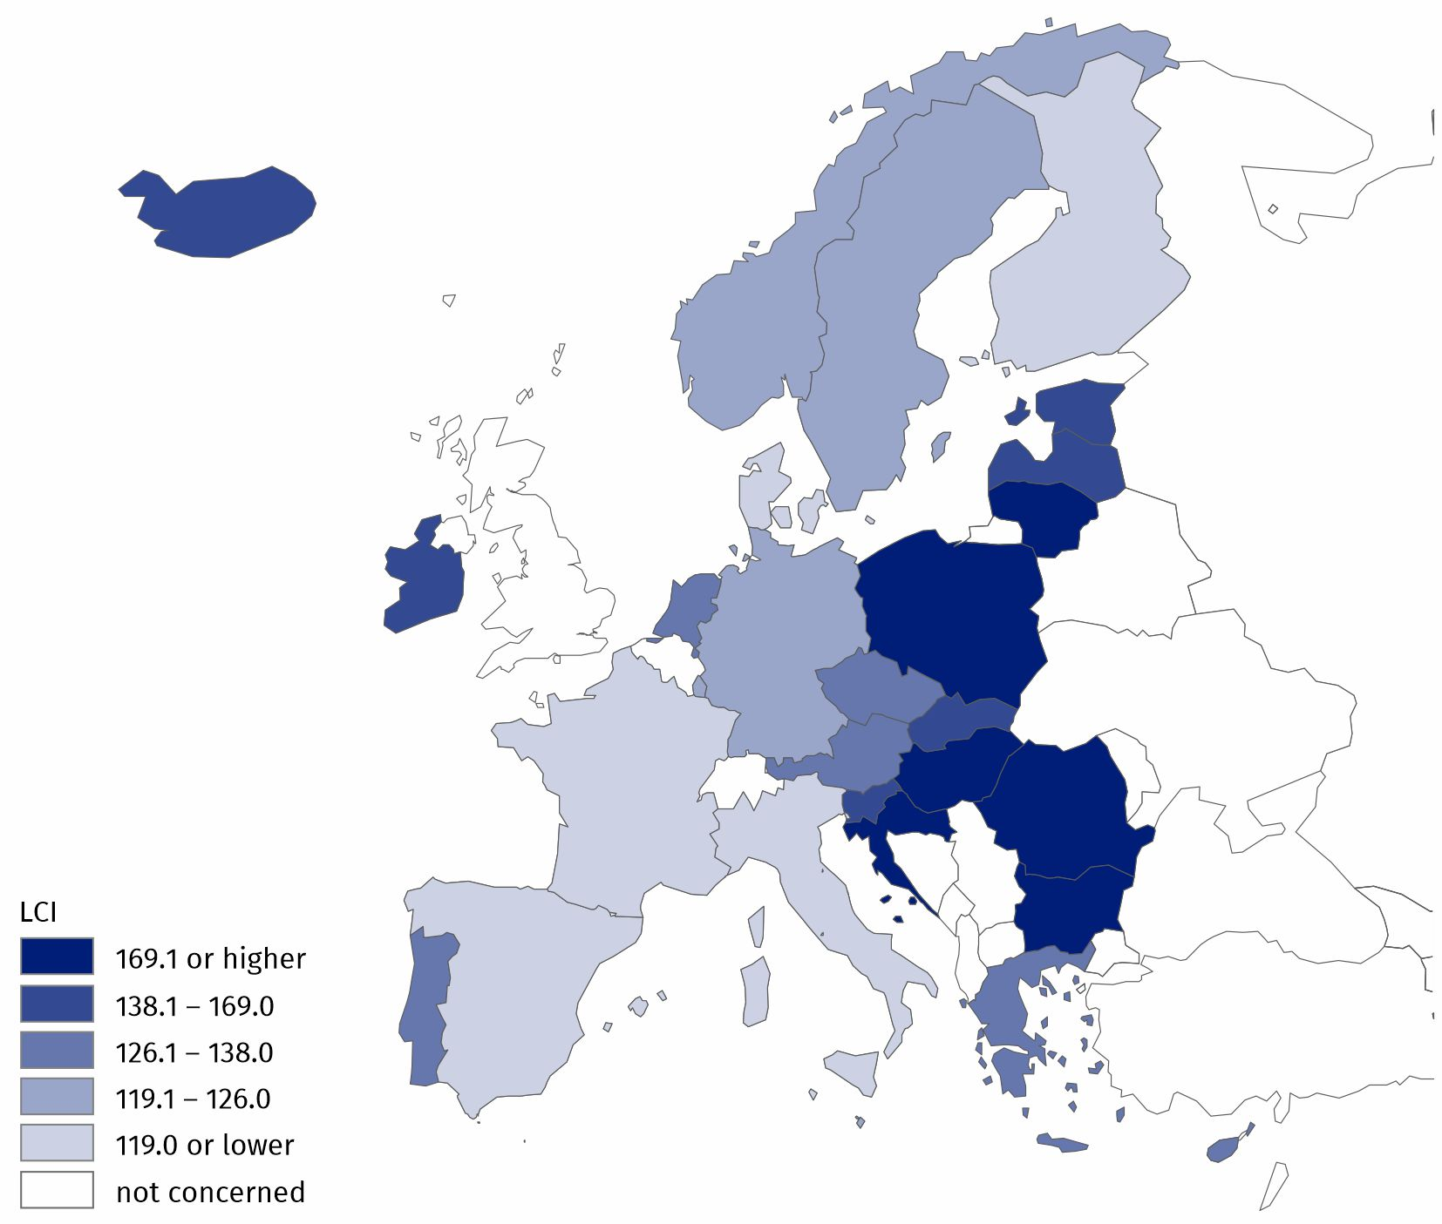
Map 1. Labour cost index for selected European countries in Quarter 4 2025
Source of data: Eurostat.
In Poland, the variation in the LCI by kind of activity is greater than in the European Union. In Quarter 4 2025, the labour cost index for Poland exceeded the average for the 27 EU Member States across B to S sections. The largest difference was recorded in the Human health and social work activities (Q) section, where the labour cost index was 55.7% higher than the EU average. On the other hand, the smallest difference was observed in the Mining and quarrying (B) section (12.8%).

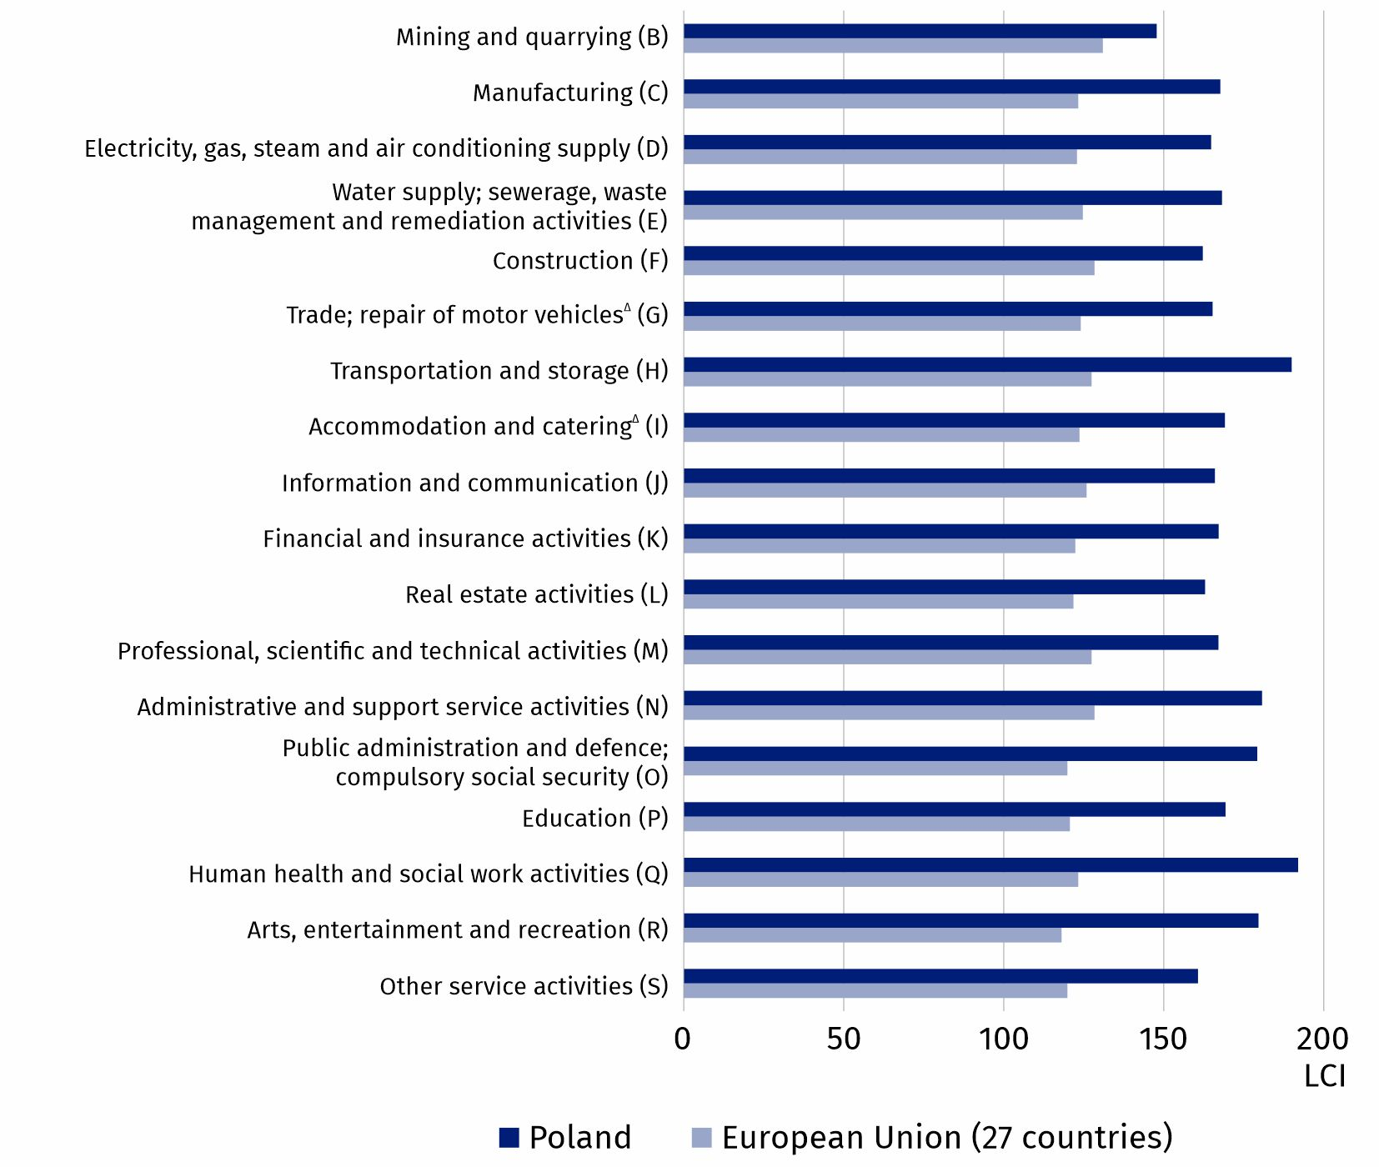
Chart 2. Labour cost index by PKD 2007/NACE Rev. 2 section (B-S) in Quarter 4 2025 for Poland and the European Union
Source of data: Eurostat.

Methodological notes
Labour cost index is one of the Principal European Economic Indicators (PEEIs), which describe the current macroeconomic situation of the European Union
The labour cost index (LCI) shows how hourly labour costs change compared to the base year. For the data presented, the base year is 2020, and the survey covers PKD 2007/NACE Rev. 2 sections B to S. The index is seasonally and working-day adjusted to limit the impact of calendar effects and seasonality on the results. The Tramo-Seats method in the JDemetra+ package is used for this purpose. The model for each series is adjusted at the beginning of the year and is used, where possible, in subsequent quarters.
The seasonal adjustment process includes:
• working-day adjustment – if the working-day effect is statistically significant,
• Easter-effect adjustment – if the effect is statistically significant,
• appropriate seasonal adjustment.
The working-day adjustment is carried out using a two-regressor model, comprising:
• the variability in the relationship between the number of working days from Monday to Friday and the number of Saturdays, Sundays and public holidays in individual years during the relevant periods,
• the variability in the number of days in the relevant periods, which in practice results from the occurrence of a leap year and applies to the first quarter.
Seasonal adjustment takes into account the Polish calendar of public holidays. Regressors representing statistically insignificant effects may be removed. The labour cost index shows the development of labour costs borne by employers. Labour costs consist of wages and salaries and non-wage costs, such as social security contributions and taxes paid by the employer, less subsidies received.
$$Labour cost index =\frac{ \frac{labour cost in the current period}{number of hours worked in the current period} }{\frac{labour cost in the base period}{number of hours worked in the base period}} ∙100$$

In this publication letter symbols and abbreviated names of PKD 2007/NACE Rev. 2 sections were used. Abbreviations are marked with a ‘Δ’ symbol.
The full names can be found in the list of PKD 2007/NACE Rev. 2 sections below.
Symbols of PKD 2007/NACE Rev. 2 sections:
A – Agriculture, forestry and fishing;
B – Mining and quarrying;
C – Manufacturing;
D – Electricity, gas, steam and air conditioning supply;
E – Water supply; sewerage, waste management and remediation activities;
F – Construction;
G – Wholesale and retail trade; repair of motor vehicles and motorcycles;
H – Transportation and storage;
I – Accommodation and food service activities;
J – Information and communication;
K – Financial and insurance activities;
L – Real estate activities;
M – Professional, scientific and technical activities;
N – Administrative and support service activities;
O – Public administration and defence; compulsory social security;
P – Education;
Q – Human health and social work activities;
R – Arts, entertainment and recreation;
S – Other service activities.

When quoting Statistics Poland data, please provide the information: ‘Source of data: Statistics Poland’, and when publishing calculations made on data published by Statistics Poland, please include the following disclaimer: ‘Own study based on figures from Statistics Poland’.

Prepared by:  Statistical Office in Bydgoszcz  Acting Director Katarzyna Klamrowska  Phone: (+48 52) 366 93 90 | Issued by:  Press Office  Mobile phone: +48 695 255 032  Landline phones: +48 22 608 38 04, +48 22 449 41 45, +48 22 608 30 09  e-mail: obslugaprasowa@stat.gov.pl

stat.gov.pl/en/

@StatPoland

@GlownyUrzadStatystyczny

@gus_stat

@GłównyUrządStatystycznyGUS

@Glówny Urząd Statystyczny

Data available in databases
Eurostat Database – Labour market
Knowledge Databases

Terms used in official statistics
Labour cost index
Time worked
Labour costs

Seasonally and working-day adjusted data.

