Blood donation in 2024
3.1%
Increase in donations of blood and its components compared to 2023

In 2024 blood donors amounted to 651.4 thousand, by 1.7% more than in previous year. They donated 1 548.4 thousand donations of blood and its components which is 47.0 thousand more than in 2023.

Blood Donation Centres
In 2024, there were 23 Blood Donation Centres
In 2024, there were 23 Blood Donation Centres (including 21 Regional Blood Donation Centres and 2 departmental ones – per one under the responsibility of the Ministry of National Defence and the Ministry of Interior and Administration) and 133 collection sites (including 7 under the responsibility of the Ministry of National Defence). The number of centres has not changed compared to previous year while the number of collection sites has decreased by two sites.

Map 1. Blood Donation Centres and Collection sites in 2024
As of 31 December
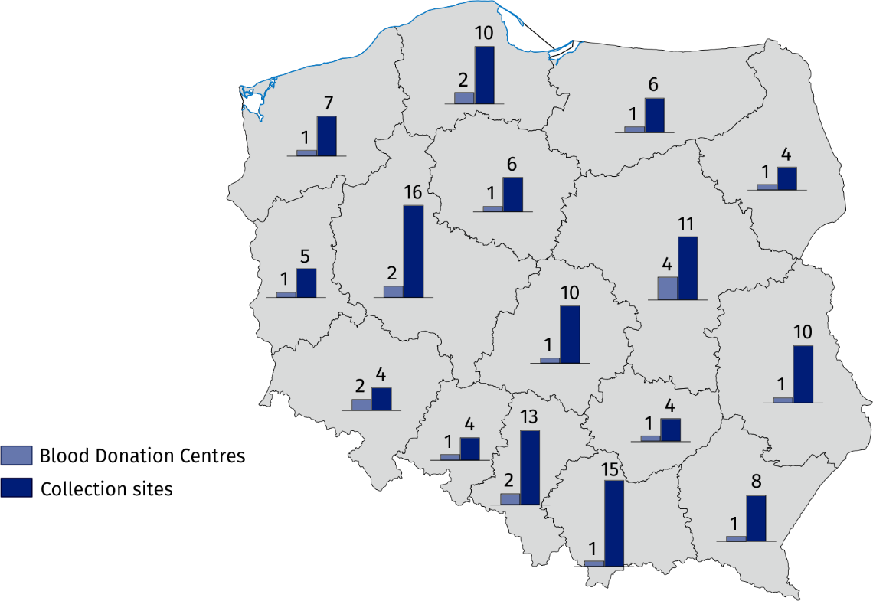

Blood donors
In 2024, among the population of blood donors there were 63.1% people aged 25 to 44 years
In 2024, the population of blood donors amounted to 651.4 thousand people (by 11.2 thousand more compared to previous year), including 651.2 thousand honorary blood donors. Among the donors, 80.6% were multiple permanent and repeated donors. The majority of blood donors (411.2 thousand) were aged 25 to 44. People aged 18 to 24 accounted for 105.4 thousand of all blood donors and those aged 45 to 65 – 134.5 thousand.
Table 1. Blood donors, collected blood and prepared blood components
Specification | 2023 | 2024
Specification | in thousands
Blood donors | 640.2 | 651.4
Collected blood and its components in donations | 1 501.4 | 1 548.4
Collected whole blood in donations | 1 358.0 | 1 388.2
Red blood cell concentrates in unitsª | 1 327.5 | 1 369.4
Fresh frozen plasma in units^{b} | 1 650.7 | 1 692.0
a One unit of red blood cell concentrate equals approximately 250 ml, one litre of red blood cell concentrate equals approximately 4 units.
b One unit of fresh frozen plasma equals approximately 200 ml, one litre of plasma equals approximately 5 units.

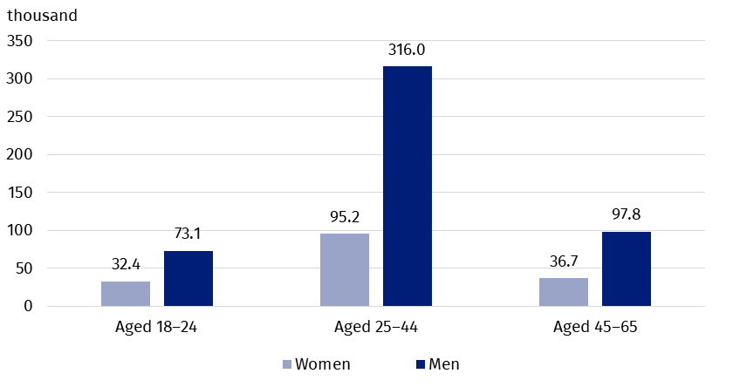
Chart 1. Blood donors by sex and age in 2024
On average there were 173 blood donors per 10 thousand population (in 2023 – 170). The maximum number of blood donors per 10 thousand population by localisation of institutions collecting blood (excluding data of the Ministry of National Defence and the Ministry of Inferior and Administration) was recorded in Podlaskie voivodship (almost 263 blood donors per 10 thousand population), while the minimum number – in Mazowieckie voivodship (approximately 132 blood donors per 10 thousand population).

Map 2. Blood donors by voivodships in 2024
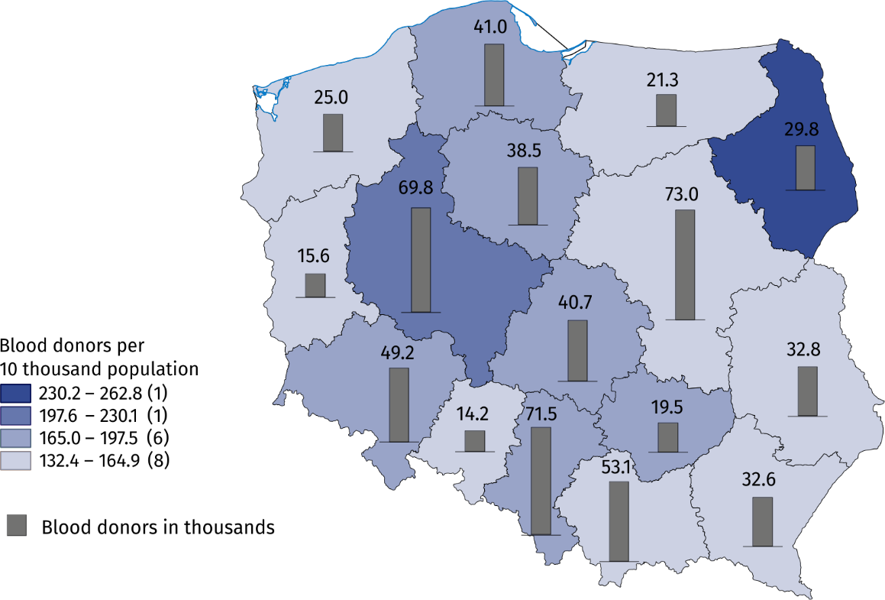Excluding data of the Ministry of National Defence (MON) and the Ministry of Interior and Administration (MSWiA).

Collected whole blood in donations
In 2024, there were 1 388.2 thousand whole blood donations
In 2024, there were 1 548.4 thousand donations of whole blood and its components (by 3.1% more than in 2023) including 1 388.2 thousand whole blood donations. The most whole blood donation was collected in Śląskie voivodship – 172.1 thousand donations. The inhabitants of three voivodships: Śląskie, Mazowieckie and Wielkopolskie gave a total of 468.5 thousand whole blood donations (33.7% of whole blood collected in Poland). Blood centres subordinated by the Ministry of National Defence and the Ministry of Inferior and Administration collected in total 42.6 thousand whole blood donations (3.1% of whole blood collected in Poland).
Among the Regional Blood Donation Centres the highest increase in the number of whole blood donation compared to 2023 was observed in Śląskie voivodship (by 6.8%), and the lowest – in Pomorskie voivodship (by 1.3%). There were decreases in the number of collected whole blood donations in following voivodships: Dolnośląskie, Wielkopolskie, Opolskie and Podlaskie (respectively: 7.1%, 3.6%, 1.3% and 0.7%).

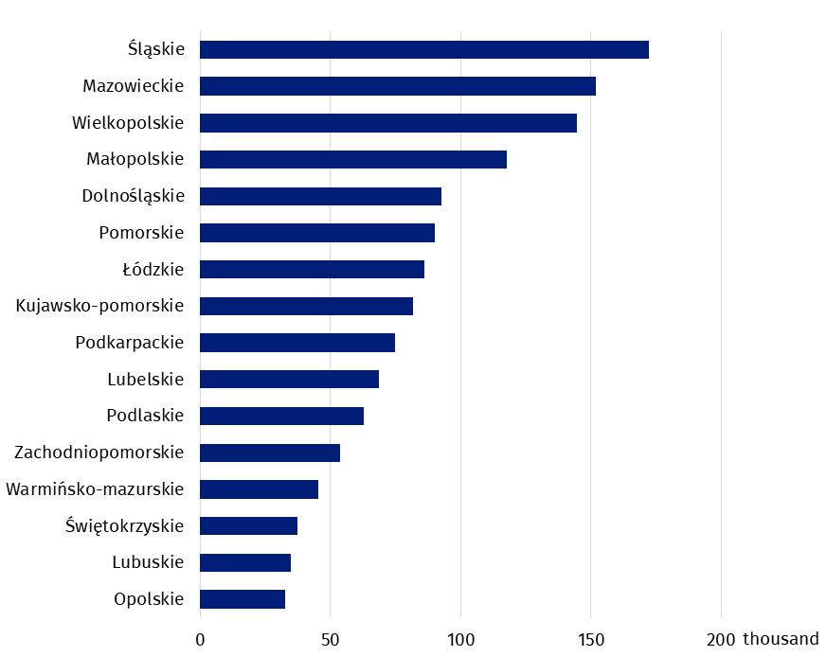
Chart 2. Whole blood donations by voivodships in 2024
Excluding data of the Ministry of National Defence (MON) and the Ministry of Interior and Administration (MSWiA).
In 2024, the most whole blood donation (172.1 thousand) was collected in Śląskie voivodship
In the case of quoting data from the Statistics Poland, please provide information: "Statistics Poland data source", and in the case of publishing calculations made on data published by the Statistics Poland, please provide information: "Own study based on Statistics Poland data".

Prepared by:  Statistical Office in Kraków  Director Agnieszka Szlubowska  Phone: (+48 12) 420 40 50 | Issued by:  Press Office  Mobile: (+48) 695 255 032  Phone: (+48 22) 608 38 04, (+48 22) 449 41 45,  (+48 22) 608 30 09  e-mail: obslugaprasowa@stat.gov.pl

stat.gov.pl/en/

@StatPoland

@GlownyUrzadStatystyczny

gus_stat

glownyurzadstatystycznygus

glownyurzadstatystyczny
Related information
Health and health care in 2023
Methodological report. Health and health care statistics – Statistics Poland’s reports
Data available in databases
Knowledge Databases -> Society -> Health and Health care
Terms used inn official statistics
The Blood Donation Centres
Donation
Blood donor
Blood donation

Multiple permanent donor is a person who regularly donates blood (at least 2 times during 24 months), multiple repeated donor is a person who donates blood in term exceeding 2 years since last donation.
In 2024, among all blood donors there were 0.2 thousand people under 18 years or over 65 years.
Population as of 30 June.
In the blood donation centres subordinated by the Ministry of National Defence and the Ministry of Inferior and Administration, there were 23.8 thousand blood donors who accounted for 3.7% of all blood donors.

