Retail sales index – June 2025
In June 2025 retail sales at constant prices were by 2.2% higher than the year before (against an increase of 4.4% in June 2024).
2.2%
An increase compared with
the corresponding month of the previous year
Compared with May 2025, a decrease by 1.8% in retail sales was recorded.
In the period of January-June 2025 sales increased y/y by 3.7% (against an increase by 4.9% in the corresponding period of 2024).

Retail sales seasonally adjusted
In June 2025, an increase of 4.2% in retail sales seasonally adjusted was recorded in comparison with June 2024
After eliminating the seasonal factors, in June 2025 retail sales at constant prices were by 4.2% higher than in the corresponding month of 2024, while compared to May this year sales increased by 0.7%.
Chart 1. Retail sales – seasonally adjusted and unadjusted data (constant prices) – monthly average 2021=100
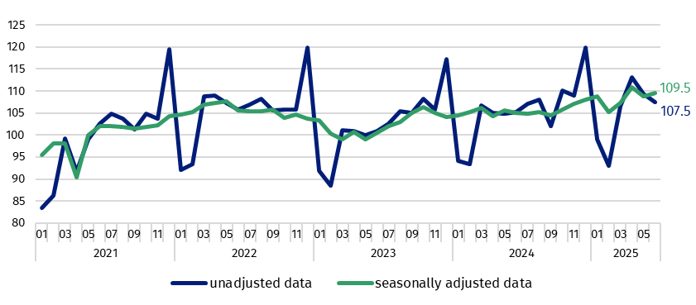

Retail sales of goods by type of enterprise activity
The lower y/y growth than a month ago was influenced by i.a. a smaller number of trading days in June this year
In June 2025, a significant increase in retail sales (at constant prices) compared with the corresponding period of 2024 was recorded in the following groups: “textiles, clothing, footwear” (by 11.8%), “furniture, radio, TV and household appliances” (by 10.2%), “motor vehicles, motorcycles, parts” (by 7.7%), “pharmaceuticals, cosmetics, orthopaedic equipment” (by 5.8%), “solid, liquid and gaseous fuels” (by 5.7%) . In the group with the highest share in “total” retail sales – “food, beverages and tobacco products” a decline in sales by 1.0 % was observed. Sales also decreased in the group “others” (by 4.0%).
In June 2025, the value of retail sales via Internet at current prices was by 8.0% higher than a year ago and the share of sales via Internet in “total” sales increased from 8.2% to 8.7%. Among the presented groups with a significant share of sales via Internet an increase in share was observed in enterprises from the groups “textiles, clothing, footwear” (from 21.6% a year ago to 23.0%) and “furniture, radio, TV and household appliances” (from 17.2% to 17.7% respectively). However a drop in share was shown by units from the group “newspapers, books, other sale in specialized stores” (from 21.4% to 20.1%).
Chart 2. Retail sales of goods (constant prices) – corresponding period of previous year=100
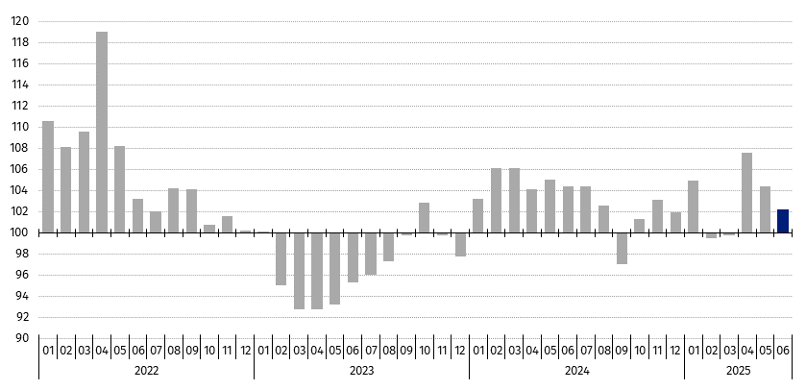

Table 1. Index numbers of retail sales (constant prices)

Specification | 06 2025 |  | 01-06 2025
Specification | 05 2025=100 | 06 2024=100 | 01-06 2024=100
TOTAL | 98.2 | 102.2 | 103.7
of which:
Motor vehicles, motorcycles, parts | 96.2 | 107.7 | 111.0
Solid, liquid and gaseous fuels | 102.3 | 105.7 | 102.4
Food, beverages and tobacco products | 96.5 | 99.0 | 100.8
Other retail sale in non-specialized stores | . | . | .
Pharmaceuticals, cosmetics, orthopaedic equipment | 96.9 | 105.8 | 106.8
Textiles, clothing, footwear | 105.2 | 111.8 | 107.7
Furniture, radio, TV and household appliances | 91.5 | 110.2 | 112.2
Newspapers, books, other sale in specialized stores | 95.3 | 101.9 | 101.4
Others | 101.1 | 96.0 | 93.5
(.) Data not available, classified data (statistical confidentiality) or providing data impossible or purposeless
Table 2. Index numbers and structure of retail sales (current prices)

Specification | 06 2025 |  | 01-06 2025
Specification | 05 2025=100 | 06 2024=100 | 01-06 2024=100 | Structure in %
TOTAL | 97.9 | 102.1 | 104.2 | 100.0
of which:
Motor vehicles, motorcycles, parts | 95.7 | 101.7 | 104.9 | 8.3
Solid, liquid and gaseous fuels | 101.2 | 97.7 | 97.1 | 13.0
Food, beverages and tobacco products | 96.7 | 104.2 | 106.5 | 26.0
Other retail sale in non-specialized stores | . | . | .
Pharmaceuticals, cosmetics, orthopaedic equipment | 96.8 | 107.7 | 109.3 | 7.8
Textiles, clothing, footwear | 103.5 | 110.1 | 106.2 | 5.8
Furniture, radio, TV and household appliances | 91.4 | 109.0 | 111.2 | 7.5
Newspapers, books, other sale in specialized stores | 95.5 | 102.0 | 101.7 | 3.8
Others | 100.9 | 97.8 | 95.4 | 9.3
(.) Data not available, classified data (statistical confidentiality) or providing data impossible or purposeless
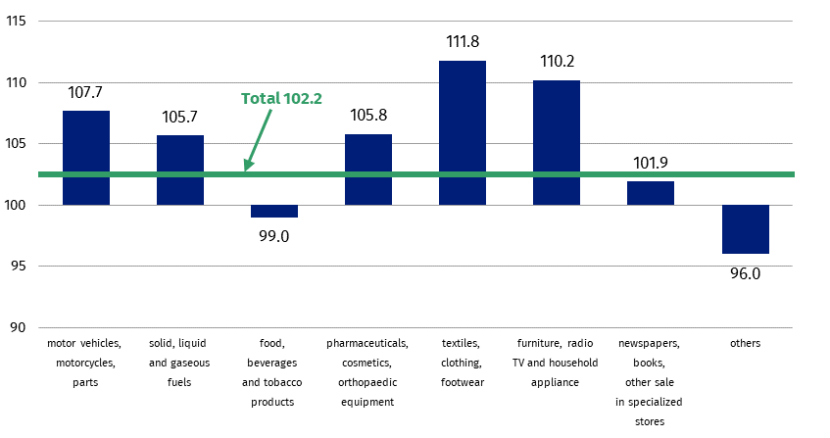
Chart 3. Retail sales of goods in June 2025 by type of enterprise activity (constant prices) – corresponding period of previous year=100

In Knowledge Databases (DBW) simultaneously with the data on retail sales, the data for the volume of sales by KAU (Kind-of-activity unit), which is prepared for the needs of European statistics, is presented additionally. The volume of sales (constant prices 2021=100) includes divisions and groups of Section G according to NACE Rev. 2.0 - "Wholesale and retail trade; repair of motor vehicles and motorcycles”. The data is disseminated on the website of the Statistics Poland in the resources Knowledge Databases/Database/Economy/Short-Term Statistics - data by Kind-of-activity unit.
When quoting Statistics Poland data, please provide the information: “Source of data: Statistics Poland”, and when publishing calculations made on data published by Statistics Poland, please include the following disclaimer: “Own study based on figures from Statistics Poland”.

Prepared by:  Trade and Services Department  Director Ewa Adach-Stankiewicz  Phone: (+48 22) 608 31 24 | Issued by:  Press Office  Mobile: (+48) 695 255 032  Phone: (+48 22) 608 38 04, (+48 22) 449 41 45,  (+48 22) 608 30 09  e-mail: obslugaprasowa@stat.gov.pl

www.stat.gov.pl/en/

@StatPoland

@GlownyUrzadStatystyczny

gus_stat

glownyurzadstatystycznygus

glownyurzadstatystyczny
Related information
Internal market in 2023
Socio-economic situation of the country
Statistical Bulletin
Data available in databases
Knowledge Database - Internal market
Local Data Bank
Macroeconomic Data Bank
Terms used in official statistics
Retail sales of goods

Data concerns trade and non-trade enterprises employing more than 9 persons. Groups of enterprises were created on the basis of the Polish Classification of Activities (PKD 2007) and a given enterprise is included to a specific category by predominating kind of activity and according to its present organizational status in mentioned period. The recorded changes of rise or fall of the dynamics of retail sales in particular groups of enterprises activity may result from a change in the predominating kind of activity and organisational changes (e.g. a merger of enterprises). This does not have impact on the dynamics of the total retail sales.
Corrections made by reporting entities were included in cumulative data.
The volume of sales is defined as turnover in trade deflated by price index i.e. turnover at constant prices (2021=100).

