Index of sold production of industry in August 2025¹
In August 2025, sold production of industry was by 0.7% higher than in August 2024 (when a decrease was recorded by 1.2%), whereas in comparison with July 2025, it decreased by 7.1%. In the period January-August of 2025, sold production of industry was by 2.0% higher than in the corresponding period of 2024 (which saw an increase by 0.4%).
A slight y/y increase in sold production and a decrease compared to July 2025 was caused by, among others, differences in the number of working days

0.7%
Increase in sold production of industry as compared to August 2024

After eliminating the seasonal factors, in August 2025 sold production of industry reached the level higher by 1.5% than in the corresponding month of 2024 and by 0.1% lower than in July 2025.
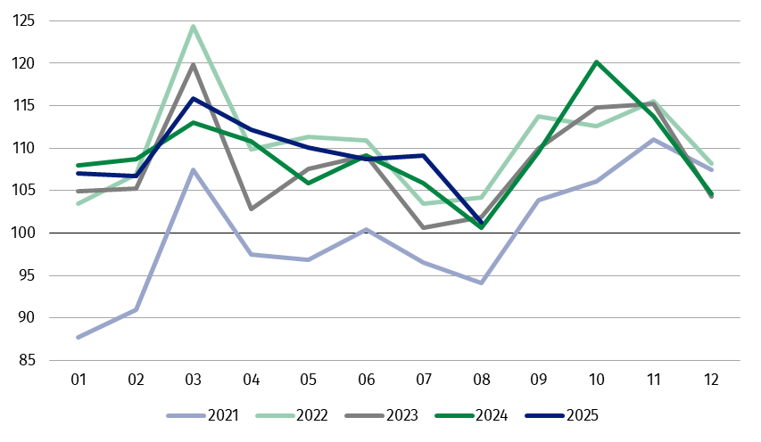
Chart 1. Sold production of industry (monthly average of 2021=100)
The highest y/y increase was recorded in the production of capital goods, while a decrease was observed, among others, in the production of energy

In August 2025, among the main industrial groupings there was an increase per year in the production of capital goods – by 7.2%, non-durable consumer goods – by 1.6% and durable consumer goods – by 0.2%. A decrease was observed in the production of energy – by 10.3% and intermediate goods – by 0.7%.

1 Preliminary data; comprise enterprises with 10 or more persons employed.

Table 1. Index of sold production of industry ª (constant prices)
SPECIFICATION | 2025
SPECIFICATION | 07 | 08 | 07 | 08 | 01-08 | 07 | 08
SPECIFICATION | previous month =100 |  | corresponding period of previous year = 100 |  |  | monthly average  of 2021 =100
INDUSTRY | 100.4* | 92.9 | 103.0* | 100.7 | 102.0 | 109.1* | 101.3
Mining and quarrying | 103.0* | 96.3 | 94.1* | 97.9 | 95.3 | 101.3* | 97.6
Manufacturing | 100.0* | 92.5 | 103.6* | 101.1 | 102.4 | 111.2* | 102.6
Electricity, gas, steam and air conditioning supply | 105.1* | 96.7 | 96.9* | 93.3 | 97.8 | 81.0* | 81.5
Water supply; sewerage waste management and remediation activities | 102.1* | 96.8 | 103.1 | 101.5 | 102.8 | 120.2* | 116.3
a Data including final information on production and prices in July and preliminary data in August.
* Data revised.
The share in total industry of sold production of divisions, which recorded an increase per year, amounted to 53.1%
According to the preliminary data, in August 2025 an increase in sold production (in constant prices), as compared to August 2024, was reported in 17 (out of 34) industry divisions, among others in repair and installation of machinery and equipment – by 37.9%, in manufacture of other transport equipment – by 34.4%, manufacture of machinery and equipment – by 9.7%, in waste collection, treatment and disposal activities; materials recovery – by 7.9%, manufacture of products of wood, cork, straw and wicker – by 5.6%, manufacture of food products – by 4.6%, manufacture of basic metals – by 2.8%, manufacture of metal products – by 2.7%.
A decrease in sold production of industry, as compared to August 2024, was recorded in 17 divisions, among others in manufacture of beverages – by 11.0%, in electricity, gas, steam and air conditioning supply – by 6.7%, in manufacture of chemicals and chemical products – by 6,1%, manufacture of motor vehicles, trailers and semi-trailers – by 4.2%, manufacture of electrical equipment – by 3.1%, manufacture of paper and paper products – by 2.7%.
Chart 2. Index of sold production of industry by selected NACE divisions (constant
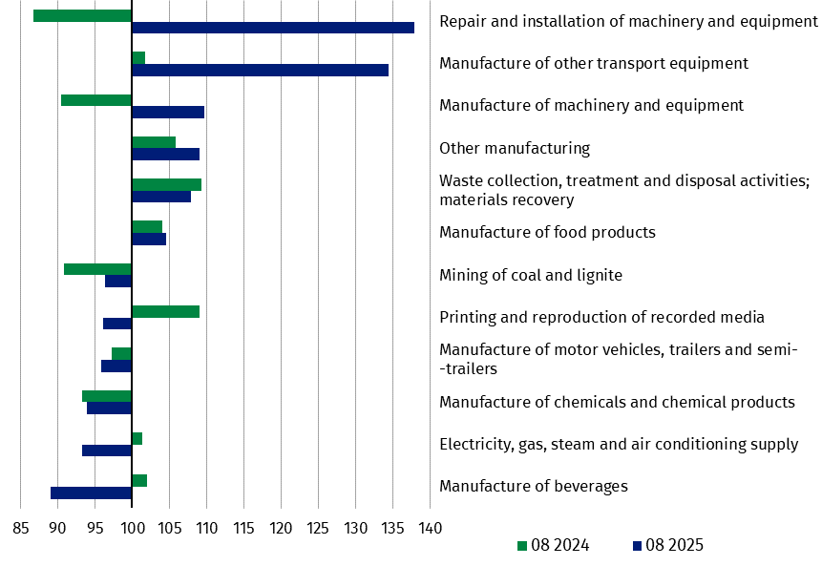
prices; corresponding period of previous year = 100)
In August 2025, a decrease in sold production (in constant prices), as compared to July 2025, was recorded in 29 (out of 34) industry divisions, among others in manufacture of motor vehicles, trailers and semi-trailers – by 22.1%, manufacture of basic metals – by 11.8%, manufacture of chemicals and chemical products – by 10.6%, manufacture of paper and paper products and manufacture of other non-metallic mineral products – by 10.1% each, manufacture of rubber and plastic products – by 9.8%, manufacture of machinery and equipment – by 8.6%, in repair and installation of machinery and equipment – by 8.3%, in manufacture of electrical equipment – by 7.7%.
The share in total industry of sold production of divisions, which recorded a decrease compared to July 2025, amounted to 91.5%

An increase in sold production of industry, as compared to the previous month, was recorded in 5 divisions, among others in manufacture of other transport equipment – by 19.3%, manufacture of furniture – by 4.6%, manufacture of computer, electronic and optical products – by 2.9%.
Chart 3. Index of sold production of industry by selected NACE divisions (constant
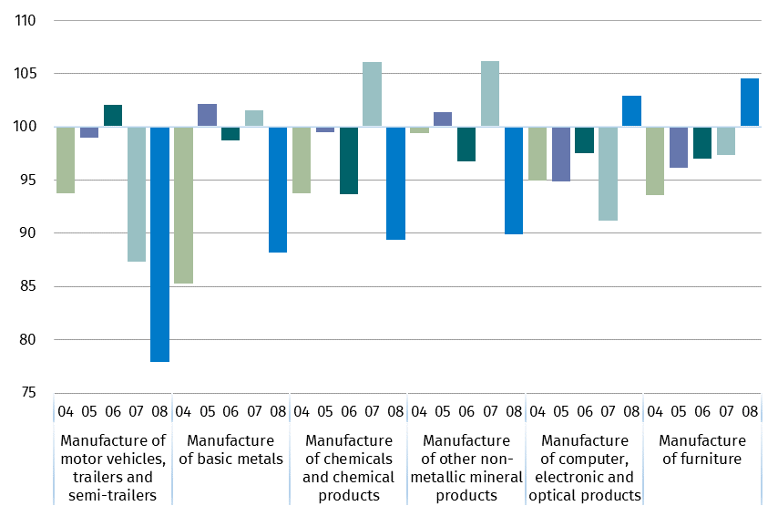
prices; previous month=100)

Data presented in this news release concern entities with 10 or more persons employed, conducting economic activity classified according to the Polish Classification of Activities (PKD 20027) to Industry, i.e. to the following sections: ‘Mining and quarrying’, ‘Manufacturing’, ‘Electricity, gas, steam and air conditioning supply’, ‘Water supply; sewerage, waste management and remediation activities’.
Statistical unit, according to which the presented data are compiled, is a legal unit. Methodology of compiling data on sold production of industry is presented in the methodological report Industrial production surveys.

In addition, for the needs of European statistics, data on industrial production are also compiled according to the kind-of-activity unit (KAU). The concept of the kind-of-activity unit is presented in the methodological report Short-term statistics by European concept of the Kind-of-activity unit.

In case of quoting Statistics Poland data, please provide information: “Source of data: Statistics Poland”, and in case of publishing calculations made on data published by Statistics Poland, please include the following disclaimer: “Own study based on figures from Statistics Poland”.
Prepared by:  Enterprises Department  Director Katarzyna Walkowska  Phone: (+48 22) 608 31 25 | Issued by:  Press Office  Mobile +48 695 255 032  Phone +48 22 608 38 04, +48 22 449 41 45,  +48 22 608 30 09  e-mail: obslugaprasowa@stat.gov.pl

stat.gov.pl

@GUS_STAT

@GlownyUrzadStatystyczny

gus_stat

glownyurzadstatystycznygus

glownyurzadstatystyczny

Related information
Statistical Bulletin
Socio-economic situation of the country
Methodological report. Industrial production surveys

Data available in databases
Knowledge Database - Industry
Macroeconomic Data Bank
Macroeconomic indicators
Local Data Bank

Terms used in official statistics
Sold production of industry
Seasonally un-adjustedindex of sold production of industry
Seasonally adjustedindex of sold production of industry
Production of capital goods
Production of non-durable consumer goods
Production of durable consumer goods
Production of intermediate goods
Production of goods related to energy

