Distribution of wages and salaries in the national economy in February 2025
In February 2025, compared with the corresponding month of the previous year, the median gross wage and salary in the national economy increased in nominal terms by 11.5%, while compared with January 2025 it increased by 4.1%
In February 2025, the median monthly gross wage and salary in the national economy in Poland was 23.5% lower than the average monthly gross wage and salary in that month.
PLN 7 166.00
Median monthly gross wage and salary
PLN 9 362.47
Average monthly gross wage and salary

Median monthly gross wage and salary in the national economy
The median gross wage and salary in the national economy in February 2025 was PLN 7 166.00, which means that half of the employees were paid a wage or salary not higher than this amount, and the other half received a wage or salary not lower than this amount. In the public sector, the median wage and salary was PLN 9 647.50, which was 134.6% of the total value, while in the private sector it was PLN 6 321.84, or 88.2% of the total value. The median wage and salary varied depending on sex – in the case of men it was PLN 7 275.20 (101.5% of the total value), while among women it was PLN 7 060.44 (98.5% of the total value). Taking the employees’ age into account, the highest median wage and salary was recorded in the 45-54 age group – it was PLN 7 560.40 (105.5% of the total value), while the lowest was in the 24-or-under age group, at PLN 5 657.90 (79.0% of the total value). In turn, in terms of entity size, the highest median wage and salary was recorded in entities with 1 000 or more employed persons – PLN 8 594.28 (119.9% of the total value), and the lowest in entities with 9 or fewer employed persons – PLN 4 666.00 (65.1% of the total value).
In February 2025, the lowest median gross wage and salary was in entities with 9 or fewer employed persons, at PLN 4 666.00
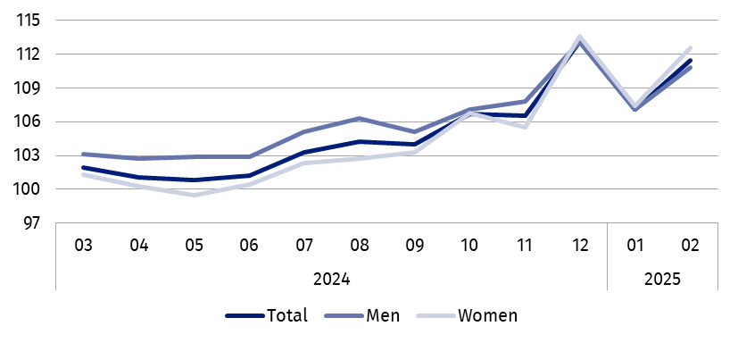
Chart 1. Indices of median monthly gross nominal wage and salary in the national economy
02 2024 = 100

Deciles of monthly gross wages and salaries in the national economy
In February 2025, the lowest earning 10% of employees received a wage or salary of at most PLN 4 666.00 (the first decile). In contrast, the highest earning 10% of employees received a wage or salary of at least PLN 16 050.00 (the ninth decile). 8 out of 9 deciles of wages and salaries varied by sex of the employees. The largest nominal difference in wages and salaries by sex occurred in the eighth decile and was PLN 324.07 in favour of women.

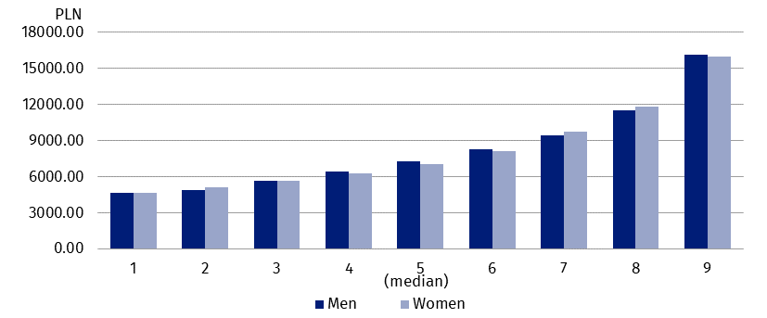
Chart 2. Deciles of monthly gross wages and salaries in the national economy by sex
in February 2025
In February 2025, the highest earning 10% of men received a wage or salary of at least PLN 16 158.04. During the same period, the highest earning 10% of women received a wage or salary of at least PLN 15 980.74

Average monthly gross wage and salary in the national economy
The average wage and salary in the national economy in February 2025 was PLN 9 362.47, among men – PLN 9 508.18, which represented 101.6% of the total average wage and salary, while among women – PLN 9 212.82, or 98.4% of the total average wage and salary. In terms of the employees’ age, the highest average wage and salary was recorded in the 65-or-over age group – PLN 10 332.10 (110.4% of the total value), and the lowest in the 24-or-under age group – PLN 6 305.69 (67.4% of the total value). Taking into account entity size, the highest average wage and salary was recorded in entities with 1 000 or more employed persons – PLN 11 201.01 (119.6% of the total value), and the lowest in entities with 5 or fewer employed persons – PLN 5 736.10 (61.3% of the total value). The average wage and salary also varied by ownership sector. In the public sector, it was PLN 11 614.77, which represented 124.1% of the total value, while in the private sector it was PLN 8 341.56 – 89.1% of the total value.
In February 2025, the average monthly gross wage and salary in entities with 9 or fewer employed persons was PLN 5 923.04

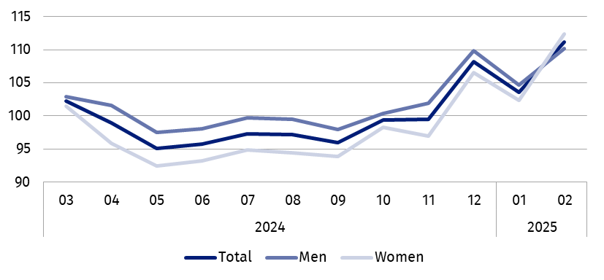
Chart 3. Indices of average monthly gross nominal wage and salary in the national economy
02 2024 = 100
Compared with February of the previous year, the average monthly gross wage and salary in the national economy increased in nominal terms by 11.2%, while compared with January 2025 it increased by 7.4%

Wages and salaries by territory
Wages and salaries in the national economy in February 2025 were differentiated territorially by place of residence of the employees, as well as by place of the entity's seat.

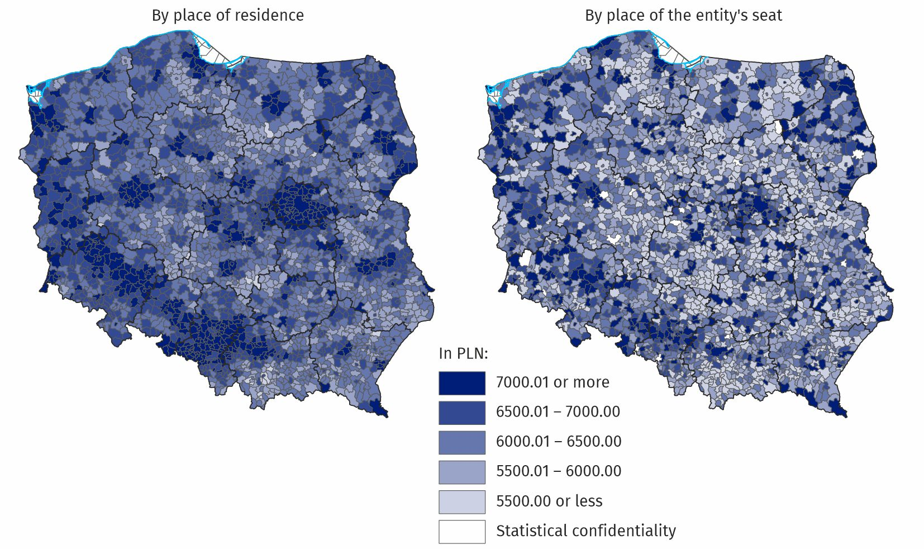
Map 1. Median monthly gross wage and salary in the national economy in February 2025
The spatial distribution of the median wage and salary by place of residence of the employees is more even than by place of the entity’s seat. The difference between the highest and lowest values of the median in the breakdown by place of the entity’s seat was PLN 9 497.30, with the median wage and salary being equal to or lower than PLN 5 500 in around 24% of gminas. On the other hand, in the breakdown by place of residence of the employees, only in around 1% of gminas was the median wage and salary equal to or lower than PLN 5 500, and the difference between the highest and lowest values of the median wage and salary was PLN 5 063.24.
In the breakdown by place of the entity’s seat, in around 27% of gminas the median gross wage and salary in February 2025 was equal to or higher than PLN 6 500

Wages and salaries by PKD 2007/NACE Rev. 2 section
Wages and salaries also varied by kind of activity. In February 2025, the highest median wage and salary, at PLN 16 105.19, was recorded in the Mining and quarrying section. In the public sector, the highest median wage and salary was in this section (PLN 21 236.65), and in the private sector – in the Information and communication section (PLN 11 251.35). In 15 of the 19 PKD 2007/NACE Rev. 2 sections analysed, men’s median wage and salary was higher than women’s median wage and salary, with the largest percentage difference occurring in the Financial and insurance activities section, at 38.1%. In 4 sections, women’s median wage and salary was higher than men’s median wage and salary, with the largest percentage difference occurring in the Construction section, at 31.9%.
In February 2025, the largest difference in the median gross wage and salary between the public and private sectors occurred in the Mining and quarrying section and was PLN 11 737.70

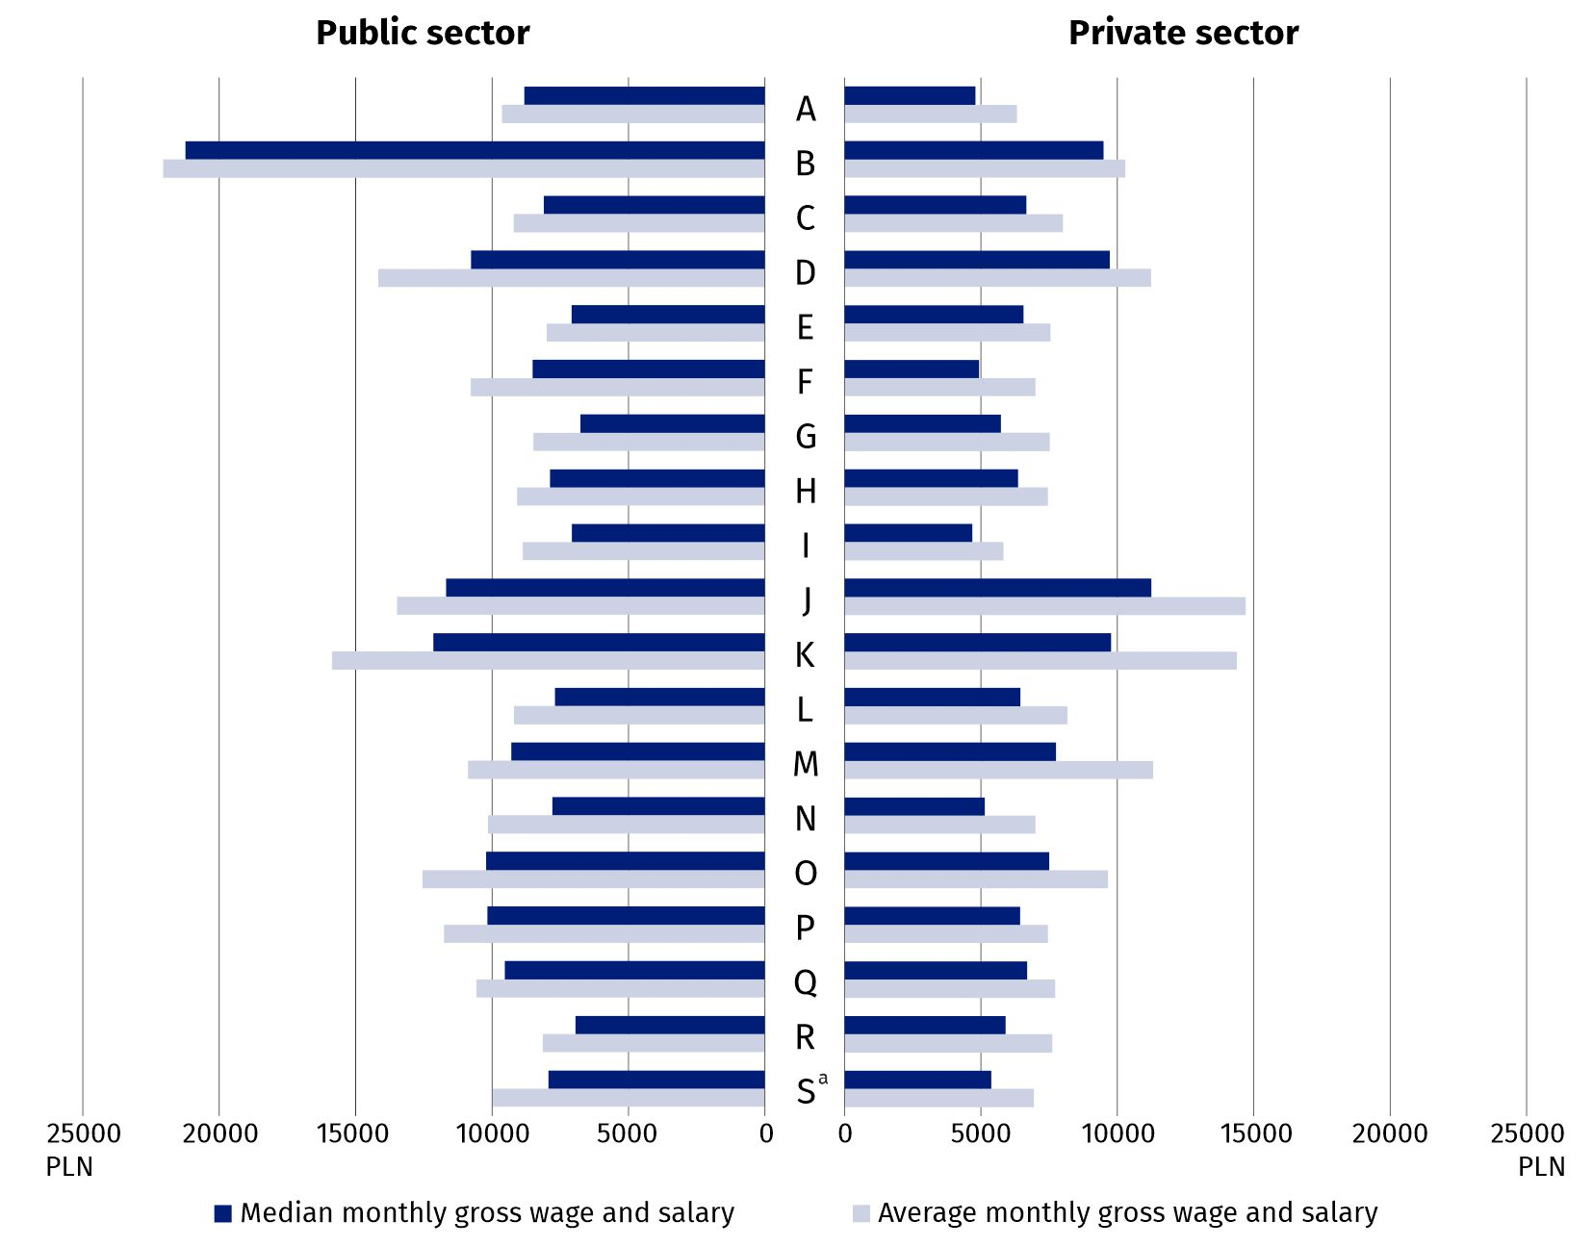
Chart 4. Average monthly gross wage and salary and median monthly gross wage and salary in the national economy by PKD 2007/NACE Rev. 2 section and ownership sector
in February 2025
a The data for the Other service activities (S) section also cover employees in the Activities of households as employers; undifferentiated goods- and services- producing activities of households for own use (T) and Activities of extraterritorial organisations and bodies (U) sections.
The highest average wage and salary in February 2025 was recorded in the Mining and quarrying section, at PLN 16 906.04. In the public sector, as in the case of the median wage and salary, the highest average wage and salary was also in the Mining and quarrying section (PLN 22 053.08), and in the private sector – in the Information and communication section (PLN 14 701.76). The largest percentage difference between men’s average wage and salary and women’s wage and salary was in the Financial and insurance activities section, amounting to 52.2% in favour of men. In 4 sections, women’s average wage and salary was higher than men’s, with the largest percentage difference occurring in the Construction section, amounting to 16.8% in favour of women.
In February 2025, in 15 sections, men’s average monthly gross wage and salary was higher than women’s average monthly gross wage and salary
***
Data source: results of the Survey on the Distribution of Wages and Salaries in the National Economy.
The presented data on wages and salaries cover monetary payments under the title of an employment relationship or a service relationship to employees, as well as payments under contracts of mandate, contracts to perform a specified task and agency agreements, if these contracts were concluded with the same employer or to the benefit of the same employer with whom a given person is employed on the basis of an employment relationship.
There is a wider range of data on the distribution of wages and salaries in the publication tables.
In this publication letter symbols and abbreviated names of PKD 2007/NACE Rev. 2 sections were used. Abbreviations are marked with a ‘Δ’ symbol. The full names can be found in the list of PKD 2007/NACE Rev. 2 sections below.
Symbols of PKD 2007/NACE Rev. 2 sections:
A – Agriculture, forestry and fishing;
B – Mining and quarrying;
C – Manufacturing;
D – Electricity, gas, steam and air conditioning supply;
E – Water supply; sewerage, waste management and remediation activities;
F – Construction;
G – Wholesale and retail trade; repair of motor vehicles and motorcycles;
H – Transportation and storage;
I – Accommodation and food service activities;
J – Information and communication;
K – Financial and insurance activities;
L – Real estate activities;
M – Professional, scientific and technical activities;
N – Administrative and support service activities;
O – Public administration and defence; compulsory social security;
P – Education;
Q – Human health and social work activities;
R – Arts, entertainment and recreation;
S – Other service activities.
The data for the Other service activities (S) section also cover employees in the Activities of households as employers; undifferentiated goods- and services- producing activities of households for own use (T) and Activities of extraterritorial organisations and bodies (U) sections.
In the case of quoting Statistics Poland data, please provide information: ‘Source of data: Statistics Poland’, and in the case of publishing calculations made on data published by Statistics Poland, please provide information: ‘Own work based on Statistics Poland data’.
Prepared by:  Statistical Office in Bydgoszcz  Director Wiesława Gierańczyk, Ph.D.  Phone: (+48 52) 366 93 90 | Issued by:  Press Office  Mobile phone: +48 695 255 032  Landline phones: +48 22 608 38 04, +48 22 449 41 45, +48 22 608 30 09  e-mail: obslugaprasowa@stat.gov.pl

www.stat.gov.pl/en/

@StatPoland

@GlownyUrzadStatystyczny

gus_stat

glownyurzadstatystycznygus

glownyurzadstatystyczny
Related information
Methodological report Distribution of wages and salaries in the national economy

