Index of sold production of industry in June 2025¹
In June 2025, sold production of industry was by 0.1% lower than in June 2024, whereas in comparison with May 2025, it decreased by 1.1%. In the period January-June of 2025, sold production of industry was by 1.4% higher than in the corresponding period of 2024 (which saw an increase by 0.1%).
0.1%
Decrease in sold production of industry as compared to June 2024

After seasonal adjustment, sold production of industry slightly increased per year

After eliminating the seasonal factors, in June 2025 sold production of industry reached the level higher by 0.1% than in the corresponding month of 2024 and by 0.5% lower than in May 2025.
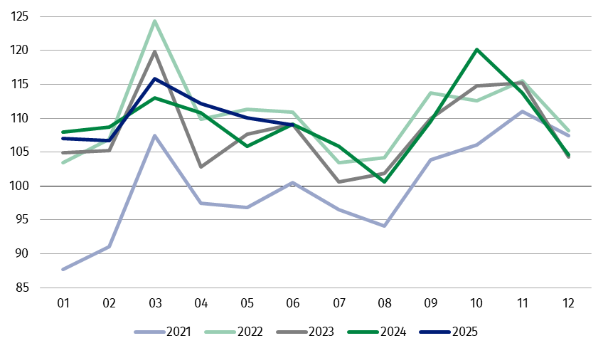
Chart 1. Sold production of industry (monthly average of 2021=100)
The highest y/y decline was recorded in the production of energy, while an increase was observed, among others, in the production of capital goods

In June 2025, among the main industrial groupings there was a decrease per year in the production of energy – by 7.7%, durable consumer goods – by 2.4% and intermediate goods – by 1.8%. An increase was observed in the production of capital goods – by 5.0% and slight in non-durable consumer goods – by 0.1%.

1 Preliminary data; comprise enterprises with 10 or more persons employed.
Table 1. Index of sold production of industry ª (constant prices)
SPECIFICATION | 2025
SPECIFICATION | 05 | 06 | 05 | 06 | 01-06 | 05 | 06
SPECIFICATION | previous month =100 |  | previous year =100 |  |  | monthly average  of 2021 =100
INDUSTRY | 98.1* | 98.9 | 104.0* | 99.9 | 101.4 | 110.1* | 109.0
Mining and quarrying | 100.6* | 99.3 | 97.9* | 91.5 | 93.4 | 98.8* | 98.2
Manufacturing | 98.3* | 99.2 | 104.3* | 100.4 | 101.7 | 112.1* | 111.8
Electricity, gas, steam and air conditioning supply | 91.0* | 91.3 | 101.6* | 93.2 | 99.1 | 88.3* | 77.3
Water supply; sewerage waste management and remediation activities | 101.3* | 100.5 | 103.7* | 103.4 | 102.2 | 117.4* | 117.9
a Data including final information on production and prices in May and preliminary data in June.
* Data revised.
The share in total industry of sold production of divisions, which recorded a decrease per year, amounted to 51.2%
According to the preliminary data, in June 2025 a decrease in sold production (in constant prices), as compared to June 2024, was reported in 18 (out of 34) industry divisions, among others in manufacture of chemicals and chemical products – by 7.7%, manufacture of other transport equipment – by 7.4%, in electricity, gas, steam and air conditioning supply – by 6.8%, in manufacture of electrical equipment – by 3.3%, manufacture of paper and paper products – by 3.1%, in mining of coal and lignite – by 2.3%.
An increase in sold production of industry, as compared to June 2024, was recorded in 16 divisions, among others in repair and installation of machinery and equipment – by 13.0%, in waste collection, treatment and disposal activities; materials recovery – by 9.4%, in manufacture of motor vehicles, trailers and semi-trailers – by 5.9%, manufacture of computer, electronic and optical products – by 4.3%, manufacture of machinery and equipment – by 3.1%, manufacture of basic metals – by 2.6%.
Chart 2. Index of sold production of industry by selected NACE divisions (constant
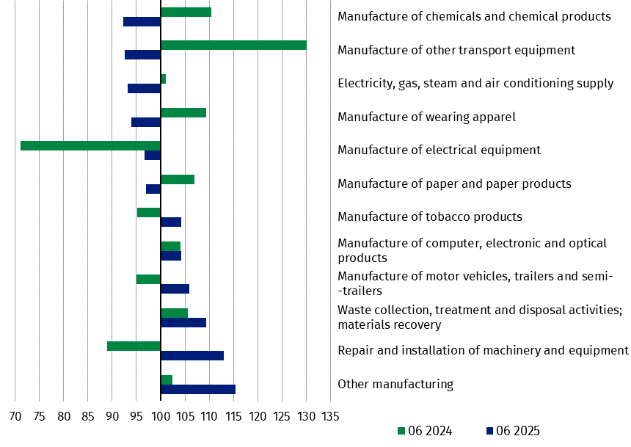
prices; previous year=100)
In June 2025, a decrease in sold production (in constant prices), as compared to May 2025, was recorded in 22 (out of 34) industry divisions, among others in electricity, gas, steam and air conditioning supply – by 8.7%, in manufacture of products of wood, cork, straw and wicker – by 7.2%, manufacture of chemicals and chemical products – by 6.2%, manufacture of paper and paper products – by 4.1%, manufacture of other non-metallic mineral products – by 2.9%, manufacture of furniture – by 2.8%, manufacture of computer, electronic and optical products – by 2.2%, manufacture of machinery and equipment – by 2.1%.
The share in total industry of sold production of divisions, which recorded a decrease compared to May 2025, amounted to 72.9%

An increase in sold production of industry, as compared to the previous month, was recorded in 12 divisions, among others in manufacture of beverages – by 22.3%, manufacture of pharmaceutical products – by 10.1%, in mining of coal and lignite – by 6.5%, in repair and installation of machinery and equipment – by 4.1%, in manufacture of motor vehicles, trailers and semi-trailers – by 2.0%.
Chart 3. Index of sold production of industry by selected NACE divisions (constant
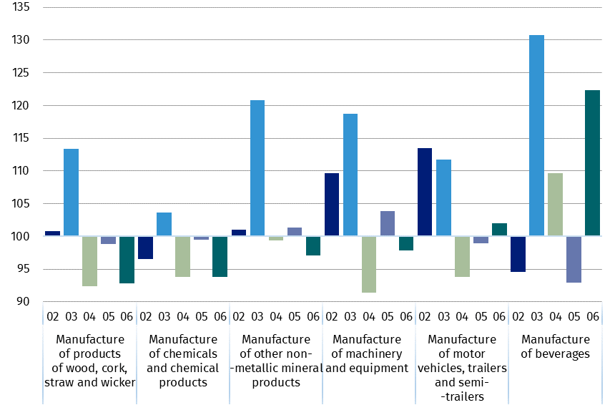
prices; previous month=100)

Data presented in this news release concern entities with 10 or more persons employed, conducting economic activity classified according to the Polish Classification of Activities (PKD 20027) to Industry, i.e. to the following sections: ‘Mining and quarrying’, ‘Manufacturing’, ‘Electricity, gas, steam and air conditioning supply’, ‘Water supply; sewerage, waste management and remediation activities’.
Statistical unit, according to which the presented data are compiled, is a legal unit. Methodology of sold production of industry is presented in the methodological report Industrial production surveys.

In addition, for the needs of European statistics, data on industrial production are also compiled according to the kind-of-activity unit (KAU). These data are disseminated in the Knowledge Databases under Short-Term Statistics - data by KAU. The concept of the kind-of-activity unit is presented in the methodological report Short-term statistics by European concept of the Kind-of-activity unit.

In case of quoting Statistics Poland data, please provide information: “Source of data: Statistics Poland”, and in case of publishing calculations made on data published by Statistics Poland, please include the following disclaimer: “Own study based on figures from Statistics Poland”.
Prepared by:  Enterprises Department  Director Katarzyna Walkowska  Phone: (+48 22) 608 31 25 | Issued by:  Press Office  Mobile +48 695 255 032  Phone +48 22 608 38 04, +48 22 449 41 45,  +48 22 608 30 09  e-mail: obslugaprasowa@stat.gov.pl

stat.gov.pl

@GUS_STAT

@GlownyUrzadStatystyczny

gus_stat

glownyurzadstatystycznygus

glownyurzadstatystyczny

Related information
Statistical Bulletin
Socio-economic situation of the country

Data available in databases
Knowledge Database - Industry
Macroeconomic Data Bank
Macroeconomic indicators
Local Data Bank

Terms used in official statistics
Sold production of industry
Seasonally un-adjustedindex of sold production of industry
Seasonally adjustedindex of sold production of industry
Production of capital goods
Production of non-durable consumer goods
Production of durable consumer goods
Production of intermediate goods
Production of goods related to energy

