Index of sold production of industry in December 2025¹
In Dcember 2025, sold production of industry was by 7.3% higher than in December 2024 (when an increase was recorded by 0.2%), whereas in comparison with November 2025, it slightly decreased by 0.1%. In the period January- -December of 2025, sold production of industry was by 3.0% higher than in the corresponding period of 2024 (which saw an increase by 0.3%).
7.3%
Increase in sold production of industry compared to December 2024

After seasonal adjustment, sold production of industry in December 2025 increased by 4.7% per year
After eliminating the seasonal factors, in December 2025 sold production of industry reached the level higher by 4.7% than in the corresponding month of 2024 and by 2.1% higher than in November 2025.
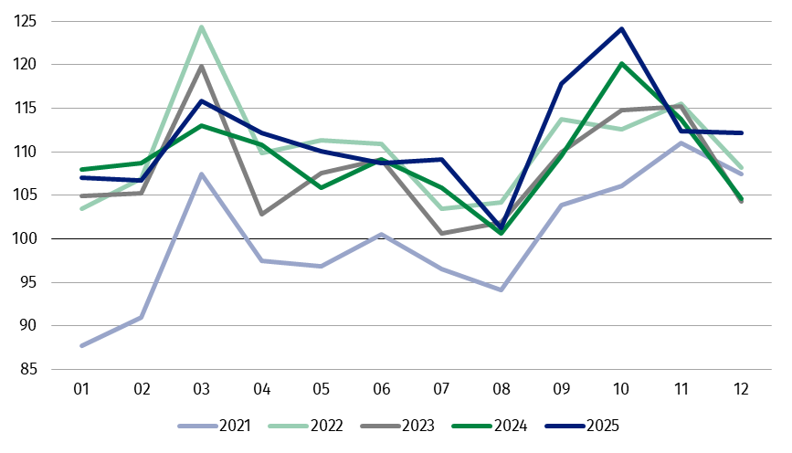
Chart 1. Sold production of industry (monthly average of 2021=100)
The highest y/y increase was recorded in the production of capital goods, while a decrease – in the production of energy

In December 2025, among the main industrial groupings there was an increase per year in the production of capital goods – by 17.1%, non-durable consumer goods – by 8.1%, durable consumer goods – by 7.8% and intermediate goods – by 6.6%. A decrease was observed in the production of energy – by 10.1%.

1 Preliminary data; comprise enterprises with 10 or more persons employed.

Table 1. Index of sold production of industry ª (constant prices)
SPECIFICATION | 2025
SPECIFICATION | 11 | 12 | 11 | 12 | 01-12 | 11 | 12
SPECIFICATION | previous month =100 |  | corresponding period of previous year = 100 |  |  | monthly average  of 2021 =100
INDUSTRY | 90.7 | 99.9 | 98.9 | 107.3 | 103.0 | 112.4 | 112.2
Mining and quarrying | 93.8* | 98.9 | 104.5* | 108.7 | 98.5 | 111.4* | 110.2
Manufacturing | 89.6* | 99.2 | 98.6 | 107.8 | 103.4 | 111.0 | 109.0
Electricity, gas, steam and air conditioning supply | 109.4* | 109.0 | 97.3* | 97.9 | 98.2 | 128.3* | 140.1
Water supply; sewerage waste management and remediation activities | 94.0* | 107.9 | 103.4* | 111.3 | 104.5 | 118.6* | 128.0
a Data including final information on production and prices in November and preliminary data in December.
* Data revised.
The share in total industry of sold production of divisions which recorded an increase per year, amounted to 77.8%
According to the preliminary data, in December 2025 an increase in sold production (in constant prices), compared to December 2024, was reported in 26 (out of 34) industry divisions, among others in repair and installation of machinery and equipment – by 37.7%, in waste collection, treatment and disposal activities; materials recovery – by 21.3%, in manufacture of metal products – by 19.9%, manufacture of machinery and equipment – by 17.8%, manufacture of other transport equipment – by 16.9%, manufacture of other non- -metallic mineral products – by 16.8%, manufacture of beverages – by 16.1%, manufacture of food products – by 9.0%.
A decrease in sold production of industry, compared to December 2024, was recorded in 8 divisions, among others in mining of coal and lignite – by 3.4%, in manufacture of electrical equipment – by 2.7%, in electricity, gas, steam and air conditioning supply – by 2.1%.
Chart 2. Index of sold production of industry by selected NACE Rev. 2 divisions
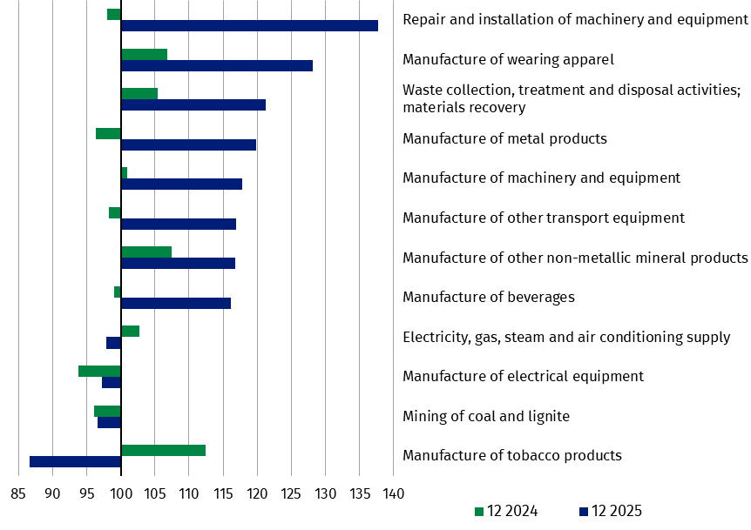
(constant prices; corresponding period of previous year = 100)
In December 2025, a decrease in sold production (in constant prices), compared to November 2025, was recorded in 18 (out of 34) industry divisions, among others in manufacture of rubber and plastic products and in manufacture of basic metals – by 15.1% each, manufacture of motor vehicles, trailers and semi-trailers – by 13.6%, manufacture of products of wood, cork, straw and wicker – by 11.8%, manufacture of furniture – by 8.2%, manufacture of chemicals and chemical products – by 7.5%, manufacture of paper and paper products – by 5.9%.
The share in total industry of sold production of divisions which recorded a decrease compared to November 2025 amounted to 47.2%

An increase in sold production of industry, compared to November 2025, was recorded in 16 divisions, among others in repair and installation of machinery and equipment – by 50.8%, in manufacture of other transport equipment – by 31.4%, manufacture of beverages – by 23.4%, manufacture of machinery and equipment – by 15.0%, in electricity, gas, steam and air conditioning supply – by 9.0%, in waste collection, treatment and disposal activities; materials recovery – by 6.7%.
Chart 3. Index of sold production of industry by selected NACE Rev. 2 divisions
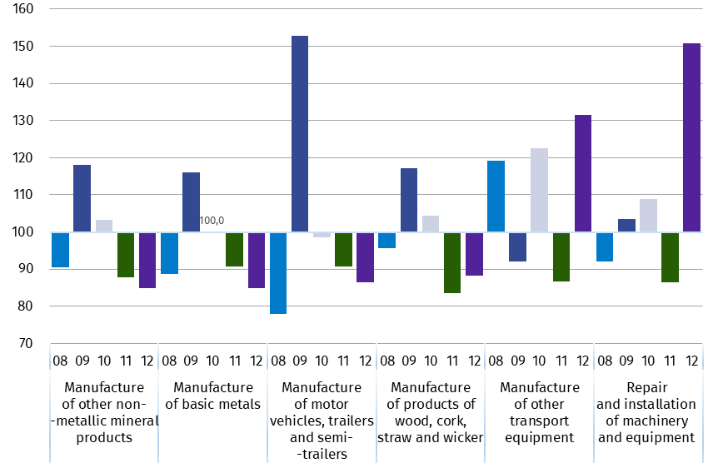
(constant prices; previous month=100)

Data presented in this news release concern entities with 10 or more persons employed, conducting economic activity classified according to the Polish Classification of Activities (PKD 2007/NACE Rev. 2) to Industry, i.e. to the following sections: ‘Mining and quarrying’, ‘Manufacturing’, ‘Electricity, gas, steam and air conditioning supply’, ‘Water supply; sewerage, waste management and remediation activities’.
Statistical unit, according to which the presented data are compiled, is a legal unit. Methodology of compiling data on sold production of industry is presented in the methodological report Industrial production surveys.
In addition, for the needs of European statistics, data on industrial production are also compiled according to the kind-of-activity unit (KAU). The concept of the kind-of-activity unit is presented in the methodological report Short-term statistics by European concept of the Kind-of-activity unit.

In case of quoting Statistics Poland data, please provide information: “Source of data: Statistics Poland”, and in case of publishing calculations made on data published by Statistics Poland, please include the following disclaimer: “Own study based on figures from Statistics Poland”.
Prepared by:  Enterprises Department  Director Katarzyna Walkowska-Macias  Phone: (+48 22) 608 31 25 | Issued by:  Press Office  Mobile +48 695 255 032  Phone +48 22 608 38 04, +48 22 449 41 45,  +48 22 608 30 09  e-mail: obslugaprasowa@stat.gov.pl

stat.gov.pl

@GUS_STAT

@GlownyUrzadStatystyczny

gus_stat

glownyurzadstatystycznygus

glownyurzadstatystyczny

Related information
Statistical Bulletin
Socio-economic situation of the country
Methodological report. Industrial production surveys

Data available in databases
Knowledge Database - Industry
Macroeconomic Data Bank
Macroeconomic indicators
Local Data Bank

Terms used in official statistics
Sold production of industry
Seasonally un-adjustedindex of sold production of industry
Seasonally adjustedindex of sold production of industry
Production of capital goods
Production of non-durable consumer goods
Production of durable consumer goods
Production of intermediate goods
Production of goods related to energy

