The demand for labour in Quarter 3 2025
In Poland, at the end of Quarter 3 2025, there were 1.0% fewer job vacancies than at the end of the previous quarter. The job vacancy rate was 0.78%.
1.0%
Decrease in the number of job vacancies compared with the end of Quarter 2 2025
At the end of Quarter 3 2025, 94.7 thousand job vacancies were recorded. There were 1.0 thousand fewer of them than in Quarter 2 2025 and 19.5 thousand fewer of them than in the corresponding quarter of 2024.
At the end of Quarter 3 2025, the job vacancy rate was 0.78%
The job vacancy rate at the end of Quarter 3 2025 remained at the same level as in Quarter 2 2025 and was 0.15 percentage points (pp) lower than in the corresponding quarter of 2024.
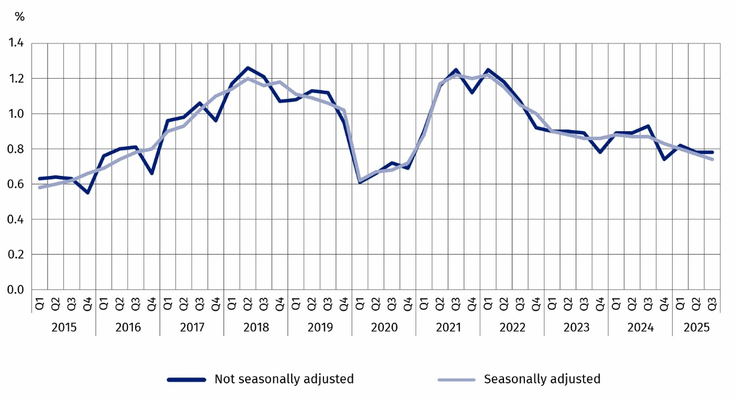
Chart 1. Job vacancy rate
As at the end of a quarter
The highest job vacancy rate at the end of Quarter 3 2025 occurred in the Dolnośląskie region (1.05%), while the lowest in the Podkarpackie region (0.45%).

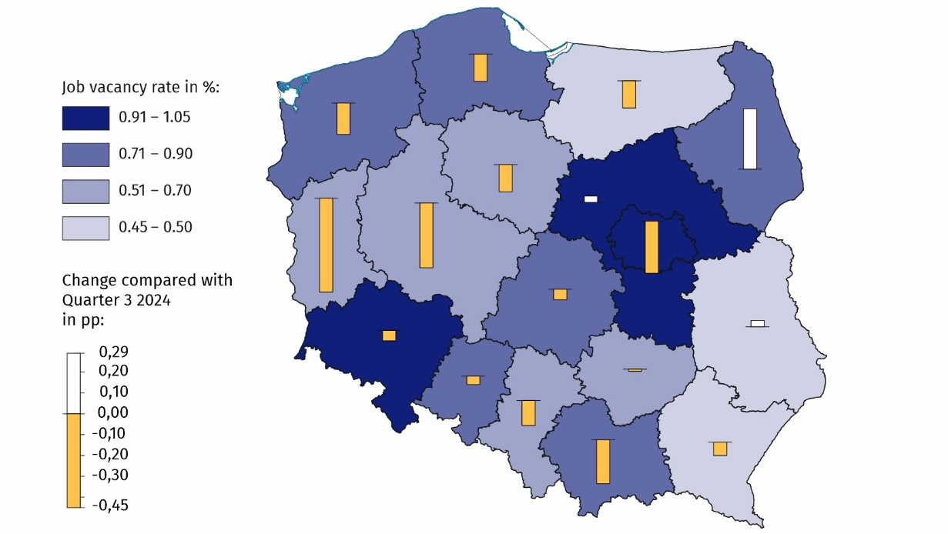
Map 1. Job vacancy rate by NUTS 2 region in Quarter 3 2025
As at the end of a quarter
In terms of the kind of activity conducted, the highest job vacancy rate occurred in the Construction section (1.47%). On the other hand, the largest increase in this rate compared with Quarter 3 2024 was recorded in the Arts, entertainment and recreation section (by 0.16 pp to 0.71%). In contrast, the largest decrease in the job vacancy rate was recorded in the Professional, scientific and technical activities section (by 0.79 pp to 0.77%).
The highest job vacancy rate was recorded in the Dolnośląskie region and amounted to 1.05%
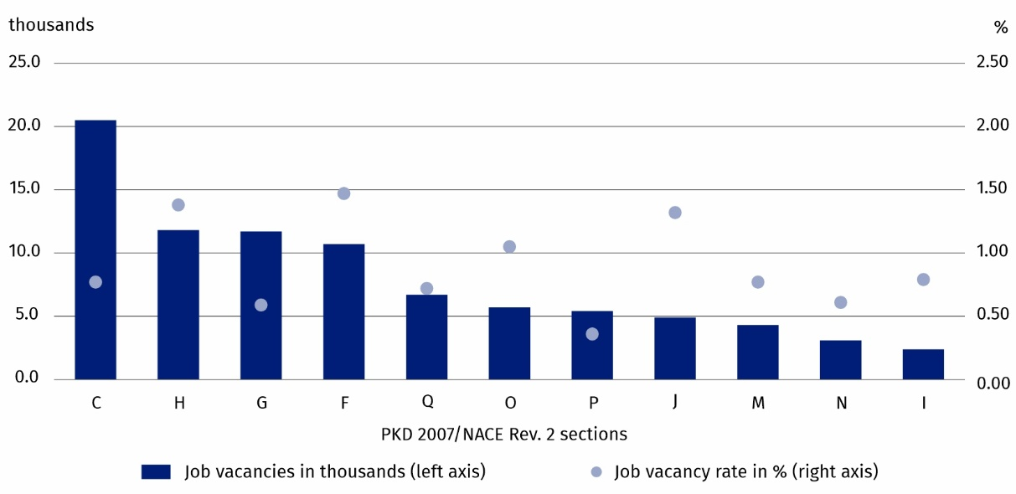
Chart 2. Job vacancies and the job vacancy rate in selected PKD 2007/NACE Rev. 2 sections in Quarter 3 2025
As at the end of a quarter
The largest number of job vacancies at the end of Quarter 3 2025 was recorded in the Manufacturing section (20.5 thousand). There was an increase in the share of job vacancies in the Transportation and storage section in the total number of job vacancies by 14.3 pp. As a result, this section came second in the list of kinds of activities offering the most jobs in Poland. In the Manufacturing section, job vacancies were mainly intended for occupations from the major occupational group of Craft and related trade workers (46.1%) and from the major occupational group of Plant and machine operators, and assemblers (21.8%). The major occupational groups mentioned above also dominated in the Construction section, with job vacancies for occupations from the occupational group of Craft and related trades workers accounting for 53.6% and for occupations from the occupational group of Plant and machine operators, and assemblers accounting for 17.0%.
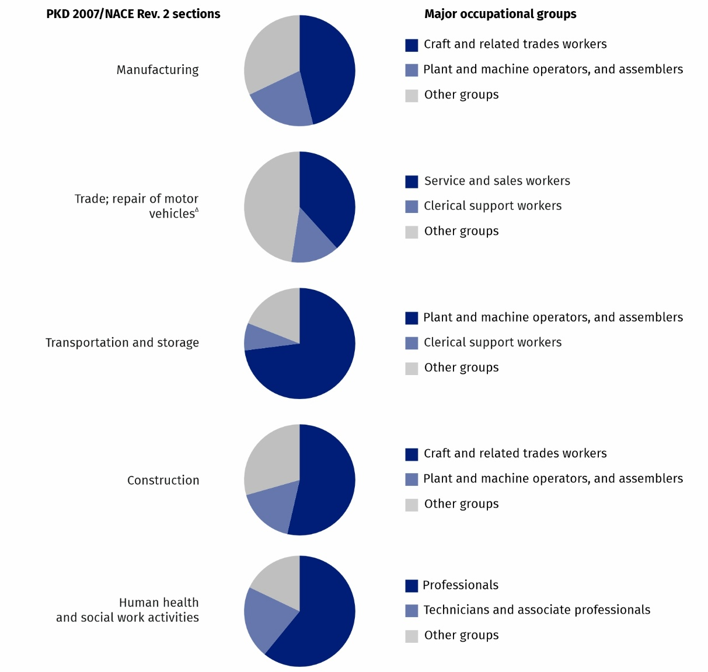
Chart 3. Structure of job vacancies by major occupational group (according to KZiS/ISCO-08) in selected PKD 2007/NACE Rev. 2 sections in Quarter 3 2025
As at the end of a quarter
Methodological notes
The survey covers national economy entities conducting activity within the scope of PKD 2007/NACE Rev. 2 sections from A (excluding natural persons running individual agricultural holdings) to S (with the exception of division 94, i.e. activities of membership organisations), on the basis of local units, in which the number of employees is at least 1 person.
The measure of the unmet labour demand is the job vacancy rate, which shows the proportion of vacant jobs compared to total jobs (vacant and occupied). The job vacancy rate is therefore calculated as the share of job vacancies in the sum of occupied jobs and job vacancies.
The data by major occupational group are presented according to the Classification of Occupations and Specializations (KZiS), a systematic set of occupations and specializations, which was developed on the basis of the International Standard Classification of Occupations ISCO-08.
In this publication symbols and abbreviated names of PKD 2007/NACE Rev. 2 sections were used. Abbreviations are marked with a ‘Δ’ symbol.
The full names can be found in the list of PKD 2007/NACE Rev. 2 sections below.

Symbols of PKD 2007/NACE Rev. 2 sections:
A – Agriculture, forestry and fishing;
B – Mining and quarrying;
C – Manufacturing;
D – Electricity, gas, steam and air conditioning supply;
E – Water supply; sewerage, waste management and remediation activities;
F – Construction;
G – Wholesale and retail trade; repair of motor vehicles and motorcycles;
H – Transportation and storage;
I – Accommodation and food service activities;
J – Information and communication;
K – Financial and insurance activities;
L – Real estate activities;
M – Professional, scientific and technical activities;
N – Administrative and support service activities;
O – Public administration and defence; compulsory social security;
P – Education;
Q – Human health and social work activities;
R – Arts, entertainment and recreation;
S – Other service activities.
Relative numbers (rates, percentages) were calculated on the basis of absolute data expressed with greater accuracy than given in the publication.
In the case of quoting Statistics Poland data, please provide information: ‘Source of data: Statistics Poland’, and in the case of publishing calculations made on data published by Statistics Poland, please provide information: ‘Own work based on Statistics Poland data.’

Prepared by:  Statistical Office in Bydgoszcz  Acting Director Katarzyna Klamrowska  Phone: (+48 52) 366 93 90 | Issued by:  Press Office  Mobile phone: +48 695 255 032  Landline phones: +48 22 608 38 04, +48 22 449 41 45, +48 22 608 30 09  e-mail: obslugaprasowa@stat.gov.pl

stat.gov.pl/en/

@StatPoland

@GlownyUrzadStatystyczny

gus_stat

glownyurzadstatystycznygus

glownyurzadstatystyczny
Related information
The demand for labour in 2024
The demand for labour in the second quarter of 2025 – news release
The demand for labour in the third quarter of 2024 – news release
Other publications containing the results of the Labour Demand Survey: stat.gov.pl → Topics → Labour Market
Methodological report. The demand for labour
Data available in databases
Knowledge Databases → Database → Society → Labour market
Strateg → Statistics by theme → Labour market
Local Data Bank → Data by domains → Labour market
Statistics for the SDGs – global indicators
Terms used in official statistics
Demand for labour
Vacancies
The job vacancy rate
Time series

The survey covers national economy entities conducting activity within the scope of PKD 2007/NACE Rev. 2 sections from A (excluding natural persons running individual agricultural holdings) to S (with the exception of division 94, i.e. activities of membership organisations), on the basis of local units, in which the number of employees is at least 1 person.
The share of job vacancies in the sum of occupied and vacant jobs.
https://ilostat.ilo.org/methods/concepts-and-definitions/classification-occupation/

