Foreign trade turnover of goods in total and by countries in January – June 2018
After six months we note increase in exports with the corresponding period of the previous year
Foreign trade turnover in January – June this year according to exports at current prices amounted to PLN 452.5 bn, while imports amounted to PLN 457.7 bn. The negative balance reached the level of PLN 5.2 bn, while the same period last year was positive and amounted to PLN 4.3 bn. In comparison to the corresponding period of the 2017, exports incteased by 3.3%, and imports by 5.5%.
103.3
Index of exports in PLN – previous year = 100

Foreign trade turnover expressed in US dollars and in EUR
Exports expressed in USD amounted to 130.7 bn USD while imports amounted to USD 132.2 bn (an increase in exports of 19.7% and in imports of 22.1%). The negative balance reached the level of USD 1.5 bn (in the corresponding period of the 2017, the positive balance amounted to USD 1.0 bn).
Exports expressed in EUR amounted to 107.6 bn while imports amounted to EUR 108.8 bn (an increase in exports of 5.7 % and in imports of 7.9%). The negative balance reached the level of EUR 1.2 bn compared to positive balance EUR 1.0 bn in the same period in 2017.
Chart 1. Turnover in the last three months in PLN billion
In June, there was a negative balance in foreign trade, while in April and May the balance was positive

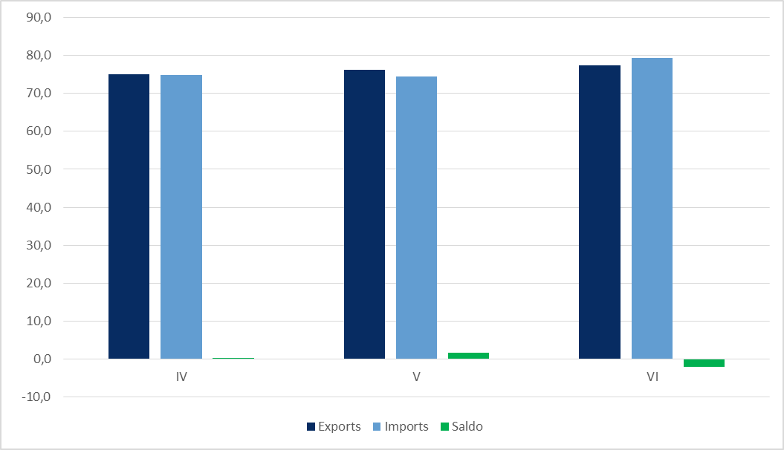

Foreign trade turnover of goods in total and by groups of countries
The high share of developed countries in trade in goods is affected by high turnover with the EU

Poland has the largest share in total exports with developed countries - 87.1% (of which EU 80.3), and imports – 66.7% (of which EU 59.3%), as against 86.9% (of which EU 80.0%) and 67.8% (of which EU 60.4%) in the corresponding period of the previous year. However, the smallest share was observed in the countries of Central and Eastern Europe, which in total exports amounted to 5.7%, and in imports – 8.9%, as against 5.6% and 7.9% in after six months of 2017.
The negative balances were recorded with developing countries – minus PLN 79.2 bn (minus USD 22.9 bn, minus EUR 18.9 bn) and with countries Central and Eastern Europe – minus PLN 15.0 bn (minus USD 4.3 bn, minus EUR 3.6 bn). The positive balances were obtained in turnover with developed countries PLN 89.0 bn (USD 25.7 bn, EUR 21.2 bn), of which EU countries a balance of PLN 92.3 bn (USD 26.7 bn, EUR 22.0 bn).
Table 1. Foreign trade turnover of goods in total and by groups of countries
SPECIFICATION | I – VI 2018 |  |  |  |  |  | 2017 | 2018
SPECIFICATION | bn  PLN | bn  USD | bn  EUR | I – VI 2017 = 100 |  |  | I – VI
 |  |  |  | PLN | USD | EUR | structure in %
Exports | 452,5 | 130.7 | 107.6 | 103.3 | 119.7 | 105.7 | 100.0 | 100.0
Developed countries | 394.3 | 113.9 | 93.8 | 103.6 | 120.0 | 106.0 | 86.9 | 87.1
of which EU | 363.6 | 105.1 | 86.5 | 103.7 | 120.2 | 106.1 | 80.0 | 80.3
of which euro-zone | 261.8 | 75.6 | 62.3 | 104.7 | 121.3 | 107.1 | 57.1 | 57.8
Developing countries | 32.6 | 9.4 | 7.8 | 99.4 | 115.0 | 101.6 | 7.5 | 7.2
Count. of Cent. and East. Europe | 25.6 | 7.4 | 6.1 | 104.2 | 120.3 | 106.4 | 5.6 | 5.7
Imports (country of origin) | 457.7 | 132.2 | 108.8 | 105.5 | 122.1 | 107.9 | 100.0 | 100.0
Developed countries | 305.3 | 88.2 | 72.6 | 103.8 | 120.2 | 106.2 | 67.7 | 66.7
of which EU | 271.3 | 78.4 | 64.5 | 103.5 | 119.8 | 105.8 | 60.4 | 59.3
of which euro-zone | 218.0 | 63.0 | 51.8 | 104.2 | 120.7 | 106.6 | 48.2 | 47.6
Developing countries | 111.8 | 32.3 | 26.6 | 105.8 | 122.5 | 108.2 | 24.4 | 24.4
Count. of Cent. and East. Europe | 40.6 | 11.7 | 9.6 | 119.0 | 137.9 | 121.8 | 7.9 | 8.9
Balance | -5.2 | -1.5 | -1.2 | X | X | X | X | X
Developed countries | 89.0 | 25.7 | 21.2 | X | X | X | X | X
of which EU | 92.3 | 26.7 | 22.0 | X | X | X | X | X
of which euro-zone | 43.8 | 12.6 | 10.5 | X | X | X | X | X
Developing countries | -79.2 | -22.9 | -18.9 | X | X | X | X | X
Count. of Cent. and East. Europe | -15.0 | -4.3 | -3.5 | X | X | X | X | X

Foreign trade turnover by major countries
Among our main trade partners in exports we recorded a decreased in turnover for Italy and United Kingdom

In January – June this year among the main trade partners of Poland there was an increase in exports to Russia, Germany, the United States, France, Netherlands, Sweden, Spain and Czech Republic and imports – from the United States, Russia, Spain, Germany, France, Belgium, Netherlands and China.
The turnover with the top ten of Polish trade partners in exports in January – June 2018 accounted for 66.6% (66.7% in the same period last year), while total imports – 65.3% (against 65.4% after six months of 2017).
The share of Germany in exports increased in comparison with the corresponding period of last year by 0.7 pp and amounted to 27.9%, and imports has decreased by 0.1 pp and accounted for 22.8%. The positive balance amounted to PLN 22.1 bn (USD 6.4 bn, EUR 5.3 bn) against PLN 19.5 bn (USD 4.8 bn, EUR 4.5 bn) in the same period of 2017.
Table 2. Foreign trade turnover by major countries
The share of Russia in imports increased by 0.7 pp compared to the same period of 2017 and it was 7.1%

SPECIFICATION | I – VI 2018 |  |  |  |  |  | 2017 | 2018
SPECIFICATION | bn  PLN | bn  USD | bn  EUR | I – VI 2017 = 100 |  |  | I – VI
 |  |  |  | PLN | USD | EUR | structure in %
EXPORTS
1. Germany | 126.4 | 36.5 | 30.1 | 106.3 | 123.2 | 108.7 | 27.2 | 27.9
2. Czech Republic | 28.8 | 8.3 | 6.9 | 101.9 | 118.0 | 104.2 | 6.5 | 6.4
3. United Kingdom | 27.1 | 7.8 | 6.5 | 96.2 | 111.6 | 98.4 | 6.5 | 6.0
4. France | 26.3 | 7.6 | 6.2 | 104.7 | 121.4 | 107.1 | 5.7 | 5.8
5. Italy | 21.2 | 6.1 | 5.1 | 94.9 | 109.9 | 97.0 | 5.1 | 4.7
6. Netherlands | 20.3 | 5.9 | 4.8 | 103.4 | 119.9 | 105.8 | 4.5 | 4.5
7. Russia | 13.4 | 3.9 | 3.2 | 107.4 | 123.8 | 109.6 | 2.8 | 3.0
8. Sweden | 12.8 | 3.7 | 3.1 | 102.8 | 119.0 | 105.2 | 2.9 | 2.8
9. United States | 12.4 | 3.6 | 3.0 | 106.2 | 122.9 | 108.6 | 2.7 | 2.8
10. Spain | 12.4 | 3.6 | 2.9 | 102.0 | 118.4 | 104.4 | 2.8 | 2.7
IMPORTS (country of origin)
1. Germany | 104.3 | 30.1 | 24.8 | 104.9 | 121.4 | 107.2 | 22.9 | 22.8
2. China | 50.3 | 14.5 | 12.0 | 101.0 | 117.0 | 103.4 | 11.5 | 11.0
3. Russia | 32.6 | 9.4 | 7.8 | 118.4 | 137.1 | 121.1 | 6.4 | 7.1
4. Italy | 23.3 | 6.7 | 5.5 | 99.6 | 115.3 | 101.9 | 5.4 | 5.1
5. France | 17.6 | 5.1 | 4.2 | 103.4 | 119.7 | 105.7 | 3.9 | 3.8
6. Netherlands | 17.4 | 5.0 | 4.1 | 102.6 | 118.9 | 104.9 | 3.9 | 3.8
7. Czech Republic | 15.8 | 4.6 | 3.8 | 98.5 | 114.1 | 100.8 | 3.7 | 3.5
8. United States | 14.8 | 4.3 | 3.5 | 121.1 | 139.4 | 123.5 | 2.8 | 3.2
9. Belgium | 11.7 | 3.4 | 2.8 | 102.9 | 119.1 | 105.2 | 2.6 | 2.6
10. Spain | 10.9 | 3.2 | 2.6 | 109.2 | 126.5 | 111.7 | 2.3 | 2.4

Imports by country of consignment in total and by groups of counties
The highest turnover in imports by country of consignment Poland recorded with the developed countries - PLN 342.3 bn, of which the EU – PLN 320.1 bn, compared to PLN 331.3 bn, of which the EU - PLN 310.6 bn in the same period of 2017.

Table 3. Imports by country of consignment in total and by groups of counties
SPECIFICATION | I – VI 2018 |  |  |  |  |  | 2017 | 2018
SPECIFICATION | bn  PLN | bn  USD | bn  EUR | I – VI 2017 = 100 |  |  | I – VI
 |  |  |  | PLN | USD | EUR | structure in %
Imports (country of consignment) | 457.7 | 132.2 | 108.8 | 105.5 | 122.1 | 107.9 | 100.0 | 100.0
Developed countries | 342.3 | 98.8 | 81.4 | 103.3 | 119.6 | 105.6 | 76.4 | 74.8
of which EU | 320.1 | 92.5 | 76.1 | 103.0 | 119.3 | 105.4 | 71.6 | 69.9
of which euro-zone | 260.0 | 75.1 | 61.8 | 103.3 | 119.6 | 105.6 | 58.0 | 56.8
Developing countries | 72.2 | 20.9 | 17.2 | 106.8 | 123.7 | 109.2 | 15.6 | 15.8
Countries of Cent. and East. Europe | 43.2 | 12.5 | 10.2 | 123.9 | 143.5 | 126.8 | 8.0 | 9.4
Balance | -5.2 | -1.4 | -1.2 | X | X | X | X | X
Developed countries | 52.0 | 15.1 | 12.4 | X | X | X | X | X
of which EU | 43.5 | 12.6 | 10.4 | X | X | X | X | X
of which euro-zone | 1.8 | 0.5 | 0.5 | X | X | X | X | X
Developing countries | -39.6 | -11.5 | -9.5 | X | X | X | X | X
Countries of Cent. and East. Europe | -17.6 | -5.1 | -4.1 | X | X | X | X | X
The share of Germany in imports by country of consignment to imports by country of origin was higher by 4.4 pp, accordingly the share of the Netherlands was higher by 1.9 pp and Belgium by 1.2 p
The share of imports from China according by country of consignment to the share of the country of origin was lower by 4.0 pp

Table 4. Imports by country of consignment – by countries
SPECIFICATION | I – VI 2018 |  |  |  |  |  | 2017 | 2018
SPECIFICATION | bn  PLN | bn  USD | bn  EUR | I – VI 2017 = 100 |  |  | I – VI
 |  |  |  | PLN | USD | EUR | structure in %
IMPORTS (country of consignment)
1. Germany | 124.5 | 36.0 | 29.6 | 103.5 | 119.8 | 105.8 | 27.7 | 27.2
2. Russia | 34.3 | 9.9 | 8.2 | 124.2 | 143.8 | 127.1 | 6.4 | 7.5
3. China | 32.0 | 9.2 | 7.6 | 104.5 | 121.2 | 107.0 | 7.1 | 7.0
4. Netherlands | 26.1 | 7.5 | 6.2 | 99.4 | 115.1 | 101.7 | 6.1 | 5.7
5. Italy | 23.4 | 6.8 | 5.6 | 99.1 | 114.8 | 101.3 | 5.4 | 5.1
6. France | 19.1 | 5.5 | 4.5 | 104.2 | 120.7 | 106.6 | 4.2 | 4.2
7. Czech Republic | 18.0 | 5.2 | 4.3 | 101.0 | 116.9 | 103.3 | 4.1 | 3.9
8. Belgium | 17.5 | 5.1 | 4.2 | 108.8 | 126.0 | 111.3 | 3.7 | 3.8
9. United Kingdom | 11.5 | 3.3 | 2.7 | 99.7 | 115.5 | 102.0 | 2.7 | 2.5
10. Spain | 11.1 | 3.2 | 2.6 | 105.7 | 122.4 | 108.1 | 2.4 | 2.4

Prepared by:  Trade and Services Department  Aldona B. Matejak  Tel: +48 22 608 34 83  e-mail: a.matejak@stat.gov.pl | Issued by:  The Spokeperson for the President  of Statistics Poland  Karolina Dawidziuk  Tel: +48 22 608 3475, 22 608 3009  e-mail: rzecznik@stat.gov.pl

Press Office  tel.: +48 22 608 34 91, +48 22 608 38 04  fax: +48 22 608 38 86  e-mail: obslugaprasowa@stat.gov.pl |  | www.stat.gov.pl/en/
 |  | @StatPoland
 |  | @GlownyUrzadStatystyczny

Related information
Yearbook of Foreign Trade Statistics of Poland 2017
Foreign trade turnover by main commodities 2016
Foreign trade. Mirror and asymmetry statistics

Data available in databases
Knowledge Databases (DBW). Foreign trade
Database. Analytical Platform - SWAiD - Knowledge Databases. Foreign trade

Terms used in official statistics
Exports of commodities
Imports of commodities
Balance foreign trade commodity turnover

Collection of data on foreign trade turnover is open. Data published formerly is updated according to new customs documentation and INTRASTAT declarations.
Country of origin is the country where the commodity was produced or processed and in this form entered the Polish customs zone.
Country of consignment is the country from which the goods were introduced into the Polish territory irrespective of their origin.

