The situation of households in 2019 – on the base of the result of Household Budget Survey

In 2019 the income situation of households improved and the dynamic of the changes was higher than the year before

In 2019 the financial situation of households in Poland improved. Households reached higher income and in comparison with 2018 spent slightly more. The average monthly available income per capita in 2019 rounded up to 1 PLN, amounted to PLN 1819 and in real terms it was 5.0% higher than the income in 2018. The average monthly expenditure per capita in households in 2019 amounted to PLN 1252 and in real terms it was 3.1% higher than in 2018. Expenditure on consumer goods and services amounted to PLN 1201 and in comparison with 2018, in real terms, was 3.3% higher.
5.0%
The increase of the average monthly available income per capita in households in 2019 – in real terms

The financial situation of households was consistently improving in years 2004–2019

Income and expenditure
Households of self-employed outside farming had the highest available monthly income (PLN 2174) and expenditure (PLN 1472) per capita
In 2019, the dispersion of the average monthly income and expenditure per capita various socio-economic groups was, similarly to the previous year, relatively high. In 2019, both average monthly available income and average monthly expenditure per capita were the highest in the households of the self-employed outside farming (similarly to the year before) and amounted to, respectively, PLN 2174 and PLN 1472. Income in this group of households was 19.5% higher than the income of total households, and expenditure 17.6% higher than total average expenditure (in 2018 – 18.8% and 17.9% respectively).

Households of pensioners were characterised by the lowest available income per capita (PLN 1498), which was by 17.7% lower than that of total households average (in 2018 – by 20.0%). The lowest expenditure was observed in the households of farmers (PLN 914) – by 27.0% lower than that of the total household average (in 2018 – lower by 26.5%).
The highest share of expenditure in available income was observed in households of pensioners and the lowest in households of farmers

The difference between average available income and expenditure among socio-economic groups in relations to the national average, in case of income was 37.2 percentage points (increase by 1.6 percentage points in comparison to 2018), while for expenditure remained at the similar level as in 2018 and amounted to 44.6 percentage points (increase by 0.2 percentage points).
The highest share of expenditure in income (81.6%) and the lowest amount of average monthly excess of income over expenditure (PLN 276) was recorded in the households of pensioners (similarly to the year before). The lowest share of expenditure in income (54.8%) and the highest average excess of income over expenditure (PLN 753) was observed in the households of the farmers. For total households the share of expenditure in income decreased by 1.3 percentage points in comparison to 2018 (in 2018 by 3.5 percentage points in comparison to 2017).

In 2019 the real growth of available income by 5.0% in total occurred (in 2018 – by 4.3%). This was observed in all socio-economic groups of households. The highest real increase of income was recorded in households of pensioners (by 7.8%) and the lowest in households of farmers – by 3.5% (in 2018 for households of farmers a decrease by 1.5% was observed).
In 2019 the income situation in households of farmers improved in comparison to 2018

A real growth of available income in households of farmers was caused mostly by a real growth of income from private farm (by 2.1% in comparison to 2018).
The highest share of income from the main source of income occurred in the households of retires (83.8%) and the lowest in the households of farmers (65.7%).

In comparison to 2018, differences in the structure of the average monthly available income per capita in households ranged from -0.8 percentage points for category ‘income from hired work’ to 0.5 percentage points for income from retirement pensions.

The dispersion of income per capita in household measured by the Gini coefficient was decreasing from 2014. However in 2019 this trend was stopped and the value of the coefficient amounted to 0.301 (in 2018 – 0.299).

The decreasing trend of Gini coefficient that describes the dispersion of income per capita in households was stopped in 2018 and took an upward trend in 2019
In real terms – the average expenditure per capita in households in 2019 increased by 3.1% in comparison to 2018
In 2019 in all socio-economic groups of households there was a real growth of average monthly expenditure per capita that amounted from 2.5% in households of retires to 4.4% in the group of the pensioners – in comparison to 2018.
Similarly to the previous years, the highest share in the structure of the expenditure of households was still held by expenditure on food and non-alcoholic beverages – 25.1%, and constituted from 21.1% of total expenditure in the households of self-employed to 31.7% in the households of farmers.
Another important item in households expenditure were those on housing, water, electricity, gas and other fuels. Its share in total expenditure was on average 18.0%. The lowest share of this expenditure was in the households of farmers (13.9%) and the highest in the households of pensioners – 22.6%.

Changes in share in expenditure structure for households in total between 2019 and 2018 in the case of the other main groups of consumer goods and services ranged from -0.8 percentage point for expenditure on transport to +0.5 percentage points for expenditure on education.

In 2019, 39.0% of households had the average monthly available income per capita at the level of PLN 2000 or more (in 2018 – 32.7%)
In 2019, 61.0% of households had an average monthly available income per capita below PLN 2000 (67.3% in 2018), 33.7% of households had income from PLN 2000 to PLN 4000 per capita (28.3% in 2018), 3.9% of households had income from 4000 to 6000 PLN per capita (3.0% in 2018), and 6000 PLN per capita or more about 1.4% of households (1.2% in 2018).
The average available income of the 20% of persons with the highest income (5th quintile group) amounted to PLN 3491 per capita, and was 4.9 times higher than the respective income of the 20% of persons with the lowest income (1st quintile group) – in 2018 it was also 4.9 times higher (amounted to PLN 3277).
Households of 20% of persons in the most favourable financial situation accumulated 38.3% income throughout surveyed population of households. Households of 20% of the poorest persons accumulated 7.8% of income
Households of 20% of persons with the highest income (5th quintile group) accumulated 38.3% income throughout surveyed population of households (in 2018 – 38.7%), while 20% of persons with the lowest income (1st quintile group) – 7.8% (in 2018 – 7.9%). Therefore, income range accumulated among the 20% of the richest people and 20% of the poorest decreased by 0.3 percentage points to 30.5 percentage points.

The average expenditure in the 5th quintile group were 2.6 times higher than the respective expenditure in the 1st quintile group. The share of expenditure in available income in the highest quintile group amounted to 59.7%, and in the lowest to 112.6%. That means that the poorest households were forced to make use of their savings, or loans or credits, to a slightly more extent than in 2018 (in 2018 the share of expenditure income in the lowest quintile group amounted 107.6%).
The average monthly available income per capita in urban households was by 28.4% higher than in rural households
The average monthly expenditure per capita in urban households was by 34.8% higher than in rural households
The place of residence is another factor that substantially diversified the level, dynamics, and structure of the income and expenditure of households.
The average available income per capita in urban households was by 28.4% (in 2018 – 29.9%) higher than in rural households. These differences were attributable not only to the amount of income obtained by households, but were also connected with the larger number of persons living within a rural household. Similar observations could be formulated on the expenditure of households. Expenditure per capita in urban households was by 34.8% higher than in rural households (in 2018 – 34.5%).

In 2019, the available income per capita was higher than the national average in voivodships: Mazowieckie, Dolnośląskie, Śląskie, Pomorskie. As in the previous year the highest average income per capita was available for households from Mazowieckie Voivodship (PLN 2108) and it was 15.9% higher than the national average income per capita. The lowest income was registered again in Podkarpackie Voivodship (PLN 1471) and it was 19.1% below the national average.
The difference between the highest and the lowest indicator of the average income per capita compared to the national average between voivodships decreased by 5.4 percentage points compared to the previous year and amounted to 35.0 percentage points.

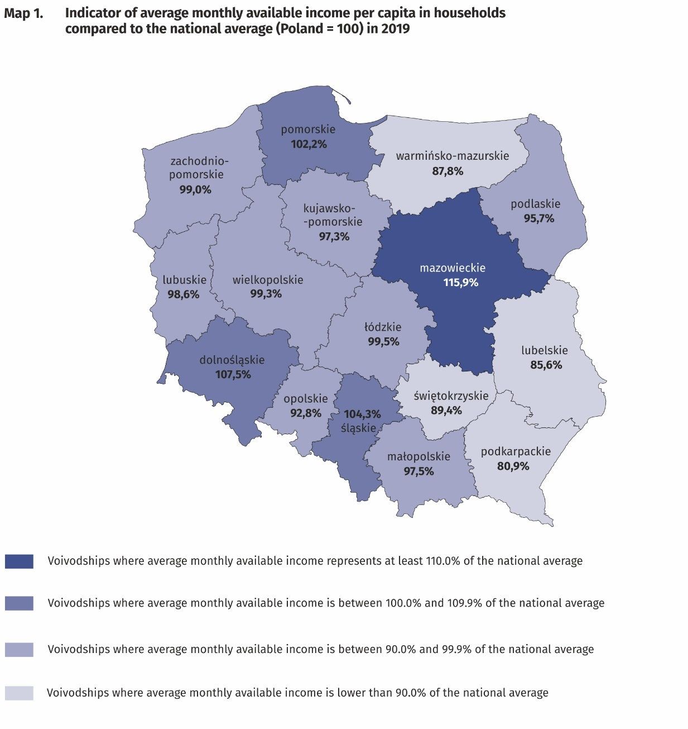
The highest average monthly available income per capita in households occurred in Mazowieckie Voivodship (PLN 2108) and the lowest in Podkarpackie Voivodship (PLN 1471)

In 2019, the average monthly expenditure above the national average was observed in voivodships: Mazowieckie, Dolnośląskie, Łódzkie, Pomorskie, Opolskie, Śląskie and Zachodniopomorskie.
As in the previous year, the highest average monthly expenditure per capita in households (PLN 1476), was recorded in the Mazowieckie Voivodship; it was higher than the average for Poland in total – by 17.9%. The lowest average expenditure per capita in households was noted in the Warmińsko-Mazurskie Voivodship (PLN 1007) – 19.6% lower than the national average.
The difference between the highest and the lowest indicator of the average expenditure per capita in voivodships in relation to the national average decreased by 1.3 percentage points in comparison to 2018 year and amounted to 37.5 percentage points.

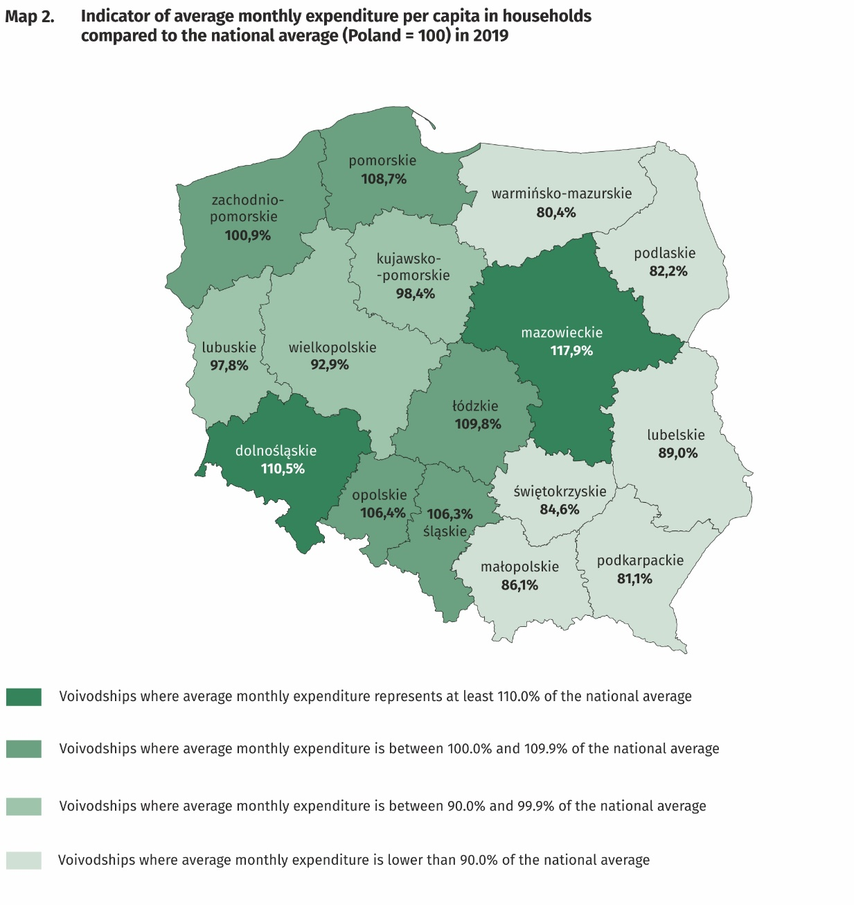
The highest average monthly expenditure per capita in households occurred in Mazowieckie Voivodship (PLN 1476) and the lowest in Warmińsko-Mazurskie Voivodship (PLN 1007)

Quantitative food consumption
In 2019 the decreasing trend in consumption of the most basic foodstuffs, as: vegetables, fish and seafood, milk, meat, bread and cereals, oils and fats and processed meat and other meat preparations, continued
In 2019 the decreasing trend in consumption of the most basic foodstuffs continued. This decrease applied especially to vegetables (by 3.9%), fish and seafood (by 3.6%), milk (by 2.4%), meat (by 2.3%), bread and cereals (by 2.2%, of which bread by 5.4%), oils and fats (by 1.9%) and processed meat and other meat preparations (by 1.5%). On the other hand, the consumption of cheese and curd increased by 2.3% and fruit by 1.1%. The decrease of consumption level could be caused by the growth of expenditure on catering establishments which amounted to 4.6% in 2019.
The level of consumption of most foodstuffs greatly depends on household income. As the wealth of households increases, so does the level of consumption of certain foodstuffs, as bread and cereals, meat, vegetables, fruit, cheese and curd and mineral and spring water.

The level of consumption is also affected by eating habits, availability and prices of foodstuff in a place of residence. Households in rural areas compared with households in urban areas are characterised by a slightly different model of nutrition.

The equipment of households with durable goods
In 2019 there was a high growth rate in household equipment with dishwasher game console, smartphone. However, the dynamics of these changes were lower than in the year 2018

In 2019 there was a high growth rate in households equipment with dishwasher (by 10.2%), game console (by 8.3%) and smartphone (o 6.8%). However, compared to 2018, this dynamic was noticeably lower, and for some goods the direction of change even reversed, resulting in a decrease in household equipment for the printer (a decrease of 4.9%, in 2018 an increase of 10.9%), home theatre system (decrease by 1.6%, in 2018 an increase of 13.0%).
The equipment of households with durable goods largely depends on the financial situation of the household.
The richest households (5th quintile group) were much better equipped than the poorest households (1st quintile group). It should be emphasised, however, that the differences in the degree of equipment between 5th and 1st quintile group decreased in comparison to 2018, the most for dishwasher (by 3.0 percentage points) and device with access to the Internet (by 1.4 percentage points). For other goods the changes were slight.

Households in urban areas were better equipped with high-tech devices (such as device with the access to the Internet or smartphone) than households in rural areas. In case of plasma or LCD TV set and dishwasher there are no significant diversity. However much larger percentage of households in rural areas had passenger car, motorcycle, scooter, moped and bicycle. Compared to 2018, the differences in equipment decreased slightly in favour of rural areas.

Larger percentage of households in rural areas had passenger car, motorcycle, scooter, moped and bicycle, while households in urban areas were better equipped with high-tech devices
Dwelling conditions
In 2019, the dwelling conditions of households improved slightly. The average household occupied a dwelling with a floor area of 80.4 m² which consisted of 3.0 rooms.

In 2019, the average household occupied a dwelling with a floor area of 80.4 m² (in 2018 – 79.4 m²) which consisted of 3.0 rooms. On average, there were 28.7 m² of usable floor area and 1 room per person (in 2018 – 28.4 m² and 1 room per person).
The largest dwelling area was declared by the households of farmers – 134.6 m², while the smallest by households of pensioners – 65.9 m^{2.}. Compared to 2018, there was a slight increase in the area of the dwelling occupied by households of employees, farmers and retirees, while a slight decrease in households of self-employed and pensioners. The changes ranged from 0.4 to 1.2 m².
The largest usable floor area per capita was in the households of pensioners (40.3 m²) and retirees (39.6 m²) – which is attributable to a lower number of persons in the household. The smallest usable floor area per capita was in the households of employees (24.5 m²).
The area of the dwellings occupied by households was diversified by level of their income. Households with the highest income (5th quintile group) occupied slightly smaller dwellings (78.8 m²) than households with the lowest income (1st quintile group) – 84.7 m², but their members had more usable floor per capita (37.0 m² and 22.5 m² respectively).
The equipment of dwellings in sanitary and technical installations steadily improved. 99.8% of households occupied dwellings equipped with running water, 98.5% with a flushing toilet and 98.2% with a bathroom.
Again the highest level of equipment with sanitary and technical installations (except gas) was observed in the dwellings of the households of self-employed outside farming and the lowest – households of pensioners.
Households in urban areas were slightly better equipped with sanitary and technical installations (except gas) than households in rural areas.

Households in urban areas were slightly better equipped with sanitary and technical installations (except gas) than households in rural areas.

The equipment of dwellings in sanitary and technical installations significantly depends on household’s income, excluding gas, which was used by the richest households the least (5th quintile group). The most significant difference in this area between 1st and 5th quintile group (in favour of the richest) concerned the equipment with central heating (11.7 percentage points), bathroom (4.7 percentage points) and flushing toilet (4.2 percentage points). Differences in the level of equipment decreased in comparison to 2018.

A subjective evaluation of the financial situation of households
The subjective assessment of the financial situation of households was constantly improving.
In all socio-economic groups, the subjective assessment of the financial situation of households was constantly improving. In 2019, there was a further increase in the percentage of households assessing their financial situation as good or rather good (48.6% of households compared to 44.0% in 2018) and decrease in the percentage of households perceiving it as bad or rather bad (7.0% compared to 8.1% in 2018). The assessment of financial situation as the most favourable was recorded in households of the self-employed (73.4% positive assessments compared to 70.1% in 2018) whereas the highest percentage of bad and rather bad assessments occurred among households of pensioners (22.4% positive assessments compared to 18.1% in 2018).

The subjective evaluation of the financial situation depends to a large extent on the place of residence. Households in rural areas assess their financial situation as worse than urban residents, in particular those from cities with a population of 500 thousand or more, however for both groups of households the assessments significantly improved in comparison to 2018. 57.0% household in cities with a population of 500 thousand or more and 44.3% households in rural areas, perceived their financial situation as good or rather good (in 2018 it was 53.0% and 39.3% respectively).

Prepared by:  Social Surveys Department  Deputy Director Małgorzata Żyra  Office: tel. (+ 48 22) 608 31 22 | Issued by:  The Spokesperson for the President of Statistics Poland  Karolina Banaszek  Mobile: (+ 48) 695 255 011

Related information
Household Budget Survey in 2018

Data available in databases
LOCAL DATA BANK private households
HBS - material conditions of population by socio-economic groups and household size
HBS - material conditions of population by class of locality
HBS - material conditions of population by voivodships

Terms used in official statistics
Household's budget
Disposable income
Household's available income
Private household
Net household's receipts
Net household's outgoings
Quantitative consumption of foodstuffs in households per person
Subjective evaluation of material situation
Housing conditions
Expenditures of a household
Expenditures on consumer goods and services
Household equipment

Press Office  Office: tel. (+ 48 22) 608 34 91, 608 38 04  e-mail: obslugaprasowa@stat.gov.pl |  | www.stat.gov.pl/en/
 |  | @StatPoland
 |  | @GlownyUrzadStatystyczny

Due to the introduction of a new classification of individual consumption by purpose in 2013, based on harmonized COICOP for all surveys of the European Statistical System, the results for 2004–2019 are presented in comparable conditions – each “expenditure” item from 2004–2012 was supplemented by the “life-insurance contributions” item.
In 209 the average number of persons in urban households was 2.32 while in rural households 3.01.
This category includes devices that enable connection to the Internet, regardless of the type of device and type of Internet connection (e.g. desktop computer, laptop, tablet, TV set, smartphone).
Despite the smartphone was included in the category "Device with access to the Internet", the level of equipment with the smartphone is also presented as a separate category of device due to its commonness and various use.
The average number of persons in 1st quintile group households was 3.41, whereas in 5th quintile group 2.07.

