Producer price indices for business services in the second quarter of 2020

In the second quarter of 2020, the producer prices for business services decreased by 0.4% compared to the previous quarter, and in comparison to the second quarter of 2019, they increased by 1.2%
0.4%
Decrease in producer prices for business services compared to the first quarter of 2020

Table 1. Producer price indices for business services in the second quarter of 2020
SPECIFICATION | II quarter 2020 |  |  | I half year 2020
SPECIFICATION | II quarter 2019=100 | IV quarter 2019=100 | I quarter 2020=100 | I half year 2019=100
TOTAL | 101,2 | 100,5 | 99,6 | 101,6
Publishing activities | 101,2 | 100,6 | 99,4 | 101,8
Motion picture, video and television programme production, sound recording and music publishing activities | 99,8 | 99,5 | 100,7 | 99,9
Programming and broadcasting activities | 99,7 | 100,9 | 100,8 | 99,6
Computer programming, consultancy and related activities | 101,9 | 100,9 | 100,1 | 102,0
Information service activities | 100,5 | 101,3 | 100,4 | 100,3
Real estate activities | 99,3 | 98,4 | 97,3 | 101,0
Legal and accounting activities; management consultancy activities | 100,6 | 100,0 | 99,6 | 101,0
Architectural and engineering activities; technical testing and analysis | 100,5 | 100,3 | 99,9 | 100,8
Advertising and market research | 101,4 | 100,0 | 100,4 | 101,0
Other professional, scientific and technical activities | 100,8 | 100,8 | 100,4 | 100,3
Rental and leasing activities | 98,8 | 98,7 | 98,9 | 99,6
Employment activities | 103,0 | 101,8 | 99,7 | 103,6
Travel agency, tour operator reservation service and related activities | 101,6 | 101,8 | 100,4 | 102,4
Security and investigation activities | 107,6 | 107,0 | 100,8 | 107,2
Services to buildings and landscape activities | 106,6 | 104,2 | 100,8 | 106,3
Office administrative, office support and other business support activities | 101,7 | 101,4 | 100,1 | 101,8

In the second quarter of 2020, the biggest drop of prices was observed in the real estate activities, i.e. by 2.7% compared to the previous quarter and by 0.7% compared to the second quarter of 2019. The prices of rental and leasing activities have also declined noticeably. In comparison to the first quarter of 2020 they went down by 1.1% and in comparison to the second quarter of 2019 by 1.2%. The fall in prices of real estate activities in the second quarter was mainly due to the decrease in rents for tenants of buildings and premises used for retail and service purposes during the COVID-19 pandemic. The lower prices obtained by the companies providing rental and leasing activities were also due to factors linked to the effects of the Covid-19 pandemic, mainly the decrease in demand for renting and leasing of passenger cars, construction machinery and equipment, agricultural machinery and equipment, office machinery and equipment and other machinery and equipment.
In the second quarter of 2020 the biggest drop of prices was observed in the real estate activities
The highest increase of prices was observed in the case of security and investigation activities, services to buildings and landscape activities as well as programming and broadcasting activities. Prices for these services in the second quarter of 2020 rose by 0.8% compared to the previous quarter. Prices of security and investigation activities as well as services to buildings and landscape activities continued to increase from the previous quarter, although at a much lower rate (compared to the corresponding period of the previous year, they increased by 7.6% and 6.6% respectively). The main reason for the rise was the increase in the costs of their provision resulting from the increase in employees' wages and salaries, and in the case of services to buildings and landscape activities also due to the increase in the costs of materials. The rise in prices of programming and broadcasting activities in the second quarter of 2020 in comparison to the previous quarter (in comparison to the second quarter of 2019 the prices dropped by 0.3%) was related to the increase in the sale prices of advertising time by TV broadcasters.

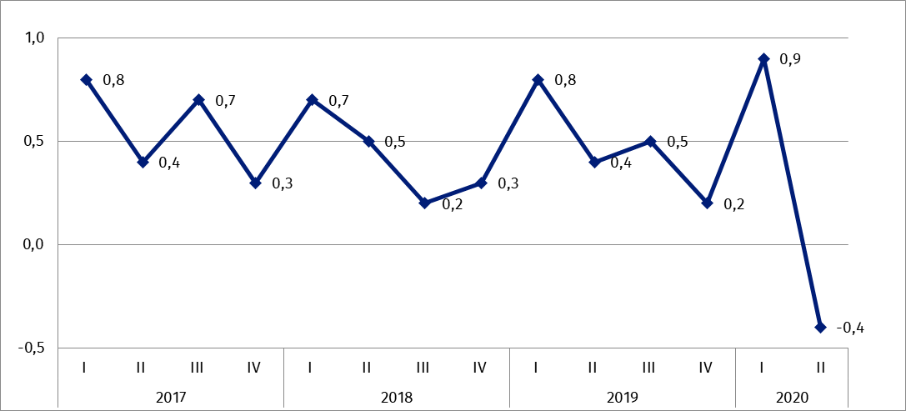
Chart 1. Producer price changes of business services in 2017-2020 (change in % compared with the previous quarter)

Chart 2. Producer price changes of business services in 2017-2020 (change in % compared with the corresponding quarter of the previous year)
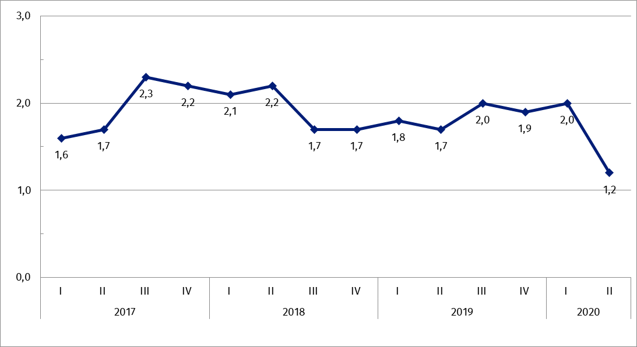

In case of quoting Statistics Poland data, please provide information: “Source of data: Statistics Poland”, and in case of publishing calculations made on data published by Statistics Poland, please include the following disclaimer: “Own study based on figures from Statistics Poland”.

Prepared by:  Trade and Services Department  Director Ewa Adach-Stankiewicz  Office: tel. (+48 22) 608 31 24 | Dissemination:  The Spokesperson for the President  of Statistics Poland  Karolina Banaszek  Mobile: (+48) 695 255 011
Press Office  Office: tel. (+48 22) 608 34 91. 608 38 04  e-mail: obslugaprasowa@stat.gov.pl |  | www.stat.gov.pl/en/
 |  | @StatPoland
 |  | @GlownyUrzadStatystyczny

Related information
News Releases

Prices in the national economy

Data available in databases
Analytical Platform - Knowledge Databases
Prices indices (Topics: Prices, Trade)

Terms used in official statistics
Producer price indices for business services

Related studies
Internal market in 2018

Subject available in databases
Knowledge Databases – Trade and Services
Macroeconomic Data Bank

Important concepts available in the dictionary
Retail sales of goods

