Producer price indices for business services in the third quarter of 2020

In the third quarter of 2020, the producer prices for business services increased by 0.5% compared to the previous quarter, and in comparison to the third quarter of 2019, they increased by 1.2%
0.5%
Increase in producer prices for business services compared to the second quarter of 2020.

Table 1. Producer price indices for business services in the third quarter of 2020
SPECIFICATION | III quarter 2020 |  |  | I-III quarter 2020
SPECIFICATION | III quarter 2019=100 | IV quarter 2019=100 | II quarter 2020=100 | I-III quarter 2019=100
TOTAL | 101,2 | 101,0 | 100,5 | 101,4
Publishing activities | 100,8 | 100,6 | 100,0 | 101,4
Motion picture, video and television programme production, sound recording and music publishing activities | 96,6 | 96,4 | 96,9 | 98,8
Programming and broadcasting activities | 99,6 | 100,9 | 100,0 | 99,6
Computer programming, consultancy and related activities | 101,8 | 101,3 | 100,4 | 101,9
Information service activities | 101,2 | 101,3 | 100,0 | 100,7
Real estate activities | 100,5 | 100,0 | 101,6 | 100,9
Legal and accounting activities; management consultancy activities | 100,7 | 100,8 | 100,8 | 101,0
Architectural and engineering activities; technical testing and analysis | 100,8 | 100,9 | 100,6 | 100,7
Advertising and market research | 102,3 | 100,9 | 100,9 | 101,4
Other professional, scientific and technical activities | 100,6 | 100,9 | 100,1 | 100,4
Rental and leasing activities | 99,0 | 99,0 | 100,3 | 99,3
Employment activities | 102,9 | 102,4 | 100,6 | 103,4
Travel agency, tour operator reservation service and related activities | 97,2 | 99,7 | 97,9 | 100,6
Security and investigation activities | 107,0 | 107,1 | 100,0 | 107,2
Services to buildings and landscape activities | 105,4 | 104,8 | 100,5 | 106,1
Office administrative, office support and other business support activities | 101,4 | 101,3 | 99,9 | 101,7
In the third quarter of 2020, the highest increase of prices was observed in the real estate activities, i.e. by 1.6% compared to the previous quarter. The increase in the prices of real estate activities in the third quarter was caused mainly by the return to previous rental prices for tenants of buildings and premises used for retail and service purposes after the period of rent reductions in the second quarter due to the COVID-19 pandemic.
In the third quarter of 2020, the highest increase of prices was observed in the real estate activities
There was also a significant increase in the prices of advertising and market research (by 0.9%) as well as of legal and accounting activities; management consultancy activities (by 0.8%). Higher prices obtained by companies providing advertising and market research resulted from the return to higher prices applied by advertising agencies after a period of reduced demand for advertising services during the greatest restrictions related to the pandemic, while in legal and accounting activities, management consultancy activities they resulted, among other things, from the increase in the costs of wages and salaries recorded in some of the entities conducting these activities.
The biggest drop of prices compared to the previous quarter was observed in motion picture, video and television programme production, sound recording and music publishing activities (by 3.1%), which cover motion picture, video and programme production services, their distribution, as well as post-production services, film projection or also sound recording and music publishing services. The main reason for the fall in prices of services in this activity was due to the drop in prices of services related to the distribution of cinema films and motion picture projection activities, which was influenced by the prevailing Covid-19 pandemic.
The prices of travel agency, tour operator reservation service and related activities have fallen to a slightly lesser extent (by 2.1%). This decline was influenced by the pandemic and the price reductions and promotions applied after the resumption of the organisation of tourist events in the third quarter.

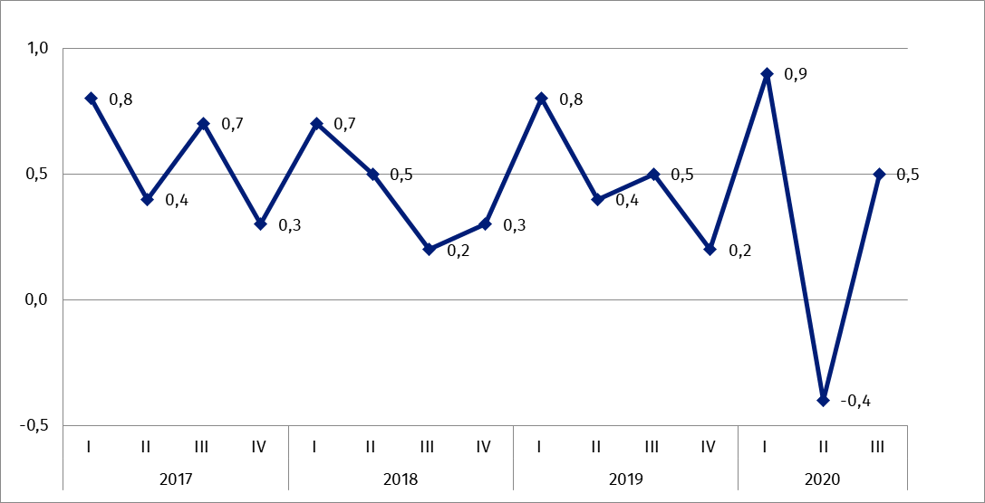
Chart 1. Producer price changes of business services in 2017-2020 (change in % compared with the previous quarter)
Chart 2. Producer price changes of business services in 2017-2020 (change in % compared with the corresponding quarter of the previous year)
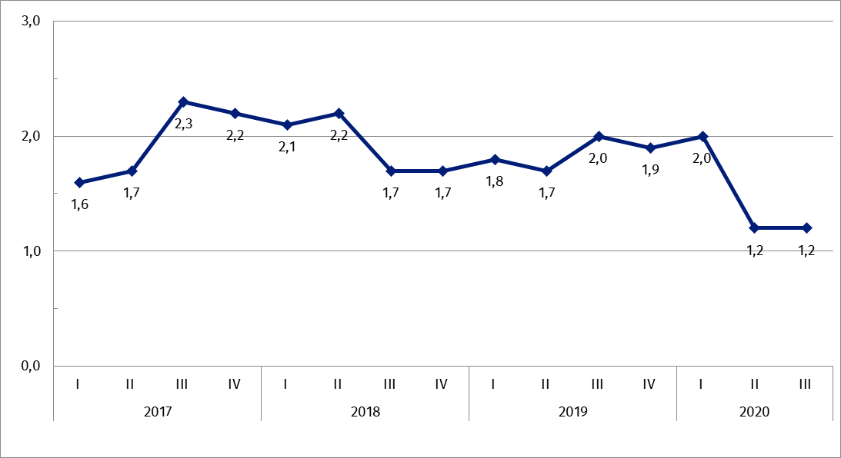

In case of quoting Statistics Poland data, please provide information: “Source of data: Statistics Poland”, and in case of publishing calculations made on data published by Statistics Poland, please include the following disclaimer: “Own study based on figures from Statistics Poland”.

Prepared by:  Trade and Services Department  Director Ewa Adach-Stankiewicz  Office: tel. (+48 22) 608 31 24 | Dissemination:  The Spokesperson for the President  of Statistics Poland  Karolina Banaszek  Mobile: (+48) 695 255 011
Press Office  Office: tel. (+48 22) 608 34 91. 608 38 04  e-mail: obslugaprasowa@stat.gov.pl |  | www.stat.gov.pl/en/
 |  | @StatPoland
 |  | @GlownyUrzadStatystyczny

Related information
News Releases

Prices in the national economy

Data available in databases
Analytical Platform - Knowledge Databases
Prices indices (Topics: Prices, Trade)

Terms used in official statistics
Producer price indices for business services

Related studies
Internal market in 2018

Subject available in databases
Knowledge Databases – Trade and Services
Macroeconomic Data Bank

Important concepts available in the dictionary
Retail sales of goods

