Accidents at work in January-September 2020
-preliminary data
40,140 persons injured in accidents at work were reported in January-September 2020, by 24.1% fewer than in the same period of 2019. The number of injured persons per 1,000 employed persons (the incidence rate) also decreased from 3.91 to 2.96 respectively.
2.96
Incidence rate
in January-September 2020

Persons injured in accidents at work and the incidence rate decreased compared to the previous year
Fatal accident victims accounted for 0.2% of all persons injured (like in January-September 2019). However, both the number of persons injured in serious accidents and in accidents with other effects decreased (by 6.7% and 24.2% respectively).
The highest incidence rates were recorded for Dolnośląskie (3.45), Warmińsko-Mazurskie (3.39), Opolskie and Śląskie (by 3.38 each) Voivodships, the lowest for Mazowieckie (1.88), Małopolskie (2.14) and Podkarpackie (2.15).
Map 1. Persons injured in accidents at work per 1,000 employed persons ª
in January-September 2020 (excluding private farms in agriculture)
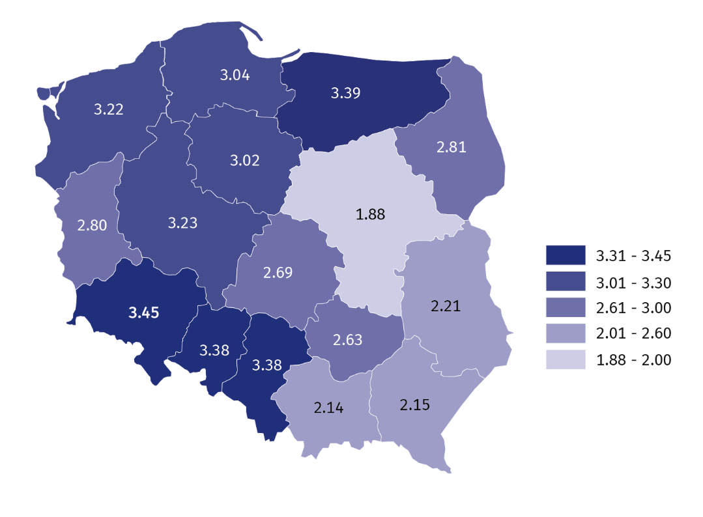
The highest incidence rate was recorded for Dolnośląskie Voivodship, whereas the lowest for Mazowieckie
a Preliminary data on the number of employees were used to calculate the incidence rate; in breakdown by voivodships, civilian employees of budgetary entities conducting activity within the scope of national defence and public safety were excluded.

In the breakdown by type of economic activity, the highest incidence rate was recorded in the sections: mining and quarrying (8.88), water supply; sewerage, waste management
and remediation activities (7.84), human health and social work activities (5.08), while
the lowest in the sections: information and communication (0.50) and financial and insurance activities (0.66).
Chart 1. Persons injured in accidents at work per 1,000 employed persons by PKD sections
in January-September 2020 (excluding private farms in agriculture)
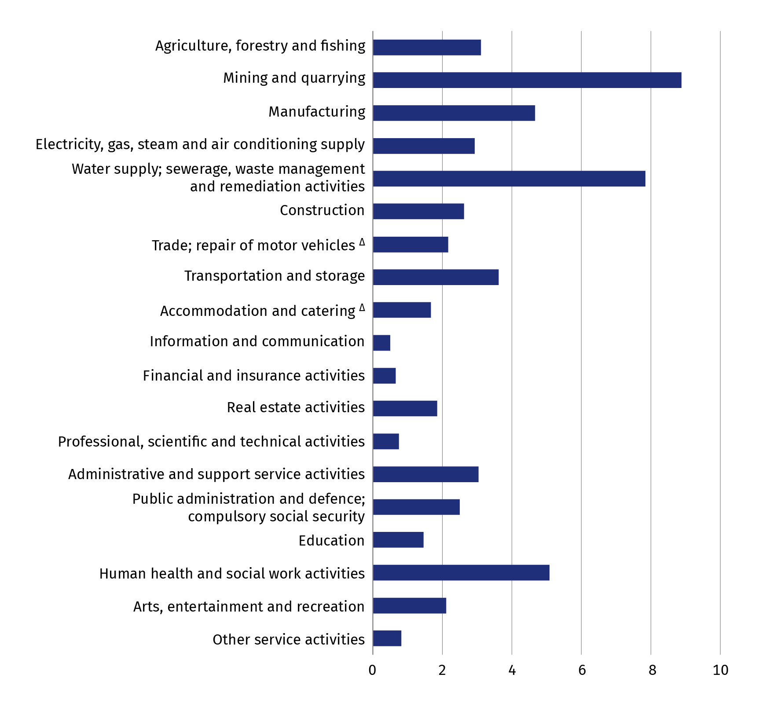
The highest incidence rate was recorded in the section mining and quarrying,
the lowest in the section information and communication
Chart 2. Persons injured in accidents at work by contact-modes of injuries
in January-September 2020
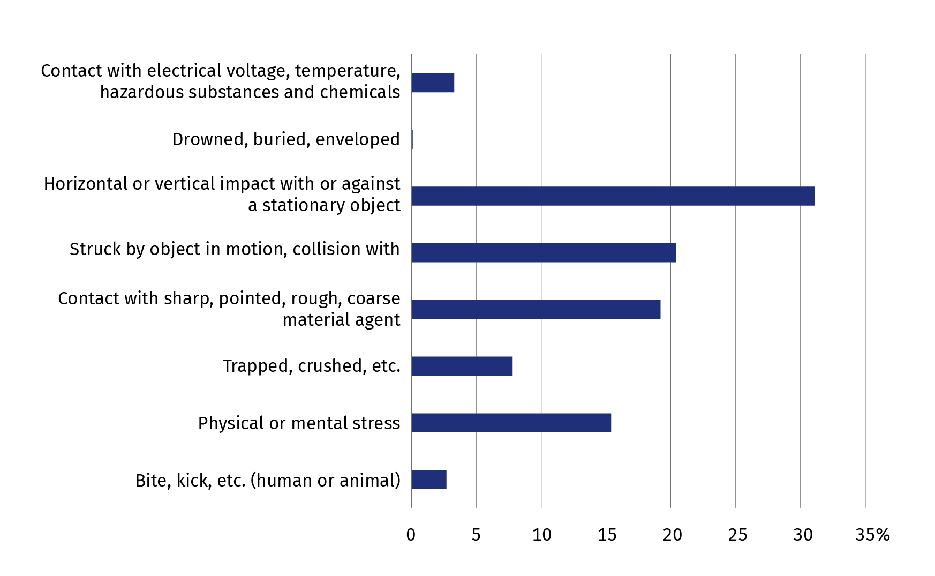
Horizontal or vertical impact with or against a stationary object (31.1%) was the prevalent group of contact-
-modes of injuries

Chart 3. Causes of accidents at work in January-September 2020
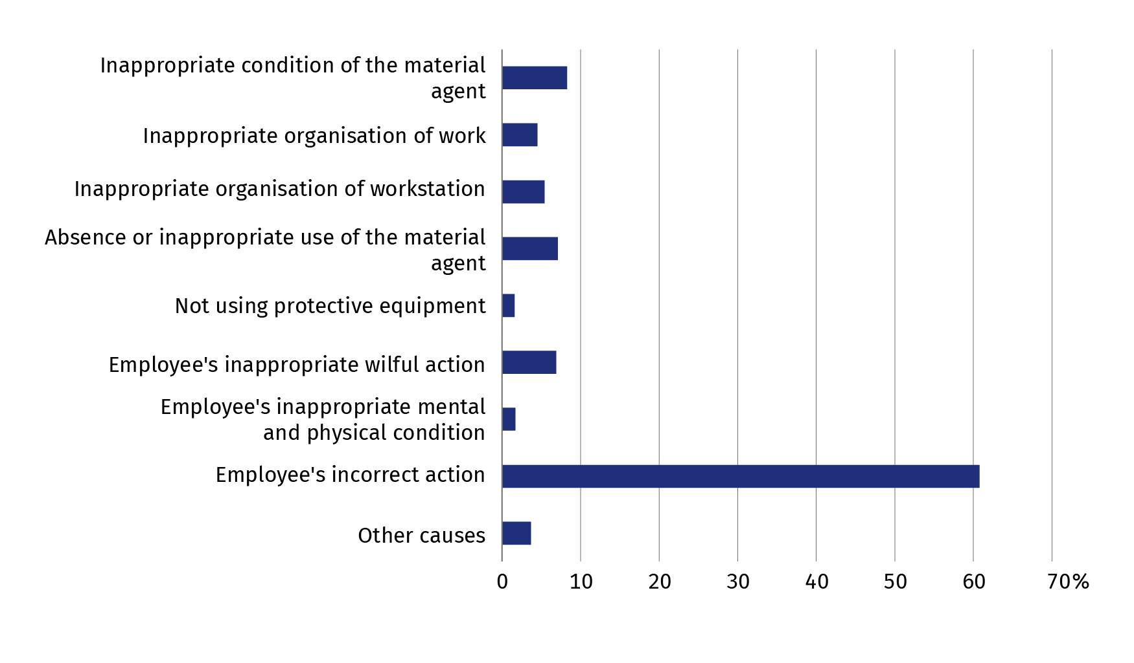
Employee's incorrect action was the cause of 60.8% of the accidents at work
Chart 4. Persons injured in accidents at work by specific physical activities performed by the victim at the time of the accident in January-September 2020
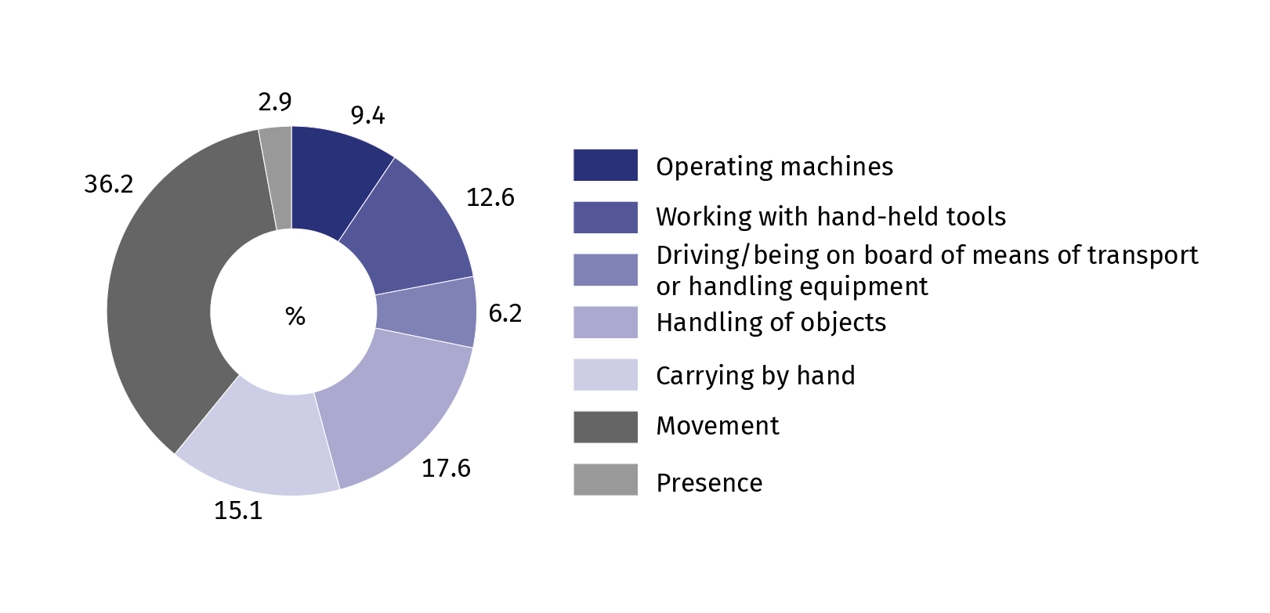
Movement was the most frequent specific physical activity performed by the victim at the time of the accident (36.2%)
Chart 5. Persons injured in accidents at work in January-September 2020 by part of body injured
79.6% of the persons injured in accidents at work sustained an extremity injury
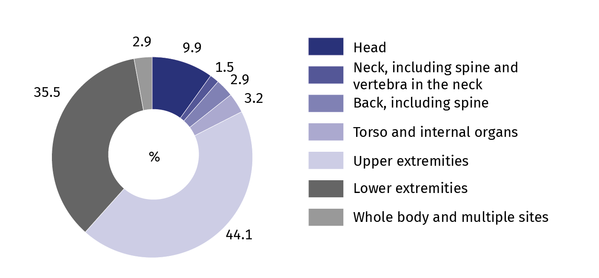

TABLE ANNEX
Table 1. Persons injured in accidents at work ¹ by sections and selected divisions of PKD in January-September 2020
SPECIFICATION  a – total  b – per 1,000 employed persons ² |  | Total | In accidents |  |  | Of total number  - women | Days lost
 |  | Total | fatal | serious | with other effect | Of total number  - women | total | per 1 person injured ³
TOTAL | a | 40140 | 99 | 236 | 39805 | 14865 | 1389725 | 34.7
TOTAL | b | 2.96 | 0.01 | 0.02 | 2.93 | • | 102.38 | •
Agriculture, forestry and fishing | a | 560 | 5 | 8 | 547 | 101 | 22637 | 40.8
Agriculture, forestry and fishing | b | 3.11 | 0.03 | 0.04 | 3.04 | • | 125.59 | •
of which crop and animal production, hunting, including service activities⁴ | a | 340 | 2 | 6 | 332 | 80 | 14357 | 42.5
Mining and quarrying | a | 1348 | 7 | 10 | 1331 | 18 | 81830 | 61.0
Mining and quarrying | b | 8.88 | 0.05 | 0.07 | 8.76 | • | 539.08 | •
of which mining of hard coal | a | 924 | 4 | 5 | 915 | 5 | 59206 | 64.3
Manufacturing | a | 13461 | 21 | 113 | 13327 | 3095 | 478984 | 35.6
Manufacturing | b | 4.67 | 0.01 | 0.04 | 4.62 | • | 166.28 | •
Electricity, gas, steam and air conditioning supply | a | 328 | 2 | 2 | 324 | 24 | 13074 | 40.1
Electricity, gas, steam and air conditioning supply | b | 2.93 | 0.02 | 0.02 | 2.89 | • | 116.60 | •
Water supply; sewerage, waste management and remediation activities | a | 1302 | 5 | 9 | 1288 | 100 | 46278 | 35.7
 | b | 7.84 | 0.03 | 0.05 | 7.76 | • | 278.64 | •
Construction | a | 2370 | 24 | 34 | 2312 | 53 | 99429 | 42.4
Construction | b | 2.62 | 0.03 | 0.04 | 2.55 | • | 109.78 | •
Trade; repair of motor vehicles ∆ | a | 5309 | 7 | 16 | 5286 | 2737 | 159732 | 30.1
Trade; repair of motor vehicles ∆ | b | 2.17 | 0.00 | 0.01 | 2.16 | • | 65.28 | •
Transportation and storage | a | 3350 | 18 | 9 | 3323 | 929 | 121330 | 36.4
Transportation and storage | b | 3.62 | 0.02 | 0.01 | 3.59 | • | 131.02 | •
Accommodation and catering ∆ | a | 499 | - | 1 | 498 | 298 | 16302 | 32.7
Accommodation and catering ∆ | b | 1.67 | • | 0.00 | 1.67 | • | 54.62 | •
Information and communication | a | 186 | 2 | 2 | 182 | 58 | 4902 | 26.6
Information and communication | b | 0.50 | 0.01 | 0.01 | 0.48 | • | 13.11 | •
Financial and insurance activities | a | 246 | - | - | 246 | 190 | 7019 | 28.5
Financial and insurance activities | b | 0.66 | • | • | 0.66 | • | 18.89 | •
Real estate activities | a | 384 | 1 | 1 | 382 | 167 | 13349 | 34.8
Real estate activities | b | 1.85 | 0.00 | 0.00 | 1.85 | • | 64.43 | •
Professional, scientific and technical activities | a | 523 | - | 3 | 520 | 247 | 13673 | 26.1
Professional, scientific and technical activities | b | 0.75 | • | 0.00 | 0.75 | • | 19.69 | •
1 Reported in a given period; excluding accidents on private farms in agriculture.
2 To calculate the incidence rate (verse b), preliminary data on the number of employed persons were used.
3 Excluding persons injured in fatal accidents and the number of days of their incapacity for work.
4 Excluding the group "Hunting, trapping and related service activities".

Table 1. Persons injured in accidents at work ¹ by sections and selected divisions of PKD in January-September 2020 (cont.)
SPECIFICATION  a – total  b – per 1,000 employed persons ² |  | Total | In accidents |  |  | Of total number  - women | Days lost
 |  | Total | fatal | serious | with other effect | Of total number  - women | total | per 1 person injured ³
Administrative and support service activities | a | 1709 | 4 | 8 | 1697 | 694 | 53519 | 31.4
Administrative and support service activities | b | 3.04 | 0.01 | 0.01 | 3.02 | • | 95.18 | •
Public administration and defence; compulsory social security | a | 1666 | 2 | 5 | 1659 | 908 | 54470 | 32.7
 | b | 2.50 | 0.00 | 0.01 | 2.49 | • | 81.75 | •
Education | a | 1755 | 1 | 5 | 1749 | 1352 | 60133 | 34.3
Education | b | 1.46 | 0.00 | 0.00 | 1.46 | • | 49.94 | •
Human health and social work activities | a | 4572 | - | 7 | 4565 | 3598 | 123924 | 27.1
Human health and social work activities | b | 5.08 | • | 0.01 | 5.07 | • | 137.61 | •
Art. entertainment and recreation | a | 335 | - | 1 | 334 | 169 | 10670 | 31.9
Art. entertainment and recreation | b | 2.11 | • | 0.01 | 2.10 | • | 67.10 | •
Other service activities | a | 237 | - | 2 | 235 | 127 | 8470 | 35.7
Other service activities | b | 0.82 | • | 0.01 | 0.81 | • | 29.25 | •
1 Reported in a given period; excluding accidents on private farms in agriculture.
2 To calculate the incidence rate (verse b), preliminary data on the number of employed persons were used.
3 Excluding persons injured in fatal accidents and the number of days of their incapacity for work.
Table 2. Persons injured in accidents at work ¹ by voivodships in January-September 2020
SPECIFICATION  a – total  b – per 1,000 employed persons ² |  | Total | In accidents |  |  | Of total number  - women | Days lost
 |  | Total | fatal | serious | with other effect | Of total number  - women | total | per 1 person injured ³
POLAND | a | 40140 | 99 | 236 | 39805 | 14865 | 1389725 | 34.7
POLAND | b | 2.96 | 0.01 | 0.02 | 2.93 | • | 102.38 | •
Dolnośląskie | a | 3874 | 14 | 16 | 3844 | 1493 | 133834 | 34.7
Dolnośląskie | b | 3.45 | 0.01 | 0.01 | 3.43 | • | 119.18 | •
Kujawsko-Pomorskie | a | 2139 | 5 | 17 | 2117 | 753 | 69714 | 32.7
Kujawsko-Pomorskie | b | 3.02 | 0.01 | 0.02 | 2.99 | • | 98.52 | •
Lubelskie | a | 1571 | 1 | 8 | 1562 | 618 | 68517 | 43.6
Lubelskie | b | 2.21 | 0.00 | 0.01 | 2.20 | • | 96.46 | •
Lubuskie | a | 972 | 1 | 10 | 961 | 353 | 31903 | 32.9
Lubuskie | b | 2.80 | 0.00 | 0.03 | 2.77 | • | 92.00 | •
Łódzkie | a | 2541 | 8 | 14 | 2519 | 1017 | 89216 | 35.2
Łódzkie | b | 2.69 | 0.01 | 0.01 | 2.67 | • | 94.36 | •
Małopolskie | a | 2841 | 8 | 20 | 2813 | 1167 | 95371 | 33.6
Małopolskie | b | 2.14 | 0.01 | 0.02 | 2.11 | • | 71.79 | •
Mazowieckie | a | 4771 | 13 | 25 | 4733 | 1927 | 159948 | 33.6
Mazowieckie | b | 1.88 | 0.01 | 0.01 | 1.86 | • | 62.92 | •
Opolskie | a | 1082 | 3 | 11 | 1068 | 333 | 36539 | 33.9
Opolskie | b | 3.38 | 0.01 | 0.03 | 3.34 | • | 114.20 | •
1 Reported in a given period; excluding accidents on private farms in agriculture.
2 To calculate the incidence rate (verse b) preliminary data on the number of employed persons were used; in breakdown by voivodships, civilian employees of budgetary entities conducting activity within the scope of national defence and public safety were excluded.
3 Excluding persons injured in fatal accidents and the number of days of their incapacity for work.
Table 2. Persons injured in accidents at work ¹ by voivodships in January-September 2020 (cont.)
SPECIFICATION  a – total  b – per 1,000 employed persons ² |  | Total | In accidents |  |  | Of total number  - women | Days lost
 |  | Total | fatal | serious | with other effect | Of total number  - women | total | per 1 person injured ³
Podkarpackie | a | 1606 | 3 | 11 | 1592 | 616 | 59114 | 36.9
Podkarpackie | b | 2.15 | 0.00 | 0.01 | 2.14 | • | 79.08 | •
Podlaskie | a | 1078 | 4 | 5 | 1069 | 357 | 40065 | 37.3
Podlaskie | b | 2.81 | 0.01 | 0.01 | 2.79 | • | 104.38 | •
Pomorskie | a | 2643 | 3 | 18 | 2622 | 994 | 90088 | 34.1
Pomorskie | b | 3.04 | 0.00 | 0.02 | 3.02 | • | 103.61 | •
Śląskie | a | 5868 | 13 | 27 | 5828 | 1817 | 219931 | 37.6
Śląskie | b | 3.38 | 0.01 | 0.02 | 3.35 | • | 126.65 | •
Świętokrzyskie | a | 1092 | 3 | 8 | 1081 | 453 | 40700 | 37.4
Świętokrzyskie | b | 2.63 | 0.01 | 0.02 | 2.60 | • | 97.88 | •
Warmińsko-Mazurskie | a | 1460 | 2 | 10 | 1448 | 555 | 49720 | 34.1
Warmińsko-Mazurskie | b | 3.39 | 0.00 | 0.02 | 3.37 | • | 115.31 | •
Wielkopolskie | a | 4799 | 13 | 26 | 4760 | 1718 | 150917 | 31.5
Wielkopolskie | b | 3.23 | 0.01 | 0.02 | 3.20 | • | 101.62 | •
Zachodniopomorskie | a | 1803 | 5 | 10 | 1788 | 694 | 54148 | 30.1
Zachodniopomorskie | b | 3.22 | 0.01 | 0.02 | 3.19 | • | 96.76 | •
1 Reported in a given period; excluding accidents on private farms in agriculture.
2 To calculate the incidence rate (verse b) preliminary data on the number of employed persons were used; in breakdown by voivodships, civilian employees of budgetary entities conducting activity within the scope of national defence and public safety were excluded.
3 Excluding persons injured in fatal accidents and the number of days of their incapacity for work.

Table 3. Persons injured in accidents at work ª on private farms in agriculture by contact-modes of injuries
in January-September 2020
SPECIFICATION | Total | Fall of |  | Persons run over, hit or caught by a moving means of transport | Persons caught or hit by moving parts of machinery and equip-ment | Persons hit. crushed or bitten by animals | Impact of |  | Other
SPECIFICATION | Total | persons | objects |  |  | Persons hit. crushed or bitten by animals | extreme temper-atures | harmful materials | Other
TOTAL | 6547 | 3114 | 358 | 107 | 761 | 803 | 37 | 8 | 1359
Of which fatal accidents | 24 | 2 | 5 | 5 | 4 | 2 | - | - | 6
a Concerns accidents for which one-off compensations were granted.
Source: data of the Agricultural Social Insurance Fund.

Mark (Δ) means that the names have been shortened in relation to the current classification. Their full names are available on the Statistics Poland website at: https://stat.gov.pl/en/metainformations/classifications/#Polish Classification of Activities (PKD)
Mark (-) magnitude zero
(0.00) magnitude not zero. but less than 0.005 of a unit
Mark (.) data not available, classified data (statistical confidentiality) or providing data impossible or purposeless
„Of which” indicates that not all elements of the sum are given

When citing data from the Statistics Poland please provide the following information: "Statistics Poland`s data". When publishing calculations made on data published by the Statistics Poland, provide the following information: "Own study based on the Statistics Poland's data".

METHODOLOGICAL NOTES
The publication includes information on accidents at work of persons employed in the entire national economy excluding budgetary entities conducting activity within the scope of the national defence and public safety for which information on accidents at work concerns only civilian employees.
Data regarding accidents at work, excluding private farms in agriculture, are obtained from “Statistical accident report” Z-KW and cover all accidents at work, as well as accidents considered equivalent to accidents at work, regardless whether incapacity for work was reported (due to hospitalisation of an injured person, or rejection of a sick leave, etc.).
Data on accidents at work on private farms in agriculture were compiled on the basis of reports of the Agricultural Social Insurance Fund (ASIF) and are related only to the accidents for which one-off compensations were granted in a given period.
Each accident, regardless whether the victim was injured during a single or multiple casualty incident, is counted as one accident at work.
Incidence rate is the number of persons injured per 1,000 persons employed. To calculate the ratio, the average number of working persons was assumed, expressed as an arithmetic mean for two states (as of 31 December of the previous year and 30 September of the current year).
Information on days lost includes the total number of calendar days of incapacity for work due to work-related accidents, estimated on the basis of sick leaves.
Pursuant to art. 3 of the Act of 30 October 2002, on Social Insurance in respect of Accidents at Work and Occupational Diseases (uniform text Journal of Laws of 2019, item 1205):
Accident at work is understood as a sudden incident, caused by external reason, leading to injury or death which occurred in connection with work:
- during or in connection with performance of ordinary activities or instructions by the employee and activities for the employers, even without instructions;
- when the employee remains at the disposal of the employer on the way between the seat of the employer and the place of performing the obligation arising from the employment relationship.
Every accident is treated equally to an accident at work, as regards entitlement to benefits defined in the law on social insurance against accidents at work and occupational diseases, if the employee had such an accident: during a business trip; during training within the scope of the national self-defence; when performing tasks ordered by trade union organisations operating at the employer’s.
Accident at work is also understood as a sudden incident, causing injury or death, which happened within the term of accident insurance in the course of: practising sports during competitions and training by a person receiving sport scholarship; performance of paid work while serving the sentence of imprisonment or temporary detentions; exercising the mandate of a Deputy or Senator who receive salaries; serving a mandate of the European Parliament member elected in the Republic of Poland; doing – on the basis of appointment issued by powiat labour office or other supervising entity – training or internship connected with a scholarship received by school leavers; performance of work by members of agricultural producers’ cooperatives, farmers’ cooperatives and by other persons treated equally to members of cooperative, for the benefit of these cooperatives; performance or cooperation in performance of work on the basis of agency agreements, contracts of mandate or contracts of services; performance of usual activities related to running, or cooperation in running, a non-agricultural economic activity; performance of religious activities or activities connected with entrusted pastoral or monastic functions by clergymen; serving supplementary forms of military service; education of students receiving scholarship at the National School of Public Administration.
Fatal accident at work is an accident which leads to the death of a victim at the site of the accident or within 6 months of the accident.
Serious accident at work is an accident which results in serious bodily harm, i.e. loss of sight, hearing, speech, ability to procreate, other bodily harm or health-related problems, which disrupts primary bodily functions or results in an incurable and life-threatening disease, permanent mental illness, a permanent, total or significant incapacity for work in the occupation, or a permanent significant disfigurement or distortion of the body.
The methodology of the survey on accidents at work is explained in more detail in the annual publication titled "Accidents at work", available on the website of Statistics Poland at: https://stat.gov.pl/en/topics/labour-market/working-conditions-accidents-at-work/accidents-at-work-in-2019,3,13.html
The data presented in this release are preliminary. The final data covering the year 2020 will be available in
a publication coming out in November 2021.

Prepared by:  Statistical Office in Gdańsk  Director Jerzy Auksztol  Office: phone (+48 58) 76 83 130 | Issued by :  The Spokesperson for the President  of Statistics Poland  Karolina Banaszek  Mobile: (+48) 695 255 011
Press Office  Office: phone (+48 22) 608 34 91. 608 38 04  e-mail: obslugaprasowa@stat.gov.pl |  | www.stat.gov.pl/en/
 |  | @StatPoland
 |  | @GlownyUrzadStatystyczny

Related information
Accidents at work in 2019
Accidents at work in the first half of 2020 – preliminary data
Other studies regarding working conditions

Data available in databases
Local Data Bank -> Labour Market -> Worknig Conditions

