Therapeutic activities of health resort facilities and inpatient rehabilitation facilities in 2019

At the end of 2019, there were operating 271 health resort facilities. 858.0 thousand patients were admitted to health resort facilities during a year, of which 782.1 thousand were inpatients. 73.9 thousand inpatients were treated in 34 inpatient rehabilitation facilities.
2.3%
Increase in the number of patients in health resort facilities compared to 2018

Health resort facilities
782.1 thousand inpatients and 75.9 thousand outpatients were treated in health resort facilities
At the end of 2019, there were operating 49 health resort hospitals (of which 6 for children), 192 health resort sanatoria (of which 3 health resort sanatoria for children and 1 sanatoria in underground mining excavations), 10 outpatient health resort units and 20 natural healing centres which conduct their treatment in health resort complexes.
At the end of the year there were 45.3 thousand health resort beds in health resort hospitals and sanatoria (the increase by 1.1% compared to the previous year). 782.1 thousand inpatients were treated during the year (by 2.9% more in relation to 2018). Women accounted for 60.8% of the total inpatients being treated, while people aged 65 years and more – 48.9%. Average stay of inpatients was 16.1 days.
The most inpatients were treated in health resort facilities in Zachodniopomorskie Voivodship (192.8 thousand persons) followed by Kujawsko-Pomorskie (152.7 thousand) and Dolnośląskie (104.2 thousand). In total, over 57% of inpatients were admitted in these three voivodships.
At the national level the share of foreigners in inpatients was more than 6%. The vast majority of foreigners (almost 91%) were admitted to health resort facilities in two voivodships: Zachodniopomorskie and Dolnośląskie.

Table 1. Activities of health resort facilities in 2019

SPECIFICATION | Health resort hospitals | Health resort sanatoria | Outpatient health resort units | Natural healing centres
Health resort facilities  (as of 31st December) | 49 | 192 | 10 | 20
Beds in thousands  (as of 31st December) | 9.0 | 36.4 | – | –
Inpatients in thousands | 134.7 | 647.4 | – | –
Average stay of inpatients (in days) | 19.1 | 15.5 | – | –
Outpatients in thousands | 7.8 | 25.5 | 23.1 | 19.4

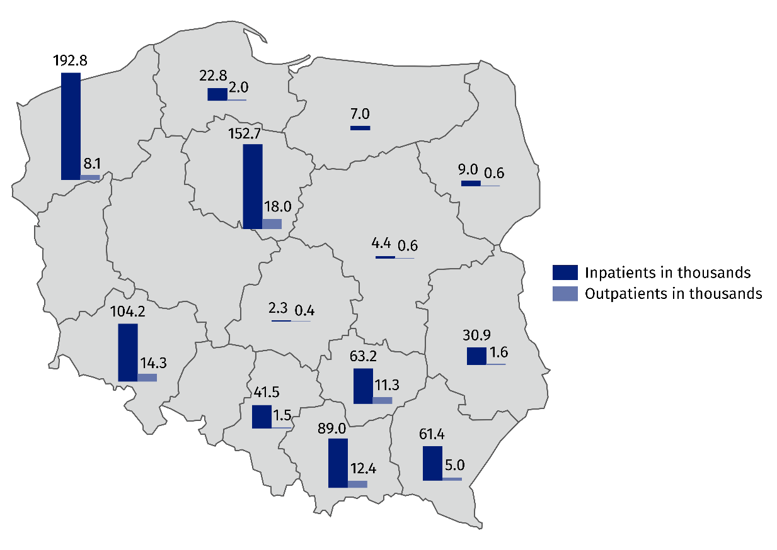
Map 1. Inpatients and outpatients treated in health resort facilities by voivodships in 2019

In 2019, more than half of inpatients were subsidized by National Health Fund (by 1.7 pp less than in 2018). However, self-pay inpatients were more than 38% of inpatients (by 1.9 pp more than in the previous year).

Chart 1. The structure of inpatients treated in health resort facilities by type of financing in 2019

In 2019, 75.9 thousand outpatients were treated in health resort facilities (by 3.5% less than in the previous year). More than half of patients were admitted to outpatient health resort units and natural healing centres.
In 2019, 38.3 million medical services were provided in health resort facilities (by 3.3% more than in 2018 ). As in the previous year, most medical services belonged to natural healing services (26.1%), among which peat treatments (10.7%) and mineral baths (7.8%) predominated. Kinesiotherapy (21.3%), electrotherapy (12.6%) and massage (10.0%) were also popular.
38.3 million medical services were provided in health resort facilities
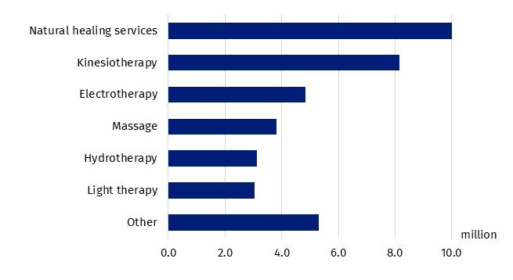
Chart 2. Medical services provided in health resort facilities in 2019

Inpatient rehabilitation facilities
At the end of 2019, 334 inpatient rehabilitation facilities were operating which possessed 3.77 thousand health resort beds. During the year 73.9 thousand patients were admitted (by 4.4% more than in the previous year), of whom 62.9 thousand inpatients and 11.1 thousand outpatients.
73.9 thousand patients were treated in inpatient rehabilitation facilities
Women accounted for 55.0% of the total inpatients being treated, while people aged 65 years and more – 36.4%. Average stay of inpatients was almost 14 days.
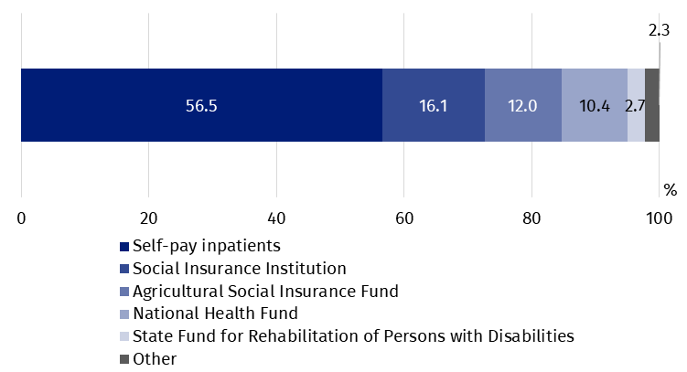
Chart 3. The structure of inpatients treated in inpatient rehabilitation facilities by type of financing in 2019

In inpatient rehabilitation facilities, most inpatients treated belonged to self-pay inpatients – 35.5 thousand persons. Of institutions subsidized inpatients, the Social Insurance Institution subsidized 10.1 thousand inpatients, the Agricultural Social Insurance Fund – 7.5 thousand and the National Health Fund – 6.5 thousand persons.
2.7 million medical services were provided in inpatient rehabilitation facilities during 2019, most of them belonged to kinesiotherapy (38.8%).

In the case of quoting data from the Statistics Poland, please provide information: "Statistics Poland data source", and in the case of publishing calculations made on data published by the Statistics Poland, please provide information: "Own study based on Statistics Poland data".

Prepared by:  Statistical Office in Kraków  Director Agnieszka Szlubowska  Office: tel. (+48 12) 420 40 50 | Issued by:  The Spokeperson for the President  of Statistics Poland  Karolina Banaszek  Mobile: (+48) 695 255 011

Press Office  Office: tel. (+48 22) 608 34 91, 608 38 04  e-mail: obslugaprasowa@stat.gov.pl |  | www.stat.gov.pl/en/
 |  | @StatPoland
 |  | @GlownyUrzadStatystyczny

Related information
Health and health care in 2018
Methodological report. Health and health care statistics − Statistics Poland’s reports

Data available in databases
Local Data Bank -> Health care, social welfare and benefits to the family
Knowladge Databases ->Health and Health care

Terms used in official statistics
Patient in health resort
Health resort treatment
Health resort facility

Medical services provided in natural healing centres operating as a functional unit of the health resort hospital, sanatorium or outpatient health resort unit, are counted together with the main unit.
There were active both within and outside health resort gminas.

