Producer price indices for business services in the fourth quarter of 2020

In the fourth quarter of 2020, prices of the providers of business-related services increased by 0.1% compared to
the previous quarter. Compared to the fourth quarter of 2019, the prices increased by 1.1%.
0.1%
Increase in producer prices for business services compared to the third quarter of 2020.

Table 1. Producer price indices for business services in the fourth quarter of 2020
SPECIFICATION | IV quarter 2020 |  | I -IV quarter 2020
SPECIFICATION | IV quarter 2019=100 | III quarter 2020=100 | I-IV quarter 2019=100
TOTAL | 101,1 | 100,1 | 101,3
Publishing activities | 101,7 | 101,1 | 101,5
Motion picture, video and television programme production, sound recording and music publishing activities | 97,5 | 101,1 | 98,5
Programming and broadcasting activities | 102,0 | 101,1 | 100,2
Computer programming, consultancy and related activities | 101,8 | 100,5 | 101,9
Information service activities | 101,3 | 100,0 | 100,8
Real estate activities | 100,3 | 100,3 | 100,8
Legal and accounting activities; management consultancy activities | 101,1 | 100,3 | 101,0
Architectural and engineering activities; technical testing and analysis | 100,9 | 100,0 | 100,8
Advertising and market research | 102,4 | 101,5 | 101,6
Other professional, scientific and technical activities | 100,7 | 99,8 | 100,5
Rental and leasing activities | 99,4 | 100,4 | 99,3
Employment activities | 103,0 | 100,6 | 103,3
Travel agency, tour operator reservation service and related activities | 91,7 | 92,0 | 98,4
Security and investigation activities | 107,2 | 100,2 | 107,3
Services to buildings and landscape activities | 105,2 | 100,5 | 105,9
Office administrative, office support and other business support activities | 101,0 | 99,7 | 101,6
In the fourth quarter of 2020, the highest increase of prices was observed in the advertising and market research – i.e. by 1.5% compared to the previous quarter. The increase in the prices of advertising and market research services in the fourth quarter was mainly caused by higher prices of media representation services (one of the components of advertising services), including in particular intermediation in the sale of radio and television advertising time or space. That, in turn, was influenced by the Christmas period that is a favourable period of time for the advertising market.
The prices of publishing activities, motion picture, video and television programme production, sound recording and music publishing activities as well as programming and broadcasting activities increased more than 1% (by 1.1%). The higher prices obtained by companies providing publishing activities were the result of i.a. a rise in the cost of publishing printednewspapers, journals and periodicals (an increase in the cost of paper). In the motion picture, video and television programme production, sound recording and music publishing activities, there was an increase in prices of services concerning motion picture, video and television programme post-production activities and distribution activities, which are components of that activities (the prices increase concerning the distribution of motion pictures). The rise in prices of programming and broadcasting activities was primarily related to the increase in the sales prices of television advertising time or space.
In the fourth quarter of 2020, the highest increase of prices was observed in the advertising and market research – i.e. by 1.5% compared to the previous quarter
A significant price decrease compared to the previous quarter was observed in the travel agency, tour operator reservation service and related activities (by 8.0%), while the biggest drop of prices was observed in the services of tour operators. The decline in demand for tourism services was due to both seasonal factors and the still ongoing Covid-19 pandemic.
Minor price declines in the fourth quarter compared to the third quarter concerned office administrative, office support and other business support activities (by 0.3%), as well as services in the field of other professional, scientific and technical activities (by 0.2%).
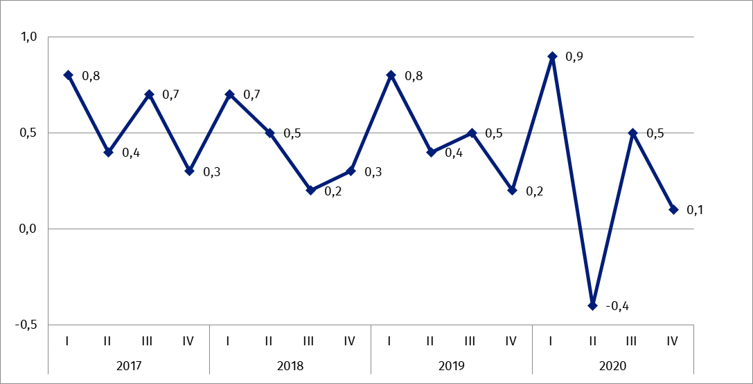
Chart 1. Producer price changes of business services in 2017-2020 (change in % compared with the previous quarter)

Chart 2. Producer price changes of business services in 2017-2020 (change in % compared with the corresponding quarter of the previous year)
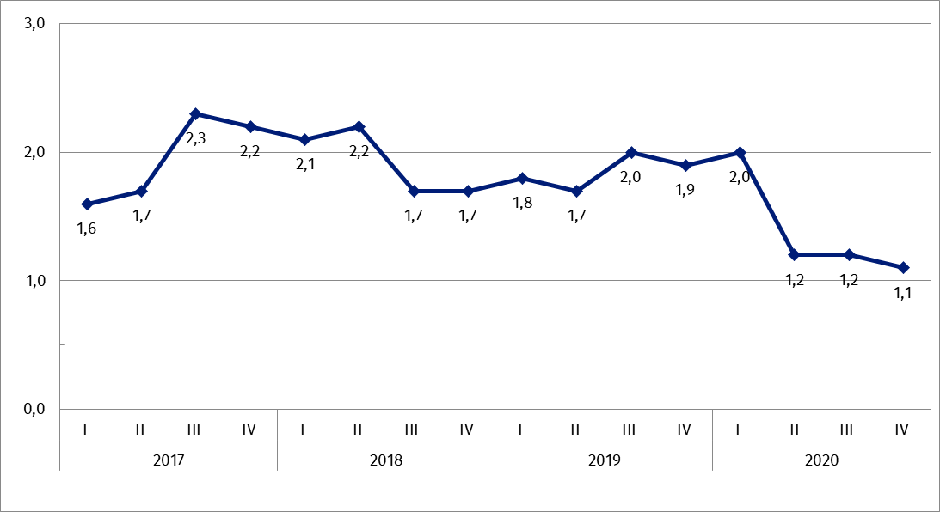

In case of quoting Statistics Poland data, please provide information: “Source of data: Statistics Poland”, and in case of publishing calculations made on data published by Statistics Poland, please include the following disclaimer: “Own study based on figures from Statistics Poland”.

Prepared by:  Trade and Services Department  Director Ewa Adach-Stankiewicz  Office: tel. (+48 22) 608 31 24 | Dissemination:  The Spokesperson for the President  of Statistics Poland  Karolina Banaszek  Mobile: (+48) 695 255 011
Press Office  Office: tel. (+48 22) 608 34 91. 608 38 04  e-mail: obslugaprasowa@stat.gov.pl |  | www.stat.gov.pl/en/
 |  | @StatPoland
 |  | @GlownyUrzadStatystyczny

Related information
News Releases

Prices in the national economy

Data available in databases
Analytical Platform - Knowledge Databases
Prices indices (Topics: Prices, Trade)

Terms used in official statistics
Producer price indices for business services

Related studies
Internal market in 2018

Subject available in databases
Knowledge Databases – Trade and Services
Macroeconomic Data Bank

Important concepts available in the dictionary
Retail sales of goods

