Registrations and bankruptcies of enterprises in the first quarter of 2021
13.05.2021
NEWS RELEASES

In the first quarter of 2021, there were 84 223 registrations of enterprises recorded i.e. 0.1% more than in the corresponding period of previous year and 126 enterprises declared bankruptcy i.e. 11.3% less than in the corresponding period of previous year.
0.1%
Increase in the number of registrations of enterprises in the first quarter of 2021 compared to the corresponding period of previous year

Registrations of enterprises
The highest increase in the number of registrations (by 39.1%) was noticed in information and communication section

The number of registrations of enterprises in the first quarter of 2021 amounted to 84 223 compared to 84 099 in the corresponding period of previous year. In the first quarter of 2021, an increase in the number of registrations of enterprises was observed in sections information and communication (by 39.1%), trade; repair of motor vehicles (by 9.5%) and in services (by 3.5%). A lower number of registrations was recorded in sections accommodation and catering (by 14.6%), construction (by 13.6%), transportation and storage (by 13.2%) and in industry (by 2.2%). Regarding the legal forms, the greatest increase of registrations was noticed in the case of general partnerships (by 124.5%) and the greatest decline was recorded for limited partnerships (by 88.4%). In the first quarter of 2021, 82.8% of all registrations of enterprises concerned natural persons conducting economic activity and 14.3% - limited liability companies (in the first quarter of 2020 the shares were 82.6% and 13.4%, respectively).

Chart 1. Number of registrations of enterprises

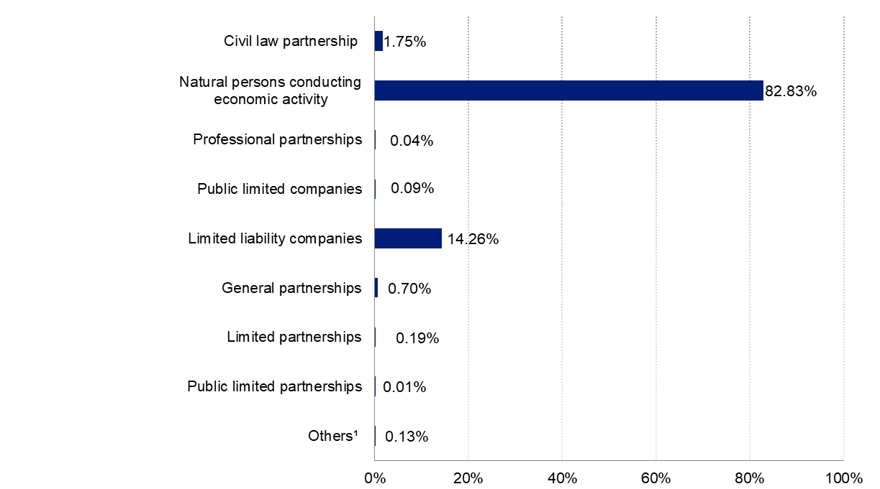
Chart 2. Structure of registrations of enterprises by legal form in the first quarter of 2021

¹"Others" includes the following legal forms: state-owned enterprises; cooperatives; branches of foreign enterprises; companies provided for in provisions other than the Commercial Companies Code and the Civil Code or legal forms to which the provisions on companies apply; foreign enterprises; entities with no specific legal form.

Bankruptcies of enterprises
In the first quarter of 2021, the number of bankruptcies of enterprises decreased by 11.3% compared to the corresponding period of previous year.

In the first quarter of 2021, a number of enterprises that declared bankruptcy amounted to 126 and was 11.3% lower than in the corresponding period of previous year. A decline in the number of entities that declared bankruptcy was recorded in transportation and storage (5 vs. 13), industry (28 vs. 33), construction (16 vs. 20), trade; repair of motor vehicles (34 vs. 38) and information and communication (3 vs. 5) accommodation and catering (9 vs. 10). An increase in the number of units that declared bankruptcy was recorded in the case of services (23 vs. 21). According to legal forms, a smaller number of bankruptcies was recorded, i.a., in natural persons conducting economic activity (28 vs. 39) and public limited companies (3 vs. 11). The increase in the number of bankruptcies was recorded in the case of limited liability companies (82 vs. 80) and cooperatives (2 vs. 1). Among the entities for which bankruptcy was declared 65.1% were limited liability companies (compared to 56.3% in the first quarter of 2020) and 22.2% were natural persons conducting economic activity (compared to 27.5% in the first quarter of 2020).

Chart 3. Number of enterprises that declared bankruptcy

Chart 4. Structure of enterprises that declared bankruptcy, by legal form, in the first quarter of 2021
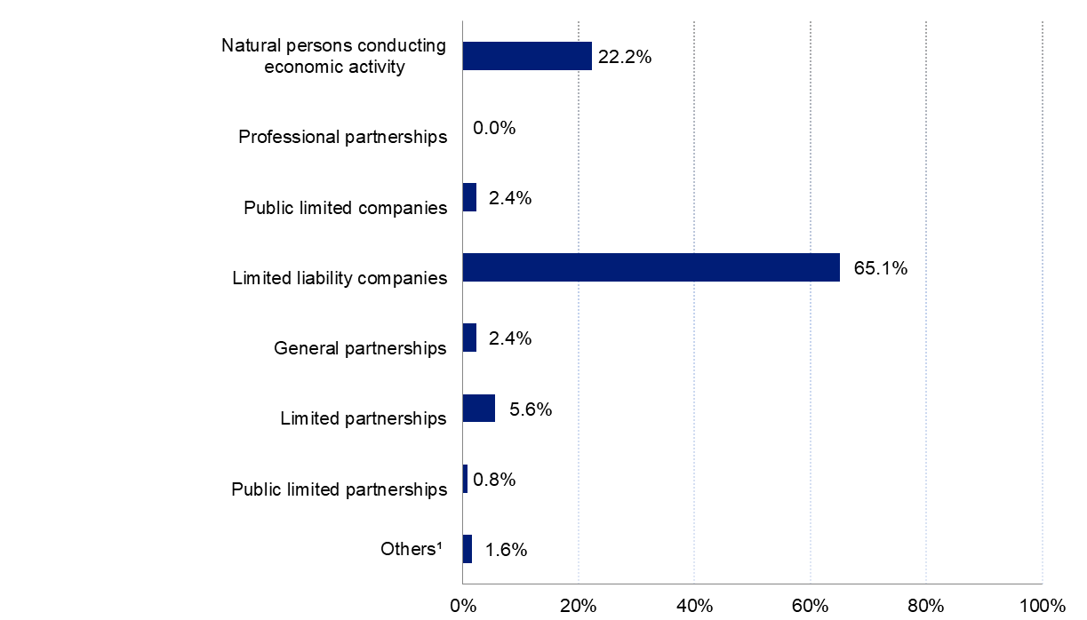
¹"Others" includes the following legal forms: state-owned enterprises; cooperatives; branches of foreign enterprises; companies provided for in provisions other than the Commercial Companies Code and the Civil Code or legal forms to which the provisions on companies apply; foreign enterprises; entities with no specific legal form.
The data presented in this study are prepared in accordance with the guidelines developed by Eurostat and include information on registration and bankruptcy of economic entities (enterprises) with a predominant type of activity classified as, according to NACE Rev. 2, sections from B (mining and quarrying) to S (other service activities), excluding section O (public administration and defence; compulsory social security) and division 94 (activities of membership organisations).
By legal form, the data include the following entities: civil partnerships operating based on a contract concluded in accordance with the Civil Code, natural persons conducting economic activity, professional partnerships, public limited companies, limited liability companies, general partnerships, limited partnerships, public limited partnerships, state enterprises, cooperatives, branches of foreign enterprises, companies provided for in provisions other than the Commercial Companies Code and the Civil Code or legal forms to which the provisions on companies apply, foreign enterprises, entities with no specific legal form.
In the study, there are additional forms of grouping introduced apart from the generally classification :
- "Industry" including sections: mining and quarrying (section B), manufacturing (section C), electricity, gas steam and air conditioning supply (section D), water supply; sewerage, waste management and remediation activities (section E);
- "services" including sections: financial and insurance activities (section K), real estate services (section L), professional, scientific and technical activities (section M), administrative and support service activities (section N);
- "other sections" including sections: education (section P), human health and social work activities (section Q), arts, entertainment and recreation (section R), other service activities (section S excluding division 94 activities of membership organisations).
The number of bankruptcies in a given quarter applies to enterprises against which a decision on declaration of bankruptcy has been issued by a competent District Court in a given quarter.
The number of registrations in a given quarter applies to enterprises that were registered in the National Official Registry of Entities of the National Economy (REGON) in a given quarter. The registrations also include natural persons that terminated than restarted economic activity.
In the case of quoting Statistics Poland data, please provide information: "Source of data: Statistics Poland", and in the case of publishing calculations made on data published by Statistics Poland, please provide information: "Own elaboration based on Statistics Poland data".

TABULAR ANNEX
Table 1. Number of registrations of enterprises
SPECIFICATION | 2019 |  |  |  | 2020 |  |  |  | 2021
SPECIFICATION | Q1 | Q2 | Q3 | Q4 | Q1 | Q2 | Q3 | Q4 | Q1
TOTAL | 95 300 | 94 385 | 87 788 | 78 308 | 84 099 | 64 410 | 87 360 | 75 925 | 84 223
Industry  (sections B,C,D,E) | 7 807 | 7 805 | 7 267 | 6 407 | 6 980 | 5 429 | 7 081 | 6 188 | 6 828
Construction  (section F) | 21 477 | 22 031 | 20 050 | 15 140 | 19 529 | 14 324 | 19 930 | 14 601 | 16 871
Trade; repair of motor vehicles (section G) | 16 863 | 15 413 | 14 236 | 13 992 | 14 285 | 12 661 | 15 547 | 14 036 | 15 648
Transportation and storage  (section H) | 6 895 | 5 865 | 5 228 | 4 934 | 5 586 | 4 047 | 4 920 | 4 214 | 4 846
Acomodation and cathering  (section I) | 3 410 | 4 912 | 3 345 | 2 547 | 2 798 | 3 349 | 3 313 | 2 002 | 2 389
Information and communication (section J) | 6 210 | 5 746 | 5 484 | 5 253 | 5 544 | 3 879 | 5 622 | 6 197 | 7 709
Services  (sections K,L,M,N) | 20 334 | 19 649 | 18 634 | 17 406 | 18 182 | 12 904 | 18 129 | 17 225 | 18 812
Other sections (P,Q,R,S excluding division 94) | 12 304 | 12 964 | 13 544 | 12 629 | 11 195 | 7 817 | 12 818 | 11 462 | 11 120

Table 2. Number of registrations of enterprises by legal form
SPECIFICATION | 2019 |  |  |  | 2020 |  |  |  | 2021
SPECIFICATION | Q1 | Q2 | Q3 | Q4 | Q1 | Q2 | Q3 | Q4 | Q1
TOTAL | 95 300 | 94 385 | 87 788 | 78 308 | 84 099 | 64 410 | 87 360 | 75 925 | 84 223
Civil law partnership | 1 836 | 1 396 | 1 304 | 1 379 | 1 455 | 918 | 1 224 | 1 123 | 1 472
Natural persons conducting economic activity | 80 947 | 81 994 | 75 080 | 64 613 | 69 472 | 53 530 | 73 987 | 63 355 | 69 760
Professional partnerships | 29 | 19 | 31 | 32 | 25 | 20 | 26 | 34 | 37
Public limited companies | 85 | 68 | 64 | 83 | 68 | 45 | 63 | 83 | 74
Limited liability companies | 10 464 | 9 279 | 9 672 | 10 459 | 11 299 | 8 559 | 10 657 | 10 328 | 12 013
General partnerships | 287 | 279 | 260 | 228 | 261 | 191 | 202 | 410 | 586
Limited partnerships | 1 503 | 1 208 | 1 235 | 1 372 | 1 385 | 1 049 | 1 089 | 492 | 160
Public limited partnerships | 28 | 32 | 26 | 32 | 25 | 16 | 15 | 13 | 8
State-owned enterprises | 0 | 0 | 0 | 0 | 0 | 0 | 0 | 0 | 0
Cooperatives | 42 | 41 | 47 | 33 | 46 | 29 | 29 | 28 | 32
Branches of foreign enterprises | 50 | 53 | 52 | 53 | 41 | 40 | 53 | 47 | 52
Others, including without specific legal form∗ | 29 | 16 | 17 | 24 | 22 | 13 | 15 | 12 | 29

Table 3. Number of bankruptcies of enterprises
SPECIFICATION | 2019 |  |  |  | 2020 |  |  |  | 2021
SPECIFICATION | Q1 | Q2 | Q3 | Q4 | Q1 | Q2 | Q3 | Q4 | Q1
TOTAL | 155 | 131 | 133 | 159 | 142 | 157 | 123 | 106 | 126
Industry  (sections B,C,D,E) | 41 | 26 | 33 | 36 | 33 | 40 | 32 | 19 | 28
Construction  (section F) | 24 | 19 | 28 | 19 | 20 | 19 | 18 | 15 | 16
Trade; repair of motor vehicles (section G) | 51 | 44 | 28 | 45 | 38 | 41 | 34 | 34 | 34
Transportation and storage  (section H) | 10 | 9 | 9 | 15 | 13 | 13 | 5 | 8 | 5
Acomodation and cathering  (section I) | 2 | 4 | 5 | 4 | 10 | 5 | 9 | 6 | 9
Information and communication (section J) | 4 | 3 | 5 | 5 | 5 | 3 | 1 | 3 | 3
Services  (sections K,L,M,N) | 17 | 21 | 21 | 26 | 21 | 25 | 18 | 16 | 23
Other sections (P,Q,R,S excluding division 94) | 6 | 5 | 4 | 9 | 2 | 11 | 6 | 5 | 8

Table 4. Number of bankruptcies of enterprises by legal form
SPECIFICATION | 2019 |  |  |  | 2020 |  |  |  | 2021
SPECIFICATION | Q1 | Q2 | Q3 | Q4 | Q1 | Q2 | Q3 | Q4 | Q1
TOTAL | 155 | 131 | 133 | 159 | 142 | 157 | 123 | 106 | 126
Natural persons conducting economic activity | 35 | 31 | 37 | 46 | 39 | 35 | 26 | 20 | 28
Professional partnerships | 0 | 0 | 0 | 0 | 0 | 0 | 0 | 0 | 0
Public limited companies | 16 | 4 | 9 | 11 | 11 | 13 | 7 | 9 | 3
Limited liability companies | 94 | 82 | 74 | 82 | 80 | 84 | 79 | 65 | 82
General partnerships | 4 | 5 | 3 | 9 | 3 | 7 | 5 | 4 | 3
Limited partnerships | 4 | 4 | 4 | 7 | 7 | 13 | 5 | 8 | 7
Public limited partnerships | 0 | 2 | 0 | 2 | 1 | 2 | 0 | 0 | 1
State-owned enterprises | 1 | 0 | 0 | 0 | 0 | 0 | 0 | 0 | 0
Cooperatives | 1 | 3 | 6 | 2 | 1 | 3 | 1 | 0 | 2
Branches of foreign enterprises | 0 | 0 | 0 | 0 | 0 | 0 | 0 | 0 | 0
Others, including without specific legal form * | 0 | 0 | 0 | 0 | 0 | 0 | 0 | 0 | 0

Prepared by:  Enterprises Department  Director Katarzyna Walkowska  Office: tel. (+48 22): 608 31 25 | Issued by:  The Spokesperson for the President  of Statistics Poland  Karolina Banaszek  Mobile: (+48) 695 255 011

Press Office  Office: tel. (+48 22) 608 34 91, 608 38 04  e-mail: obslugaprasowa@stat.gov.pl |  | www.stat.gov.pl/en/
 |  | @StatPoland
 |  | @GlownyUrzadStatystyczny

Related information
Rejestracje i upadłości podmiotów gospodarczych w I kwartale 2019 roku
Rejestracje i upadłości podmiotów gospodarczych w II kwartale 2019 roku
Rejestracje i upadłości podmiotów gospodarczych w III kwartale 2019 roku
Rejestracje i upadłości podmiotów gospodarczych w IV kwartale 2019 roku
Rejestracje i upadłości podmiotów gospodarczych w I kwartale 2020 roku
Rejestracje i upadłości podmiotów gospodarczych w II kwartale 2020 roku
Rejestracje i upadłości podmiotów gospodarczych w III kwartale 2020 roku
Rejestracje i upadłości podmiotów gospodarczych w IV kwartale 2020 roku

∗”Others” includes the following legal forms: companies provided for in the provisions of acts other than the Code of Commercial Companies and the Civil Code or legal forms, to which regulations on companies apply, foreign companies, without specific legal form.
*”Others” includes the following legal forms: companies provided for in the provisions of acts other than the Code of Com-mercial Companies and the Civil Code or legal forms, to which regulations on companies apply, foreign companies, without specific legal form.

