The demand for labour in the third quarter of 2021
At the end of the third quarter of 2021, there were 153.5 thousand job vacancies, 68.5% more than in the corresponding period of the previous year. The job vacancy rate was 1.25%. In the third quarter of 2021, there were 2.3 newly created jobs per liquidated job.
↑7.5%
Increase in the number of job vacancies compared to the second quarter of 2021

The Labour Demand Survey is conducted using the representative method on a quarterly basis, on the Z–05 reporting form. It covers national economy entities employing at least one person. In the third quarter of 2021, private sector entities constituted the majority of the covered population (91.1% of all entities), whereas in terms of size expressed by the number of employed persons – entities with up to 9 employed persons prevailed (68.8% of the total number). At the end of the third quarter of 2021, 42.7 thousand out of 635.1 thousand reporting units had job vacancies (6.7% of their total number, i.e. 2.0 percentage points more than in the corresponding period of the previous year).
The results of the survey for the third quarter of 2021 indicate that despite the ongoing SARS-CoV-2 coronavirus epidemic in Poland, the situation on the labour market improved compared to the previous year. At the end of the quarter under review, the number of job vacancies was higher and the job vacancy rate increased significantly. During the third quarter, an increase in the number of newly created jobs was also recorded, while the number of liquidated jobs decreased. The number of newly created jobs was more than two times higher than the number of liquidated jobs.
In Poland, in the third quarter of 2021, the job vacancy rate was 1.25% and was higher than in the third quarter of 2020 and higher than in the second quarter of this year

For comparison, in Poland, in the corresponding period of 2020 there were decreases compared to 2019, both in the number of job vacancies (by 38.7%), the number of newly created jobs (by 16.4%) and liquidated jobs (by 24.1%).

Table 1. Basic results of the Labour Demand Survey in Poland
OUARTERS  A – corresponding  quarter = 100  B – previous  quarter = 100 | Employed persons | Job vacancies |  |  | Newly  created job vacancies | Liquidated job  vacancies
 | Employed persons | total | of total |  | Newly  created job vacancies | Liquidated job  vacancies
 | Employed persons | total | newly  created | reported to labour  offices | Newly  created job vacancies | Liquidated job  vacancies
 | at the end of the quarter |  |  |  | during the quarter
 | in thousands
2020
Quarter 3 | 12 647.6 | 91.1 | 18.3 | 12.1 | 126.4 | 62.4
Quarter 4 | 12 218.5 | 84.4 | 17.5 | 10.2 | 91.5 | 53.9
2021
Quarter 1 | 12 186.9 | 110.2 | 24.0 | 13.7 | 191.7 | 70.2
Quarter 2 | 12 189.8 | 142.8 | 35.0 | 21.9 | 145.8 | 58.5
Quarter 3 | 12 172.4 | 153.5 | 35.7 | 22.8 | 132.6 | 57.8
A | 96.2 | 168.5 | 194.9 | 187.7 | 104.9 | 92.7
B | 99.9 | 107.5 | 101.9 | 103.8 | 91.0 | 98.8

In Poland, at the end of the third quarter of this year, the number of job vacancies was also higher than in the second quarter of 2021. On the other hand, the number of newly created and liquidated jobs (during the quarter) decreased in a short period of time, i.e. in comparison with the second quarter of this year.

Chart 1. Newly created and liquidated jobs in Poland
During the quarter

Job vacancies at the end of the third quarter of 2021
The Labour Demand Survey enables the analysis of data on job vacancies, i.e. positions or jobs unoccupied due to labour turnover or newly created ones that simultaneously meet the following three conditions:
1) the positions and jobs were actually unoccupied on the survey day,
2) the employer made efforts to find people willing to take up the job,
3) if adequate candidates were found to occupy the vacancies, the employer would readily take them on.
The total number of job vacancies in Poland recorded at the end of the third quarter of 2021 amounted to 153.5 thousand. This means that compared to the third quarter of 2020 it increased by 68.5%. Almost a quarter of all job vacancies were newly created jobs. The number of vacant newly created jobs was 94.9% higher than at the end of the third quarter of the previous year. The entities were looking for employees for instance through labour offices.
At the end of the third quarter of 2021, 22.8 thousand job vacancies were reported to labour offices. They accounted for 14.8% of all job vacancies at the end of the third quarter.
One of the measures for assessing the situation on the labour market is the job vacancy rate, which is the share of job vacancies in the sum of the number of occupied posts and the number of job vacancies in a given period. At the end of the third quarter of 2021, this rate for
Poland amounted to 1.25% and was 0.53 percentage points higher than in the corresponding period of 2020 and 0.09 percentage points higher than in the previous quarter. In the period from the beginning of 2012, it was the second highest rate (the highest job vacancy rate was recorded in the second quarter of 2018, i.e. 1.26%).

Chart 2. Job vacancy rate in Poland
As at the end of the quarter
The highest job vacancy rate at the end of the third quarter, as in the previous year, was recorded in the Zachodniopomorskie region

When analysing the job vacancy rate at regional level, it can be noted that the highest value was recorded in the Zachodniopomorskie region (it amounted to 1.68%). High rates were also recorded in the following regions: Małopolskie (1.57%), Warszawski stołeczny (1.50%), Dolnośląskie (1.49%) and Opolskie (1.47%).

Table 2. Job vacancy rate and the ratio of the number of newly created jobs to the number
of liquidated jobs in Poland
PERIODS | Job vacancy rate  (as at the end of the quarter) | The ratio of the number  of newly created jobs  to the number of liquidated jobs (during the quarter)
PERIODS | in %
2020
Quarter 3 | 0.72 | 2.0
Quarter 4 | 0.69 | 1.7
2021
Quarter 1 | 0.90 | 2.7
Quarter 2 | 1.16 | 2.5
Quarter 3 | 1.25 | 2.3
As in previous quarters, the largest number of job vacancies remained in entities operating in the field of manufacturing
When analysing data by kind of conducted activity it can be noted that at the end of the third quarter of 2021, the most, i.e. almost a quarter of job vacancies were recorded in entities operating in the field of manufacturing (34.3 thousand). In this section, 8.3 thousand newly created jobs were vacant. When compared to the corresponding quarter of 2020, the total number of job vacancies as well as the number of vacant newly created jobs increased by more than half.
Numerous job vacancies at the end of the third quarter were also recorded in the construction section (22.5 thousand job vacancies, of which 19.1% were newly created jobs) and in the trade; repair of motor vehicles∆ (19.3 thousand job vacancies, of which 23.8% were newly created jobs). At the end of the analysed quarter of 2021, the shares of these two sections in the total number of job vacancies increased on an annual basis and amounted to 14.7% in the construction section, and 12.6% in trade; repair of motor vehicles∆ section.

Chart 3. Job vacancies and the job vacancy rate in Poland by selected PKD/NACE sections
in the third quarter of 2021
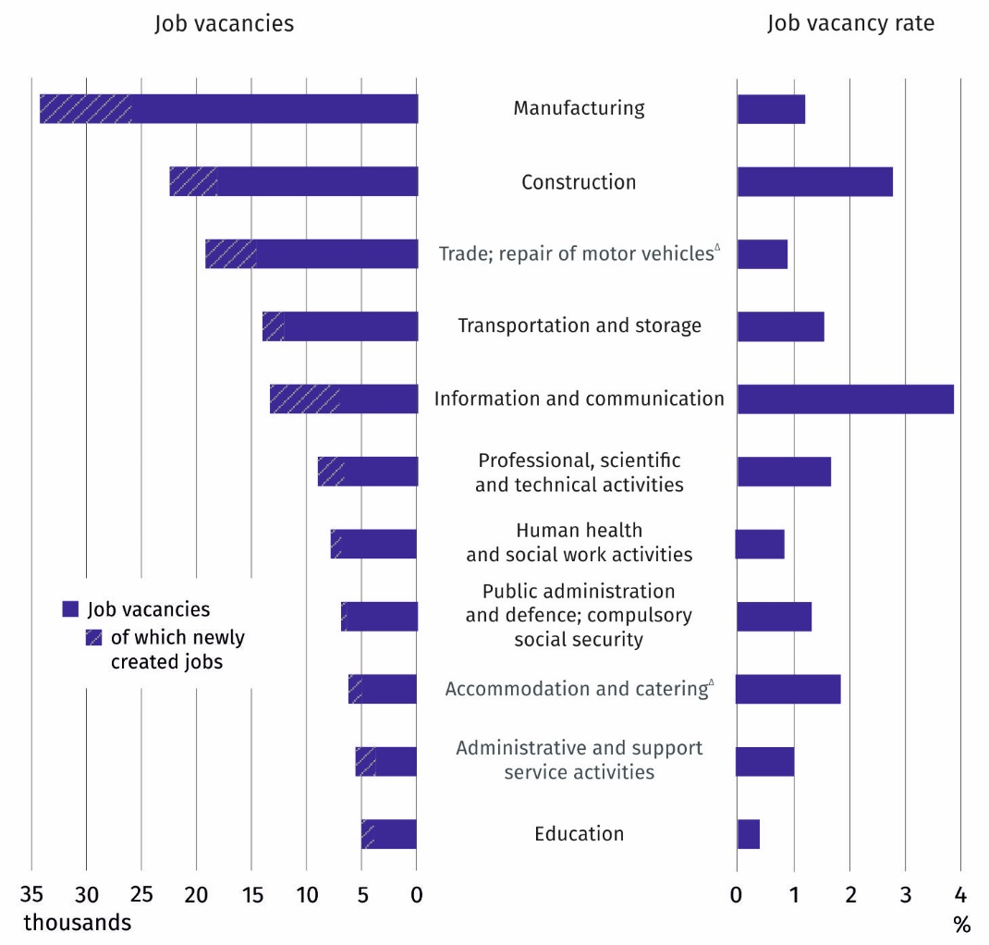
As at the end of the quarter
When analysing data broken down by PKD/NACE section it can be noted that the highest job vacancy rate in the third quarter of the year was recorded in the information and communication section

In the third quarter of this year the largest annual increase, more than threefold, in the number of job vacancies occurred in the accommodation and catering∆ section, and in the case of vacant newly created jobs the increase was almost sevenfold. The section with a significant increase in the number of jobs was the information and communication section. Compared to the third quarter of 2020, the number of job vacancies increased by 154.1%, and the number of vacant newly created jobs – by 244.1%.
In the third quarter of 2021, job vacancies were offered primarily to professionals (22.7%), craft and related trades workers (22.4%) and plant and machine operators and assemblers (17.5%)

The analysis of the results of the Labour Demand Survey for the third quarter of 2021 broken down by major occupational group shows that the number of job vacancies in all occupational groups increased over a year's time. Among the entities with job vacancies, the most in-demand group were professionals (34.9 thousand job vacancies, of which 29.7% were newly created jobs). The number of job vacancies in this occupational group increased by 71.7% over a year's time.
In the analysed period, an increase in the number of job vacancies higher than that recorded for professionals, i.e. amounting to 88.9%, was recorded for a major occupational group plant and machine operators and assemblers. In the third quarter of 2021, there were 26.8 thousand job vacancies for this occupational group (17.5% of the total number of job vacancies). In the analysed quarter, more job vacancies than for the latter group (34.4 thousand jobs) were also intended for craft and related trades workers (22.4% of the total number of job vacancies). Over the year, their number increased by 60.6%.

Chart 4. The structure of job vacancies and occupied jobs in Poland by major occupational group and ownership sector in the third quarter of 2021
As at the end of the quarter

Newly created and liquidated jobs during the third quarter of 2021
The Labour Demand Survey also enables to analyse the situation on the labour market in terms of the number of newly created jobs (resulting from organisational changes, expansion or change in the business profile and all jobs in newly created units) and liquidated jobs (lost as a result of organisational changes, limiting or changing the business profile).
In the third quarter of 2021, an annual increase in the number of newly created jobs and an annual decrease in the number of liquidated jobs were recorded. There were 2.3 newly created jobs per liquidated job

During the third quarter of 2021, in Poland, 132.6 thousand jobs were created, and 57.8 thousand jobs were liquidated. Compared to the corresponding period of the previous year, the number of newly created jobs increased by 4.9% and the number of jobs liquidated decreased by 7.3%.

When comparing the results of the current Labour Demand Survey with the results for the second quarter of this year, there is a noticeable decrease in both the number of newly created and liquidated jobs (by 9.0% and 1.2%, respectively).
The measure of the labour market's adjustment to the labour demand is the ratio of the number of newly created jobs to the number of jobs liquidated in a given period. Data for the third quarter of 2021 indicate an increase in the ratio compared to the corresponding period of 2020 (an increase from 2.0 newly created jobs per liquidated job to 2.3 newly created jobs in the third quarter of this year).

When analysing data broken down by PKD/NACE section it can be noted that, in the third quarter of 2021, the largest number of new jobs were created in units operating in the field of trade; repair of motor vehicles∆ (21.9 thousand jobs). The largest number of jobs were liquidated also in this section (11.8 thousand jobs). In relation to the third quarter of 2020, the number of newly created jobs decreased by 9.1% and the number of liquidated jobs increased by 51.5%. As a result, in the third quarter of this year, in the above-mentioned section, there were 1.9 newly created jobs per liquidated job (3.1 jobs in the previous year).
In the third quarter of 2021, the most intense movement was observed in the trade; repair of motor vehicles∆
– the largest number of jobs were created (16.5% of the total number of newly created jobs) and liquidated (20.4%
of the total number of liquidated jobs)
In the third quarter of 2021, the second section in terms of the number of newly created jobs (21.2 thousand new jobs) and liquidated jobs (11.0 thousand liquidated jobs) was manufacturing. In this section, as compared to the third quarter of 2020, there was a decrease in both discussed categories of jobs, by 15.5% and 18.2%, respectively. A similar scale of decreases resulted in the fact that, similarly as in the previous year in the third quarter 2021, there were 1.9 newly created jobs per liquidated job.
In analysing quarter of 2021, the largest annual increases in the number of newly created jobs – by more than 90% – took place in the following sections: accommodation and catering∆ and information and communication. In each of the above-mentioned sections, there were more than 5 newly created jobs per liquidated job (5.1 jobs and 5.9 jobs, respectively).

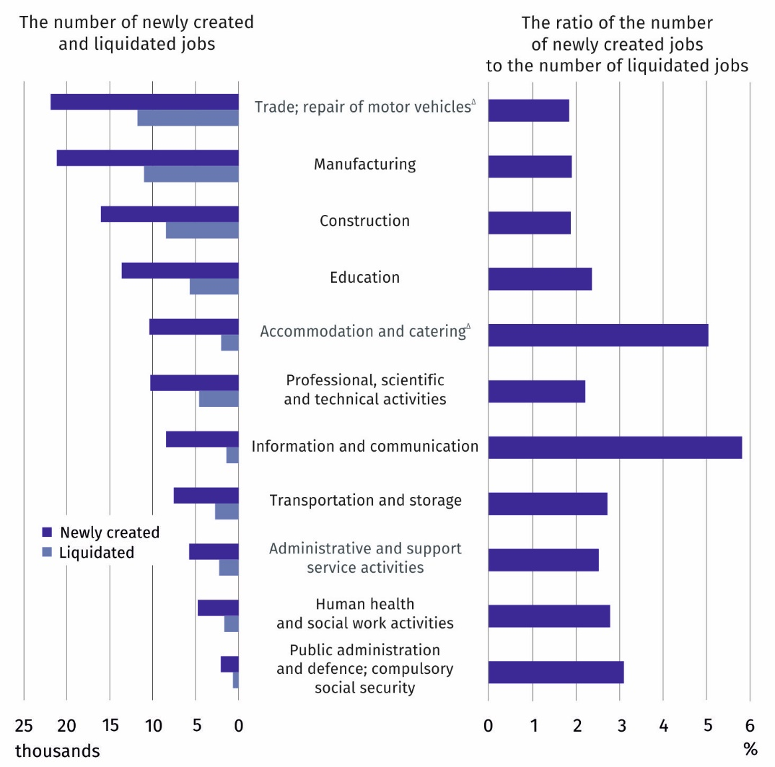
Chart 5. Newly created and liquidated jobs in Poland in selected PKD/NACE sections in the third quarter of 2021
In the third quarter of 2021, the largest number of newly created jobs (4.0 jobs) per
liquidated job were recorded in the Kujawsko-Pomorskie region
The distribution of jobs in the third quarter of 2021 in a territorial breakdown shows that the largest number of newly created jobs per liquidated job were recorded in the Kujawsko-
-Pomorskie region (4.0 newly created jobs), and a similar ratio was recorded in the Świętokrzyskie region (3.8 jobs). On the other hand, the smallest number, i.e. 1.5 new jobs, were created in the Mazowiecki regionalny and Warmińsko-Mazurskie regions.

In this news release abbreviated names of NACE, Rev. 2 sections were used. Abbreviations
are marked with a ‘Δ’ symbol. Full names are available on the Eurostat website at:
https://ec.europa.eu/eurostat/data/classifications
Relative numbers (rates, percentages) were calculated on the basis of absolute data expressed with greater accuracy than given in the study.

In the case of quoting Statistics Poland data, please provide information: "Source of data: Statistics Poland", and in the case of publishing calculations made on data published by Statistics Poland, please provide information: "Own elaboration based on Statistics Poland data.”

Prepared by:  Statistical Office in Bydgoszcz  Director Wiesława Gierańczyk, Ph.D.  Office: tel. (+48 52) 366 93 90 | Issued by:  The Spokesperson for the President  of Statistics Poland  Karolina Banaszek  Mobile: (+48) 695 255 011

Press Office  Office: tel. (+48 22) 608 34 91, 608 38 04  e–mail: obslugaprasowa@stat.gov.pl |  | https://stat.gov.pl/en/
 |  | @GUS_STAT
 |  | @GlownyUrzadStatystyczny

Related information
The demand for labour in 2020 – annual publication
The demand for labour in the second quarter of 2021
The impact of the Covid-19 epidemic on selected elements of the labour market in the second quarter of 2021
Other publications that contain the results of these surveys: stat.gov.pl → Topics → Labour market

Data available in databases
Knowledge databases – Labour market
Strateg → Themes → Labour market
Local Data Bank → Labour market
Statistics for the SDGs – global indicators

Terms used in official statistics
Demand for labour
Vacancies
Newly created jobs
Liquidated jobs

Classification of Occupations and Specialisations (KZiS) – introduced by the Regulation of the Minister of Labour and Social Policy of 7 August 2014 on the classification of occupations and specialisations for the needs of the labour market and the scope of its applications (Journal of Laws (Dz. U.) 2018, item 227).

