Accidents at work in January-September 2021
– preliminary data
43,600 persons injured in accidents at work were reported in January-September 2021, by 8.6% more than in January-September 2020. The number of injured persons per 1,000 employed persons (the incidence rate) also increased from 2.96 to 3.23.
3.23
Incidence rate in January-September 2021
Fatal accident victims accounted for 0.3% of all persons injured in accidents at work, while persons injured in serious accidents at work had a 0.5% share (0.1 percentage point increase and 0.1 percentage point decrease respectively as compared to January-September 2020). However, the number of persons injured in accidents with other effects increased by 8.6%.
The number of persons injured in accidents at work and the incidence rate increased compared to January- September 2020
The highest incidence rate was recorded for Podlaskie (4.36), Opolskie (4.05) and Warmińsko--mazurskie (4.04), Voivodships, the lowest for Mazowieckie (2.27), Małopolskie (2.55) and Podkarpackie (2.95).
Map 1. Persons injured in accidents at work per 1,000 employed persons 1 in January-September 2021 (excluding private farms in agriculture)
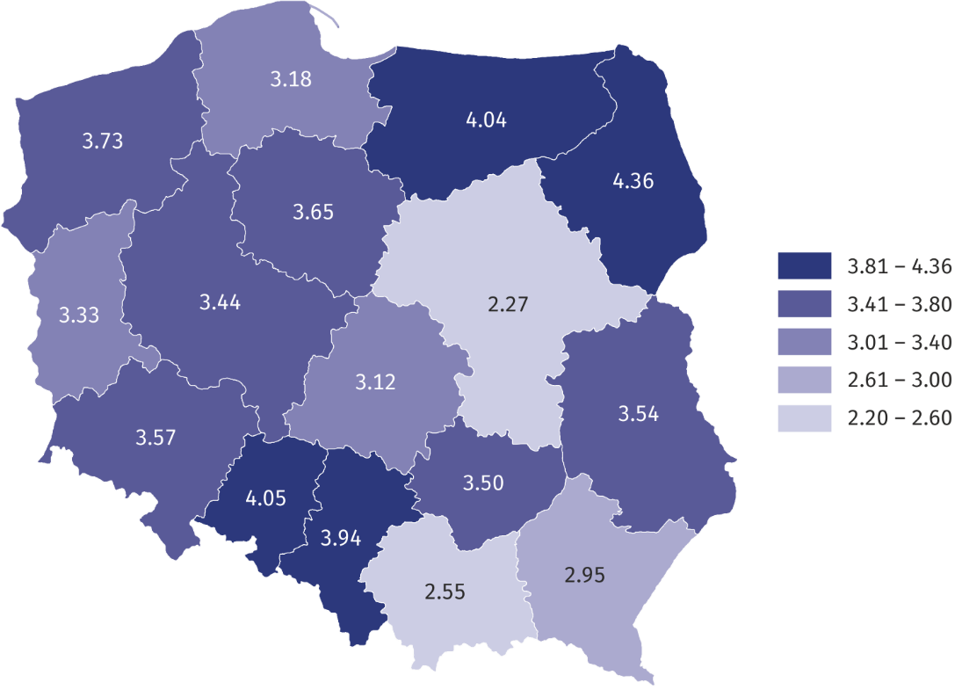
The highest incidence rate was recorded for Podlaskie Voivodship, whereas the lowest for Mazowieckie
1 The incidence rate was calculated using preliminary data on the number of employees; civilian employees of budgetary entities conducting activity within the scope of national defence and public safety were not included in the breakdown by voivodships.
In the breakdown by types of economic activity, the highest incidence rate was recorded in the sections: mining and quarrying (9.89), water supply; sewerage, waste management
and remediation activities (8.15) and human health and social work activities (5.29), while
the lowest in the sections: information and communication (0.45), financial and insurance activities (0.69) and other service activities (0.77).
Chart 1. Persons injured in accidents at work per 1,000 employed persons by sections
in January-September 2021 (excluding private farms in agriculture)
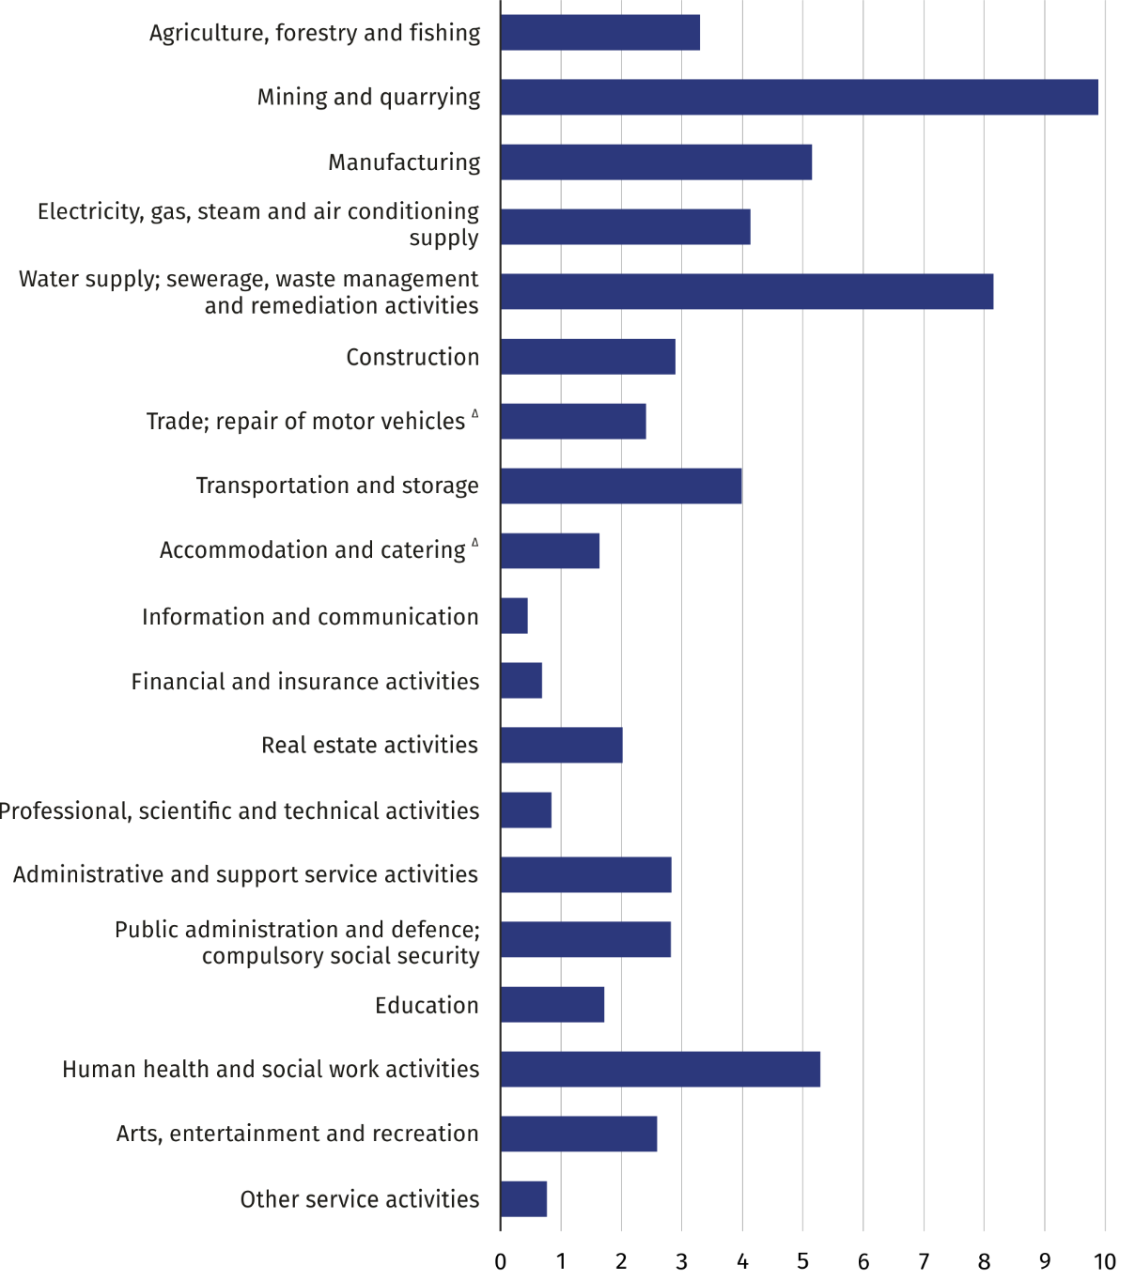
The highest incidence rate was recorded in the section mining and quarrying,
the lowest in the section information and communication
Chart 2. Persons injured in accidents at work in January-September 2021 by contact-modes of injuries
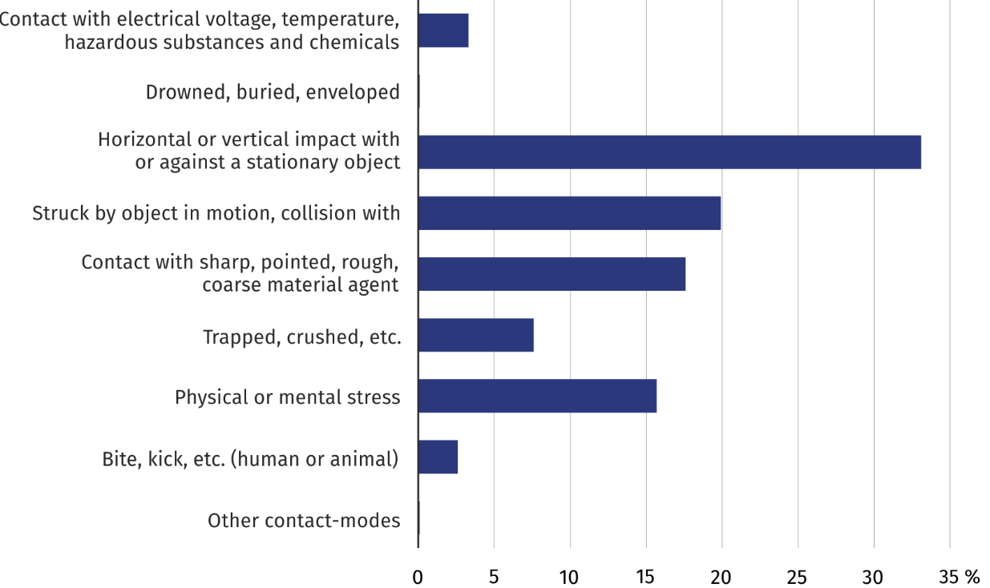
Horizontal or vertical impact with or against a stationary object was the prevalent group of contact-modes of injuries (33.1%)
Chart 3. Causes of accidents at work in January-September 2021
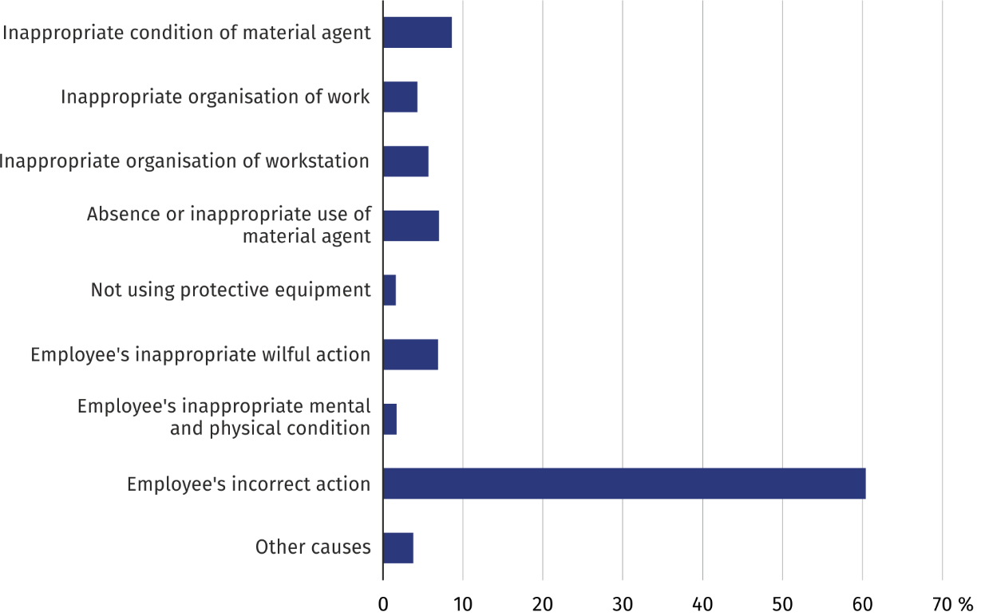
Employee's incorrect action was the cause of 60.4% of the accidents at work
Chart 4. Persons injured in accidents at work in January-September 2021 by specific physical activities performed by the victim at the time of the accident
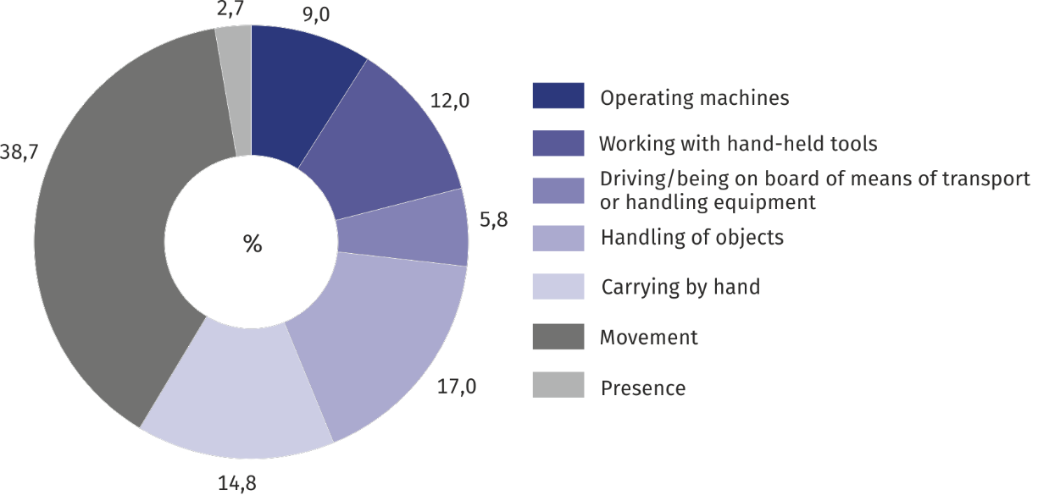
Movement was the most frequent specific physical activity performed by the victim at the time of the accident (38.7%)
Chart 5. Persons injured in accidents at work in January-September 2021 by part of body injured
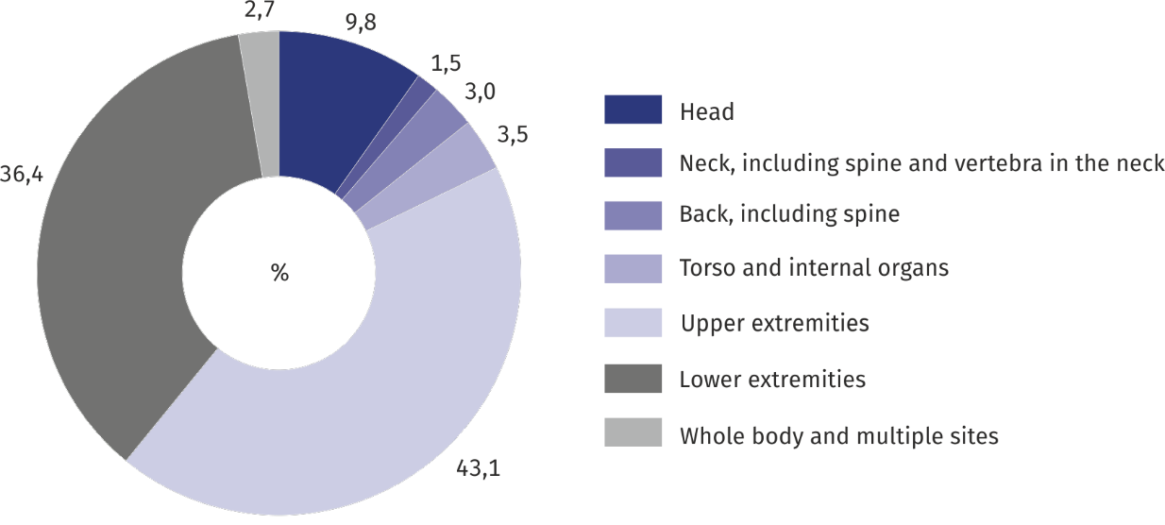
79.5% of the persons injured in accidents at work sustained an extremity injury

TABLE ANNEX
Table 1. Persons injured in accidents at work ¹ by sections in January-September 2021
SPECIFICATION  a – total  b – per 1,000 employed persons ² |  | Total | In accidents |  |  | Of total number  – women | Days lost
 |  | Total | fatal | serious | with other effect | Of total number  – women | total | per person injured ³
TOTAL | a | 43600 | 149 | 234 | 43217 | 16207 | 1506843 | 34.7
TOTAL | b | 3.23 | 0.01 | 0.02 | 3.20 | • | 111.76 | •
Agriculture, forestry and fishing | a | 567 | 9 | 5 | 553 | 104 | 24253 | 43.5
Agriculture, forestry and fishing | b | 3.30 | 0.05 | 0.03 | 3.22 | • | 141.36 | •
Mining and quarrying | a | 1454 | 8 | 6 | 1440 | 23 | 83613 | 57.8
Mining and quarrying | b | 9.89 | 0.05 | 0.04 | 9.80 | • | 568.77 | •
Manufacturing | a | 14735 | 32 | 110 | 14593 | 3433 | 523349 | 35.6
Manufacturing | b | 5.15 | 0.01 | 0.04 | 5.10 | • | 182.82 | •
Electricity, gas, steam and air conditioning supply | a | 449 | 2 | 6 | 441 | 38 | 18009 | 40.3
Electricity, gas, steam and air conditioning supply | b | 4.13 | 0.02 | 0.06 | 4.05 | • | 165.60 | •
Water supply; sewerage, waste management and remediation activities | a | 1369 | 5 | 8 | 1356 | 138 | 51268 | 37.6
 | b | 8.15 | 0.03 | 0.05 | 8.07 | • | 305.19 | •
Construction | a | 2609 | 29 | 34 | 2546 | 81 | 114184 | 44.2
Construction | b | 2.89 | 0.03 | 0.04 | 2.82 | • | 126.52 | •
Trade; repair of motor vehicles ∆ | a | 5855 | 16 | 21 | 5818 | 2944 | 178782 | 30.6
Trade; repair of motor vehicles ∆ | b | 2.41 | 0.01 | 0.01 | 2.39 | • | 73.47 | •
Transportation and storage | a | 3730 | 27 | 16 | 3687 | 1021 | 130428 | 35.2
Transportation and storage | b | 3.99 | 0.03 | 0.02 | 3.94 | • | 139.42 | •
Accommodation and catering ∆ | a | 478 | 1 | 3 | 474 | 293 | 14627 | 30.7
Accommodation and catering ∆ | b | 1.64 | 0.00 | 0.01 | 1.63 | • | 50.21 | •
Information and communication | a | 174 | - | - | 174 | 49 | 4916 | 28.3
Information and communication | b | 0.45 | • | • | 0.45 | • | 12.79 | •
Financial and insurance activities | a | 246 | 2 | - | 244 | 177 | 6188 | 25.4
Financial and insurance activities | b | 0.69 | 0.01 | • | 0.68 | • | 17.24 | •
Real estate activities | a | 412 | - | 3 | 409 | 160 | 15861 | 38.5
Real estate activities | b | 2.02 | • | 0.01 | 2.01 | • | 77.78 | •
Professional, scientific and technical activities | a | 590 | 2 | 3 | 585 | 284 | 15899 | 27.0
Professional, scientific and technical activities | b | 0.84 | 0.00 | 0.00 | 0.84 | • | 22.71 | •
Administrative and support service activities | a | 1594 | 5 | 6 | 1583 | 639 | 52145 | 32.8
Administrative and support service activities | b | 2.83 | 0.01 | 0.01 | 2.81 | • | 92.65 | •
Public administration and defence; compulsory social security | a | 1876 | 2 | 4 | 1870 | 1109 | 61996 | 33.1
 | b | 2.82 | 0.00 | 0.01 | 2.81 | • | 93.23 | •
1 Reported in a given period; excluding accidents on private farms in agriculture.
2 The incidence rate was calculated using preliminary data on the number of employees (verse b).
3 Excluding persons injured in fatal accidents and the number of days of their incapacity for work.
Table 1. Persons injured in accidents at work ¹ by sections in January-September 2021 (cont.)
SPECIFICATION  a – total  b – per 1,000 employed persons ² |  | Total | In accidents |  |  | Of total number  – women | Days lost
 |  | Total | fatal | serious | with other effect | Of total number  – women | total | per person injured ³
Education | a | 2072 | 5 | 4 | 2063 | 1635 | 66734 | 32.3
Education | b | 1.72 | 0.00 | 0.00 | 1.72 | • | 55.51 | •
Human health and social work activities | a | 4760 | 4 | 2 | 4754 | 3775 | 122934 | 25.8
Human health and social work activities | b | 5.29 | 0.00 | 0.00 | 5.29 | • | 136.71 | •
Arts, entertainment and recreation | a | 408 | - | - | 408 | 198 | 12895 | 31.6
Arts, entertainment and recreation | b | 2.59 | • | • | 2.59 | • | 81.88 | •
Other service activities | a | 222 | - | 3 | 219 | 106 | 8762 | 39.5
Other service activities | b | 0.77 | • | 0.01 | 0.76 | • | 30.31 | •
1 Reported in a given period; excluding accidents on private farms in agriculture.
2 The incidence rate was calculated using preliminary data on the number of employees (verse b).
3 Excluding persons injured in fatal accidents and the number of days of their incapacity for work.
Table 2. Persons injured in accidents at work ¹ by voivodships in January-September 2021
SPECIFICATION  a – total  b – per 1,000 employed persons ² |  | Total | In accidents |  |  | Of total number  – women | Days lost
 |  | Total | fatal | serious | with other effect | Of total number  – women | total | per person injured ³
POLAND | a | 43600 | 149 | 234 | 43217 | 16207 | 1506843 | 34.7
POLAND | b | 3.23 | 0.01 | 0.02 | 3.20 | • | 111.76 | •
Dolnośląskie | a | 3883 | 15 | 24 | 3844 | 1503 | 121310 | 31.4
Dolnośląskie | b | 3.57 | 0.01 | 0.02 | 3.54 | • | 111.51 | •
Kujawsko-Pomorskie | a | 2363 | 3 | 10 | 2350 | 835 | 76791 | 32.5
Kujawsko-Pomorskie | b | 3.65 | 0.00 | 0.02 | 3.63 | • | 118.76 | •
Lubelskie | a | 1965 | 8 | 9 | 1948 | 767 | 81376 | 41.6
Lubelskie | b | 3.54 | 0.01 | 0.02 | 3.51 | • | 146.75 | •
Lubuskie | a | 1084 | 1 | 6 | 1077 | 424 | 35301 | 32.6
Lubuskie | b | 3.33 | 0.00 | 0.02 | 3.31 | • | 108.36 | •
Łódzkie | a | 2642 | 2 | 17 | 2623 | 1093 | 89590 | 33.9
Łódzkie | b | 3.12 | 0.00 | 0.02 | 3.10 | • | 105.69 | •
Małopolskie | a | 3075 | 11 | 13 | 3051 | 1272 | 102047 | 33.3
Małopolskie | b | 2.55 | 0.01 | 0.01 | 2.53 | • | 84.60 | •
Mazowieckie | a | 5454 | 19 | 24 | 5411 | 2202 | 176276 | 32.4
Mazowieckie | b | 2.27 | 0.01 | 0.01 | 2.25 | • | 73.43 | •
Opolskie | a | 1184 | 5 | 16 | 1163 | 377 | 40061 | 34.0
Opolskie | b | 4.05 | 0.02 | 0.05 | 3.98 | • | 136.95 | •
1 Reported in a given period; excluding accidents on private farms in agriculture.
2 The incidence rate was calculated using preliminary data on the number of employees (verse b); civilian employees of budgetary entities conducting activity within the scope of national defence and public safety were not included in the breakdown by voivodships.
3 Excluding persons injured in fatal accidents and the number of days of their incapacity for work.
Table 2. Persons injured in accidents at work ¹ by voivodships in January-September 2021 (cont.)
SPECIFICATION  a – total  b – per 1,000 employed persons ² |  | Total | In accidents |  |  | Of total number  – women | Days lost
 |  | Total | fatal | serious | with other effect | Of total number  – women | total | per person injured ³
Podkarpackie | a | 1820 | 10 | 7 | 1803 | 689 | 66688 | 36.8
Podkarpackie | b | 2.95 | 0.02 | 0.01 | 2.92 | • | 108.26 | •
Podlaskie | a | 1407 | 4 | 5 | 1398 | 476 | 55685 | 39.7
Podlaskie | b | 4.36 | 0.01 | 0.02 | 4.33 | • | 172.45 | •
Pomorskie | a | 2642 | 12 | 21 | 2609 | 939 | 90987 | 34.6
Pomorskie | b | 3.18 | 0.01 | 0.03 | 3.14 | • | 109.42 | •
Śląskie | a | 6557 | 27 | 26 | 6504 | 2061 | 243868 | 37.3
Śląskie | b | 3.94 | 0.02 | 0.02 | 3.90 | • | 146.60 | •
Świętokrzyskie | a | 1177 | 3 | 14 | 1160 | 456 | 45046 | 38.3
Świętokrzyskie | b | 3.50 | 0.01 | 0.04 | 3.45 | • | 134.02 | •
Warmińsko-Mazurskie | a | 1588 | 1 | 7 | 1580 | 606 | 58092 | 36.6
Warmińsko-Mazurskie | b | 4.04 | 0.00 | 0.02 | 4.02 | • | 147.80 | •
Wielkopolskie | a | 4767 | 21 | 30 | 4716 | 1720 | 159163 | 33.5
Wielkopolskie | b | 3.44 | 0.02 | 0.02 | 3.40 | • | 114.88 | •
Zachodniopomorskie | a | 1992 | 7 | 5 | 1980 | 787 | 64562 | 32.5
Zachodniopomorskie | b | 3.73 | 0.01 | 0.01 | 3.71 | • | 121.04 | •
1 Reported in a given period; excluding accidents on private farms in agriculture.
2 The incidence rate was calculated using preliminary data on the number of employees (verse b); civilian employees of budgetary entities conducting activity within the scope of national defence and public safety were not included in the breakdown by voivodships.
3 Excluding persons injured in fatal accidents and the number of days of their incapacity for work.
Table 3. Persons injured in accidents at work 1 on private farms in agriculture by contact-modes of injuries
in January-September 2021
SPECIFICATION | Total | Fall of |  | Persons run over, hit or caught by a moving means of transport | Persons caught or hit by moving parts of machinery and equip-ment | Persons hit, crushed or bitten by animals | Impact of |  | Other contact-modes
SPECIFICATION | Total | persons | objects |  |  | Persons hit, crushed or bitten by animals | extreme temper-atures | harmful materials | Other contact-modes
TOTAL | 7472 | 3768 | 396 | 108 | 927 | 880 | 38 | 9 | 1346
Of which fatal accidents | 30 | 3 | 4 | 7 | 3 | 3 | - | - | 10
1 Concerns accidents in respect of which one-off compensations were granted.
Source: data of the Agricultural Social Insurance Fund.
Symbol (Δ) means that the names have been shortened in relation to the current classification. Their full names are available on website of the Statistics Poland under Polish Classification of Activities
(-) magnitude zero.
(0.00) magnitude not zero. but less than 0.005 of a unit.
Symbol (•) data not available, classified data (statistical confidentiality) or providing data impossible or purposeless.
“Of which” indicates that not all elements of the sum are given.
When citing data from the Statistics Poland please provide the following information: "Statistics Poland`s data". When publishing calculations made on data published by the Statistics Poland, provide the following information: "Own study based on the Statistics Poland's data".
METHODOLOGICAL NOTES
The publication includes information on accidents at work of persons employed in the national economy excluding budgetary entities conducting activity within the scope of the national defence and public safety for which information on accidents at work concerns only civilian employees.
Data regarding accidents at work, excluding private farms in agriculture, are obtained from “Statistical accident report” Z-KW and cover all accidents at work, as well as accidents considered equivalent to accidents at work, regardless whether incapacity for work was reported (due to hospitalisation of an injured person, or rejection of a sick leave, etc.).
Data on accidents at work on private farms in agriculture were compiled on the basis of reports of the Agricultural Social Insurance Fund (ASIF) and are related only to the accidents for which one-off compensations were granted in a given period.
Each accident, regardless whether the victim was injured during a single or multiple casualty incident, is counted as one accident at work.
Incidence rate is the number of persons injured per 1,000 persons employed. The ratio was calculated using the average number of employed persons expressed as an arithmetic mean for two dates (as of 31 December of the previous year and 31 September of the current year).
Information on days lost includes the total number of calendar days of incapacity for work due to work-related accidents, estimated on the basis of sick leaves.
Pursuant to art. 3 of the Act of 30 October 2002 on Social Insurance in Respect of Accidents at Work and Occupational Diseases (uniform text Journal of Laws of 2019, item 1205):
- accident at work is understood as a sudden incident, caused by external reason, leading to injury or death, which occurred in connection with work:
- during or in connection with performance of ordinary activities or the superiors’ instructions by the employee and activities on behalf of the employers, even without instructions;
- when the employee remains at the disposal of the employer on the way between the seat of the employer and the place of performing the obligation arising from the employment relationship.
- every accident is treated considered equivalent to an accident at work, as regards entitlement to benefits defined in the law on social insurance against accidents at work and occupational diseases, if the employee had such an accident: during a business trip; during training within the scope of the national self-defence; when performing tasks ordered by trade union organisations operating at the employer’s.
- accident at work is also understood as a sudden incident, causing injury or death, which happened within the term of accident insurance in the course of: practising sports during competitions and training by a person receiving sport scholarship; performance of paid work while serving the sentence of imprisonment or temporary detentions; exercising the mandate of a Deputy or Senator who receives a salary; doing–on the basis of appointment issued by powiat labour office or other supervising entity–training or internship connected with a scholarship received by school leavers; performance of work by members of agricultural producers’ cooperatives, farmers’ cooperatives and by other persons treated equally to members of cooperative, for the benefit of these cooperatives; performance or cooperation in performance of work on the basis of agency agreements, contracts of mandate or contracts of services; performance of usual activities related to running, or cooperation in running, a non-agricultural economic activity; performance of religious activities or activities connected with entrusted pastoral or monastic functions by clergymen; serving supplementary forms of military service; education of students receiving scholarship at the National School of Public Administration.
Fatal accident at work is an accident which leads to the death of a victim at the site of the accident or within 6 months of the accident.
Serious accident at work is an accident which results in serious bodily harm, i.e. loss of sight, hearing, speech, ability to procreate, other bodily harm or health-related problems, which disrupts primary bodily functions or results in an incurable and life-threatening disease, permanent mental illness, a permanent, total or significant incapacity for work in the occupation, or a permanent significant disfigurement or distortion of the body.
The methodology of the survey on accidents at work is explained in more detail in the annual publication titled "Accidents at work", available on the website of Statistics Poland
The data presented in this release are preliminary. The final data covering the year 2021 will be available in a publication coming out in November 2022.

Prepared by:
Statistical Office in Gdańsk
Director Jerzy Auksztol
Office: phone (+48 58) 76 83 130
Press Office
Office: phone (+48 22) 608 34 91, 22 608 38 04
e-mail: obslugaprasowa@stat.gov.pl
Issued by:
Related information
Accidents at work in 2020
Accidents at work in the first half of 2021–preliminary data
Other studies regarding working conditions
Data available in databases
Local Data Bank -> Labour Market -> Working Conditions
The Spokesperson for the President
of Statistics Poland
Karolina Banaszek
Mobile: (+48) 695 255 011

www.stat.gov.pl/en/

@StatPoland

@GlownyUrzadStatystyczny

