Activities of associations and similar social organizations, foundations, faith-based charities, country housewives associations as well as business and professional associations in 2020 – preliminary results

In 2020, there were 95.2 thousand registered non-profit organizations. They had 150.3 thousand full-time jobs, which accounted for 1.4% of the average employment in the national economy. Organizations with additional activities in connection with the COVID-19 epidemic covered 5.0 million people and provided financial and tangible support worth PLN 850.0 million.
18,9%
increase in the number of registry organizations in 2010-2020
Active organizations
In 2020, there were 95.2 thousand registered non-profit organizations, including 9.3 thousand units with the status of public benefit organization
In 2020, 95.2 thousand registered non-profit organizations (i.e. associations and similar social organizations with legal personality, foundations, faith-based charities, country housewives associations as well as business and professional associations) were active in Poland, among which the most numerous group were associations and similar social organizations (66.8 thousand; 70.1%), and then foundations (16.0 thousand; 16.8%). In 2020, for the first time, groups of country housewives associations were included, which numbered 8.5 thousand (8.9%) of the surveyed population. Almost every tenth non-profit organization had the status of a public benefit organization (9.3 thousand). In turn, social economy entities accounted for 99.2% of active organizations, i.e. 94.5 thousand (including as at December 31, 2020, 0.3 thousand units were on the list of social enterprises kept by the Ministry of Family and Social Policy).
Chart 1. Number of registered and non-registered non-profit organizations in 2020
ª Data for Catholic parish-based organizations concern 2018
Apart from registered organizations with legal personality, there were also less formalized social organizations. According to the data of powiat-level local governments and city offices with poviat status, in 2020 there were 8.0 thousand ordinary associations registered in the country. In turn, within the Catholic Church, non-formal social initiatives had a relatively large scale. Institute of Statistics of the Catholic Church SAC research shows that in 2018 there were 65.5 Catholic parish-based organizations.
Map 1. Number of registered non-profit organizations active in 2020 by voivodship

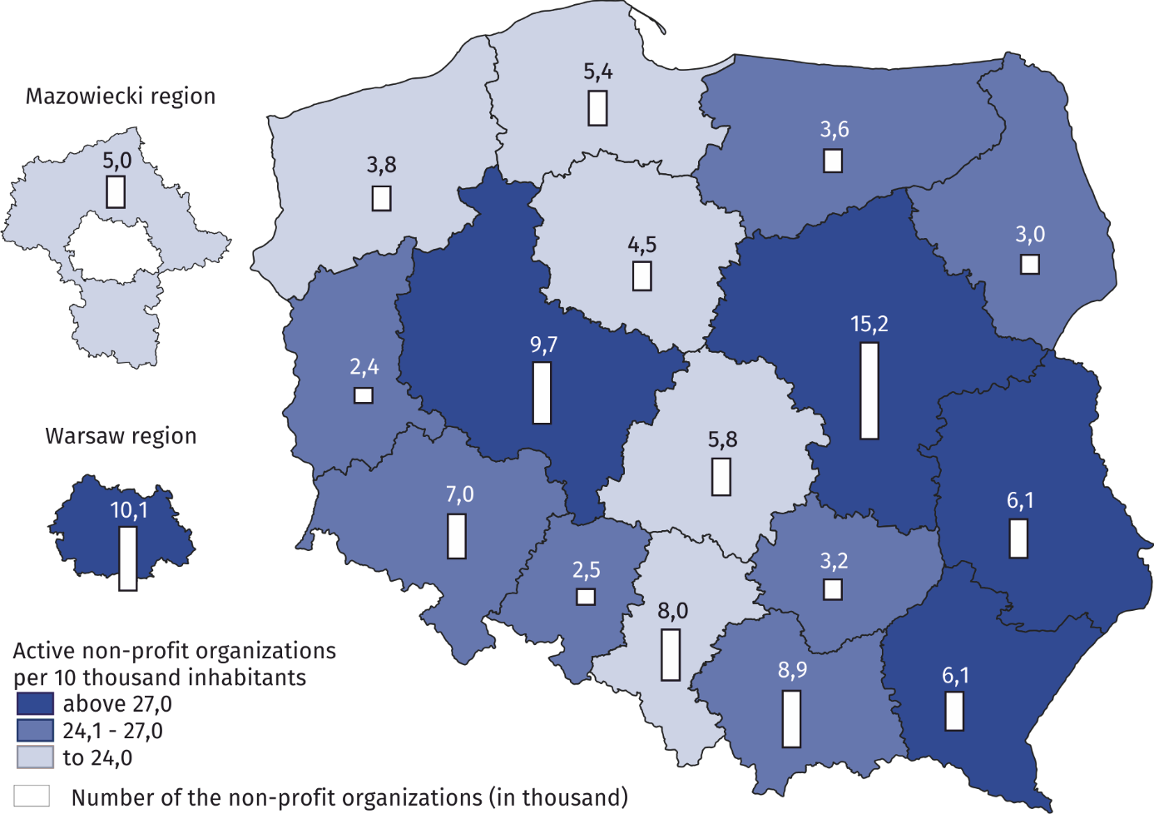

The field of statutory activity
More than half of the organizations were active in the field of sport, tourism and recreation, hobby, rescue services, as well as culture and arts
Chart 2. Structure of the surveyed non-profit organizations according to the main area of statutory activity in 2020
Non-profit organizations are characterized by carrying out various and multi-field activities. In 2020, as part of their statutory activities, most organizations dealt with sports, tourism, recreation, and hobbies (26.9%), and then - rescue services (15.3%). There was a large group of organizations that indicated culture and arts (12.4%), education and research (10.5%) and social services (8.3%) as the main field of their activity. Units with the status of public benefit organization (PBO) declared that they operated mainly in the field of social services (24.7% compared to 8.3%) and health (12.9% versus 3.9%).

The vast majority of non-profit organizations conducted only unpaid statutory activities - 81.4%. The remaining 18.6% of entities declared to conduct paid statutory activity or business activity, of which 2.9% were organizations obtaining funds from both these sources.

Membership base
At the end of 2020, 8.3 million memberships of natural persons were affiliated to active registered organizations

Active registry organizations showed that at the end of 2020 they had a total of 8.3 million memberships of natural persons and half of the organizations had no more than 28 members.

The highest membership potential was characteristic of associations and similar social organizations - they accounted for the vast majority of memberships of natural persons declared by non-profit entities (81.2%). Another important group in terms of membership were business and professional associations - they accounted for 14.3% of all members of natural persons.

Labour resources
The vast majority of non-profit organizations in 2020 operated solely on the basis of community service 61.6% of them declared that they did not use paid personnel.
Chart 3. Structure of non-profit organizations by having paid personnel in 2020
In 2020, 2.6 million people performed social work for the organizations and at the end of 2020 organizations employed 181.2 thousand of full-time employees

In non-profit organizations using paid work, employment only under civil law contracts (contract of mandate, contract for specific work, etc.) was much more frequent - 24.1% than full-time employment - 14.2%.
89.4% of organizations declared the use of volunteer work in 2020. Community service was most often used among associations and similar social organizations (90.2%) and least often among faith-based charities (43.4%).
In total, 2.6 million people (both members of the organization and non-members) provided volunteer work in 2020.
At the end of 2020, 181.2 thousand people were employed in non-profit organizations on the basis of an employment contract, including for 149.7 thousand people this work was the main place of employment. The average number of employees in employing organizations was 13.

Chart 4. The percentage of non-profit organizations using volunteer work and employing on the basis of an employmentcontract in 2020 by type of organization
The share of employment in the surveyed organizations accounted for 0.9% of the average number of people working in the national economy as at the end of December 2020. In turn, in employment based on an employment contract, this share was higher and amounted to 1.4%. The average full-time employment in 2020 amounted to 150.3 thousand full-time jobs, which constituted 1.4% of the average full-time employment during the year.
Non-profit organizations also employed personnel on the basis of civil law contracts. In 2020, there were 394.3 thousand such people, of which 38.8 thousand (i.e. 9.8%) it was the main source of income.

Revenues
The sum of revenues obtained by non-profit organizations in 2020 amounted to PLN 34.4 billion

In 2020, the total sum of revenues obtained by non-profit organizations amounted to PLN 34.4 billion. The two most numerous groups of entities - associations and similar social organizations and foundations - achieved revenues of PLN 28.4 billion, which constituted 82.4% of all financial resources collected by non-profit organizations.

In terms of the average value of revenues (calculated for all entities), the highest values ​​were generated by faith-based charities – PLN 1,984.7 thousand (with average revenues for the entire community - PLN 366.8 thousand). The lowest average income was observed among the country housewives associations (PLN 5.3 thousand).

More than half of the revenues generated by non-profit organizations came from non-market sources (63.0%). In this category, public funds had the largest share (45.2%), including co-financing from local government administration (19.6%). The share of revenues from market sources was 28.5%. Revenues from paid statutory activity (14.8%) and economic activity (11.6%) dominated here. Membership fees and other financial resources accounted for 8.6% of all revenues generated by non-profit organizations.

The situation related to COVID-19
The COVID-19 epidemic affected 74.9% of non-profit organizations
In March 2020, an epidemic threat was announced in Poland, followed by an epidemic in connection with the spread of an infectious disease caused by the SARS-CoV-2 virus, known as COVID-19. In 2020, this situation influenced on the statutory activities of 71.3 thousand non-profit organizations (74.9%). Among this group, it was most often indicated that due to the COVID-19 epidemic, the activity of the organization were temporarily suspended (60.9%). To a lesser extent, it contributed to a change in the form or scope of an organization's operation (38.3%) or the implementation of electronic / remote services (23.1%).
15.8% of organizations from the units affected by the COVID-19 epidemic declared that they undertook additional actions for recipients in 2020 in connection with the COVID-19 epidemic. This percentage was the highest in the group of entities dealing with rescue services (36.9%), and then operating in the field of social services (32.4%).
Chart 5. Percentage of non-profit organizationsª undertaking additional actions for recipients in relation to the COVID-19 epidemic in 2020 by main field of activity
a The basis for the percentage were organizations that declared that in 2020 the COVID-19 epidemic had an impact on their statutory activities.
Additional actions for recipients in connection with the COVID-19 epidemic were most often undertaken for the benefit of natural persons (58.8% of organizations that undertook such actions). Subsequently, the recipients were whole communities (e.g. housing estate, village council, gmina) - 32.9%.
As part of the activities related to the COVID-19 epidemic, support was provided to 5.0 million individual natural persons
In 2020, a total of 5.0 million individual natural persons were supported, half of which were people who were supported by foundations (2.5 million). Typical associations and similar social organizations directed actions to 1.3 million people, and volunteer fire brigades to 0.6 million people.
As part of additional activities related to the COVID-19 epidemic, non-profit organizations most often provided social services (45.8%), followed by information activities (45.3%). Tangible support was provided less frequently (24.9%) and then financial support (9.1%).
The total value of material support in connection with the COVID-19 epidemic was 850.0 million PLN

The amount of tangible and financial support provided by non-profit organizations in 2020 amounted to PLN 850.0 million. The largest part of these funds, i.e. 75.6%, that is PLN 642.5 million, was transferred to their recipients by foundations, which constituted 31.0% of organizations providing this type of support.

16.0 thousand of non-profit organizations declared to use of aid or facilitation under the anti-crisis shield in 2020. In this group, the most frequent use was made of subsidies, exemptions or postponements in the field of salaries and social security contributions (43.9%), followed by preferential loans or changes to their current terms, or other repayable instruments (39.4%).

Changes in 2010-2020
Between 2010 and 2020, the number of active organizations increased by 18.9%, the number of employees by 31.9% and revenues by 26.8% (in real terms)

Between 2010 and 2020, the number of active organizations increased by 18.9% (from 80.1 thousand to 95.2 thousand). Between 2016 and 2018, there was a decrease in the number of organizations by 4.0% as a result of deletion from the REGON register of entities from former court registers that had not registered in the National Court Register (KRS). On the other hand, the increase in the number of active organizations, recorded between 2018 and 2020, was mainly related to the introduction of a separate legal form and a register of the activities of country housewives associations .
Chart 6. Number of organizations, memberships, employment and revenues of non-profit organizations
8,0%
-4,0%
5,0%
5,2%
3,8%

8,7%%
18,7%%
7,3%
5,2%
2,7%
real
In the period in question, the membership base of non-profit organizations was gradually shrinking. Between 2010 and 2020, the number of memberships of natural persons decreased by 18.3% (from 10.2 million people to 8.3 million people). The changes in this respect were partially related to the much greater dynamics of establishing new foundations compared to the groups of entities of a member character.

On the other hand, there was an increase in the average number of people employed during the year between 2010 and 2020 - by 31.9% (from 114.0 thousand full-time equivalents to 150.3 thousand FTEs).

The total amount of revenues of non-profit organizations between 2010 and 2020 increased in nominal terms by 49.5% (from PLN 23.0 billion to PLN 34.4 billion), but in real terms - by 26.8%.

Methodological information
The note was created on the basis of the preliminary results of the research conducted by the resort of public statistics in 2020: Associations, foundations, business and professional associations and faith-based charities. Data on registration organizations with the use of SOF-1 and SOF-4s reports were collected by the Statistical Office in Krakow.
The study covered a group of selected types of non-profit organizations with legal personality, such as: associations and similar social organizations, foundations, faith-based charities conducting social activity, business associations and professional associations.
The research covered the above-mentioned units that met at least one of the following conditions: they employed more than 5 people; in 2019, they had tax revenue in excess of 1 million PLN; had a registered business activity and, at the same time, tax revenues for 2019 over 100 thousand PLN; public benefit organizations that have submitted a full financial and substantive report to the National Freedom Institute; ESF project promoters; faith-based charities; associations of national and ethnic minorities and foreigners; provided institutionalized social services.
From among the entities that did not meet these conditions, a stratified-random sample was drawn within each voivodeship and legal form consisting of 17.6 thousand entities. Ultimately, the study on the SOF-1 or SOF-4s forms covered over 34.5 thousand organizations.
Data on non-registered organizations come, in the field of ordinary associations (a simplified form of association that does not require registration in the National Court Register), from powiat-level local governments and presidents of cities with powiat status-level, and in the field of parish organizations of the Catholic Church from the census survey of Catholic parishes carried out every 5th years by the Institute of Statistics of the Catholic Church SAC (ISKK).

In the case of quoting data of Statistics Poland, please provide annotation: "Source data of Statistics Poland". When publishing calculations made on the data published by Statistics Poland, please include the following information: "Own elaboration based on data from Statistics Poland".

Prepared by:  Social Surveys Department  Director Dr Piotr Łysoń  Tel. 22 449 40 27  Statistical Office in Kraków  Director Agnieszka Szlubowska  Tel: 12 420 40 50 | Issued by:  The Spokesperson for the President of Statistics Poland  Karolina Banaszek  Tel: 22 608 34 75, 22 608 30 09  e-mail: rzecznik@stat.gov.pl

Press Office  Tel: 22 608 34 91, 22 608 38 04  e-mail: obslugaprasowa@stat.gov.pl |  | www.stat.gov.pl
 |  | @StatPoland
 |  | @GlownyUrzadStatystyczny

Related information
The non-profit sector in 2018
Development of the social economy in 2019. The results of pilot studies
Management of non-profit organizations in 2019
The cooperation of non-profit organizations with other entities in 2019

Operating on the basis of the Act of November 9, 2018 on country housewives associations.
Due to the limited scope of the collected data, the remainder of the note concerns only registration organizations, i.e. those with legal personality.
Community service, also known as volunteer work, is work performed voluntarily and without remuneration, both by members of the organization and non-members.
Data on the number of employed persons and persons employed on the basis of an employment relationship in the national economy as at December 31, from: Statistical Yearbook of Poland 2021, GUS, Warsaw, p. 130.
Average employment data for: Concise Statistical Yearbook of Poland 2021, p. 130.
This solution was introduced by the amendment to the Act on the National Court Register of 2014 and concerned the deletion of entities that until December 31, 2015, did not submit an application for entry into the National Court Register.
The possibility of registering country housewives associations as separate legal entities was introduced by the Act of 9 November 2018 on country housewives associations.
The data is the sum of the numbers of natural persons associated in them declared by the surveyed organizations, in the case of non-member organizations the number of members of the bodies was taken into account.
Converted into constant prices, ie. after taking into account the impact of inflation that took place between individual years.

