The situation of households in 2020 on the basis of results of the Household Budget Survey
In 2020, the income situation of households slightly improved, however, the dynamics of changes was lower than in the previous year

The structure and level of expenditure changed as a result of the COVID-19 pandemic and the related restrictions
In 2020, the financial situation of households slightly improved despite the COVID-19 pandemic, which had a significant impact on the level and structure of expenditure in particular. Households reached higher income, but in comparison with previous year spent noticeably less. Expenditure changed in response to the dynamics and constraints of the pandemic.The level of average monthly available income per capita in 2020 rounded up to 1 PLN, amounted to PLN 1919 and in real terms it was higher by 2.0% (by 5.4% in nominal terms) than the income in 2019. Thereby the upward trend in available income was maintained, but its dynamics slowed down. The average monthly expenditure per capita in households in 2020 amounted to PLN 1210 and in real terms it was lower by 6.5% (by 3.4% in nominal terms) than expenditure in 2019. Expenditure on consumer goods and services amounted to PLN 1165 and in real terms it was lower by 6.2% (by 3.0% in nominal terms) in comparison with 2019.At the same time, expenditure on food and non-alcoholic beverages, as well as housing, water, electricity, gas and other fuels (which have the highest share in the expenditure structure) increased in relation to 2019. These changes were conditioned by the changing dynamics of the COVID-19 pandemic and related restrictions.
2.0%
The increase of the average monthly available income per capita in households in 2020 – in real terms

In the years 2004–2020, the financial situation of households was systematically improving

Income and expenditure
Households of the self-employed outside farming had the highest average available monthly income (PLN 2238) and expenditure (PLN 1412) per capita
In 2020, there was still a relatively large diversity in average monthly income and expenditure between various socio-economic groups of households. Similarly to the previous years, the highest average monthly available income per capita in households (PLN 2238) and average monthly expenditure per capita (PLN 1412) were recorded in households of the self-employed outside farming. In this group of households – in comparison with the average for the total of households in Poland - both income and expenditure were higher by 16.6% and 16.8% respectively (in 2019, by 19.5% and 17.6% respectively).
Households of pensioners had the lowest average monthly available income per capita in 2020. Their average income per capita amounted to (PLN 1522), which was by 20.7% lower than average for households in total (in 2019 – by 17.7%). The lowest average expenditure was noted in the households of farmers (PLN 840) and it was by 30.6% lower than average for households in total (in 2019 – lower by 27.0%).

The highest share of expenditure in available income was observed in households of pensioners and the lowest in households of farmers

The difference between average available income and expenditure among socio-economic groups in relation to the national average in the case of income remained at a level similar to 2019 and it was 37.3 percentage points (in 2019 – 37.2 percentage points), while for expenditure it amounted to 47.4 percentage points (increase by 2.8 percentage points).
As in previous years, the highest share of expenditure in income (78.8%) and the lowest amount of average monthly excess of available income over expenditure (PLN 322) was recorded in the households of pensioners. The lowest share of expenditure in income (45.3%) and the highest average excess of income over expenditure (PLN 1014) was observed in the households of farmers.
In comparison with the previous year the share of expenditure in income for total households decreased by 5.8 percentage points to 63,0% (in 2019 by 1.3 percentage points).
In relation to 2019 the income situation in the group of households of farmers improved

In 2020, there was a growth in average monthly available income per capita in real terms in total – by 2.0% (in 2019 – by 5.0%). This was observed in most socio-economic groups of households, except households of the self-employed outside farming, where income in real terms remained at a similar level (decrease by 0.1%) and households of pensioners (decrease by 2.6%). The highest real increase in income was recorded in households of farmers (by 7.7%) and the lowest in the group of retirees (by 0.2%).

A real growth in available income in households of farmers was mainly influenced by a real increase in income from private farm in relation to 2019 (by 12.0%) and to lesser extent from social benefits (by 2.7%), and at the same time with a decrease in current outlays on a farm (by 9.4%).
The highest share of income from the main source of income occurred in the households of retirees (84.5%) and the lowest in the households of self-employed (68.1%).
In comparison with 2019, differences in the structure of the average monthly available income per capita in households ranged from -1.3 percentage points in the case of other income to +1.2 percentage points for income from hired work.

In 2020, as a result of the COVID-19 pandemic and its diverse dynamics, there were both periods of tightening and loosening of sanitary restrictions, and thus in individual quarters of this year compared to the corresponding quarters of the previous year, there were noticeable changes in the structure of the average monthly available income per capita in households. The largest differences occurred in the case of income from hired work, for which in the first quarter was recorded a decrease in the share in the structure of total income (by 1.0 percentage point in comparison with the same period of 2019), and beginning with the second quarter there was observed a systematic increase (from 1.2 percentage points in the second quarter to 2.8 percentage points in the fourth quarter). In the first and second quarter of 2020, a significant increase in the share of income from other social benefits in total income was recorded (by 1.7 and 2.0 percentage points compared with the corresponding quarters of 2019), but in the following quarters these differences decreased. A decline in the share in total income in all quarters compared with the previous year was observed in income from social security benefits (the largest decrease in the second quarter – by 2.0 percentage points) and other income (the largest decrease in the fourth quarter – by 2.3 percentage points).

Table 1. Structure of average monthly available income per capita in households by quarters
SPECIFICATION | Total |  | the 1st quarter |  | the 2nd quarter |  | the 3rd quarter |  | the 4th quarter
SPECIFICATION | 2019 | 2020 | 2019 | 2020 | 2019 | 2020 | 2019 | 2020 | 2019 | 2020
SPECIFICATION | in % of total income
Income from hired work | 51,8 | 53,0 | 53,2 | 52,2 | 51,7 | 52,9 | 51,6 | 53,5 | 50,7 | 53,5
Income from self-employment | 9,1 | 9,1 | 8,9 | 8,8 | 9,2 | 9,1 | 9,2 | 9,2 | 9,0 | 9,2
Income from private farm in agriculture | 3,4 | 3,3 | 3,2 | 3,9 | 2,8 | 3,2 | 3,5 | 2,5 | 4,0 | 3,6
Income from social security benefits | 24,8 | 23,9 | 24,9 | 23,9 | 26,6 | 24,6 | 24,4 | 23,8 | 23,5 | 23,4
of which: from retirement pensions | 21,0 | 20,5 | 21,0 | 20,3 | 22,6 | 21,0 | 20,7 | 20,5 | 19,9 | 20,3
from pensions | 3,2 | 2,9 | 3,3 | 3,0 | 3,5 | 3,1 | 3,1 | 2,9 | 3,1 | 2,7
Income from other social benefits | 7,3 | 8,3 | 6,7 | 8,4 | 6,2 | 8,2 | 7,9 | 8,5 | 8,4 | 8,3
Of which from child-rising benefit | 4,8 | 6,1 | 4,0 | 6,2 | 3,7 | 6,2 | 5,4 | 6,0 | 6,1 | 6,1
Other income* | 3,7 | 2,4 | 3,1 | 2,9 | 3,6 | 1,9 | 3,4 | 2,5 | 4,5 | 2,2
* In the category 'Other income' are included: income from property, income from real estate renting and other income.

The diversity of income per capita in households, measured by the Gini coefficient, after a period of decline in 2014-2017 and temporary stabilisation in 2019 and 2020 increased and amounted to 0.301 and 0.313 respectively.

Recorded in the years 2014-2017 significant decline in disparity in income per capita in households, measured by Gini coefficient, in 2018 was stopped and in the years 2019-2020 it increased
In 2020, the percentage of households with the income above PLN 4000 per capita increased and the percentage of households with income below PLN 2000 per capita decreased
In 2020, 56.0% of households had an average monthly available income per capita below PLN 2000 (61.0% in 2019), 37.6% of households had an income between PLN 2000 and PLN 4000 per capita (33.7% in 2019), 4.7% of households had an income from PLN 4000 to PLN 6000 per capita (3.9% in 2019) and PLN 6000 or more per capita had 1.7% of households (1.4% in 2019). In 2020, the percentage of households with an average monthly income of at least PLN 2000 per capita amounted to 44.0% (in 2019 – 39.0%).
In 2020 in all socio-economic groups of households there was a real decline in average monthly expenditure per capita in comparison with 2019 (from 5.7% in the group of retirees to 11.1% in the group of farmers).
In real terms – the average expenditure per capita in households in 2020 decreased by 6.5% in comparison with the previous year

In a specific year of the COVID-19 pandemic and the related restrictions (2020), there were significant changes in the structure of expenditure: the share of expenditure on food and non-alcoholic beverages as well as on housing, water, electricity, gas and other fuels increased, while it decreased on restaurants and hotels, recreation and culture, transport, clothing and footwear
Expenditure on food and non-alcoholic beverages, similarly to the previous years, had the highest share in the structure of expenditure for households in total – 27.7% and ranged from 24.0% in households of the self-employed outside farming to 35.2% in households of farmers. Since 2016, the share of expenditure on food and non-alcoholic beverages rose moderately in the structure of total expenditure and in 2020 rose significantly due to the COVID-19 pandemic. Additionally, it should be mentioned that in 2020 the share of the following groups in the structure of expenditure decreased: restaurants and hotels (by 1.1 percentage points), recreation and culture, transport (by 0.9 percentage points each) as well as clothing and footwear (by 0.7 percentage points), which is also related to the COVID-19 pandemic and epidemic restrictions.
Another important item in households expenditure was on housing, water, electricity, gas and other fuels. Its share in total expenditure was on average 18.8% and increased by 0,8 percentage points in 2020. The lowest share of this expenditure was in the households of farmers (16.1%) and the highest in the households of pensioners – 23.1%.

In the case of the main groups of costumer goods and services, between 2019 and 2020, changes in the share in expenditure structure for households in total ranged from -1.1 percentage points (restaurants and hotels) to +2.6 percentage points (food and non-alcoholic beverages).

As a result of connected with the COVID-19 pandemic consecutive periods of closure of the economy and its opening as well as changes in lifestyle of population, there were observed significant changes in the structure of average monthly expenditure per capita in households in individual quarters of 2020 in comparison with the corresponding quarters of 2019. The largest differences occurred in the 2nd quarter between 2019 and 2020 and were caused by the introduction of freezing of a large part of the economy and restrictions on social contacts in response to the appearance of the coronavirus in Poland in March 2020.
An increase in the share in total expenditure in all quarters was observed in 3 expenditure groups: food and non-alcoholic beverages, communication (this group includes expenditure on connection to the Internet) and alcoholic beverages, tobacco (grain alcohol is included in the group). In these groups the highest increase in relation to the previous year took place in the 2nd quarter and amounted to 4.2 percentage points, 0.8 percentage points and 0.5 percentage points respectively. A decrease in the share in total expenditure in all quarters of 2020 in comparison with 2019 was recorded in 3 expenditure groups: restaurants and hotels (the largest decrease in the 2nd quarter – by 2.2 percentage points), recreation and culture (the largest decrease in the 3rd quarter – by 1.6 percentage points) and clothing and footwear (the largest decrease in the 2nd quarter – by 1.3 percentage points). It is also worth noting that the share of expenditure on health in total expenditure increased between 2019 and 2020, in the 1st and the 4th quarter by 0.5 percentage points and in the 2nd quarter decreased by 0.6 percentage points.

Table 2. Structure of average monthly expenditure per capita in households by quarters
SPECIFICATION | Total |  | the 1st quarter |  | the 2nd quarter |  | the 3rd quarter |  | the 4th quarter
SPECIFICATION | 2019 | 2020 | 2019 | 2020 | 2019 | 2020 | 2019 | 2020 | 2019 | 2020
SPECIFICATION | in % of total expenditure
Food and non-alcoholic beverages | 25,1 | 27,7 | 25,0 | 27,1 | 25,6 | 29,8 | 24,7 | 25,8 | 25,2 | 28,1
Alcoholic beverages, tobacco | 2,5 | 2,9 | 2,3 | 2,4 | 2,6 | 3,1 | 2,6 | 3,0 | 2,6 | 3,0
Clothing and footwear | 4,8 | 4,1 | 4,5 | 3,7 | 5,1 | 3,8 | 4,7 | 4,7 | 5,1 | 4,4
Housing, water, electricity, gas and other fuels | 18,0 | 18,8 | 19,3 | 19,1 | 17,4 | 19,6 | 17,7 | 17,9 | 17,6 | 18,8
Furnishings, household equipment and routine maintenance of the house | 5,6 | 5,7 | 5,5 | 5,0 | 5,6 | 5,9 | 5,8 | 5,9 | 5,7 | 6,0
Health | 5,1 | 5,3 | 5,6 | 6,1 | 5,0 | 4,4 | 5,0 | 5,0 | 5,1 | 5,6
Transport | 9,7 | 8,8 | 10,5 | 9,1 | 10,1 | 8,8 | 9,4 | 9,4 | 8,9 | 7,9
Communication | 4,4 | 4,9 | 4,6 | 4,7 | 4,5 | 5,3 | 4,4 | 4,7 | 4,3 | 5,0
Recreation and culture | 6,6 | 5,7 | 5,8 | 5,7 | 6,4 | 5,4 | 8,1 | 6,5 | 6,0 | 5,3
Education | 1,5 | 1,0 | 1,3 | 1,4 | 1,1 | 0,7 | 0,8 | 0,8 | 2,8 | 1,2
Restaurants and hotels | 4,9 | 3,8 | 4,1 | 3,9 | 5,1 | 2,9 | 6,2 | 5,8 | 4,2 | 2,7
Miscellaneous goods and services | 6,2 | 6,1 | 6,2 | 6,3 | 5,8 | 5,7 | 6,0 | 5,9 | 6,7 | 6,7
Other expenditure | 4,0 | 3,7 | 3,9 | 4,1 | 4,2 | 3,3 | 3,3 | 3,4 | 4,6 | 4,1
Pocket money | 1,4 | 1,3 | 1,5 | 1,4 | 1,6 | 1,3 | 1,3 | 1,2 | 1,4 | 1,2
In the households of 20% of persons in the most favourable financial situation was accumulated 38.8% of income of entire surveyed population of households, while in the households of 20% of the persons in the worst situation – 7.0%
The average available income of the 20% of persons with the highest income (5th quintile group) amounted to PLN 3728 per capita, and it was 5.6 times higher (in 2019 – 4.9 times higher and amounted to PLN 3491) than the respective income of the 20% of persons with the lowest income (1st quintile group). This means that there was an increase in disproportions between the richest and the poorest persons in the last year.
In the households of 20% of persons in the most favourable income situation, there was accumulated 38.8% of income of entire surveyed population of households (in 2019 – 38.3%), while in the households of 20% of persons in the worst income situation – 7.0% (in 2019 – 7.8%). The difference in accumulated income between the extreme quintile groups increased by 1.3 percentage points to 31.8 percentage points.
The average monthly expenditure per capita in the 5th quintile group were 2.3 times higher than in the 1st quintile group (in 2019 – 2.6 times higher). The share of expenditure in available income in the highest quintile group amounted to 51.8%, and in the lowest – 126.5%. Similarly to the previous years, the poorest households still were forced to use their savings, or loans, or credits, and to more extent than in 2019, when expenditure amounted to 112.6% of income.

The average monthly available income per capita in urban households was by 28.0% higher than in rural households
The average monthly expenditure per capita in urban households was by 35.4% higher than in rural households
The place of residence is another factor that substantially diversified dynamics and structure of income and expenditure of households.
The average monthly available income per capita in urban households was by 28.0% higher than in rural households (in 2019 by 28.4%). These differences resulted from the amount of income obtained by households, but were also connected with the larger number of persons living in rural households. Similar situation was observed in the case of expenditure of households. Average monthly expenditure per capita in urban households was by 35.4% higher than in rural households (in 2019 – 34.8%).

In territorial terms the income higher than the national average appeared in the voivodships: Mazowieckie, Śląskie, Dolnośląskie, Lubuskie and Podlaskie. As in the previous year, definitely the highest average income per capita was in households in the Mazowieckie Voivodship (PLN 2241). This income was higher than the average national income per capita by 16.7% (of which higher than national average by 33.6% in the Warsaw Capital Region and lower by 7.6% in the remaining part of the Mazowieckie Voivodship). As in 2019, the lowest income obtained households in the Podkarpackie Voivodship (PLN 1589) – by 17.2% below the national average. The next voivodships with the lowest level of income were Lubelskie (by 12.5% lower than the average for Poland) and Opolskie (lower by 10.8%).
The difference between the highest and the lowest average income per capita in voivodships in relation to the national average compared with the previous year decreased by 1.1 percentage points and amounted to 33.9 percentage points.

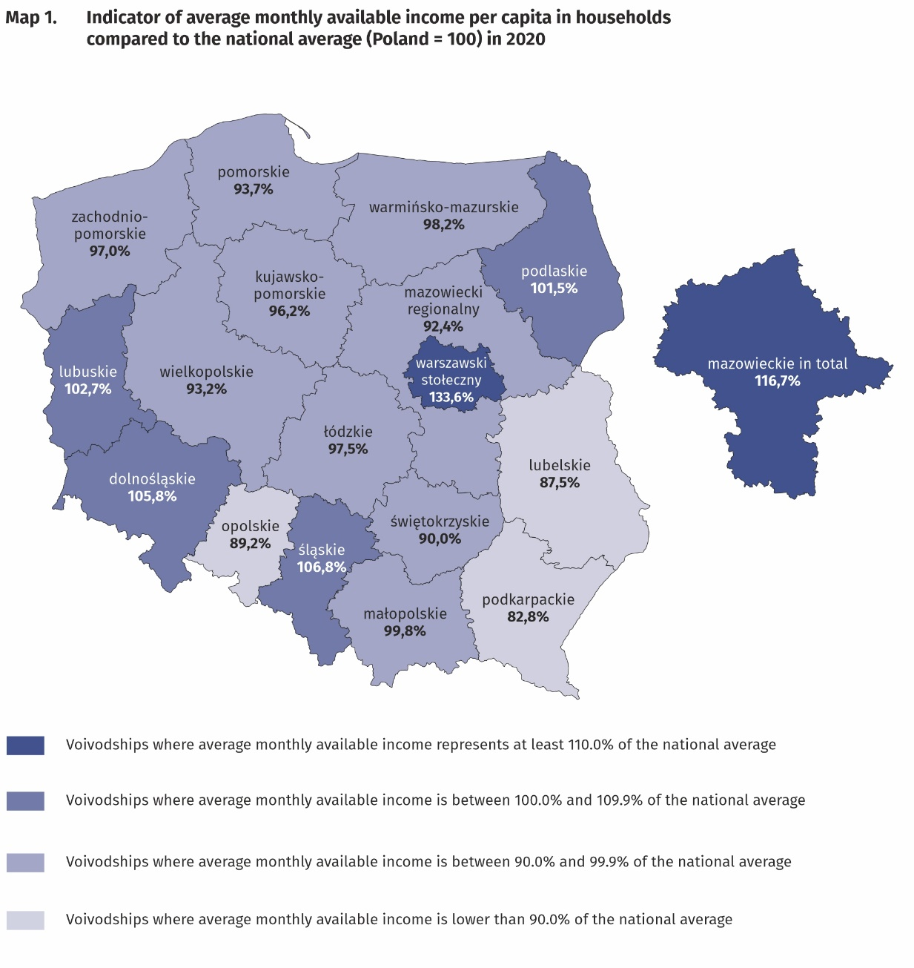
The highest average monthly available income per capita had households from the Mazowieckie Voivodship (PLN 2241) and the lowest –household living in the Podkarpackie Voivodship (PLN 1589)

In the case of expenditure, average monthly values above average for Poland in 2020 were recorded in voivodships: Mazowieckie, Dolnośląskie, Pomorskie, Opolskie, Śląskie, Zachodniopomorskie and Łódzkie. As in the previous year, the highest average monthly expenditure per capita (PLN 1443) were noted in the Mazowieckie voivodship and they were higher than the national average by 19.3% (of which by 40.9% higher in the Warsaw Capital Region and lower by 11.8% in the remaining part of the Mazowieckie Voivodship). The lowest average expenditure per capita occurred in the Podkarpackie Voivodship (PLN 931) and in comparison with the average for the whole country was lower by 23.0% as well as in the Świętokrzyskie Voivodship (lower by 17.8%).
The difference between the highest and the lowest average expenditure per capita in voivodships increased by 4.8 percentage points in comparison with 2019 year and amounted to 42.3 percentage points.

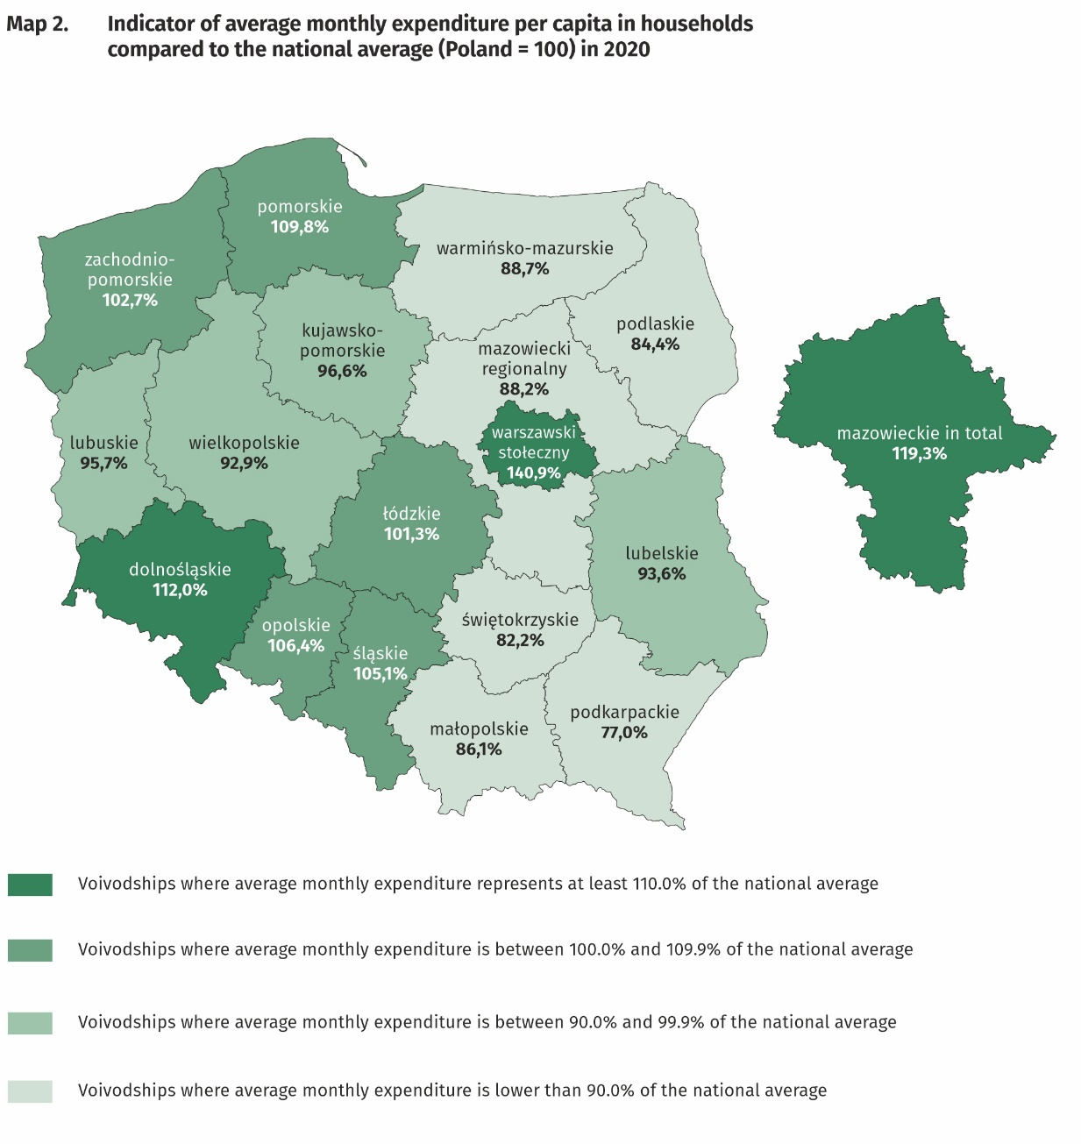
The highest average monthly expenditure per capita in households occurred in the Mazowieckie Voivodship (PLN 1443) and the lowest in the Podkarpackie Voivodship (PLN 931)

Quantitative food consumption
In 2020, there was an increase in consumption of the most basic foodstuffs, such as: flour, butter, cheese and curd, milk, sugar, pasta and pasta products, cream, oils and fats, fruit, vegetables, eggs and meat
In 2020, there was an increase in consumption of the majority of basic foodstuffs. The highest growth was recorded in: flour (by 18.6%), butter (by 14.1%), cheese and curd (by 6.7%), milk (by 6.6%), sugar as well as pasta and pasta products (5.0% each), cream as well as oils and fats (2.9% each), fruit (by 1.8%), vegetables (by 1.4%, with a simultaneous decrease in potato consumption by 2.5%), eggs (by 0.5%) and meat (by 0.2%). The consumption of fish and seafood remained at the same level, while a decrease was recorded in the case of bread and cereals (by 0.9%, of which bread by 7.7%) and processed meat and other meat preparations (by 0.5%). In 2020, the increase in the level of consumption of most basic foodstuffs and the decrease by 26.7% in expenditure on catering was due to the closure of restaurants for a significant part of the year as well as changes in the frequency, volume and structure of purchases made in connection with the COVID-19 pandemic. These changes resulted in a significant increase in the share of expenditure on food and non-alcoholic beverages in 2020.
The level of consumption of most foodstuffs greatly depends on household income. As the wealth of households increases, so does the level of consumption of certain foodstuffs, as bread and cereals, meat, vegetables, fruit, cheese and curd as well as mineral and spring water.

The level of food consumption is also affected by dietary habits, prices of foodstuffs and a place of residence. Households in rural areas compared with households in urban areas are characterised by a slightly different model of nutrition.
An increase in the value of monthly consumption per capita of vegetables (by 0.4 kg) and fruit (by 0.2 kg) in urban areas is a positive phenomenon.

The equipment of households with durable goods
In 2020, due to the COVID-19 pandemic, and thus the transition to work and learning remotely (this also applies to other interpersonal contacts), there was an increase in the level of household equipment, including the following goods: printer, device with access to the Internet (of which personal computer and smartphone)
In 2020, there was an increase in the level of household equipment with printer (by 17.1%), dishwasher (by 14.0%), smartphone (by 9.6%), device with access to the Internet (by 6.1%), passenger car (by 5.3%) and personal computer (by 5.2%). In comparison with 2019, dynamics were higher (except for device with access to the Internet, where dynamics remained at the same level as in 2019). For some goods the direction of changes reversed, resulting in a decrease in the level of household equipment with motorcycle, scooters, motorbikes (decrease by 25.0% in the number of households owning them) and game console (decrease by 4.2%). It should be noted that in the case of devices with access to the Internet, the highest rise in comparison with 2019 was recorded in the group of retirees and pensioners (by 18.8%), where an increase in equipping with smartphone was of particular importance (by 27.9%).
The level of household equipment with durable goods largely depends on their financial situation.
The richest households (5th quintile group) were much better equipped than the poorest households (1st quintile group). It should be emphasised, however, that the differences in the degree of equipment between 5th and 1st quintile groups decreased in comparison with 2019, the most – by 5.7 percentage points – in the case of passenger car and 5.1 percentage points – dishwasher. For other goods the changes were insignificant.

In terms of equipping with new generation devices, such as device with the access to the Internet, of which smartphone, households in urban areas were in a better situation than households in rural areas. In the case of plasma or LCD TV set and dishwasher there were insignificant differences, while much higher percentage of households in rural areas had bicycle (by 25.0 percentage points), passenger car (by 14.1 percentage points) or motorcycle, scooters, motorbikes (by 5.4 percentage points). In comparison with 2019, the differences between urban and rural areas in the level of equipment with new generation devices decreased slightly in favour of rural areas.

In rural areas there is a higher percentage of households owning bicycle, passenger car or motorcycle, scooters, motorbikes, while urban households were better equipped with new generation devices

Dwelling conditions
In 2020, the dwelling conditions of households improved slightly. The average household occupied a dwelling with a floor area of 81.9 m², which consisted of 3 rooms. The systematic increase in the average size of a dwelling has continued since 2013

The average household in 2020 occupied a dwelling with a floor area of 81.9 m² (in 2019 – 80.4 m²), which consisted of 3 rooms. There was an average of 29.2 m² of usable floor area and 1 room per capita in the household (in 2019 – 28.7 m² and 1 room).
The largest average usable floor area of dwellings was held by households of farmers – 132.0 m², while the smallest by households of pensioners – 66.2 m². In comparison with 2019, the highest increase in the floor area of the dwellings occupied by households occurred in the households of employees (by 2.3 m²), while the highest decrease – in households of farmers (by 2.6 m²).
The largest usable floor area per capita was in the households of retirees and pensioners (40.3 m² each), which is related to a smaller number of persons in the household, while the smallest usable floor area per capita – in the households of employees (25.4 m²).
The area of dwellings occupied by households was also differentiated according to the level of their income. In the case of the households with the highest income (5th quintile group) occupied area was slightly smaller (80.3 m²) than households with the lowest income (1st quintile group) – 86.6 m², however, their members had much greater floor area per capita (respectively 37.5 m² versus 23.4 m²).
The equipment of dwellings with technical and sanitary installations is systematically improving. Dwellings equipped with running water accounted for 99.9% of all households, with a flushing toilet – 98.9% and with a bathroom – 98.7%.
As in the previous years, the best equipped with technical and sanitary installations (except gas and central heating) were the dwellings of self-employed outside farming, and the worst – households of pensioners.
Households in urban areas were slightly better equipped with sanitary and technical installations (except gas) than households in rural areas.
Households in urban areas were slightly better equipped with sanitary and technical installations (except gas) than households in rural areas

There is clear relationship between household’s income and the equipment of dwellings in sanitary and technical installations, excluding gas, which was used by the richest households the least (5th quintile group). The most significant difference in this area between 1st and 5th quintile group in favour of the richest households concerned the equipment with central heating (6.9 percentage points), bathroom (3.0 percentage points) and flushing toilet (2.5 percentage points). These differences decreased in comparison with 2019.

A subjective evaluation of the financial situation of households
The subjective evaluation of the financial situation of households constantly improves
In all socio-economic groups, the subjective evaluation of the financial situation of households was systematically improving. In 2020, there was a further increase in the percentage of households assessing their financial situation as good or rather good (51.6% of households compared to 48.6% in 2019) and decrease in the percentage of households perceiving it as bad or rather bad (5.8% compared to 7.0% in 2019). Households of the self-employed outside farming assessed their financial situation the most favourably (73.4% positive assessments, no changes in comparison with 2019) whereas households of pensioners assessed their situation the worst (23.5% positive assessments compared with 22.4% in 2019).

The subjective evaluation of the financial situation of households depends to a large extent on the place of residence of a household. Households in rural areas assessed their financial situation worse than urban residents, especially those from cities with a population of 500 thousand or more, however, for both groups of households the assessments significantly improved in comparison with 2019. 60.9% of household in cities with a population of 500 thousand or more and 47.2% households in rural areas assessed their financial situation as good or rather good (in 2019 it was 57.0% and 44.3% respectively).

As a result of the COVID-19 pandemic, a part of households were forced to make decisions on: reducing expenditure, using savings, taking out credits and loans, selling some assets, resigning from repayment of fixed financial liabilities or providing financial support to family and friends. The most frequent decision taken by households was to reduce expenditure, which was done to a different extent by 37.2% of households (the remaining decisions were taken much less frequently). The situation of households of the self-employed was the most severely affected by the pandemic. Almost every second of them had to reduce their expenditure and as much as 6.9% to a significant extent. In the best situation in terms of the necessity to reduce expenditure were households of retirees, where expenditure was reduced by 29.5% of households.

The percentage of households in which, as a result of the COVID-19 pandemic, according to the subjective opinion of respondents total income remained at the same or similar level amounted to 74.8%, and the percentage of households where income decreased significantly – 8.2% or insignificantly – 15.7%. The increase in income according to the subjective evaluation of respondents was recorded for 1.3% of households. When analysing the situation in individual socio-economic groups, it can be noticed that the least affected by the decline in income were the households of retirees – their income in the vast majority remained at the same or similar level (91.2% of households). In the most difficult situation regarding a decrease in income compared with the previous year were the households of the self-employed outside farming, among which 51.3% experienced a significant (20.8%) or insignificant (30.5%) decline in income.
However, it should be emphasized that despite the above changes, the group of self-employed households outside farming, remained the group with the highest level of available income per capita.

In the case of a change in the income situation caused by the COVID-19 pandemic, the level of available income per capita in the household was also important. The best situation was for persons in the richest households (5th quintile group), which in 75.6% of households declared that their income did not change significantly, and in 22.2% of households that their income decreased significantly (6.9%) or insignificantly (15.3%). Among the poorest households (1st quintile group), 68.2% stated that their income remained at a similar level, while those who assessed that their income decreased significantly was 13.1%, and insignificantly – 17.8%.

In case of quoting Statistics Poland data, please provide information: “Source of data: Statistics Poland”, and in case of publishing calculations made on data published by Statistics Poland, please include the following disclaimer: “Own study based on figures from Statistics Poland”.

Prepared by:  Social Surveys Department  Director Piotr Łysoń  Office: tel. (+ 48 22) 449 40 27,  (+ 48 22) 608 31 22 | Issued by:  The Spokesperson for the President of Statistics Poland  Karolina Banaszek  Mobile: (+ 48) 695 255 011

Related information
Household Budget Survey in 2019

Data available in databases
LOCAL DATA BANK private households
HBS - material conditions of population by socio-economic groups and household size
HBS - material conditions of population by class of locality
HBS - material conditions of population by voivodships

Terms used in official statistics
Household's budget
Disposable income
Household's available income
Private household
Net household's receipts
Net household's outgoings
Quantitative consumption of foodstuffs in households per person
Subjective evaluation of material situation
Housing conditions
Expenditures of a household
Expenditures on consumer goods and services
Household's equipment

Press Office  Office: tel. (+ 48 22) 608 34 91, 608 38 04  e-mail: obslugaprasowa@stat.ob.pl |  | www.stat.gov.pl/en/
 |  | @StatPoland
 |  | @GlownyUrzadStatystyczny

In 2020, in connection with the pandemic and the introduction of various types of restrictions aimed at reducing the transmission of coronavirus by limiting interpersonal contacts, there was a change in the current method of collecting information from respondents from personal interview to telephone interview.
Due to the introduction of a new classification of individual consumption by purpose in 2013, based on harmonized COICOP classification for all surveys of the European Statistical System, the results for 2004–2020 are presented in comparable conditions – each “expenditure” item from 2004–2012 was supplemented by the “life-insurance contributions” item.
In 2020, due to favourable weather conditions, in comparison with the previous year, the estimated production of the main agricultural and horticultural crops increased (including, among others, cereals by 16% and potatoes by 40%), which in turn led in relation to 2019 to an increase in the purchase of agricultural products (including, among others, cereals by 33.2% and potatoes by 24.3%). (Source: "The resulting estimate of main agricultural and horticultural crops in 2020" and data from BDL).
The decrease in the disproportion in income from other social benefits between 2019 and 2020 in the 3rd and 4th quarter results from the fact that before 1 July 2019 the 500+ benefit was paid for the first child only in the poorest families, and only from that date for the second and subsequent child regardless of the parents' income.
In 2020, there was an increase in income from a private farm in agriculture in the socio-economic group of farmers, while it decreased in the group of: employees, self-employed and retirees.
This category includes the solidarity allowance, which could be used by people who lost their job or their contract expired after 15 March 2020 as a result of the COVID-19 pandemic. The solidarity allowance in the amount of PLN 1400 was available since 1 June 2020, for a maximum 3 months.
In 2020 the average number of persons in urban households was 2.31, while in rural households – 3.04.
This category includes devices that enable connection to the Internet, regardless of the type of device and type of Internet connection (e.g. desktop computer, laptop, tablet, TV set, smartphone).
Despite the smartphone was included in the category "Device with access to the Internet", the level of equipment with the smartphone is also presented as a separate category of device due to its universality and various uses.
The average number of persons in 1st quintile group of households was 3.35, and in 5th quintile group – 2.09.
In the 2nd quarter of 2020, in the BR-04 questionnaire, questions concerning selected aspects of the functioning of households in the conditions of an epidemic threat of an infectious disease caused by SARS-CoV-2 called "COVID-19" were added to the Household Budgets Survey.

