Index numbers of sold production of industry in January 2022^{a)}

In January 2022, sold production of industry was by 19.2% higher than in January 2021, when an increase was recorded by 0.7% as compared to the previous year, whereas in comparison with December 2021, it decreased by 3.0%.
19.2%
Increase in sold production of industry as compared to January 2021

After seasonal adjustment, an increase in sold industrial production in January 2022 amounted to 16.4% per year

After eliminating the seasonal factors, in January 2022 sold production of industry reached the level higher by 16.4% than in the corresponding month of 2021 and by 4.2% higher as compared to December 2021.
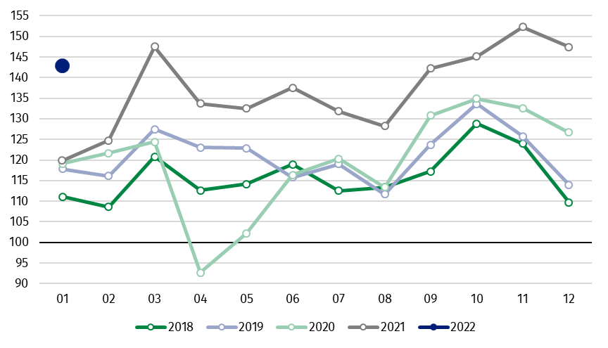
Chart 1. Sold production of industry (average monthly level in 2015=100)

In January 2022, an increase of production, as compared to previous year, was recorded in all main industrial groupings. The highest growth was observed in production of energy – by 39.2%. The lower increase was observed in production of intermediate goods – by 19.0%, durable consumer goods – by 15.9%, capital goods – by 11.5% and non-durable consumer goods – by 10.4%.

^{a)} Reported data; comprise enterprises with 10 or more persons employed.
Table 1. Index numbers of sold production of industry (constant prices)
SPECIFICATION | 01 2022
SPECIFICATION | 12 2021=100 | 01 2021=100 | monthly average  of 2015=100
INDUSTRY | 97.0 | 119.2 | 142.9
Mining and quarrying | 95.8 | 132.6 | 88.7
Manufacturing | 96.0 | 115.6 | 139.3
Electricity, gas, steam and air conditioning supply | 106.3 | 151.6 | 208.4
Water supply; sewerage waste management and remediation activities | 90.1 | 112.6 | 139.3

Share of production value of industry divisions, which saw an increase in comparison to January 2021, stood at 99.98%

According to the preliminary data, in January 2022, as compared to January 2021, an increase in sold production (in constant prices) was reported in 33 (out of 34) industry divisions, among others, in manufacture of other transport equipment – by 40.2%, in mining of coal and lignite – by 34.9%, manufacture of chemicals and chemical products – by 32.5%, manufacture of machinery and equipment – by 28.1%, manufacture of computer, electronic and optical products – by 27.5%, manufacture of metal products – by 25.1%, manufacture of products of wood, cork, straw and wicker – by 24.2%, manufacture of paper and paper products – by 19.9%.

Chart 2. Index numbers of sold production of industry by selected NACE divisions (constant prices;
previous year =100)
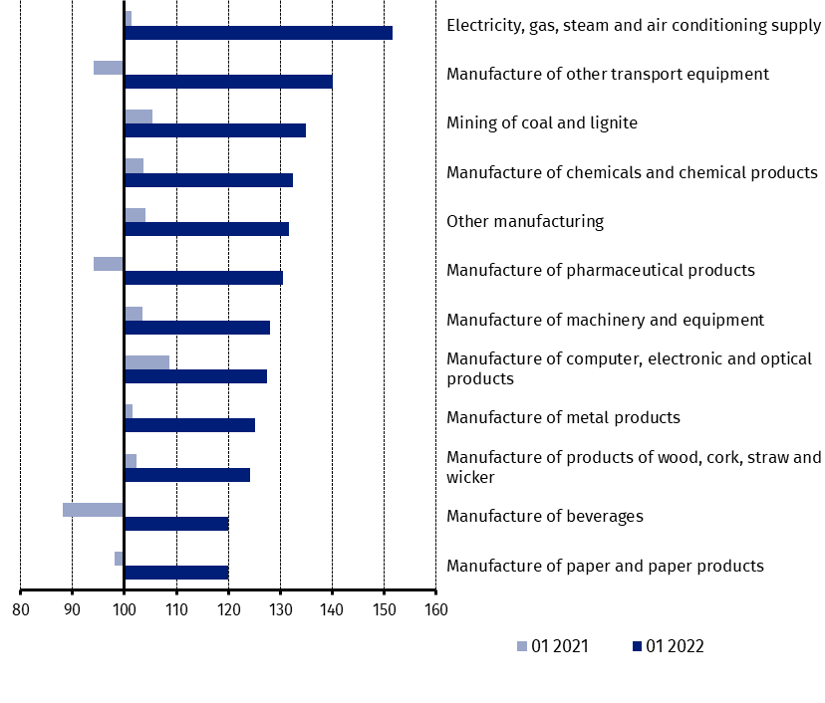
As compared to December 2021, a decrease in sold production (in constant prices) in January 2022 was recorded in 22 industry divisions, among others, in manufacture of other transport equipment – by 27.5%, manufacture of machinery and equipment – by 14.0%, manufacture of electrical equipment – by 12.1%, manufacture of coke and refined petroleum products – by 9.6%, manufacture of other non-metallic mineral products – by 6.4%, manufacture of food products – by 4.8%.
An increase in sold production of industry, as compared to December 2021, was recorded in 12 divisions, among others, in manufacture of products of wood, cork, straw and wicker – by 19.1%, manufacture of basic metals – by 14.5%, manufacture of rubber and plastic products – by 9.8%, manufacture of chemicals and chemical products – by 9.3%, manufacture of paper and paper products – by 6.7%.

Chart 3. Index numbers of sold production of industry by selected NACE divisions (constant prices;
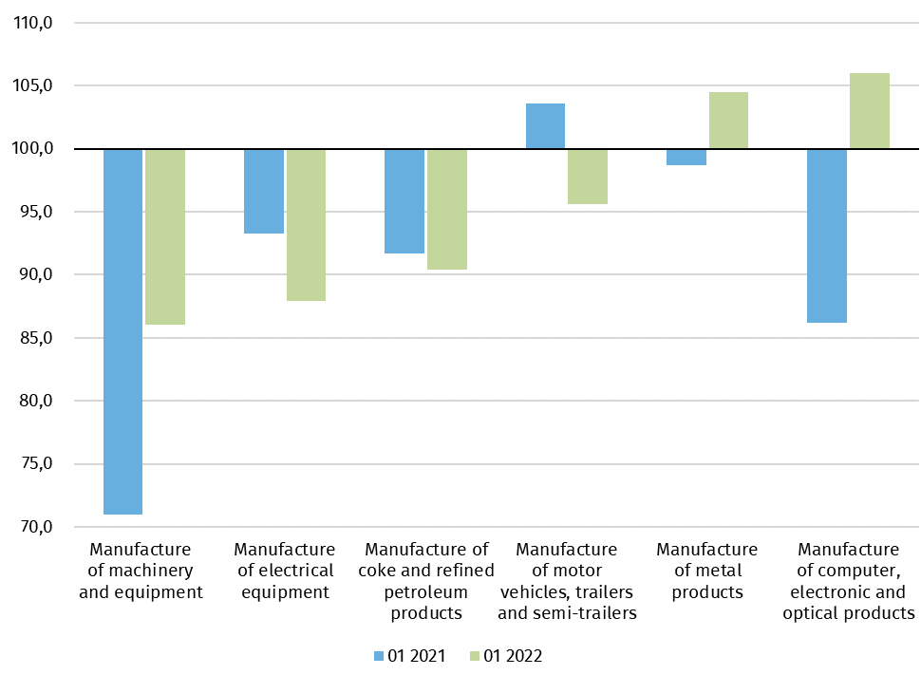
previous month =100)

In case of quoting Statistics Poland data, please provide information: “Source of data: Statistics Poland”, and in case of publishing calculations made on data published by Statistics Poland, please include the following disclaimer: “Own study based on figures from Statistics Poland”
Prepared by:  Enterprises Department  Director Katarzyna Walkowska  Phone: (+48 22) 608 31 25 | Issued by:  The Spokesperson for the President  of Statistics Poland  Karolina Banaszek  Phone: (+48) 695 255 011
Press Office  Phone: (+48 22) 608 38 04  e-mail: obslugaprasowa@stat.gov.pl |   www.stat.gov.pl/en/

@StatPoland

@GlownyUrzadStatystyczny

gus_stat

glownyurzadstatystycznygus

glownyurzadstatystyczny

Related information
Statistical Bulletin
Socio-economic situation of the country

Data available in databases
Knowledge Database - Industrial Production
Macroeconomic Data Bank
Macroeconomic indicators
Local Data Bank

Terms used in official statistics
Sold production of industry
Seasonally un-adjustedindex of sold production of industry
Seasonally adjustedindex of sold production of industry
Production of capital goods
Production of non-durable consumer goods
Production of durable consumer goods
Production of intermediate goods
Production of goods related to energy

