Index numbers of sold production of industry in February 2022^{a)}
In February 2022, sold production of industry was by 17.6% higher than in February 2021, when an increase was recorded by 2.5% as compared to the previous year, whereas in comparison with January 2022, it increased by 3.6%. In the period January-February of 2022, sold production of industry was by 17.4% higher than in the corresponding period of 2021, which saw an increase by 1.9%.
17.6%
Increase in sold production of industry as compared to February 2021

After seasonal adjustment, an increase in sold industrial production in February 2022 amounted to 17.6% per year

After eliminating the seasonal factors, in February 2022 sold production of industry reached the level higher by 17.6% than in the corresponding month of 2021 and by 2.1% higher as compared to January 2022.
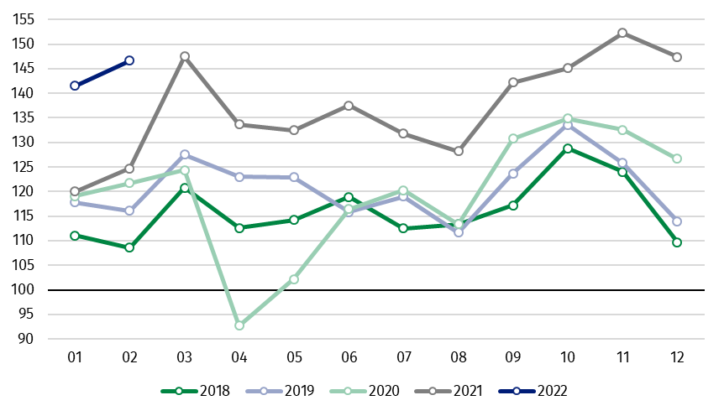
Chart 1. Sold production of industry (average monthly level in 2015=100)

In February 2022, an increase of production, as compared to previous year, was recorded in all main industrial groupings. The highest growth was observed in production of energy – by 32.7%. The lower increase was observed in production of intermediate goods – by 19.0%, capital goods – by 13.8%, durable consumer goods – by 11.6% and non-durable consumer goods – by 9.9%.

^{a)} Reported data; comprise enterprises with 10 or more persons employed.
Table 1. Index numbers of sold production of industry (constant prices)
SPECIFICATION | 02 2022 |  |  | 01-02 2022^{a)}
SPECIFICATION | 01 2022=100 | 02 2021=100 | monthly average  of 2015=100 | 01-02 2021=100
INDUSTRY | 103.6 | 117.6 | 146.6 | 117.4
Mining and quarrying | 101.3 | 119.6 | 89.6 | 126.0
Manufacturing | 105.0 | 115.8 | 146.1 | 115.4
Electricity, gas, steam and air  conditioning supply | 94.9 | 137.7 | 182.1 | 136.5
Water supply; sewerage waste  management and remediation  activities | 99.6 | 108.9 | 138.6 | 109.3

^{a)} Data including final information on production and prices in January and reported data – in February.
Share of production value of industry divisions, which saw an increase in comparison to February 2021, stood at 94.3%

According to the preliminary data, in Feabruary 2022, as compared to February 2021, an increase in sold production (in constant prices) was reported in 29 (out of 34) industry divisions, among others, in repair and installation of machinery and equipment – by 60.0%,
in mining of coal and lignite – by 34.3%, in manufacture of basic metals – by 33.5%, manufacture of computer, electronic and optical products – by 32.9%, manufacture of other non-metallic mineral products – by 27.3%, manufacture of chemicals and chemical products – by 26.4%, manufacture of coke and refined petroleum products – by 24.6%, manufacture of products of wood, cork, straw and wicker – by 24.2%, manufacture of metal products – by 21.6%.
A decrease in sold production of industry, as compared to February 2021, was recorded in 5 divisions, including manufacture of electrical equipment – by 4.0%.

Chart 2. Index numbers of sold production of industry by selected NACE divisions (constant prices;
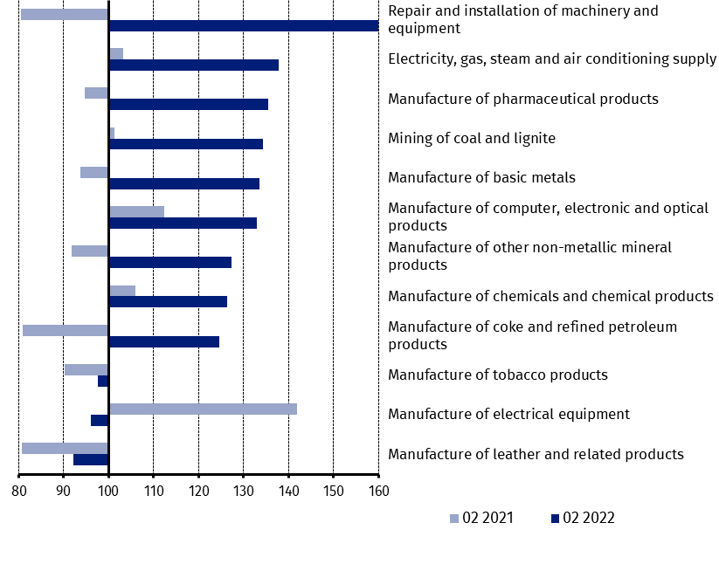
previous year =100)
As compared to January 2022, an increase in sold production (in constant prices) in February 2022 was recorded in 24 industry divisions, among others, in repair and installation of machinery and equipment – by 25.9%, in manufacture of machinery and equipment – by 10.3%, manufacture of other non-metallic mineral products – by 9.5%, manufacture of metal products – by 9.0%, manufacture of motor vehicles, trailers and semi-trailers – by 8.8%, manufacture of electrical equipment – by 6.5%, manufacture of products of wood, cork, straw and wicker – by 6.1%.
A decrease in sold production of industry, as compared to January 2022, was recorded in 10 divisions, among others, in electricity, gas, steam and air conditioning supply – by 5.1%, in manufacture of paper and paper products – by 2.8%, manufacture of other transport equipment – by 2.6%.

Chart 3. Index numbers of sold production of industry by selected NACE divisions (constant prices;
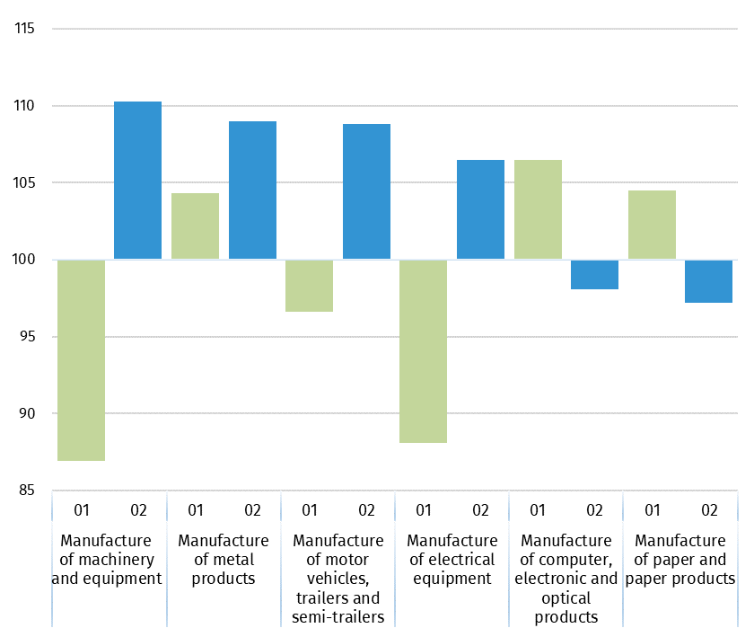
previous month =100)

In case of quoting Statistics Poland data, please provide information: “Source of data: Statistics Poland”, and in case of publishing calculations made on data published by Statistics Poland, please include the following disclaimer: “Own study based on figures from Statistics Poland”
Prepared by:  Enterprises Department  Director Katarzyna Walkowska  Phone: (+48 22) 608 31 25 | Issued by:  The Spokesperson for the President  of Statistics Poland  Karolina Banaszek  Phone: (+48) 695 255 011
Press Office  Phone: (+48 22) 608 38 04  e-mail: obslugaprasowa@stat.gov.pl |   www.stat.gov.pl/en/

@StatPoland

@GlownyUrzadStatystyczny

gus_stat

glownyurzadstatystycznygus

glownyurzadstatystyczny

Related information
Statistical Bulletin
Socio-economic situation of the country

Data available in databases
Knowledge Database - Industrial Production
Macroeconomic Data Bank
Macroeconomic indicators
Local Data Bank

Terms used in official statistics
Sold production of industry
Seasonally un-adjustedindex of sold production of industry
Seasonally adjustedindex of sold production of industry
Production of capital goods
Production of non-durable consumer goods
Production of durable consumer goods
Production of intermediate goods
Production of goods related to energy

