Index numbers of sold production of industry in May 2022^{a)}
In May 2022, sold production of industry was by 15.0% higher than in May 2021, when an increase was recorded by 29.7% as compared to the previous year, whereas in comparison with April 2022, it increased by 1.4%. In the period January-May of 2022, sold production of industry was by 14.6% higher than in the corresponding period of 2021, which saw an increase by 18.1%.
15.0%
Increase in sold production of industry as compared to May 2021

After seasonal adjustment, an increase in sold industrial production in May 2022 amounted to 11.9% per year

After eliminating the seasonal factors, in May 2022 sold production of industry reached the level higher by 11.9% than in the corresponding month of 2021 and by 1.7% lower as compared to April 2022.
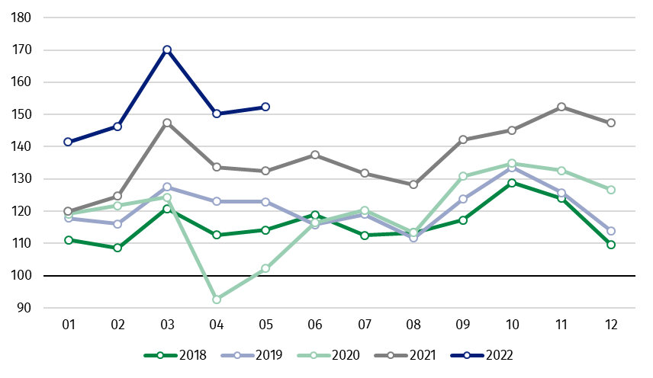
Chart 1. Sold production of industry (average monthly level in 2015=100)

In May 2022, an increase of production as compared to previous year was recorded in all main industrial groupings. The highest growth was observed in production of capital goods – by 23.0%, energy – by 18.1%, non-durable consumer goods – by 14.0%, and intermediate goods – by 12.7%. The lower increase was observed in production of durable consumer goods – by 1.7%.

^{a)} Reported data; comprise enterprises with 10 or more persons employed.
Table 1. Index numbers of sold production of industry ^{a)} (constant prices)
SPECIFICATION | 2022
SPECIFICATION | 04 | 05 | 04 | 05 | 01-05 | 04 | 05
SPECIFICATION | previous month =100 |  | previous year =100 |  |  | monthly average  of 2015=100
INDUSTRY | 88.3* | 101.4 | 112.4* | 115.0 | 114.6 | 150.2* | 152.4
Mining and quarrying | 89.7* | 100.8 | 118.6* | 117.9 | 122.8 | 97.9 | 98.7
Manufacturing | 90.7* | 103.2 | 111.1* | 115.2 | 112.9 | 152.5* | 157.4
Electricity, gas, steam and air conditioning supply | 66.5* | 81.6 | 128.2* | 112.1 | 132.5 | 150.0* | 122.4
Water supply; sewerage waste management and remediation activities | 98.2 | 103.7 | 107.0* | 111.0 | 108.7 | 151.8* | 157.5

^{a)} Data including final information on production and prices in April and reported data – in May.
* Data revised.
Share of production value of industry divisions, which saw an increase in comparison to May 2021, stood at 96.3%

According to the preliminary data, in May 2022 as compared to May 2021, an increase in sold production (in constant prices) was reported in 30 (out of 34) industry divisions, among others, in mining of coal and lignite – by 38.5%, in manufacture of machinery and equipment – by 26.9%, manufacture of coke and refined petroleum products – by 25.5%, manufacture of metal products – by 24.5%, manufacture of chemicals and chemical products – by 22.6%, manufacture of motor vehicles, trailers and semi-trailers – by 21.5%, manufacture of products of wood, cork, straw and wicker – by 16.2%, manufacture of paper and paper products – by 15.5%.
A decrease in sold production of industry, as compared to May 2021, was recorded in 3 divisions, among others, in manufacture of computer, electronic and optical products – by 5.7%.

Chart 2. Index numbers of sold production of industry by selected NACE divisions (constant prices;
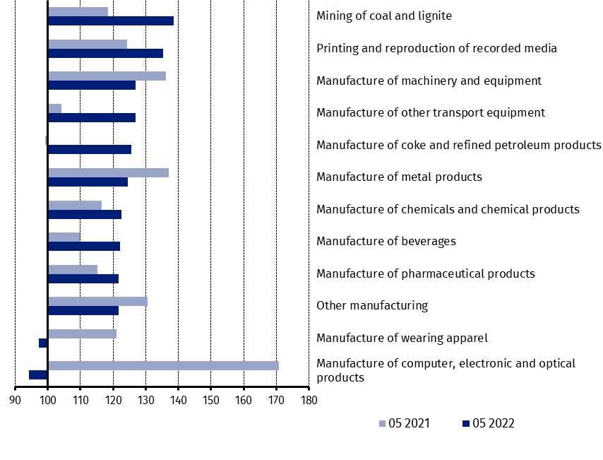
previous year =100)
As compared to April 2022, an increase in sold production (in constant prices) in May 2022 was recorded in 28 industry divisions, among others, in manufacture of coke and refined petroleum products – by 11.2%, manufacture of other non-metallic mineral products – by 9.1%, manufacture of machinery and equipment – by 8.1%, manufacture of electrical equipment – by 6.7%, manufacture of paper and paper products – by 5.7%, manufacture of computer, electronic and optical products – by 4.9%, manufacture of chemicals and chemical products – by 4.7%.
A decrease in sold production of industry, as compared to April 2022, was recorded in 6 divisions, among others, in electricity, gas, steam and air conditioning supply – by 18.4%, in mining of coal and lignite – by 4.3%, in manufacture of basic metals – by 2.9%.

Chart 3. Index numbers of sold production of industry by selected NACE divisions (constant prices;
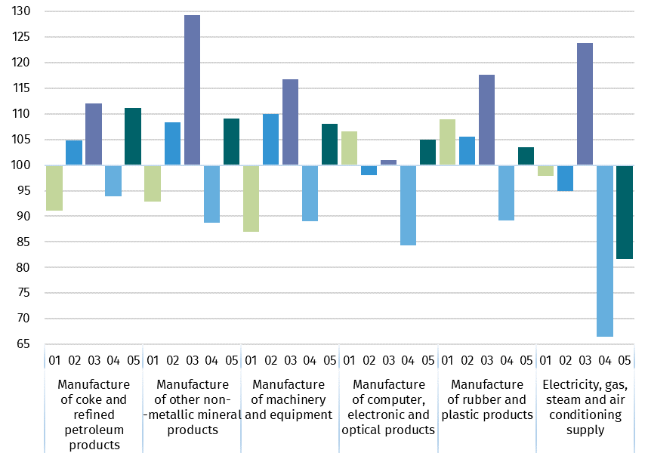
previous month =100)

In case of quoting Statistics Poland data, please provide information: “Source of data: Statistics Poland”, and in case of publishing calculations made on data published by Statistics Poland, please include the following disclaimer: “Own study based on figures from Statistics Poland”
Prepared by:  Enterprises Department  Director Katarzyna Walkowska  Phone: (+48 22) 608 31 25 | Issued by:  The Spokesperson for the President  of Statistics Poland  Karolina Banaszek  Phone: (+48) 695 255 011
Press Office  Phone: (+48 22) 608 38 04  e-mail: obslugaprasowa@stat.gov.pl |   www.stat.gov.pl/en/

@StatPoland

@GlownyUrzadStatystyczny

gus_stat

glownyurzadstatystycznygus

glownyurzadstatystyczny

Related information
Statistical Bulletin
Socio-economic situation of the country

Data available in databases
Knowledge Database - Industrial Production
Macroeconomic Data Bank
Macroeconomic indicators
Local Data Bank

Terms used in official statistics
Sold production of industry
Seasonally un-adjustedindex of sold production of industry
Seasonally adjustedindex of sold production of industry
Production of capital goods
Production of non-durable consumer goods
Production of durable consumer goods
Production of intermediate goods
Production of goods related to energy

