Index numbers of sold production of industry in July 2022^{a)}
In July 2022, sold production of industry was by 7.6% higher than in July 2021, when an increase was recorded by 9.5% as compared to the previous year, whereas in comparison with June 2022, it decreased by 6.5%. In the period January-July of 2022, sold production of industry was by 12.9% higher than in the corresponding period of 2021, which saw an increase by 17.0%.
7.6%
Increase in sold production of industry as compared to July 2021

After seasonal adjustment, an increase in sold industrial production in July 2022 amounted to 10.2% per year

After eliminating the seasonal factors, in July 2022 sold production of industry reached the level higher by 10.2% than in the corresponding month of 2021 and by 0.5% higher as compared to June 2022.
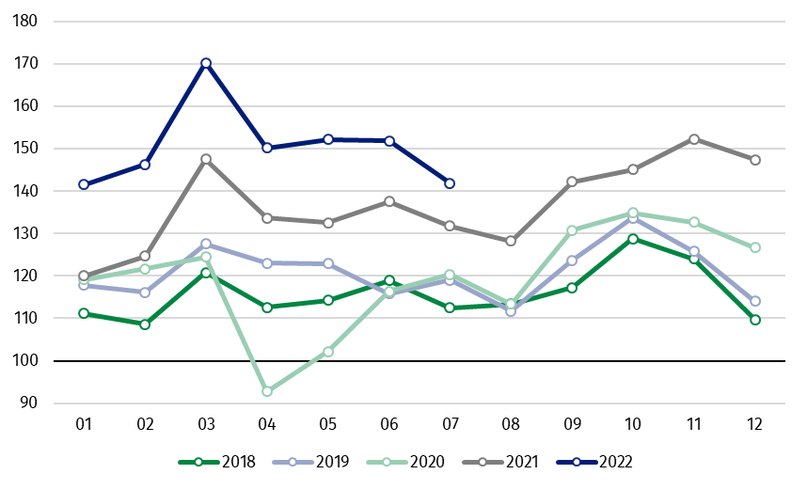
Chart 1. Sold production of industry (average monthly level in 2015=100)

In July 2022, an increase of production, as compared to previous year, was recorded in most of the main industrial groupings. The production of capital goods went up by 13.4%, energy – by 11.0%, non-durable consumer goods – by 9.3% and intermediate goods – by 5.0%. A decrease was observed in production of durable consumer goods – by 7.3%.

^{a)} Reported data; comprise enterprises with 10 or more persons employed.
Table 1. Index numbers of sold production of industry ^{a)} (constant prices)
SPECIFICATION | 2022
SPECIFICATION | 06 | 07 | 06 | 07 | 01-07 | 06 | 07
SPECIFICATION | previous month =100 |  | previous year =100 |  |  | monthly average  of 2015=100
INDUSTRY | 99.7 | 93.5 | 110.4 | 107.6 | 112.9 | 151.8 | 141.9
Mining and quarrying | 107.6* | 93.0 | 125.2* | 122.0 | 124.3 | 106.0* | 98.6
Manufacturing | 100.0* | 93.1 | 109.9* | 107.4 | 111.7 | 156.9* | 146.0
Electricity, gas, steam and air conditioning supply | 92.4* | 98.9 | 112.8* | 107.7 | 126.1 | 116.8* | 115.5
Water supply; sewerage waste management and remediation activities | 101.7* | 94.8 | 107.2* | 103.2 | 107.8 | 160.1* | 151.7

^{a)} Data including final information on production and prices in June and reported data in July.
* Data revised.
Share of production value of industry divisions, which saw an increase in comparison to July 2021, stood at 85.0%

According to the preliminary data, in July 2022 as compared to July 2021, an increase in sold production (in constant prices) was reported in 26 (out of 34) industry divisions, among others, in mining of coal and lignite – by 45.4%, in manufacture of motor vehicles, trailers and semi-trailers – by 20.4%, manufacture of machinery and equipment – by 19.0%, manufacture of chemicals and chemical products – by 16.7%, manufacture of coke and refined petroleum products – by 10.0%, manufacture of food products – by 9.9%, manufacture of metal products – by 9.4%, manufacture of electrical equipment – by 8.0%.
A decrease in sold production of industry, as compared to July 2021, was recorded in 8 divisions, among others, in manufacture of basic metals – by 8.8%, manufacture of furniture – by 7.6%, in repair and installation of machinery and equipment – by 7.0%, in manufacture of products of wood, cork, straw and wicker – by 4.0%.

Chart 2. Index numbers of sold production of industry by selected NACE divisions (constant prices;
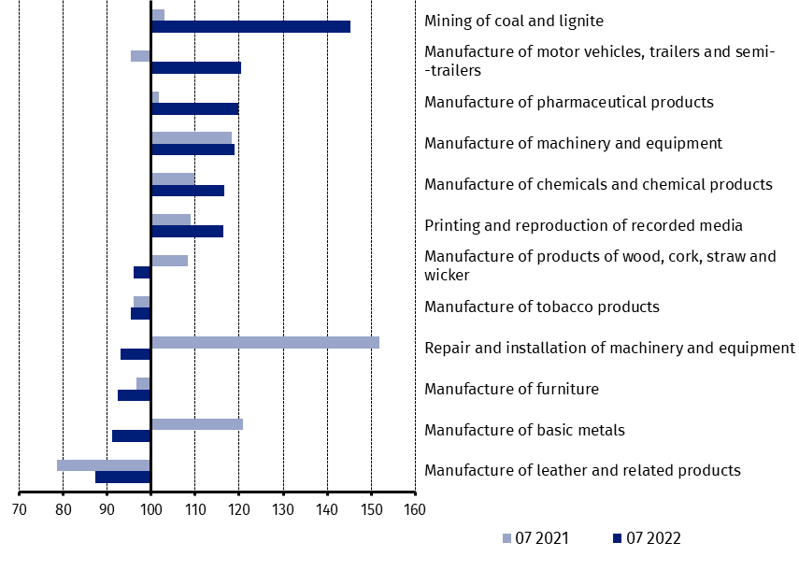
previous year =100)
As compared to June 2022, a decrease in sold production (in constant prices) in July 2022 was recorded in 28 industry divisions, among others, in repair and installation of machinery and equipment – by 28.7%, in manufacture of machinery and equipment – by 14.7%, manufacture of furniture – by 14.3%, manufacture of products of wood, cork, straw and wicker – by 13.9%, manufacture of motor vehicles, trailers and semi-trailers – by 9.7%, manufacture of metal products – by 8.5%, manufacture of other non-metallic mineral products – by 7,8%, manufacture of rubber and plastic products – by 6.6%.
An increase in sold production of industry, as compared to June 2022, was recorded in 6 divisions, among others, in manufacture of coke and refined petroleum products – by 4.4%, in mining of coal and lignite – by 2.5%.

Chart 3. Index numbers of sold production of industry by selected NACE divisions (constant prices;
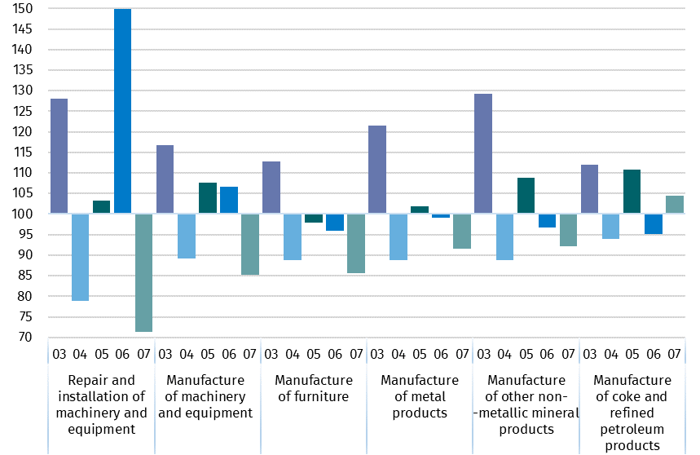
previous month =100)

In case of quoting Statistics Poland data, please provide information: “Source of data: Statistics Poland”, and in case of publishing calculations made on data published by Statistics Poland, please include the following disclaimer: “Own study based on figures from Statistics Poland”
Prepared by:  Enterprises Department  Director Katarzyna Walkowska  Phone: (+48 22) 608 31 25 | Issued by:  The Spokesperson for the President  of Statistics Poland  Karolina Banaszek  Phone: (+48) 695 255 011
Press Office  Phone: (+48 22) 608 38 04  e-mail: obslugaprasowa@stat.gov.pl |   www.stat.gov.pl/en/

@StatPoland

@GlownyUrzadStatystyczny

gus_stat

glownyurzadstatystycznygus

glownyurzadstatystyczny

Related information
Statistical Bulletin
Socio-economic situation of the country

Data available in databases
Knowledge Database - Industrial Production
Macroeconomic Data Bank
Macroeconomic indicators
Local Data Bank

Terms used in official statistics
Sold production of industry
Seasonally un-adjusted index of sold production of industry
Seasonally adjusted index of sold production of industry
Production of capital goods
Production of non-durable consumer goods
Production of durable consumer goods
Production of intermediate goods
Production of goods related to energy

