Index numbers of sold production of industry in October 2022^{a)}
In October 2022, sold production of industry was by 6.8% higher than in October 2021, when an increase was recorded by 7.6% as compared to the corresponding period of the previous year, whereas in comparison with September 2022, it decreased by 0.7%. In the period January-October of 2022, sold production of industry was by 11.6% higher than in the corresponding period of 2021, which saw an increase by 14.8% as compared to the corresponding period of the previous year.
6.8%
Increase in sold production of industry as compared to October 2021

After seasonal adjustment, an increase in sold industrial production in October 2022 amounted to 7.5% per year

After eliminating the seasonal factors, in October 2022 sold production of industry reached the level higher by 7.5% than in the corresponding month of 2021 and by 0.3% lower as compared to September 2022.
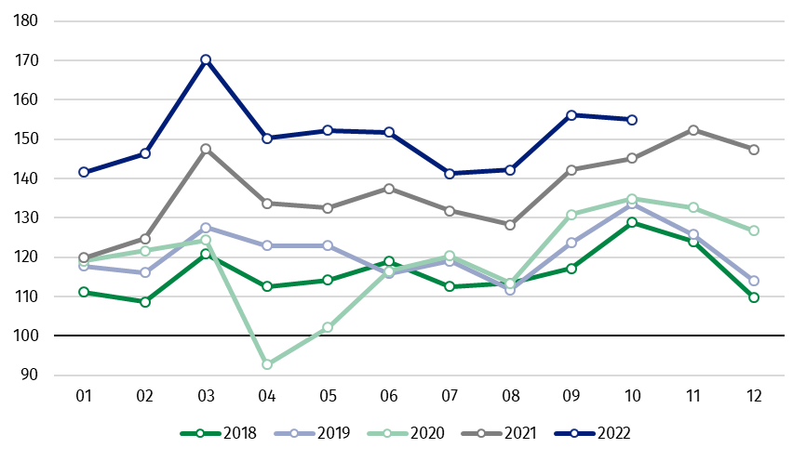
Chart 1. Sold production of industry (average monthly level in 2015=100)

In October 2022, among the main industrial groupings there was an increase per year in the production of capital goods by 26.4%, non-durable consumer goods – by 8.7% and intermediate goods – by 5.6%. A decrease was observed in production of energy – by 10.8% and durable consumer goods – by 6.6%.

^{a)} Reported data; comprise enterprises with 10 or more persons employed.
Table 1. Index numbers of sold production of industry ^{a)} (constant prices)
SPECIFICATION | 2022
SPECIFICATION | 09 | 10 | 09 | 10 | 01-10 | 09 | 10
SPECIFICATION | previous month =100 |  | previous year =100 |  |  | monthly average  of 2015 =100
INDUSTRY | 109.8 | 99.3 | 109.8 | 106.8 | 111.6 | 156.1 | 155.0
Mining and quarrying | 100.3* | 97.0 | 108.6* | 104.6 | 118.0 | 98.3* | 95.4
Manufacturing | 111.2 | 98.3 | 111.0 | 109.3 | 111.5 | 163.1* | 160.4
Electricity, gas, steam and air conditioning supply | 98.0* | 117.3 | 96.8* | 83.8 | 112.8 | 108.3* | 127.0
Water supply; sewerage waste management and remediation activities | 98.6* | 97.0 | 102.6* | 100.5 | 107.0 | 156.0* | 151.3

^{a)} Data including final information on production and prices in September and reported data in October.
* Data revised.
Share of production value of industry divisions, which saw an increase in comparison to October 2021, stood at 68.7%

According to the preliminary data, in October 2022 as compared to October 2021, an increase in sold production (in constant prices) was reported in 25 (out of 34) industry divisions, among others, in manufacture of motor vehicles, trailers and semi-trailers – by 41.6%, manufacture of electrical equipment – by 25.2%, in repair and installation of machinery and equipment – by 23.4%, in manufacture of machinery and equipment – by 17.6%, manufacture of computer, electronic and optical products – by 12.3%, manufacture of metal products – by 8.5%,
manufacture of food products– by 7.9%.
A decrease in sold production of industry, as compared to October 2021, was recorded in 9 divisions, among others, in electricity, gas, steam and air conditioning supply – by 16.2%, in manufacture of chemicals and chemical products – by 12.1%, manufacture of furniture – by 8.6%, manufacture of basic metals – by 4.5%, manufacture of products of wood, cork, straw and wicker – by 3.6%.

Chart 2. Index numbers of sold production of industry by selected NACE divisions (constant prices;
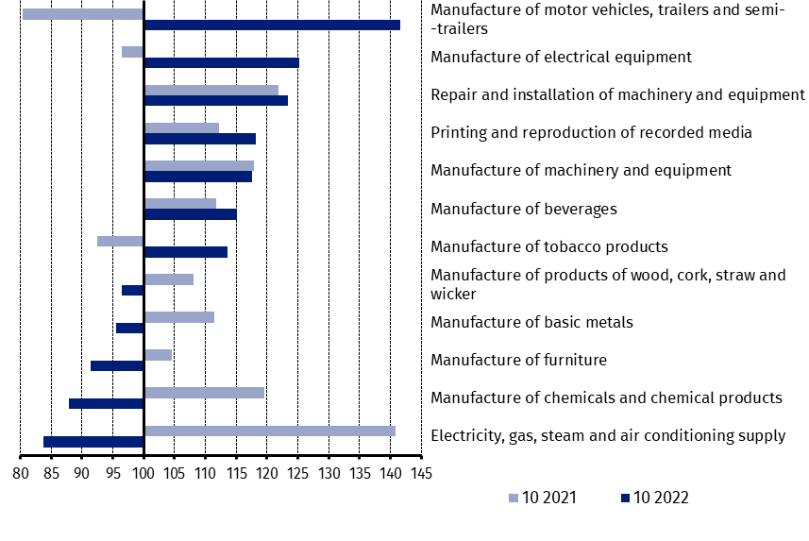
previous year =100)
As compared to September 2022, a decrease in sold production (in constant prices) in October 2022 was recorded in 24 industry divisions, among others, in manufacture of basic metals – by 8.0%, in repair and installation of machinery and equipment – by 7.4%, in manufacture of machinery and equipment – by 6.2%, manufacture of motor vehicles, trailers and semi-trailers – by 5.2%, manufacture of products of wood, cork, straw and wicker – by 4.1%, manufacture of other non-metallic mineral products – by 4.0%, manufacture of metal products – by 2.5%.
An increase in sold production of industry, as compared to September 2022, was recorded in 10 divisions, among others, in electricity, gas, steam and air conditioning supply – by 17.3%, in manufacture of computer, electronic and optical products – by 12.8%.

Chart 3. Index numbers of sold production of industry by selected NACE divisions (constant prices;
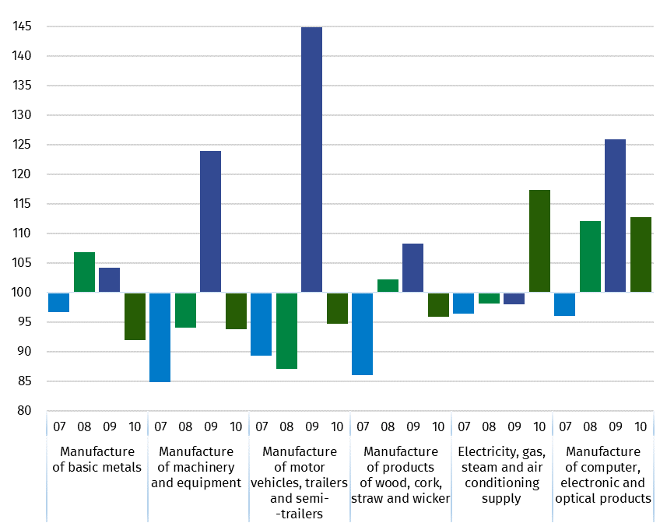
previous month =100)

In case of quoting Statistics Poland data, please provide information: “Source of data: Statistics Poland”, and in case of publishing calculations made on data published by Statistics Poland, please include the following disclaimer: “Own study based on figures from Statistics Poland”
Prepared by:  Enterprises Department  Director Katarzyna Walkowska  Phone: (+48 22) 608 31 25 | Issued by:  The Spokesperson for the President  of Statistics Poland  Karolina Banaszek  Phone: (+48) 695 255 011
Press Office  Phone: (+48 22) 608 38 04  e-mail: obslugaprasowa@stat.gov.pl |   www.stat.gov.pl/en/

@StatPoland

@GlownyUrzadStatystyczny

gus_stat

glownyurzadstatystycznygus

glownyurzadstatystyczny

Related information
Statistical Bulletin
Socio-economic situation of the country

Data available in databases
Knowledge Database - Industrial Production
Macroeconomic Data Bank
Macroeconomic indicators
Local Data Bank

Terms used in official statistics
Sold production of industry
Seasonally un-adjustedindex of sold production of industry
Seasonally adjustedindex of sold production of industry
Production of capital goods
Production of non-durable consumer goods
Production of durable consumer goods
Production of intermediate goods
Production of goods related to energy

