Index numbers of sold production of industry in November 2022^{a)}
In November 2022, sold production of industry was by 4.6% higher than in November 2021, when an increase was recorded by 14.8% as compared to the corresponding period of the previous year, whereas in comparison with October 2022, it increased by 2.9%. In the period January-November of 2022, sold production of industry was by 10.9% higher than in the corresponding period of 2021, which saw an increase by 14.9% as compared to the corresponding period of the previous year.
4.6%
Increase in sold production of industry as compared to November 2021

After seasonal adjustment, an increase in sold industrial production in November 2022 amounted to 4.4% per year

After eliminating the seasonal factors, in November 2022 sold production of industry reached the level higher by 4.4% than in the corresponding month of 2021 and by 2.7% higher as compared to October 2022.
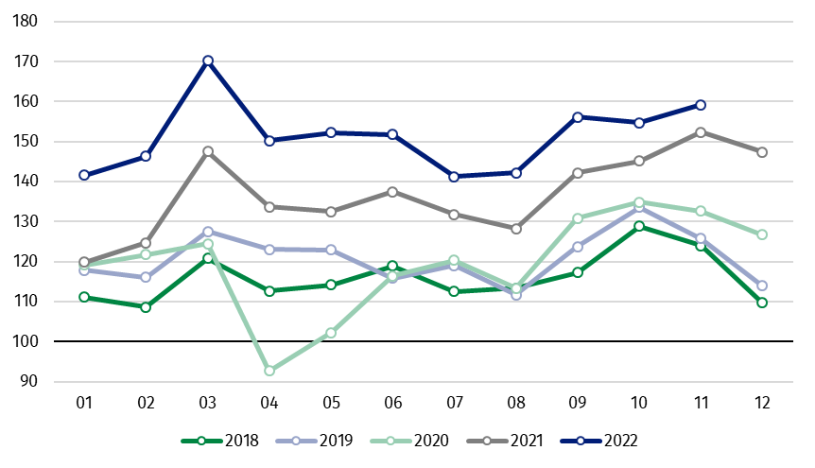
Chart 1. Sold production of industry (average monthly level in 2015=100)

In November 2022, among the main industrial groupings there was an increase per year in the production of capital goods by 13.8%, non-durable consumer goods – by 7.5% and intermediate goods – by 2.6%. A decrease was observed in production of energy – by 5.4% and durable consumer goods – by 3.2%.

^{a)} Reported data; comprise enterprises with 10 or more persons employed.
Table 1. Index numbers of sold production of industry ^{a)} (constant prices)
SPECIFICATION | 2022
SPECIFICATION | 10 | 11 | 10 | 11 | 01-11 | 10 | 11
SPECIFICATION | previous month =100 |  | previous year =100 |  |  | monthly average  of 2015 =100
INDUSTRY | 99.1* | 102.9 | 106.6* | 104.6 | 110.9 | 154.7* | 159.2
Mining and quarrying | 97.0 | 99.8 | 104.5* | 100.6 | 116.5 | 95.3* | 95.2
Manufacturing | 98.2* | 101.5 | 109.2* | 106.1 | 111.0 | 160.2* | 162.6
Electricity, gas, steam and air conditioning supply | 116.2* | 123.5 | 83.0* | 91.5 | 110.0 | 125.8* | 155.4
Water supply; sewerage waste management and remediation activities | 97.0 | 99.1 | 100.5 | 100.7 | 106.1 | 151.4* | 150.0

^{a)} Data including final information on production and prices in October and reported data in November.
* Data revised.
Share of production value of industry divisions, which saw an increase in comparison to November 2021, stood at 61.9%

According to the preliminary data, in November 2022 as compared to November 2021, an increase in sold production (in constant prices) was reported in 19 (out of 34) industry divisions, among others, in manufacture of machinery and equipment – by 24.0%, manufacture of electrical equipment – by 18.1%, manufacture of motor vehicles, trailers and semi-trailers – by 17.4%, manufacture of computer, electronic and optical products – by 16.1%,
manufacture of metal products – by 13.7%, manufacture of food products – by 6.9%, in mining of coal and lignite – by 6.7%.
A decrease in sold production of industry, as compared to November 2021, was recorded in 14 divisions, among others, in manufacture of other transport equipment – by 13.4%, manufacture of basic metals – by 13.3%, manufacture of chemicals and chemical products – by 11.1%, in electricity, gas, steam and air conditioning supply – by 8.5%, in manufacture of products of wood, cork, straw and wicker – by 4.8%, manufacture of furniture – by 4.3%.

Chart 2. Index numbers of sold production of industry by selected NACE divisions (constant prices;
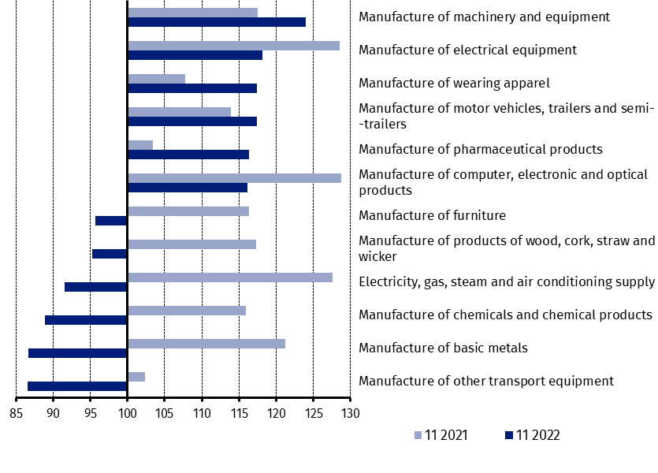
previous year =100)
As compared to October 2022, an increase in sold production (in constant prices) in November 2022 was recorded in 15 industry divisions, among others, in electricity, gas, steam and air conditioning supply – by 23.5%, in manufacture of motor vehicles, trailers and semi-trailers – by 10.4%, manufacture of machinery and equipment – by 7.5%, manufacture of furniture – by 5.1%, manufacture of metal products and manufacture of computer, electronic and optical products – by 4.0% each, manufacture of electrical equipment – by 3.7%.
A decrease in sold production of industry, as compared to October 2022, was recorded in 19 divisions, among others, in manufacture of basic metals – by 3.9%, manufacture of other non-metallic mineral products – by 2.9%, manufacture of paper and paper products – by 2.5%, manufacture of rubber and plastic products – by 2.3%, manufacture of products of wood, cork, straw and wicker – by 2.0%.

Chart 3. Index numbers of sold production of industry by selected NACE divisions (constant prices;
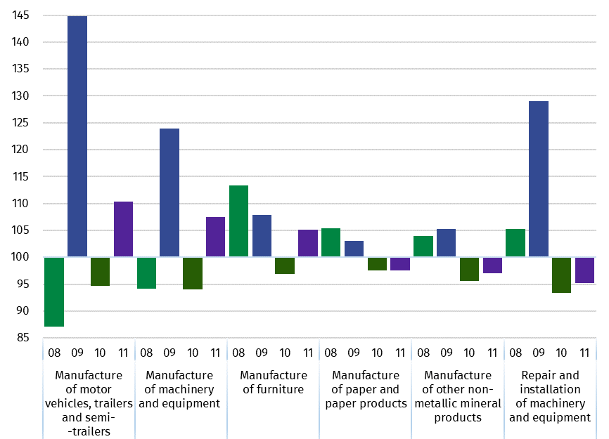
previous month =100)

In case of quoting Statistics Poland data, please provide information: “Source of data: Statistics Poland”, and in case of publishing calculations made on data published by Statistics Poland, please include the following disclaimer: “Own study based on figures from Statistics Poland”
Prepared by:  Enterprises Department  Director Katarzyna Walkowska  Phone: (+48 22) 608 31 25 | Issued by:  The Spokesperson for the President  of Statistics Poland  Karolina Banaszek  Phone: (+48) 695 255 011
Press Office  Phone: (+48 22) 608 38 04  e-mail: obslugaprasowa@stat.gov.pl |   www.stat.gov.pl/en/

@StatPoland

@GlownyUrzadStatystyczny

gus_stat

glownyurzadstatystycznygus

glownyurzadstatystyczny

Related information
Statistical Bulletin
Socio-economic situation of the country

Data available in databases
Knowledge Database - Industrial Production
Macroeconomic Data Bank
Macroeconomic indicators
Local Data Bank

Terms used in official statistics
Sold production of industry
Seasonally un-adjustedindex of sold production of industry
Seasonally adjustedindex of sold production of industry
Production of capital goods
Production of non-durable consumer goods
Production of durable consumer goods
Production of intermediate goods
Production of goods related to energy

