Producer price indices for business services in the fourth quarter of 2021

In the fourth quarter of 2021, the producer prices for business services increased by 0.9% compared to the previous quarter. Compared to the fourth quarter of 2020, the prices increased by 3.4%.
100,9
Increase in producer prices for business services compared to the third quarter of 2021

Table 1. Producer price indices for business services in the fourth quarter of 2021
Specification | quarter 4 2021 |  | quarter 1-4 2021
Specification | quarter 3 2021=100 | quarter 4 2020=100 | quarter 1-4 2020=100
Total | 100,9 | 103,4 | 102,3
Publishing activities | 102,5 | 104,0 | 102,1
Motion picture, video and television programme production, sound recording and music publishing activities | 99,2 | 98,7 | 98,1
Programming and broadcasting activities | 97,9 | 91,5 | 94,9
Computer programming, consultancy and related activities | 101,0 | 104,1 | 103,4
Information service activities | 101,0 | 101,7 | 100,9
Real estate activities | 100,5 | 103,1 | 102,2
Legal and accounting activities; management consultancy activities | 101,2 | 103,1 | 101,9
Architectural and engineering activities; technical testing and analysis | 100,3 | 102,7 | 102,7
Advertising and market research | 100,7 | 101,2 | 101,8
Other professional, scientific and technical activities | 102,1 | 103,4 | 101,2
Rental and leasing activities | 105,5 | 110,8 | 105,1
Employment activities | 101,1 | 106,0 | 105,2
Travel agency, tour operator reservation service and related activities | 99,1 | 109,8 | 98,8
Security and investigation activities | 100,5 | 108,2 | 107,9
Services to buildings and landscape activities | 100,8 | 104,8 | 104,7
Office administrative, office support and other business support activities | 101,5 | 104,3 | 102,0
In the 4th quarter of 2021, the highest increase of prices was recorded in the rental and leasing activities
In the fourth quarter of 2021, the highest increase of prices was recorded in the rental and leasing activities – i.e. by 5.5% compared to the previous quarter. The increase in prices of rental and leasing activities in the fourth quarter was mainly caused by higher prices of renting and leasing of motor vehicles. The prices of publishing activities (by 2.5%) and other professional, scientific and technical activities (by 2.1%) increased more than 2.0%.
In terms of publishing activities there was observed a significant increase in prices of publishing of newspapers and software publishing. In terms of the other professional, scientific and technical activities increase in prices of services was noticed in, among others, in translation and interpretation activities, specialised design activities and photographic activities.
Price decrease compared to the previous quarter was recorded in the case of programming and broadcasting activities (by 2.1%), travel agency, tour operator reservation service and related activities (by 0.9%), as well as motion picture, video and television programme production, sound recording and music publishing activities (by 0.8%).
Compared to the fourth quarter of 2020 the highest increase of prices was related to rental and leasing activities (by 10.8%), travel agency, tour operator reservation service and related activities (by 9.8%) as well as security and investigation activities (by 8.2%).
On the other hand the decrease in prices compared to the fourth quarter of 2020 was recorded in the case of programming and broadcasting activities (by 8.5%) as well as motion picture, video and television programme production, sound recording and music publishing activities (by 1.3%).

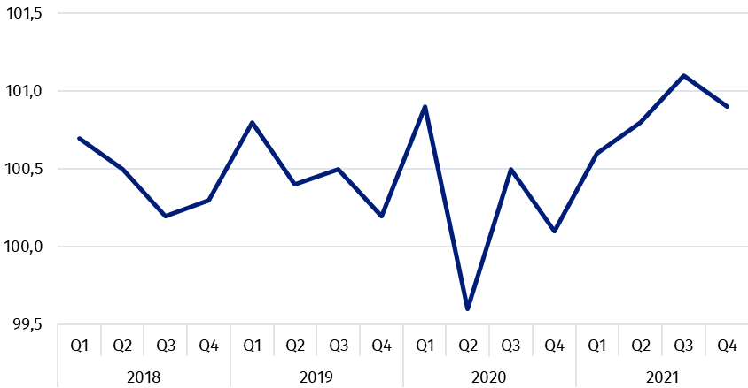
Chart 1. Producer price changes of business services in 2018-2021 (the previous quarter = 100)

Chart 2. Producer price changes of business services in 2018-2021 (corresponding period of the previous year = 100)
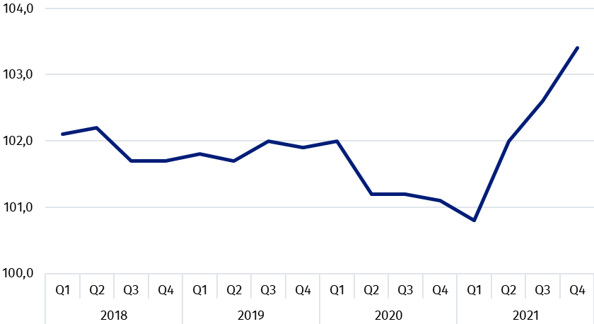

In case of quoting Statistics Poland data, please provide information: “Source of data: Statistics Poland”, and in case of publishing calculations made on data published by Statistics Poland, please include the following disclaimer: “Own study based on figures from Statistics Poland”.

Prepared by:  Trade and Services Department  Director Ewa Adach-Stankiewicz  Phone: (+48 22) 608 31 24 | Issued by:  The Spokesperson for the President  of Statistics Poland  Karolina Banaszek  Phone: (+48) 695 255 011
Press Office  Phone: (+48 22) 608 38 04  e-mail: obslugaprasowa@stat.gov.pl |   www.stat.gov.pl/en/

@StatPoland

@GlownyUrzadStatystyczny

gus_stat

glownyurzadstatystycznygus

glownyurzadstatystyczny
Related information
News releases

Prices in the national economy

Data available in databases
Analytical Platform - Knowledge Databases
Prices indices (Topics: Prices, Trade)

Terms used inn official statistics
Producer price indices for business services

