The demand for labour in the fourth quarter of 2021
10.5%
Decrease in the number of job vacancies compared to the end of the third quarter
of 2021
At the end of the fourth quarter of 2021, there were 137.4 thousand job vacancies in Poland, 62.8% more than in the corresponding period of 2020. During the fourth quarter, an annual increase (over 20%) in both the number of newly created jobs and liquidated jobs also occurred. In the fourth quarter of 2021, there were 1.7 newly created jobs per liquidated job.

The Labour Demand Survey is conducted using the representative method on a quarterly basis, on the Z–05 reporting form. It covers national economy entities employing at least one person. In the fourth quarter of 2021, private sector entities accounted for 91.0% of the covered population. In terms of size expressed by the number of employed persons, the most numerous were entities with up to 9 employed persons (68.6% of the total number), but in these entities, there were less than one fifth of all occupied jobs. Most of employed persons – 59.6% – were related to entities with 50 or more employed persons. As in the previous quarters, in the fourth quarter of 2021 around three quarters of employed persons worked in entities belonging to the private sector.
At the end of the fourth quarter of 2021, 5.8% out of 626.0 thousand economic entities had job vacancies (1.6 percentage points more than in the corresponding period of 2020). Among entities that had job vacancies, 85.1% were private sector entities, and 53.0% were the smallest entities (up to 9 employed persons).
Compared to the corresponding period of 2020, there was an increase in the number of job vacancies, the number of newly created jobs, but also an increase in the number of liquidated jobs. However, it should be emphasised that in the fourth quarter of 2021 the number of newly created jobs was still higher than the number of liquidated jobs.
In Poland, in the fourth quar-ter of 2021, the job vacancy rate was 1.12% and was higher than a year ago but lower than in the previous quarter of 2021

Table 1. Basic results of the Labour Demand Survey
QUARTERS  A – corresponding quarter  = 100  B – previous quarter  = 100 | Occupied jobs  (employed persons) | Job vacancies |  |  | Newly  created jobs | Liquidated jobs
 | Occupied jobs  (employed persons) | total | of total |  | Newly  created jobs | Liquidated jobs
 | Occupied jobs  (employed persons) | total | newly created | reported to labour offices | Newly  created jobs | Liquidated jobs
 | at the end of the quarter |  |  |  | during the quarter
 | in thousands
2020
Quarter 4 | 12 218.5 | 84.4 | 17.5 | 10.2 | 91.5 | 53.9
2021
Quarter 1 | 12 186.9 | 110.2 | 24.0 | 13.7 | 191.7 | 70.2
Quarter 2 | 12 189.8 | 142.8 | 35.0 | 21.9 | 145.8 | 58.5
Quarter 3 | 12 172.4 | 153.5 | 35.7 | 22.8 | 132.6 | 57.8
Quarter 4 | 12 149.4 | 137.4 | 32.3 | 16.8 | 112.5 | 64.9
A | 99.4 | 162.8 | 184.1 | 165.5 | 123.1 | 120.3
B | 99.8 | 89.5 | 90.5 | 73.8 | 84.8 | 112.2

The labour demand statistics presented in this study looked slightly different in relation to the third quarter of 2021: the number of job vacancies and the number of newly created jobs decreased, but the number of liquidated jobs increased.
Table 2. Selected indicators in the scope of the demand for labour
QUARTERS | Share of economic entities with job  vacancies in %  (as at the end of  the quarter) | Job vacancy rate in %  (as at the end of  the quarter) | The ratio of the number of newly created jobs to the number  of liquidated jobs (during the quarter)
2020
Quarter 4 | 4.2 | 0.69 | 1.7
2021
Quarter 1 | 5.5 | 0.90 | 2.7
Quarter 2 | 6.1 | 1.16 | 2.5
Quarter 3 | 6.7 | 1.25 | 2.3
Quarter 4 | 5.8 | 1.12 | 1.7

Job vacancies at the end of the fourth quarter of 2021
The Labour Demand Survey enables the analysis of data on job vacancies, i.e. positions or jobs unoccupied due to labour turnover or newly created ones that simultaneously meet the following three conditions:
- the positions and jobs were actually unoccupied on the survey day,
- the employer made efforts to find people willing to take up the job,
- if adequate candidates were found to occupy the vacancies, the employer would readily take them on.
The total number of job vacancies in Poland recorded at the end of the fourth quarter of 2021 amounted to 137.4 thousand. This number compared to the third quarter of 2020 increased by 62.8%. Almost a quarter of these jobs were newly created ones. At that time, the number of newly created jobs also increased, to an even greater degree, by 84.1%. Economic entities were looking for employees for instance through labour offices, to which 16.8 thousand job vacancies (12.2% of the total number of job vacancies) were reported.
At the end of the fourth quar-ter of 2021, there was recorded a significant increase in the number of vacant newly created jobs in comparison with the corresponding period of the previous year

Chart 1. Job vacancy rate
As at the end of the quarter
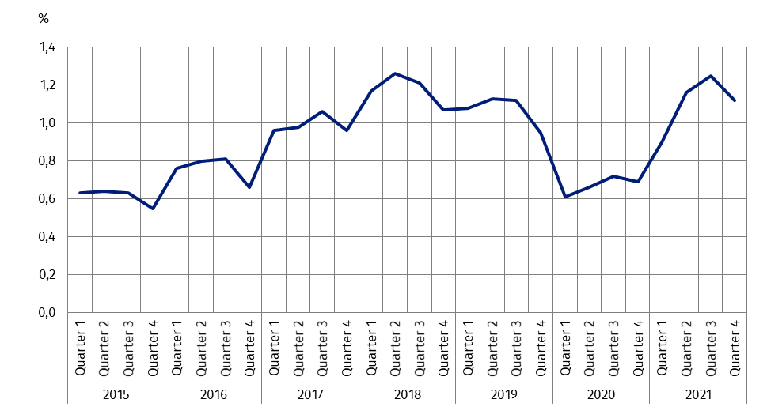
One of the measures for assessing the situation on the labour market is the job vacancy rate, which is the share of job vacancies in the sum of the number of occupied posts and the number of job vacancies in a given period. At the end of the fourth quarter of 2021 this rate amounted to 1.12% and was 0.43 percentage points higher than in the corresponding period of 2020, but 0.13 percentage points lower than in the third quarter of 2021.
When analysing data by kind of conducted activity it was noticed that at the end of the fourth quarter of 2021, the most, i.e. 23.7% of job vacancies were in entities conducting economic activities in the scope of Manufacturing (32.6 thousand). In this section, there were 8.4 thousand vacant newly created jobs (25.9% of all job vacancies). Compared to the corresponding quarter of 2020, in this section, the total number of job vacancies, as well as vacant newly created jobs, increased by more than a half.
In the fourth quarter, the highest job vacancy rate, as
a year ago, was recorded in the Information and communication section
Many job vacancies at the end of the fourth quarter of 2021 were also recorded in the Construction section (21.9 thousand jobs, including 17.7% newly created jobs). This section had the second highest job vacancy rate (2.76%). Large numbers of job vacancies were also recorded in sections: Trade; repair of motor vehicles∆ (15.2 thousand), Transportation and storage (12.9 thousand) and Information and communication (12.8 thousand job vacancies). In the latter section the highest job vacancy rate (3.65%) among all NACE sections occurred.
In the fourth quarter of 2021, the largest increase per year in the number of job vacancies was recorded in the Accommodation and catering∆ section (2.6-fold increase, with an almost sevenfold increase in the number of newly created jobs). The sections with a significant increase in the number of jobs compared to the fourth quarter of 2020 also included Construction and Information and communication (increases of almost 150%).

Chart 2. Job vacancies and the job vacancy rate by PKD/NACE sections in the fourth quarter of 2021
As at the end of the quarter
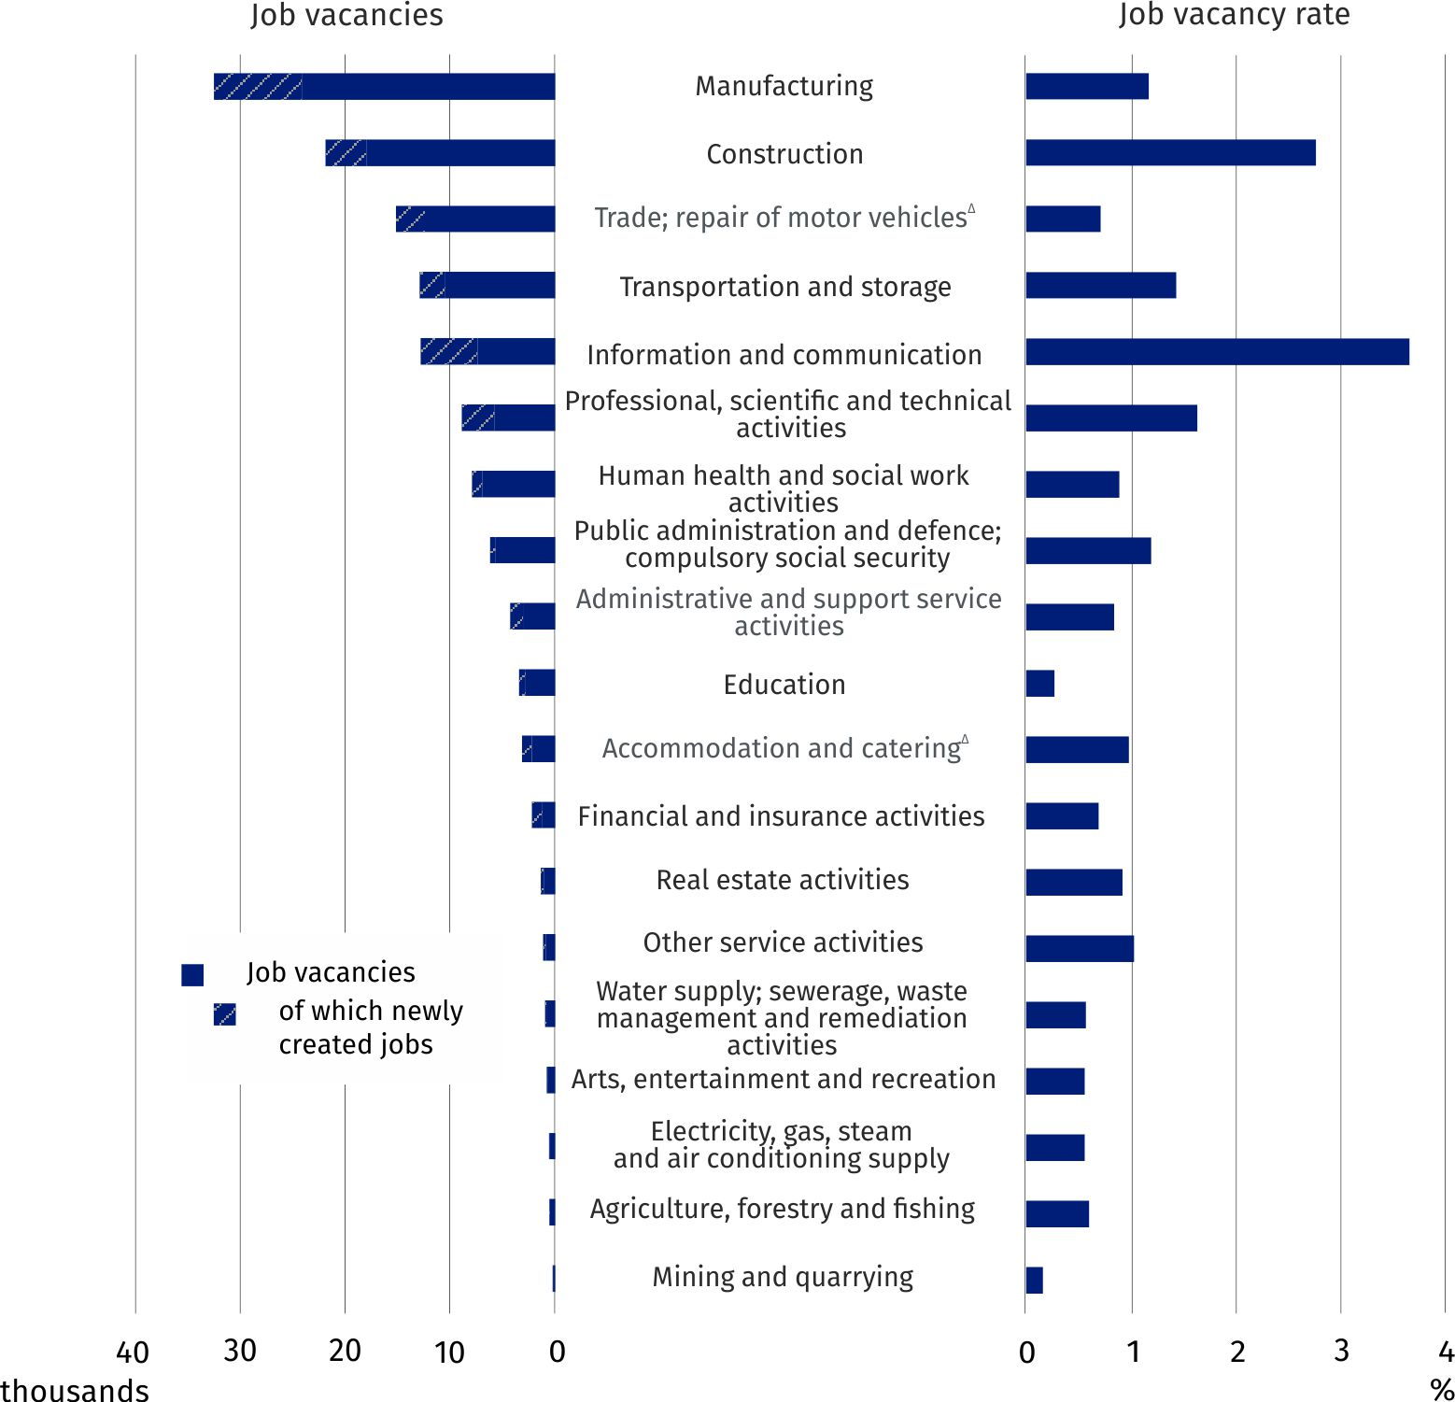
The analysis of the results of the Labour Demand Survey for the fourth quarter of 2021 broken down by major occupational group shows that the number of job vacancies in all occupational groups increased over a year's time. Entities with job vacancies were most often seeking Professionals (33.8 thousand job vacancies, of which 32.2% were newly created jobs). The number of job vacancies in this occupational group increased by 58.9% over a year's time.
In the fourth quarter of 2021, job vacancies were offered primarily in occupations
belonging to major occupational groups of Professionals and Craft and related trades workers
In the analysed quarter, many job vacancies (31.8 thousand jobs) were recorded in the major occupational group of Craft and related trades workers (23.1% of all job vacancies), and their number increased by 87.8% per year. In the occupational group: Craft and related trades workers, vacant newly created jobs accounted for 18.1% of their total number.
The highest job vacancy rate at the end of the fourth quarter of 2021 was recorded in the Opolskie region

When looking at the job vacancy rate in the fourth quarter of 2021 in a territorial breakdown by region, it can be seen that its highest value was recorded in the Opolskie region (2.02%). This value of the indicator was more than four times higher than in the Podkarpackie region (0.48%). In the Opolskie region, the number of job vacancies increased over 3.5 times compared to the fourth quarter of 2020. High values of the indicator were also recorded in the following regions: Małopolskie (1.60%), Dolnośląskie (1.36%), Zachodniopomorskie (1.35%) and Warszawski stołeczny (1.34%).

Newly created and liquidated jobs during the fourth quarter of 2021
The Labour Demand Survey also enables to analyse the situation on the labour market in terms of the number of newly created jobs (resulting from organisational changes, expansion or change in the business profile and all jobs in newly created units) and liquidated jobs (lost as a result of organisational changes, limiting or changing the business profile). During the fourth quarter of 2021, 112.5 thousand new jobs were created in Poland and 64.9 thousand jobs were liquidated. Compared to the corresponding period of the previous year, there was an increase of 23.1% in the number of newly created jobs and an increase of 20.3% in the number of liquidated jobs.
In the fourth quarter of 2021, there was an annual increase in the number of newly created jobs as well as liquidated jobs
Comparing the results of the current survey with the results for the third quarter of 2021, there is a noticeable decrease in the number of newly created jobs (by 15.2%), with an increase in the number of liquidated jobs (by 12.2%).
Chart 3. Newly created and liquidated jobs
During the quarter
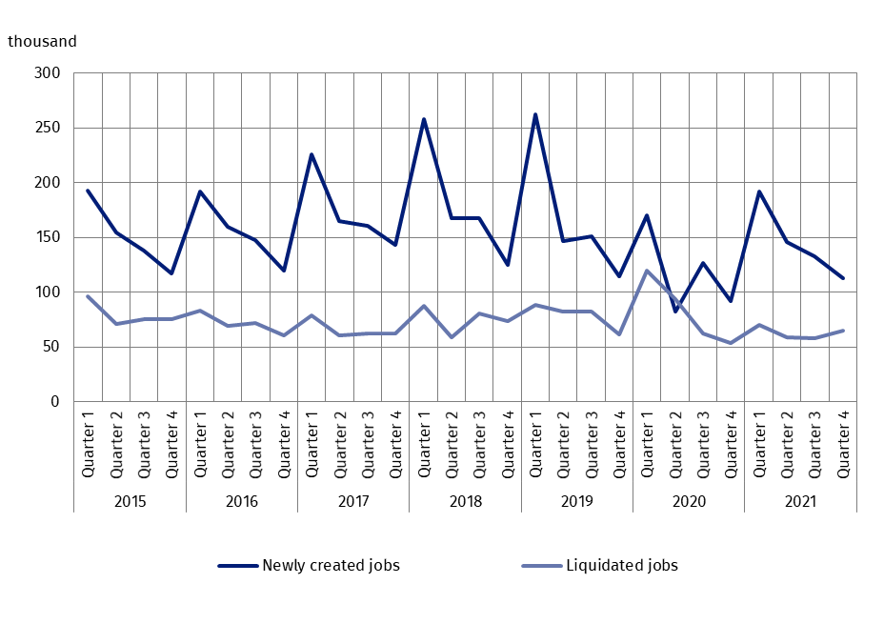
One of the measures for assessing the labour market's adjustment to the labour demand is the ratio of the number of newly created jobs to the number of jobs liquidated in a given period. In the fourth quarter of 2021, as in the corresponding period of 2020, 1.7 new jobs were created per job liquidated, which was the same as a year ago. In the third quarter of 2021, the indicator was higher, amounting to 2.3 jobs.

Chart 4. The ratio of the number of newly created jobs to the number of liquidated jobs
During the quarter
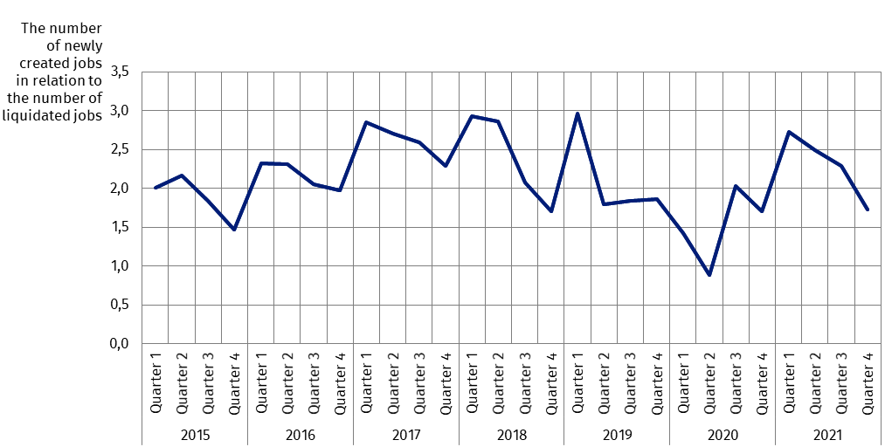
In the analysed quarter of 2021, the most jobs were created in the Manufacturing section, while the most jobs were liquidated in the Trade; repair of motor vehicles∆ section

When analysing data broken down by PKD/NACE section it can be noted that, in the fourth quarter of 2021, the largest number of jobs were created in entities operating in Manufacturing (21.6 thousand jobs, i.e. 73.6% more compared to the fourth quarter of 2020). In the same period, 10.6 thousand jobs were liquidated (a decrease of 16.3% annually). There were 2.0 newly created jobs per liquidated job.
In the fourth quarter of 2021, the most jobs were liquidated in the Trade; repair of motor vehicles∆ section (13.9 thousand jobs), in which section, in the same period 19.3 thousand new jobs were created. As a result of these movements in the analysed quarter, 1.4 new jobs were created per job liquidated.
Among sections with a significant scale of job losses in the fourth quarter of 2021 was also Construction (16.4% of liquidated jobs). In this section 1.1 new jobs were created per job liquidated (10.9 thousand jobs were liquidated and 12.1 thousand jobs were created). This indicator was also high in the sections: Education and Professional, scientific and technical activities, in which there were more than 3.5 newly created jobs per liquidated job.
In the fourth quarter of 2021, the largest number of newly created jobs per liquidated job were in the Lubelskie region

The distribution of jobs in the fourth quarter of 2021 in a territorial breakdown shows that the largest number of new jobs per liquidated job were created in the Lubelskie region (2.9 newly created jobs). Moreover, more than 2 newly created jobs per liquidated job were recorded in the following regions: Warszawski stołeczny, Wielkopolskie and Śląskie. The lowest ratio (0.9 new jobs per liquidated job) occurred in the Mazowiecki regionalny region.

Chart 5. Newly created and liquidated jobs in Poland by PKD/NACE section in the fourth quarter of 2021
During the quarter
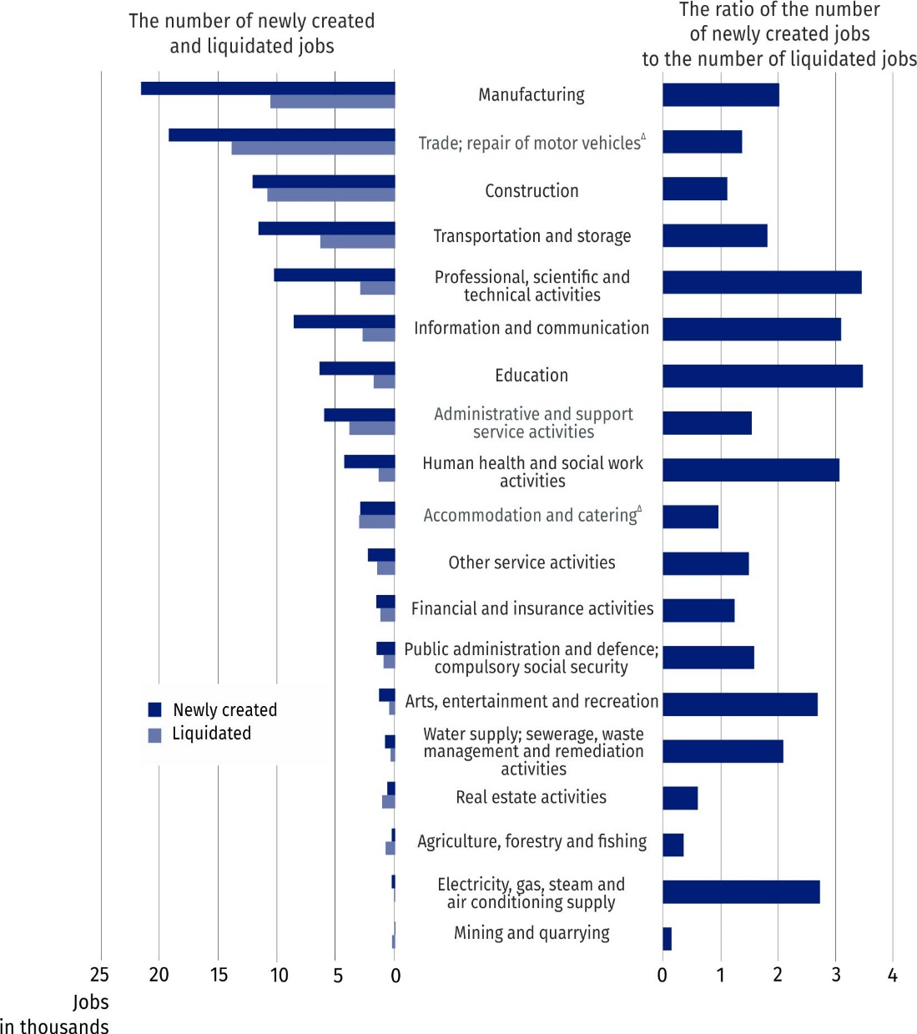

In this news release abbreviated names of NACE, Rev. 2 sections were used. Abbreviations are marked with a ‘Δ’ symbol. Full names are available on the Eurostat website at:
https://ec.europa.eu/eurostat/data/classifications
Relative numbers (rates, percentages) were calculated on the basis of absolute data expressed with greater accuracy than given in the study.

In the case of quoting Statistics Poland data, please provide information: ‘Source of data: Statistics Poland’, and in the case of publishing calculations made on data published by
Statistics Poland, please provide information: ‘Own elaboration based on Statistics Poland data’.

Prepared by:  Statistical Office in Bydgoszcz  Director Wiesława Gierańczyk, Ph.D.  Office: tel. (+48 52) 366 93 90 | Issued by:  The Spokesperson for the President  of Statistics Poland  Karolina Banaszek  Mobile: (+48) 695 255 011
Press Office  Office: tel. (+48 22) 608 38 04  e-mail: obslugaprasowa@stat.gov.pl |   stat.gov.pl/en/

@StatPoland

@GlownyUrzadStatystyczny

gus_stat

glownyurzadstatystycznygus

glownyurzadstatystyczny
Related information
The demand for labour in 2020 – annual publication
The demand for labour in the third quarter of 2021
The impact of the Covid-19 epidemic on selected elements of the labour market in the third quarter of 2021
Other publications that contain the results of these surveys: stat.gov.pl → Topics → Labour market
Methodological report. The demand for labour
Data available in databases
Knowledge databases – Labour market
Strateg → Themes → Labour market
Local Data Bank → Labour market
Statistics for the SDGs – global indicators
Terms used in official statistics
Demand for labour
Vacancies
Newly created jobs
Liquidated jobs

Classification of Occupations and Specialisations (KZiS) – introduced by the Regulation of the Minister of Labour and Social Policy of 7 August 2014 on the classification of occupations and specialisations for the needs of the labour market and the scope of its applications (Journal of Laws (Dz. U.) 2018, item 227).

