The situation of households in 2021 on the basis of results of the Household Budget Survey
In 2021, the income situation of households slightly improved, while the increase
of income in real terms was at the level similar to the previous year

The structure and level
of expenditure have changed as a result of the gradual loosening of restrictions
on the lasting since 2020
COVID-19 pandemic
In 2020, the financial situation of households slightly improved despite the ongoing COVID-19 pandemic, which had a significant impact on the level and structure of expenditure in particular. Households achieved both higher income and expenditure. The level of average monthly available income per capita in 2021 rounded
to 1 PLN, amounted to PLN 2062 and in real terms it was higher by 2.2% (by 7.4% in nominal terms) than the income in 2020. Thereby the upward trend in available income was maintained and its dynamics remained at the level similar to the previous year. The average monthly expenditure per capita in households in 2021 amounted to PLN 1316 and in real terms it was higher by 3.5% (by 8.8% in nominal terms) than expenditure in 2020. Expenditure on consumer goods and services amounted to PLN 1269 and in real terms it was higher by 3.6% (by 8.9% in nominal terms) in comparison with 2020. The largest increase was in expenditure on education, restaurants and hotels, transport, clothing and footwear, and health. These changes were conditioned by the changing pandemic situation and the loosening of restrictions and a gradual return to pre-pandemic expenditure, which was significantly reduced in 2020.
2.2%
The increase of the average monthly available income per capita in households in 2021 – in real terms

In the years 2004–2021,
the financial situation
of households was systematically improving
Income and expenditure
Households of self-employed outside farming had the highest average available monthly income (PLN 2487) and expenditure (PLN 1490) per capita
In 2021, there was still a relatively large diversity in average monthly income and expenditure between various socio-economic groups of households. Similarly to the previous years, the highest average monthly available income per capita in households (PLN 2487) and average monthly expenditure per capita (PLN 1490) were recorded in households of self-employed outside farming. In this group of households – in comparison with the average for the total of households in Poland – both income and expenditure were higher by 20.6% and 13.2% respectively (in 2020, by 16.6% and 16.8% respectively).
Similarly to the previous years, households of pensioners had the lowest average monthly available income per capita in 2021. Their average income per capita amounted to PLN 1638, which was by 20.5% lower than average for households in total (in 2020 – by 20.7%). The lowest average expenditure was noted in the households of farmers (PLN 942) and it was by 28.4% lower than average for households in total (in 2020 – lower by 30.6%).

The highest share of expenditure in available income was observed in households of pensioners and the lowest in households of farmers

As in previous years, the highest share of expenditure in income (79.7%) and the lowest amount of average monthly excess of available income per capita over expenditure per capita
(PLN 332) was recorded in the households of pensioners. The lowest share of expenditure in income (46.9%) and the highest average excess of income over expenditure (PLN 1066), similarly to the previous year, was observed in the households of farmers.
In comparison with the previous year the share of expenditure in income for total households increased by 0.8 percentage points to 63.8% (in 2020 decreased by 5.8 percentage points), which might be related to the dynamics of the COVID-19 pandemic and associated limitations.
The difference between average monthly available income among socio-economic groups in relation to the national average amounted to 41.1 percentage points (in 2020 – 37.3 percentage points), while the difference of average monthly expenditure was 41.6 percentage points (in 2020 – 47.4 percentage points).

In 2021, there was a growth in average monthly available income per capita in real terms in total – by 2.2% (in 2020 – by 2.0%). Growth in real terms occurred in all socio-economic groups of households, among which the highest income in real terms was recorded in the households of self-employed outside farming (by 5.6%), and the lowest – in the households of employees (by 0.6%).
The highest share of income from the main source of income occurred in the households of retirees (84.7%) and the lowest in the households of farmers (70.4%).
In 2021, in comparison with 2020, differences in the structure of the average monthly available income per capita in households ranged from -0.7 percentage points in the case of income from other social benefits to +0.9 percentage points for income from self-employment.

In 2021, as a result of the lasting since March 2020 COVID-19 pandemic and its diverse dynamics, there were both periods of tightening and loosening of sanitary restrictions, and thus in individual quarters of 2021 compared with the corresponding quarters of the previous year, there were noticeable changes in the structure of the average monthly available income per capita in households. The largest differences occurred in the case of income from self-employment, for which an increase in the share in the structure of total income was recorded in all quarters (the highest in the second quarter – by 2.0 percentage point in comparison with the corresponding period of 2020). A decline in the share in total income in all quarters compared with the previous year was observed in the income from other social benefits, including child-rising benefit (the highest decrease in the second quarter – by 0.9 and 0.7 percentage points respectively). In the case of income from hired work in the first three quarters of 2021 a slight increase in the share in the structure of total income was recorded in relation to the same quarters of 2020, and in the fourth quarter there was a decrease (by 1.5 percentage points), which is also related to the dynamics of the epidemic situation and the related restrictions, both in 2020 and in 2021.

Table 1. Structure of average monthly available income per capita in households by quarters
SPECIFICATION | Total |  | the 1st quarter |  | the 2nd quarter |  | the 3rd quarter |  | the 4th quarter
SPECIFICATION | 2020 | 2021 | 2020 | 2021 | 2020 | 2021 | 2020 | 2021 | 2020 | 2021
SPECIFICATION | in % of total income
Income from hired work | 53,0 | 53,0 | 52,2 | 52,6 | 52,9 | 53,1 | 53,5 | 54,1 | 53,5 | 52,0
Income from self-employment | 9,1 | 10,0 | 8,8 | 9,3 | 9,1 | 11,1 | 9,2 | 9,8 | 9,2 | 9,8
Income from private farm in agriculture | 3,3 | 3,3 | 3,9 | 3,9 | 3,2 | 2,6 | 2,5 | 2,6 | 3,6 | 4,3
Income from social security benefits | 23,9 | 23,9 | 23,9 | 24,0 | 24,6 | 24,0 | 23,8 | 23,1 | 23,4 | 24,5
of which: from retirement pensions | 20,5 | 21,0 | 20,3 | 20,9 | 21,0 | 20,8 | 20,5 | 20,5 | 20,3 | 21,6
from pensions | 2,9 | 2,6 | 3,0 | 2,8 | 3,1 | 2,9 | 2,9 | 2,3 | 2,7 | 2,5
Income from other social benefits | 8,3 | 7,6 | 8,4 | 8,0 | 8,2 | 7,3 | 8,5 | 7,9 | 8,3 | 7,3
Of which from child-rising benefit | 6,1 | 5,6 | 6,2 | 6,0 | 6,2 | 5,5 | 6,0 | 5,6 | 6,1 | 5,6
Other income* | 2,4 | 2,1 | 2,9 | 2,2 | 1,9 | 1,9 | 2,5 | 2,5 | 2,2 | 2,0
* In the category 'Other income' are included: income from property, income from real estate renting and other income.

The diversity of income per capita in households, measured by the Gini coefficient, after a period of decline in 2014-2017 and temporary stabilisation, since 2019 increases. In 2021 value of Gini coefficient amounted to 0.319.

Recorded in the years 2014-2017 significant decline in disparity in income per capita in households, measured by Gini coefficient, in 2018 was stopped and since 2019 the diversity of income increases
In 2021, the percentage of households with the income below PLN 2000 per capita decreased
In 2021, 49.7% of households had an average monthly available income per capita below PLN 2000 (56.0% in 2020), 42.4% of households had an income between PLN 2000 and PLN 4000 per capita (37.6% in 2020), 5.6% of households had an income from PLN 4000 to PLN 6000 per capita (4.7% in 2020), and PLN 6000 or more per capita had 2.3% of households (1.7% in 2020). In 2021, the percentage of households with an average monthly income of at least PLN 2000 per capita amounted to 50.3% (in 2020 – 44.0%).
In 2021, in comparison with the previous year, in real terms the average expenditure per capita increased by 3.5%. Also in all socio-economic groups of households there was a real increase in average monthly expenditure per capita in comparison with 2020 (from 0.3% in the group of self-employed to 6.1% in the group of farmers).
In real terms – the average expenditure per capita in households in 2021 increased by 3.5% in comparison with the previous year

In the second year of the COVID-19 pandemic there were significant changes in the structure of expenditure: the share of expenditure on electricity, gas and other fuels as well as on transport increased the most, while the share of expenditure on food and non-alcoholic beverages decreased the most
Expenditure on food and non-alcoholic beverages, similarly to the previous years, had the highest share in the structure of expenditure for households in total – 26.4% and ranged from 23.6% in households of self-employed outside farming to 32.3% in households of farmers. Since 2016, the share of expenditure on food and non-alcoholic beverages rose moderately in the structure of total expenditure, in 2020 rose significantly due to the COVID-19 pandemic, and in 2021 – declined by 1.3 percentage point.
Another important item in households expenditure was on housing, water, electricity, gas and other fuels. Its share in total expenditure was on average 19.0% and increased by 0.2 percentage points in 2021. The lowest share of this expenditure was in the households of self-employed (16.4%) and the highest in the households of pensioners – 23.5%.
In 2021, the second year of pandemic, in relation to the previous year, the share in the structure of expenditure increased the most in the following groups: electricity, gas and other fuels (by 0.7 percentage points), transport (by 0.6 percentage points), clothing and footwear, health, restaurants and hotels as well as recreation and culture (by 0.3 percentage points each), which is related to the slow return to the pre-COVID-19 pandemic expenditure state and the specific structure of expenditure in the base year 2020 due to the pandemic and the resulting restrictions.

In the case of the main groups of costumer goods and services, between 2020 and 2021, changes in the share in expenditure structure for households in total ranged from -1.3 percentage points (food and non-alcoholic beverages) to +0.6 percentage points (transport).

As a result of connected with lasting since 2020 the COVID-19 pandemic consecutive periods of closure of the economy and its opening as well as changes in lifestyle of population, there were observed significant changes in the structure of average monthly expenditure per capita in households in individual quarters of 2021 in comparison with the corresponding quarters of 2020. The increase in the share in total expenditure from the second to fourth quarters was observed in 4 groups of expenditure: transport (the greatest increase compared to the previous year was in second quarter and amounted to 1.4 percentage points), health (the highest increase in the second quarter – 1.1 percentage point), restaurants and hotels (the highest increase in the fourth quarter – 1.0 percentage point), and recreation and culture (the highest increase in the second quarter – 0.5 percentage points). The decrease in the share in total expenditure from the second to fourth quarters of 2021 compared with 2020 was recorded in 3 expenditure groups: food and non-alcoholic beverages (the largest decrease in the second quarter – by 3.2 percentage points), furnishings, household equipment and routine maintenance of the house (the highest decrease in the fourth quarter
– by 0.6 percentage points), and alcoholic beverages, tobacco (the highest decrease in the second and fourth quarter – by 0.3 percentage points).

Table 2. Structure of average monthly expenditure per capita in households by quarters
SPECIFICATION | Total |  | the 1st quarter |  | the 2nd quarter |  | the 3rd quarter |  | the 4th quarter
SPECIFICATION | 2020 | 2021 | 2020 | 2021 | 2020 | 2021 | 2020 | 2021 | 2020 | 2021
SPECIFICATION | in % of total expenditure
Food and non-alcoholic beverages | 27,7 | 26,4 | 27,1 | 27,8 | 29,8 | 26,6 | 25,8 | 25,0 | 28,1 | 26,3
Alcoholic beverages, tobacco | 2,9 | 2,7 | 2,4 | 2,7 | 3,1 | 2,8 | 3,0 | 2,8 | 3,0 | 2,7
Clothing and footwear | 4,1 | 4,4 | 3,7 | 3,7 | 3,8 | 4,4 | 4,7 | 4,7 | 4,4 | 4,7
Housing, water, electricity, gas and other fuels | 18,8 | 19,0 | 19,1 | 20,6 | 19,6 | 18,4 | 17,9 | 17,8 | 18,8 | 19,2
Furnishings, household equipment and routine maintenance of the house | 5,7 | 5,6 | 5,0 | 5,8 | 5,9 | 5,6 | 5,9 | 5,6 | 6,0 | 5,4
Health | 5,3 | 5,6 | 6,1 | 5,9 | 4,4 | 5,5 | 5,0 | 5,2 | 5,6 | 5,8
Transport | 8,8 | 9,4 | 9,1 | 8,6 | 8,8 | 10,2 | 9,4 | 9,5 | 7,9 | 9,2
Communication | 4,9 | 4,8 | 4,7 | 5,0 | 5,3 | 4,9 | 4,7 | 4,7 | 5,0 | 4,6
Recreation and culture | 5,7 | 6,0 | 5,7 | 5,1 | 5,4 | 5,9 | 6,5 | 7,5 | 5,3 | 5,6
Education | 1,0 | 1,1 | 1,4 | 1,3 | 0,7 | 1,1 | 0,8 | 1,0 | 1,2 | 1,2
Restaurants and hotels | 3,8 | 4,1 | 3,9 | 2,4 | 2,9 | 3,8 | 5,8 | 6,4 | 2,7 | 3,7
Miscellaneous goods and services | 6,1 | 6,0 | 6,3 | 6,1 | 5,7 | 5,7 | 5,9 | 5,6 | 6,7 | 6,6
Other expenditure | 3,7 | 3,6 | 4,1 | 3,7 | 3,3 | 3,6 | 3,4 | 3,1 | 4,1 | 3,9
Pocket money | 1,3 | 1,2 | 1,4 | 1,3 | 1,3 | 1,3 | 1,2 | 1,1 | 1,2 | 1,2
In the households of 20% of persons in the most favourable financial situation was accumulated 39.7% of income of entire surveyed population of households, while in the households of 20% of the persons in the worst situation
– 6.3%
The average available income per capita in the group of the 20% of persons with the highest income (5th quintile group) amounted to PLN 4099 per capita, and it was 6.3 times higher (in 2020 – 5.6 times higher and amounted to PLN 3728) than the respective income of the 20% of persons with the lowest income (1st quintile group). This means that there was an increase in disproportions between the richest and the poorest persons in the last year.
In the households of 20% of persons in the most favourable income situation, there was accumulated 39.7% of income of entire surveyed population of households (in 2020 – 38.8%), while in the households of 20% of persons in the worst income situation – 6.3% (in 2020
– 7.0%). The difference in the share of accumulated income between the extreme quintile groups increased by 1.6 percentage points to 33.4 percentage points.

The average monthly expenditure per capita in the 5th quintile group were 2.1 times higher than in the 1st quintile group (in 2020 – 2.3 times higher). The share of expenditure in available income in the highest quintile group amounted to 50.9%, and in the lowest – 151.5%. Similarly to the previous years, the poorest households still were forced to use their savings, or loans, or credits, and to more extent than in 2020, when their average expenditure amounted to 126.5% of their average income.

The average monthly available income per capita in urban households was by 28.9% higher than in rural households
The average monthly expenditure per capita in urban households was by 31.3% higher than in rural households
The place of residence is another factor that substantially diversified dynamics and structure of income and expenditure of households.
The average monthly available income per capita in urban households was by 28.9% higher than in rural households (in 2020 by 28.0%). These differences resulted from the amount of income obtained by households, but were also connected with the larger number of persons living in rural households. Similar situation was observed in the case of expenditure of households. Average monthly expenditure per capita in urban households was by 31.3% higher than in rural households (in 2020 – 35.4%).

In territorial terms the income higher than the national average appeared in the voivodships: Mazowieckie, Dolnośląskie, Śląskie, Lubuskie, Łódzkie and Warmińsko-Mazurskie. As in the previous year, definitely the highest average income per capita was in households in the Mazowieckie Voivodship – PLN 2450, of which PLN 2758 in the Warszawski Stołeczny Region and PLN 1993 in the remaining part of the Mazowieckie Voivodship (Region Mazowiecki Regionalny). This income was higher than the average national income per capita by 18.8% (of which higher than national average by 33.7% in the Warszawski Stołeczny Region and lower by 3.3% in the remaining part of the Mazowieckie Voivodship). The lowest income obtained households in the Opolskie Voivodship (PLN 1691) – by 18.0% below the national average. The next voivodships with the lowest level of income were voivodships: Podkarpackie (by 17.4% lower than the average for Poland) and Pomorskie (lower by 11.0%).
The difference between the highest and the lowest average income per capita in voivodships in relation to the national average compared with the previous year increased by 2.9 percentage points and amounted to 36.8 percentage points.

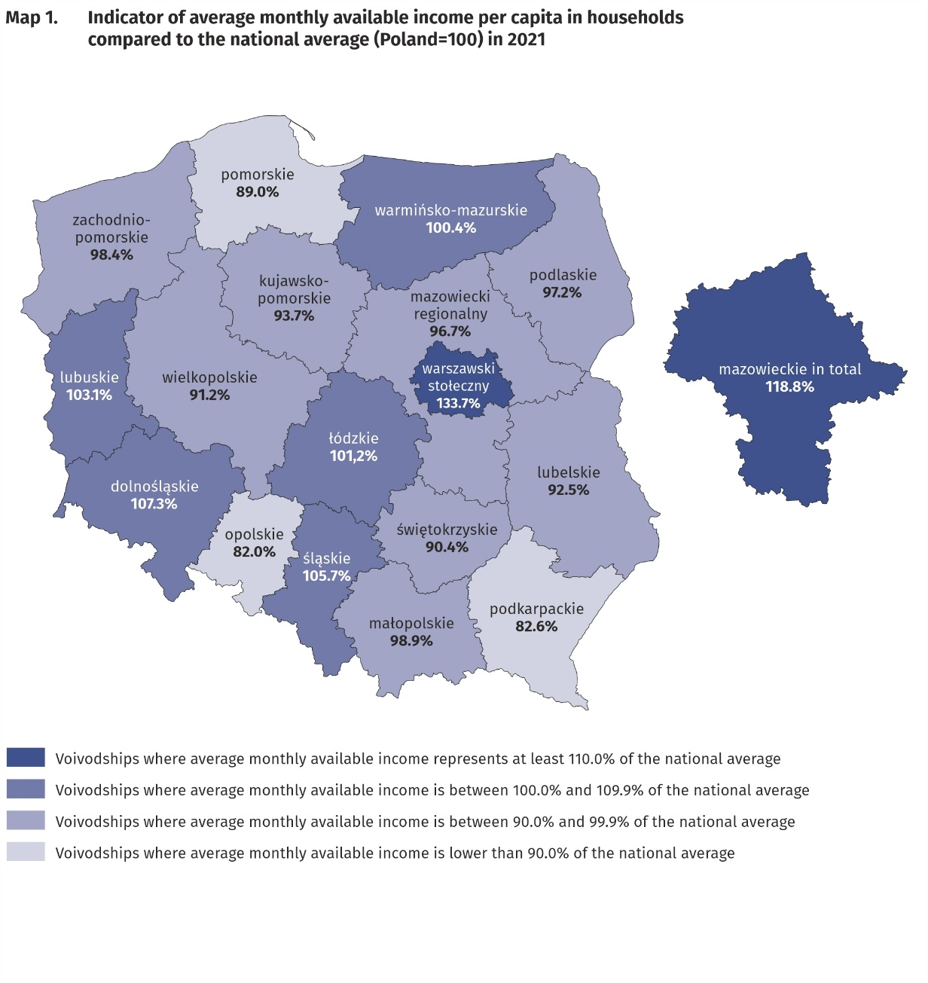
The highest average monthly available income per capita had households from the Mazowieckie Voivodship (PLN 2450) and the lowest
– household living in the Opolskie Voivodship (PLN 1691)

In the case of expenditure, average monthly values above average for Poland in 2021 were recorded in voivodships: Dolnośląskie, Mazowieckie, Pomorskie, Śląskie, Opolskie and Łódzkie. The highest average monthly expenditure per capita (PLN 1561) was noted in the Dolnośląskie voivodship and they were higher than the national average by 18.6%. This means that for the first time this expenditure was the highest in a voivodeship other than Mazowieckie, for which it amounted to PLN 1508 and was higher than the national average by 14.6%, of which by 33.6% higher in the Warszawski Stołeczny Region and lower by 13.6% in the remaining part of the Mazowieckie Voivodship (Region Mazowiecki Regionaly). The lowest average expenditure per capita occurred in the Podkarpackie Voivodship (PLN 1005) and in comparison with the average for the whole country was lower by 23.6%, the Świętokrzyskie Voivodship (lower by 18.2%), Małopolskie Voivodship (lower by 17.5%) as well as Podlaskie Voivodship (lower by 16.4%).
The difference between the highest and the lowest average expenditure per capita in voivodships decreased only by 0.1 percentage points in comparison with 2020 year and amounted to 42.2 percentage points.
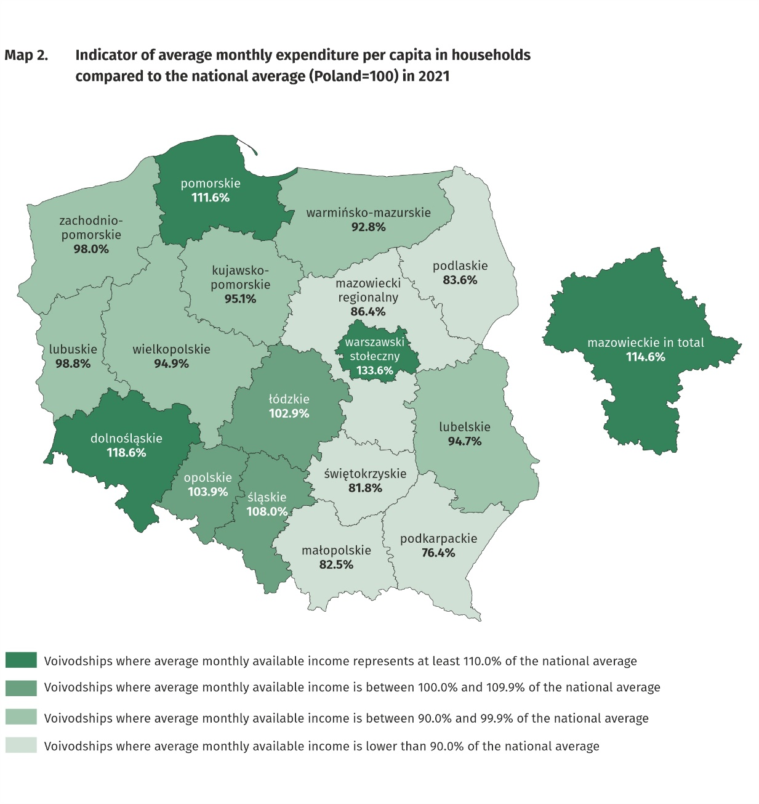
The highest average monthly expenditure per capita in households occurred in the Dolnośląskie Voivodship (PLN 1561) and the lowest – in the Podkarpackie Voivodship (PLN 1005)

Quantitative food consumption
In 2021, there was a decrease in consumption of the most basic foodstuffs, such as: sugar, flour, oils and fats, milk, vegetables, cream, bread and cereals, processed meat and other meat preparations, meat, pasta and pasta products, eggs
In 2021, there was a decrease in consumption of the majority of basic foodstuffs. The highest decline was recorded in: sugar (by 10.7%), flour (by 10.0%), oils and fats (by 5.6%, of which of which margarine and other hard vegetable fats by 11.5%), milk (by 5.2%), vegetables (by 3.8%, of which potatoes by 7.8%), cream (by 2.8%), bread and cereals (by 2.6%, of which bread by 2.9%), processed meat and other meat preparations (by 2.6%), meat (by 2.4%, of which raw poultry meat by 6.5%), pasta and pasta products (by 2.4%) as well as eggs (by 2.2%). An increase in consumption was noted in the case of fish and seafood (by 3.7%), fruit (by 2.3%) as well as cheese and curd (by 2.1%). The decrease in the level of consumption of most basic foodstuffs and the increase by 15.6% in expenditure on catering was influenced, as well as the rise in food prices, by the gradual loosening of restrictions related to the COVID-19 pandemic, enabling functioning of catering establishments and the resulting from it changes in the frequency, volume and structure of purchases made. These changes resulted in a noticeable decrease in the share of expenditure on food and non-alcoholic beverages in the total expenditure of households in 2021 (in 2020, there was a significant increase in this type of expenditure in comparison with the period before the COVID-19 pandemic).
The level of consumption of most foodstuffs greatly depends on household income. As the wealth of households increases, so does the level of consumption of certain foodstuffs, as bread and cereals, meat, vegetables, fruit, cheese and curd as well as mineral and spring water.

The level of food consumption is also affected by dietary habits, prices of foodstuffs and a place of residence. Households in rural areas compared with households in urban areas are characterised by a slightly different model of nutrition. In the rural areas there was
a higher consumption of bread and cereals, meat and sugar, and in urban areas – fruit as well as mineral and spring waters.
A positive phenomenon is a decrease in the value of monthly consumption per capita of sugar (by 0.1 kg), both in urban and rural areas.

The equipment of households with durable goods
In 2021, there was an increase in the number of households equipped with the following goods: dishwasher, smartphone, plasma or LCD set, bicycle, passenger car, device with access to the Internet as well as satellite or cable television equipment
In 2020, there was an increase in the number of households equipped with dishwasher (by 4.2%), smartphone (by 2.2%), plasma or LCD TV set and bicycle (by 1.6% each), passenger car (by 1.3%), device with access to the Internet (by 1.2%) and satellite or cable television equipment (by 1.0%). It should be noted that in the case of passenger cars, the highest increase in relation to 2020 was recorded in the group of pensioners (by 17.8%), which results from the fact that households of pensioners were not saturated with this good (only 1/3 of them had
a passenger car). For some types of goods there was a further decline in the number of households equipped with them and it concerned following goods: CRT set (drop by 42.9% in the number of households owning them), motorcycle, scooters, motorbikes (drop by 11.9%), home theatre system (drop by 5.6%) as well as equipment for reception, recording and reproduction of sound (drop by 4.3%).
The level of household equipment with durable goods largely depends on their financial situation.
The richest households (5th quintile group) were much better equipped than the poorest households (1st quintile group). It should be emphasised, however, that the differences in the degree of equipment between 5th and 1st quintile groups decreased in comparison with 2020, the most – by 3.6 percentage points – in the case of dishwasher and – by 3.1 percentage points – smartphone. For other goods the changes were insignificant.

In terms of equipping with new generation devices, such as device with the access to the Internet, of which smartphone, there were slight differences in the degree of equipping with these devices between households in urban and rural areas (by 1.1 percentage points in favour of urban areas and by 1.4 percentage points in favour of rural areas respectively). In the case of plasma or LCD TV set and dishwasher there were slightly larger differences (by 2.9 percentage points and 3.3 percentage points respectively) in favour of households in rural areas. Much higher percentage of households in rural areas had bicycle (by 25.2 percentage points), passenger car (by 15.9 percentage points) or motorcycle, scooters, motorbikes (by 4.1 percentage points). In comparison with 2020, the distance between urban and rural areas in terms of equipment with new generation devices has decreased, and in the case of equipment with
a dishwasher, has increased the difference between better equipped with this good households in the rural areas and those in the urban areas.

In rural areas there was a higher percentage of households owning dishwasher, bicycle, passenger car or motorcycle, scooters, motorbikes, while urban households were better equipped with devices with access to the Internet

Dwelling conditions
In 2021, the dwelling conditions of households improved slightly. The average household occupied a dwelling with a floor area of 83.9 m², which consisted of 3 rooms. The systematic increase in the average size of a dwelling has continued since 2013

The average household in 2021 occupied a dwelling with a floor area of 83.9 m² (in 2020 – 81.9 m²), which consisted of 3 rooms. There was an average of 30.0 m² of usable floor area and 1 room per capita in the household (in 2020 – 29.2 m² and 1 room).
The largest average usable floor area of dwellings was held by households of farmers
– 132.5 m², while the smallest by households of pensioners – 67.9 m². In comparison with 2020, the highest increase in the floor area of the dwellings occupied by households occurred in the households of employees (by 2.5 m²), while the lowest increase – in households of farmers (by 0.5 m²).
The largest usable floor area per capita was in the households of retirees (41.2 m²) and pensioners (40.9 m²), which is related to a smaller number of persons in the household, while the smallest usable floor area per capita – in the households of employees (26.2 m²).
The area of dwellings occupied by households was also differentiated according to the level of their income. In the case of the households with the highest income (5th quintile group) occupied area was smaller (82.5 m²) than households with the lowest income (1st quintile group)
– 90.2 m², however, their members had much greater floor area per capita (respectively 38.5 m² versus 24.7 m²).
The equipment of dwellings with technical and sanitary installations is systematically improving. Dwellings equipped with running water accounted for 99.9% of all households, with a flushing toilet – 99.2% and with a bathroom – 99.0%.
As in the previous years, the best equipped with technical and sanitary installations (except gas and central heating) were the dwellings of self-employed outside farming, and the worst – households of pensioners.
Households in urban areas were slightly better equipped with sanitary and technical installations (except gas) than households in rural areas. Among households in rural areas, particularly favourable changes in comparison with 2020 took place in the case of equipment with a bathroom (increase by 0.8 percentage points) and a flushing toilet (increase by 0.7 percentage points).

Households in urban areas were slightly better equipped with sanitary and technical installations (except gas) than households in rural areas
There is clear relationship between household’s income and the equipment of dwellings in sanitary and technical installations, excluding gas, which was used by the richest households the least (5th quintile group). The most significant difference in this area between 1st and 5th quintile group in favour of the richest households concerned the equipment with central heating (6.0 percentage points), bathroom (1.8 percentage points) and flushing toilet (1.7 percentage points). These differences decreased in comparison with 2020.

A subjective evaluation of the financial situation of households
The subjective evaluation of the financial situation of households constantly improves
The subjective evaluation of the financial situation of households is systematically improving in all socio-economic groups, except pensioners, among whom in the last year this evaluation slightly worsened. In 2021, there was a further increase in the percentage of households assessing their financial situation as good or rather good (53.0% of households compared with 51.6% in 2020) and decrease in the percentage of households perceiving it as bad or rather bad (5.1% compared with 5.8% in 2020). Households of self-employed outside farming assessed their financial situation the most favourably (75.8% positive assessments compared with 73.4% in 2020), whereas households of pensioners assessed their situation the worst (23.3% positive assessments compared with 23.5% in 2020).

The subjective evaluation of the financial situation of households depends to a large extent on the place of residence of a household. Households in rural areas assessed their financial situation worse than urban residents, especially those from cities with a population of 500 thousand or more, however, for both groups of households the assessments significantly improved in comparison with 2020. 62.7% of household in cities with a population of 500 thousand or more and 48.9% households in rural areas assessed their financial situation as good or rather good (in 2020 it was 60.9% and 47.2% respectively).

As a result of the lasting since 2020 COVID-19 pandemic, a part of households were forced to make decisions on: reducing expenditure, using savings, taking out credits and loans, selling some assets, resigning from repayment of fixed financial liabilities or providing financial support to family and friends. In 2021, in comparison with 2020, subjective evaluation of households improved in all socio-economic groups. The most frequent decision relating to financial management taken by households was to reduce expenditure, which was done to a different extent by 29.1% (37.2% in 2020) of households as well as using savings, which took place in 11.7% (15.8 in 2020) of households (the remaining decisions were taken much less frequently). Similarly to 2020, the pandemic had the greatest impact on the situation of households of self-employed. More than every third of them (almost every second of them in 2020) had to reduce their expenditure, of which 3.5% of all households of this type (6.9% in 2020) to a significant extent. As in the previous year, in the best situation in terms of the scale of necessity to reduce expenditure were households of retirees, where expenditure was reduced by 24.7% (29.5% in 2020) of households.

According to the subjective evaluation of respondents, the percentage of households in which, as a result of the lasting since 2020 COVID-19 pandemic, total income remained at the same or similar level amounted to 81.1% (74.8% in 2020), and the percentage of households where income decreased significantly – 5.5% (8.2% in 2020) or insignificantly – 11.3% (15.7% in 2020). The increase in income according to the subjective evaluation of respondents was recorded for 2.1% (1.3% in 2020) of households. When analysing the situation in individual socio-economic groups, it can be noticed that the least affected by the decline in income were the households of retirees – their income in the vast majority remained at the same or similar level 90.9% of households (91.2% in 2020). Similarly to 2020, in the most difficult situation regarding a decrease in income in relation to the previous year were the households of self-employed outside farming, among which 33.9% experienced a decline in income, of which to a significant extent – 10.9% of all the households of this type compared with 20.8% in 2020, and insignificant extent – 23.0% compared with 30.5% in 2020.
However, it should be emphasized that despite the mentioned above conditions, the group of self-employed households outside farming, remained the group with the highest level of available income per capita, and at the same time in this socio-economic group the highest percentage (4.3%) of declarations of income growth in comparison with 2020 was recorded.

In the case of a change in the income situation in the second year of the COVID-19 pandemic, the level of available income per capita in the household was also important. In the best situation were the persons in the richest households (5th quintile group), which in 81.9% (75.6% in 2020) declared that their income did not change significantly. On the other hand, in 14.6% of households in this quantile group they assessed that their income decreased significantly (4.2% compared with 6.9% in 2020) or insignificantly (10.4% compared with 15.3% in 2020). Among the poorest households (1st quintile group), 74.4% (68.2% in 2020) stated that their income remained at a similar level, while those who assessed that their income decreased was 24.2% of households, of which significantly – 9.9% (13.1% in 2020), and insignificantly – 14.3% (17.8% in 2020). A significant or insignificant increase in income in the 5th quintile group was declared by 3.5% of households (2.2% in 2020), while in the 1st quintile group - 1.4% of households (0.9% in 2020 r.).

In case of quoting Statistics Poland data, please provide information: “Source of data: Statistics Poland”, and in case of publishing calculations made on data published by Statistics Poland, please include the following disclaimer: “Own study based on figures from Statistics Poland”.

Prepared by:  Social Surveys Department  Director Piotr Łysoń  Office: tel. (+ 48 22) 449 40 27,  (+ 48 22) 608 31 22 | Issued by:  The Spokesperson for the President  of Statistics Poland  Karolina Banaszek  Phone: (+48) 695 255 011
Press Office  Phone: (+48 22) 608 38 04  e-mail: obslugaprasowa@stat.gov.pl |   stat.gov.pl/en/

@StatPoland

@GlownyUrzadStatystyczny

gus_stat

glownyurzadstatystycznygus

glownyurzadstatystyczny
Related information
Household Budget Survey in 2020

Data available in databases
LOCAL DATA BANK private households
HBS - material conditions of population by socio-economic groups and household size
HBS - material conditions of population by class of locality
HBS - material conditions of population by voivodships

Terms used in official statistics
Household's budget
Disposable income
Household's available income
Private household
Net household's receipts
Net household's outgoings
Quantitative consumption of foodstuffs in households per person
Subjective evaluation of material situation
Housing conditions
Expenditures of a household
Expenditures on consumer goods and services
Household's equipment

In 2021, in connection with the lasting since 2020 pandemic and the introduction of various types of restrictions aimed at reducing the transmission of coronavirus by limiting interpersonal contacts, a change in the current method of collecting information from respondents from personal interview to telephone interview was maintained.
Due to the introduction of a new classification of individual consumption by purpose in 2013, based on harmonized COICOP classification for all surveys of the European Statistical System, the results for 2004–2021 are presented in comparable conditions – each “expenditure” item from 2004–2012 was supplemented by the “life-insurance contributions” item.
In 2020, there was an increase in income from a private farm in agriculture in the socio-economic group of farmers, while it decreased in the group of: employees, self-employed and retirees.
This category includes the solidarity allowance, which could be used by people who lost their job or their contract expired after 15 March 2020 as a result of the COVID-19 pandemic. The solidarity allowance in the amount of PLN 1400 was available since 1 June 2020, for a maximum 3 months.
In 2021 the average number of persons in urban households was 2.26, while in rural households – 3.00.
This category includes devices that enable connection to the Internet, regardless of the type of device and type of Internet connection (e.g. desktop computer, laptop, tablet, TV set, smartphone).
Despite the smartphone was included in the category "Device with access to the Internet", the level of equipment with the smartphone is also presented as a separate category of device due to its universality and various uses.
The average number of persons in 1st quintile group of households was 3.25, and in 5th quintile group – 2.04.
In the 2nd quarter of 2020, in the BR-04 questionnaire, questions concerning selected aspects of the functioning of households in the conditions of an epidemic threat of an infectious disease caused by SARS-CoV-2 called "COVID-19" were added to the Household Budgets Survey.

