Employed persons, wages and salaries in the national economy in 2021 – preliminary data
1.6%
Increase in the number of employed persons in 2021 (as at 31 December) in the national economy compared with the previous year
According to preliminary data, at the end of 2021, the number of employed persons in the national economy was 15.0 million. Compared with the last day of 2020, this number was 1.6% higher.
Employed persons in the national economy
On the last day of 2021, the largest increase in the number of employed persons compared with the last day of 2020 was recorded in the Information and communication section
According to preliminary data, at the end of 2021, the number of employed persons in the national economy increased in most PKD/NACE sections compared with 31 December 2020. The sections with the largest increase in the number of employed persons were Information and communication (7.2%) and Professional, scientific and technical activities (3.9%). When compared with the last day of 2020, the number of employed persons decreased in four sections. The largest decrease in the number of employed persons took place in the Mining and quarrying section (2.6%) and in the Financial and insurance activities section (1.8%). On the last day of 2021, the Manufacturing section continued to have the largest number of employed persons. Employed persons in this section constituted 18.9% of the total number of employed persons in the national economy.
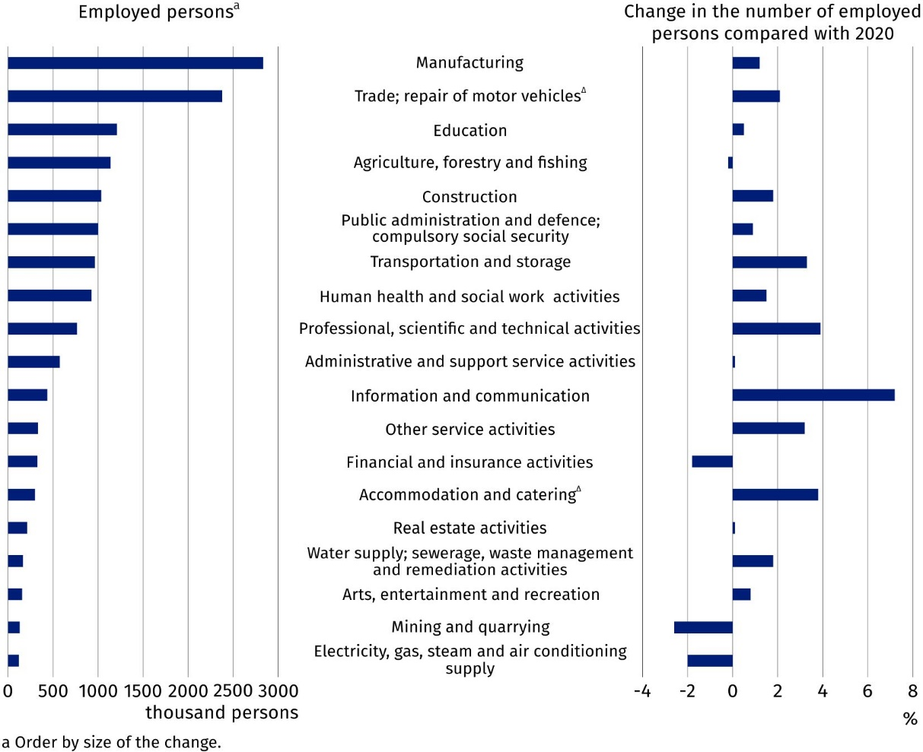
Chart 1. Employed persons in the national economy by PKD/NACE section in 2021 – preliminary data
As at 31 December
Average paid employment in the national economy
In 2021, according to preliminary data, the average paid employment in the national economy in Poland was 10.8 million full-time equivalent employees. It was 1.4% higher compared with the previous year.
Average paid employment
includes full-time employees and part-time employees converted into full-time equivalent employees
In the analysed period, the average paid employment decreased in six sections. The largest decrease was recorded in the sections: Electricity, gas, steam and air conditioning supply (2.4%) and Mining and quarrying (2.2%).
Compared with 2020, the average paid employment increased most in the sections: Information and communication (6.7%) as well as Transportation and storage (3.1%).
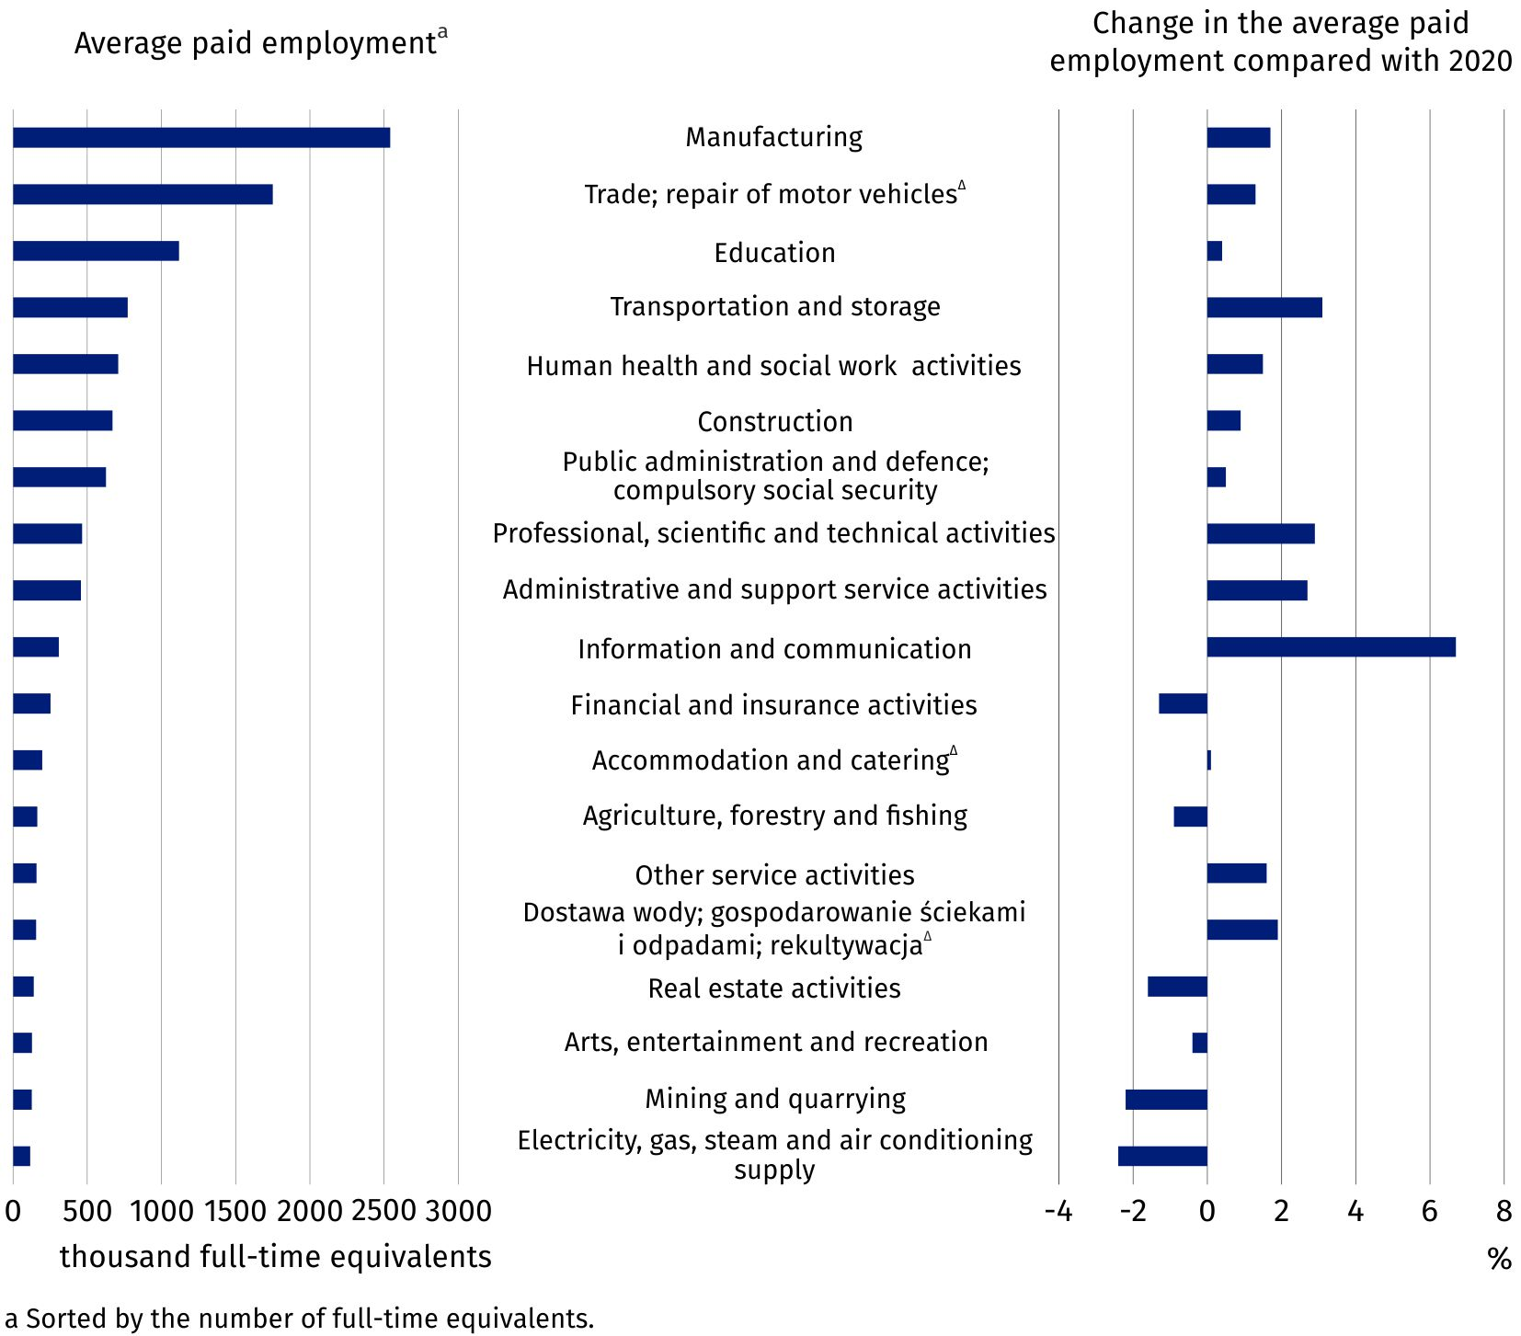
Chart 2. Average paid employment in the national economy by PKD/NACE section in 2021 – preliminary data
Average monthly gross wage and salary in the national economy
According to preliminary data, the average monthly gross wage and salary in the national economy in Poland, in 2021, was PLN 5 662.53. Compared with 2020, it increased by 8.4% in nominal terms. This is a larger increase than that recorded in 2020 compared with 2019 – the average monthly gross wage and salary increased then by 6.2%. The average monthly gross wage and salary still remained diverse when broken down by PKD/NACE section.
In 2021, it ranged from PLN 3 593.79 in the Accommodation and catering∆ section to PLN 9 851.26 in the Information and communication section. It was respectively 36.5% lower and 74.0% higher than the average monthly gross wage and salary in Poland.

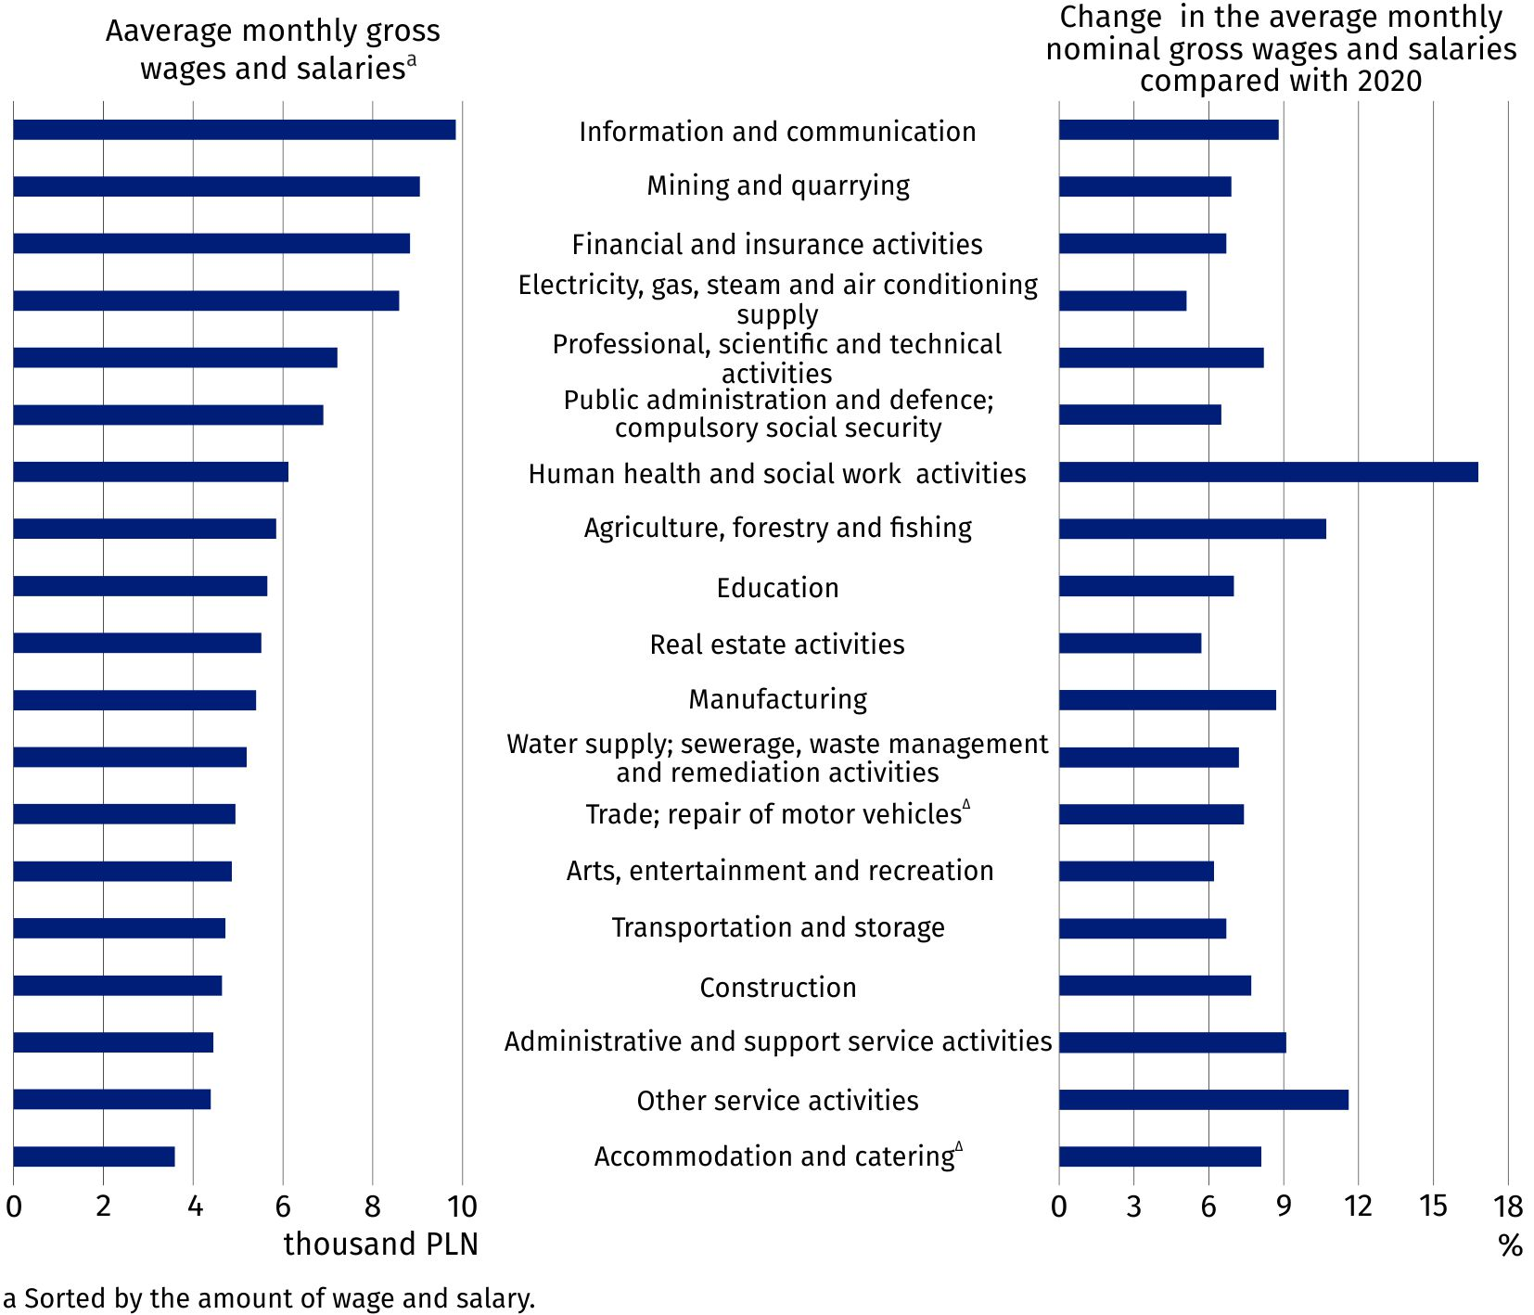
Chart 3. Average monthly gross wages and salaries in the national economy by PKD/NACE section
in 2021 – preliminary data
In all PKD/NACE sections, increases in the average gross nominal wage and salary compared with 2020 were recorded. The increases ranged from 5.1% in the Electricity, gas, steam and air conditioning supply section to 16.8% in the Human health and social work activities section.
Minimum gross wage and salary
In 2021, the average monthly nominal gross wage and salary in the national economy increased by 8.4% compared with the previous year
In 2021, the minimum gross wage and salary increased by PLN 200 compared with 2020 and amounted to PLN 2800.00. After the rise, it constituted 50% of the average monthly gross wage and salary without annual awards in 2021. In December 2021, 461.5 thousand employees received wages and salaries equal to or lower than the minimum wage and salary. The number of such employees was 4.5% lower than the year before.
In this news release abbreviated names of NACE, Rev. 2 sections were used. Abbreviations are marked with a ‘Δ’ symbol. Full names are available on the Eurostat website at: https://ec.europa.eu/eurostat/data/classifications
In the case of quoting Statistics Poland data, please provide information: ‘Source of data: Statistics Poland’, and in the case of publishing calculations made on data published by Statistics Poland, please provide information: ‘Own elaboration based on Statistics Poland data.’

Prepared by:  Statistical Office in Bydgoszcz  Director Wiesława Gierańczyk, Ph.D.  Phone: (+48 22) 366 93 90 | Issued by:  The Spokesperson for the President  of Statistics Poland  Karolina Banaszek  Phone: (+48) 695 255 011
Press Office  Phone: (+48 22) 608 38 04  e-mail: obslugaprasowa@stat.gov.pl |   stat.gov.pl/en/

@GUS_STAT

@GlownyUrzadStatystyczny

gus_stat

glownyurzadstatystycznygus

glownyurzadstatystyczny
Related information
Employment in the national economy in 2020
Yearbook of Labour Statistics 2021
Other publications related to the labour market
Data available in databases
Local Data Bank -> Labour market
Strateg -> Statistics by theme -> Labour market
Knowledge Databases >> Labour market
Terms used in official statistics
Average paid employment
Employment in national economy

Data on employed persons in the national economy in 2020 and 2021 are not fully comparable with the data for the previous years. They take into account the number of employed persons on individual farms in agriculture estimated on the basis of the results of the Agricultural Census 2020 (data for the previous years are based on the results of the Agricultural Census 2010). Due to taking into account the results of the Agricultural Census 2020, the data on employed persons for 2020 differ from the previously published data for that year, based on the results of the Agricultural Census 2010.
Data on the average paid employment in the national economy in 2020 and 2021 are not fully comparable with the data for the previous years. They take into account the number of paid employees on individual farms in agriculture estimated on the basis of the results of the Agricultural Census 2020 (data for the previous years are based on the results of the Agricultural Census 2010). Due to taking into account the results of the Agricultural Census 2020, the data on the average paid employment for 2020 differ from the previously published data for that year based on the results of the Agricultural Census 2010.
From profit for distribution or balance surpluses in cooperatives and annual extra wages and salaries for employees of budgetary sphere units.
Data concern national economy entities with 10 or more employed persons and budgetary sphere units regardless of the number of employed persons.

