Therapeutic activities of health resort facilities and inpatient rehabilitation facilities in 2021
At the end of 2021, there were operating 258 health resort facilities. 599.9 thousand patients were admitted to health resort facilities during a year, of which 529.9 thousand were inpatients. 61.0 thousand inpatients were treated in 43 inpatient rehabilitation facilities.
35.4%
Increase in the number of inpatients in health resort facilities compared to 2020

Due to the outbreak of the COVID-19 epidemic, in period 2020-2021, temporary restrictions were introduced in performing medical activities, including the suspension of services in the field of health resort treatment and therapeutic rehabilitation (from 14 March to 14 June 2020 and from 24 October 2020 until 10 March 2021). The rules for patients' stay in spas were also changed – the condition for starting health resort treatment was a negative result of the diagnostic test for SARS-CoV-2 or vaccination against SARS-CoV-2. The presented data show the impact of the COVID-19 epidemic on therapeutic activities in health resort facilities and inpatient rehabilitation facilities from 11 March 2021.

Health resort facilities
529.9 thousand inpatients and 70.0 thousand outpatients were treated in health resort facilities
At the end of 2021, there were operating 41 health resort hospitals (of which 6 for children), 187 health resort sanatoria (of which 1 health resort sanatoria for children and 1 sanatoria in underground mining excavations), 10 outpatient health resort units and 20 natural healing centres which conduct their treatment in health resort complexes.
At the end of the year there were almost 45.5 thousand health resort beds in health resort hospitals and sanatoria (the increase by 1.2% compared to the previous year). 529.9 thou-sand inpatients were treated during the year (by 35.4% more in relation to 2020). Women accounted for 61.5% of the total inpatients being treated, while people aged 65 years and more – 52.6%. Average stay of inpatients was 15.9 days.
The most inpatients were treated in health resort facilities in Zachodniopomorskie Voivoship (137.5 thousand persons) followed by Kujawsko-Pomorskie (104.4 thousand) and Dolnośląskie (66.4 thousand). In total, 58.2% of inpatients were admitted in these three voivodships.
At the national level the share of foreigners in inpatients was 3.6%. The vast majority of foreigners (above 94.4%) were admitted to health resort facilities in three voivodships: Zachodniopomorskie, Dolnośląskie and Pomorskie.

SPECIFICATION | Health resort hospitals | Health resort sanatoria | Outpatient health resort units | Natural healing centres
Health resort facilities  (as of 31 December) | 41 | 187 | 10 | 20
Beds in thousands  (as of 31 December) | 8.1 | 37.4 | – | –
Inpatients in thousands | 82.8 | 447.1 | – | –
Average stay of inpatients (in days) | 19.1 | 15.3 | – | –
Outpatients in thousands | 5.1 | 29.3 | 14.3 | 21.3

Table 1. Activities of health resort facilities by type of facility in 2021

In 2021, 53.4% of inpatients were subsidized by National Health Fund (by 1.9 pp less than in 2020). However, self-pay inpatients were 38.8% of inpatients (by 1.0 pp more than in the previous year).

Chart 1. The structure of inpatients treated in health resort facilities by type of financing in 2021
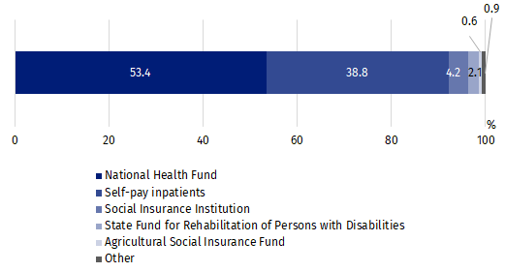
In 2021, 70.0 thousand outpatients were treated in health resort facilities (by 91.7% more than in the previous year). Above 72% of patients were admitted to outpatient health resort units and natural healing centres.

VOIVODSHIPS | Beds  (as of  31 December) | Inpatients | Outpatients | Average stay of inpatients  (in days)
VOIVODSHIPS | in thousands |  |  | Average stay of inpatients  (in days)
POLSKA | 45.5 | 529.9 | 70.0 | 15.9
Dolnośląskie | 5.9 | 66.4 | 10.6 | 16.7
Kujawsko-pomorskie | 8.5 | 104.4 | 10.6 | 16.1
Lubelskie | 1.4 | 15.5 | 1.0 | 17.5
Łódzkie | 0.1 | 1.5 | – | 15.8
Małopolskie | 5.8 | 63.8 | 6.7 | 17.4
Mazowieckie | 0.2 | 1.9 | 0.5 | 22.5
Podkarpackie | 4.3 | 41.0 | 2.8 | 18.6
Podlaskie | 0.5 | 6.2 | 0.2 | 11.0
Pomorskie | 2.0 | 16.0 | 20.3 | 14.7
Śląskie | 2.6 | 24.4 | 0.8 | 17.7
Świętokrzyskie | 3.0 | 47.0 | 5.3 | 15.2
Warmińsko-mazurskie | 0.5 | 4.3 | – | 17.6
Zachodniopomorskie | 10.7 | 137.5 | 11.4 | 13.8

Table 2. Activities of health resort facilities by voivodships in 2021
The most inpatients were treated in health resort fa-cilities in Zachodniopomor-skie Voivodship (137.5 thou-sand persons)
Note: In three voivodships (Lubuskie, Opolskie, Wielkopolskie) the health resort facilities do not occur.
26.0 million medical services were provided in health resort facilities
In 2021, 26.0 million medical services were provided in health resort facilities (by 42.8% more than in 2020). As in the previous year, most medical services belonged to natural healing services (25.1%), among which peat treatments (11.1%) and mineral baths (7.6%) predominated. Kinesiotherapy (21.1%), electrotherapy (12.5%), massage (10.3%) and hydrotherapy (9.0%) were also popular.

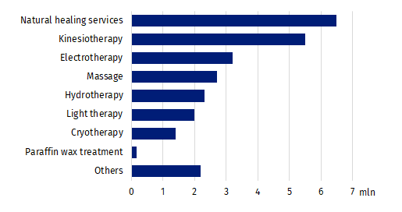
Chart 2. Medical services provided in health resort facilities in 2021

Inpatient rehabilitation facilities
61.0 thousand patients were treated in inpatient rehabili-tation facilities
As the end of 2021, 43 inpatient rehabilitation facilities were operating in which there were 4.6 thousand health resort beds. During the year 61.0 thousand patients were admitted (by 67.7% more than in the previous year), of whom 52.6 thousand inpatients and 8.4 thousand outpatients.
Women accounted for 56.8% of the total inpatients being treated, while people aged 65 years and more – 46.1%. Average stay of inpatients was above 12 days.

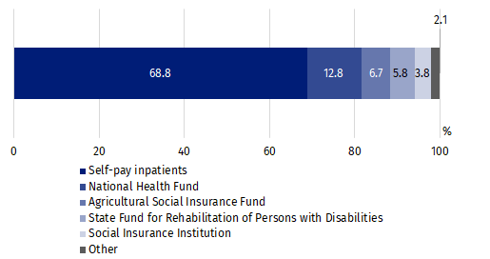
Chart 3. The structure of inpatients treated in inpatient rehabilitation facilities by type of financing in 2021
In inpatient rehabilitation facilities, most inpatients treated belonged to self-pay inpatients – 36.2 thousand persons. Among institutions subsidized inpatients, the National Health Fund subsidized 6.8 thousand persons, the Agricultural Social Insurance Fund – 3.5 thousand and the Social Insurance Institution – 2.0 thousand.
2.1 million medical services were provided in inpatient rehabilitation facilities during 2021 (by 47.9% more than in previous year), most of them belonged to kinesiotherapy (31.2%).
In the case of quoting data from the Statistics Poland, please provide information: "Statistics Poland data source", and in the case of publishing calculations made on data published by the Statistics Poland, please provide information: "Own study based on Statistics Poland data".

Prepared by:  Statistical Office in Kraków  Director Agnieszka Szlubowska  Phone: (+48 12) 420 40 50 | Issued by:  The Spokesperson for the President  of Statistics Poland  Karolina Banaszek  Phone: (+48) 695 255 011
Press Office  Phone: (+48 22) 608 38 04  e-mail: obslugaprasowa@stat.gov.pl |   stat.gov.pl/en/

@StatPoland

@GlownyUrzadStatystyczny

gus_stat

glownyurzadstatystycznygus

glownyurzadstatystyczny
Related information
Health and health care in 2020
Methodological report. Health and health care statistics − Statistics Poland’s reports
Data available in databases
Local Data Bank -> Health care, social welfare and benefits to the family
Analytical Platform – SWAID – Knowledge Databases -> Health and Health care
Terms used in official statistics
Patient in health resort
Health resort treatment
Health resort facility

Medical services provided in natural healing centres operating as a functional unit of the health resort hospital, sanatorium or outpatient health resort unit, are counted together with the main unit.

