Participation in sport and recreational activities in 2021
55.1%
Increase in expenditure on sport and recreational activities made by a household compared to 2016

In the period from 1.10.2020 to 30.09.2021, 38.8% of Poles (36.7% of females and 41.0% of males) participated in sports or recreational activities. They undertook physical activity mainly for pleasure and entertainment. The most frequent form of sport and recreational activities was cycling. The average cost incurred by a household for sport and recreational activities amounted to PLN 870, including the purchase of sports equipment – PLN 154.

In the 4th quarter 2021, another survey on the topic of participation in sport and recreational activities was conducted on a sample of households participating in the household budgets survey (the previous edition took place in 2016). The survey was originally scheduled to be conducted in the 4th quarter 2020, but due to the COVID-19 pandemic in the country, it was postponed to 2021. It covered household expenditure and participation of household members in sport and recreational activities between 1.10.2020 and 30.09.2021.
Assessment of physical fitness and participation of household members in sports or recreational activities
Very good and good physical condition was declared (in a subjective assessment) by 65.7% of people (59.8% in 2016), of which 22.0% of household members rated themselves as very fit (i.e. 1.5 pp more than in 2016). Those rating their physical condition as bad or very bad were 7.8%. Compared to 2016, this percentage decreased by 4.7 pp. Males were more likely than females to rate their physical condition as very good or good (70.1% compared to 61.7% of females). More rural residents (68.0%) than urban residents (64.4%) declared high physical fitness.
Chart 1. Participation of household members in sports or recreational activities in 2021
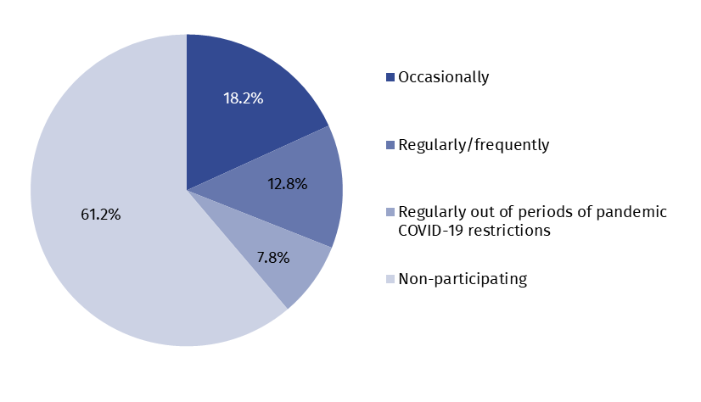

Participation in sport or recreational activities was declared by 38.8% of people (36.7% of females and 41.0% of males). Compared to the previous edition of the survey, a decrease of 7.6 pp in the number of people who were physically active was observed. However, it is worth noting that this was a time when restrictions were imposed on those conducting sports, entertainment and recreational activities due to the COVID-19 pandemic. Access to sports facilities was also more difficult. 20.6% of participants took part in sports activities regularly (21.7% in 2016). Of these, 37.6% exercised regularly, but only outside periods of COVID-19 pandemic restrictions. Physical activity was undertaken by over 40% of urban residents (most in large cities with a population of 500,000 or more – over 50%). However, only one in three residents of rural areas declared participation in sports or recreational activities.
The most popular sport activity declared by the participants was cycling. Among both exercising females and males over 60% practiced this sport. Of those who cycled, 6.4% did so only at times when COVID-19 pandemic restrictions were not in force. Swimming was also a popular sport, practised by 34.2% of the sports participants (30.4% females and 37.9% males). Of these, 22.4% practiced this sport only during periods when the Covid restriction was not in force. General sports and fitness activities (e.g. recreational walking, skipping on a skipping rope, exercise on a stationary bicycle, link trainer) were participated in by 25.5% of people (9.5% of them only in periods without restrictions). In addition to the above-mentioned forms of activity, females often chose aerobics, fitness and gymnastics (25.1%) and jogging and Nordic walking (19.2%), while males chose football (28.3%) and strength sports and bodybuilding (12.1%).
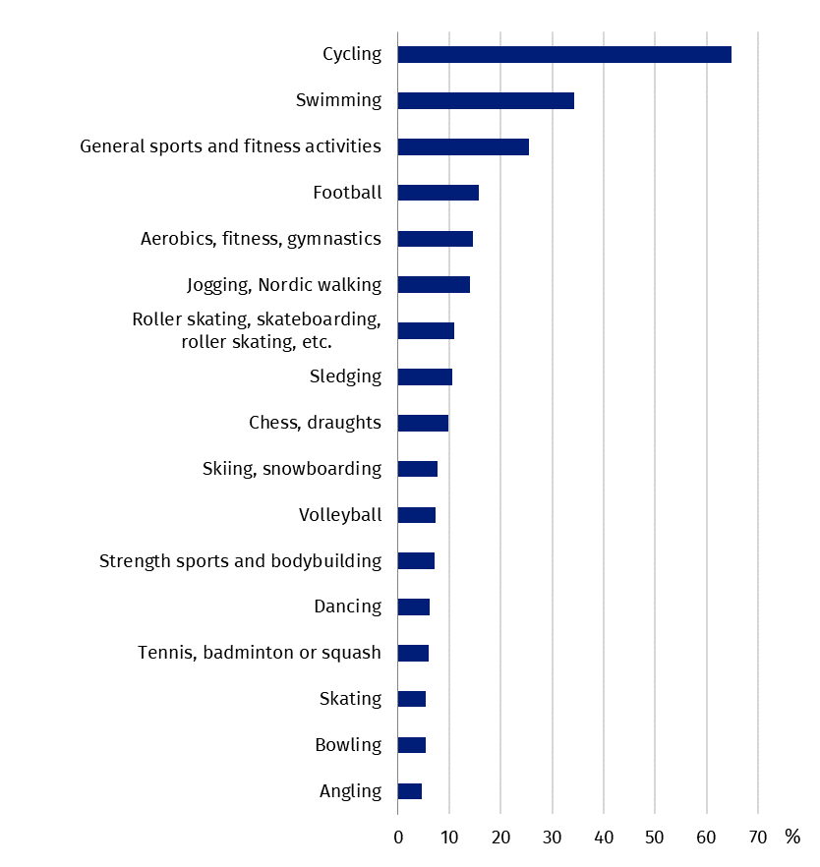
Chart 2. Participation of household members in sports or recreational activities in selected forms of activity in 2021

Cycling, as the most popular form of activity among Poles, was also the most frequently declared skill, both among females (95.5%) and males (96.4%). Among females, cycling was followed by sledging (73.5%), dancing (66.0%) and swimming (58.4%). In the case of males, skills in football (83.9%), swimming (75.4%) and sledging (75.1%) were often declared, in addition to cycling. Over 50% were also skilled in other popular team games such as volleyball and basketball. In females, these came next, with less than half declaring them.
In 2021, 95.9% of people declared that they were able to ride a bicycle and this was 3.1 pp higher than in 2016
Motives for practising sport or recreational activities by household members
Pleasure and entertainment was the most frequent motive for members of households for practising sport or recreational activities – 67.5% of males and 62.3% of females. Keeping fit and maintaining a good body shape were also important. Slightly more females (41.0%) than males (39.8%) indicated this reason. Health and doctor's recommendations were also important motives (females – 27.3%, males – 21.9%). Other motives (meeting friends, doing sport or recreation in the past and other) did not exceed 10% of the responses. In 2016, pleasure and entertainment, keeping fit and health were also the main motives for undertaking physical activity.
Chart 3. Motives for practising sport or recreational activities by household members
of households in 2021
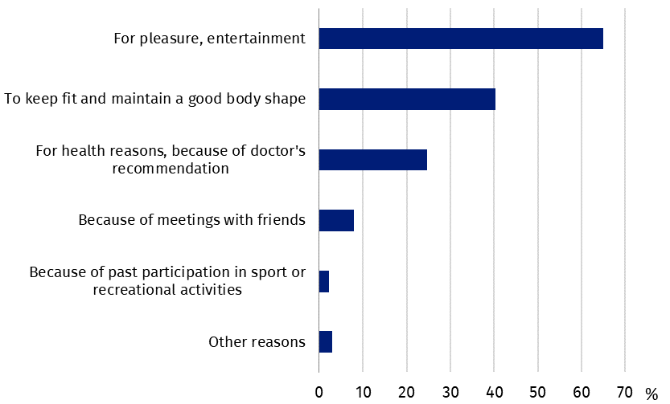

Reasons for non-participation of household members in sports or recreational activities
Every third person not participating in sports or recreational activities indicated lack of free time as the reason, and this was more often the case for males (33.3%) than females (26.9%). The second significant reason was lack of interest or preference for passive recreation (22.9%), followed by age (17.1%). In 2016, also ca. 30% of people did not participate in physical activity due to lack of free time. This was followed by lack of interest also, but with a percentage lower by 3.8 pp, and medical conditions and doctor's contraindications (18.2%).
In 2021, for 4.2% of people, restrictions related to the COVID-19 pandemic were the reason for not participating in sports or recreational activities, while for 1.2%, fear of infection was the barrier
Chart 4. Reasons for non-participation of household members in sports or recreational
activities in 2021
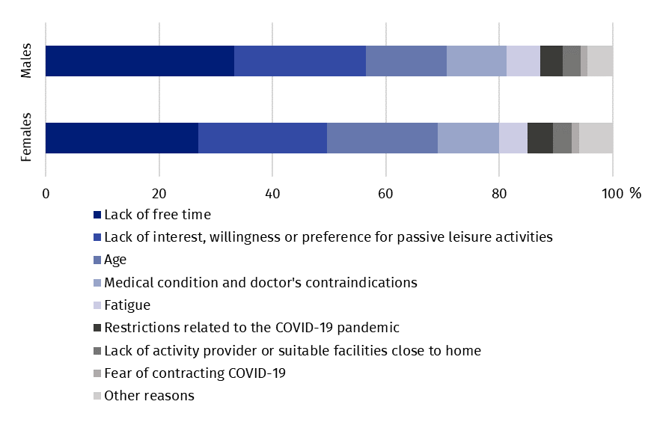
Household sport equipment and expenditure on sport and recreational activities
According to the results obtained from the survey, 85.0% of households had sports equipment. Compared to 2016, this percentage increased by 1.8 pp. Most households were equipped with a bicycle – 79.2% (in 2016 – 72.2%), followed by a ball for team games (football, volleyball, basketball, etc.) – 36.6% of households, and a sled – 33.4%. Other popular equipment included in-line skates, a skateboard and roller skates (25.7%) and fitness equipment (18.6%). Households located in rural areas were more often equipped with sports equipment (93.4%) than urban households (80.9%).
Expenditure on the purchase of sports equipment was incurred by 18.6% of households (in 2016 – 23.7%). It amounted to 154 PLN per household (including the highest amount for a bicycle – 92 PLN). This was almost 50% higher than the corresponding expenditure incurred by households in 2016.
39.6% of households spent on other sports and recreational purposes. Compared to 2016, this percentage was 7.5 pp lower, but the amount spent per household increased by 56.3% and amounted to PLN 716. The highest amount was spent on participation in sports and recreational activities (PLN 493). Expenditure for this purpose was made by 25.9% of all households. The purchase of sportswear amounted to 151 PLN (29.7% of households spent this amount), maintenance and rental of sports equipment – 40 PLN (10.1% of households), and participation in sports or sports and recreation camps – 32 PLN (2.4% of households).
Chart 5. Expenditure on sport and recreational activities per household
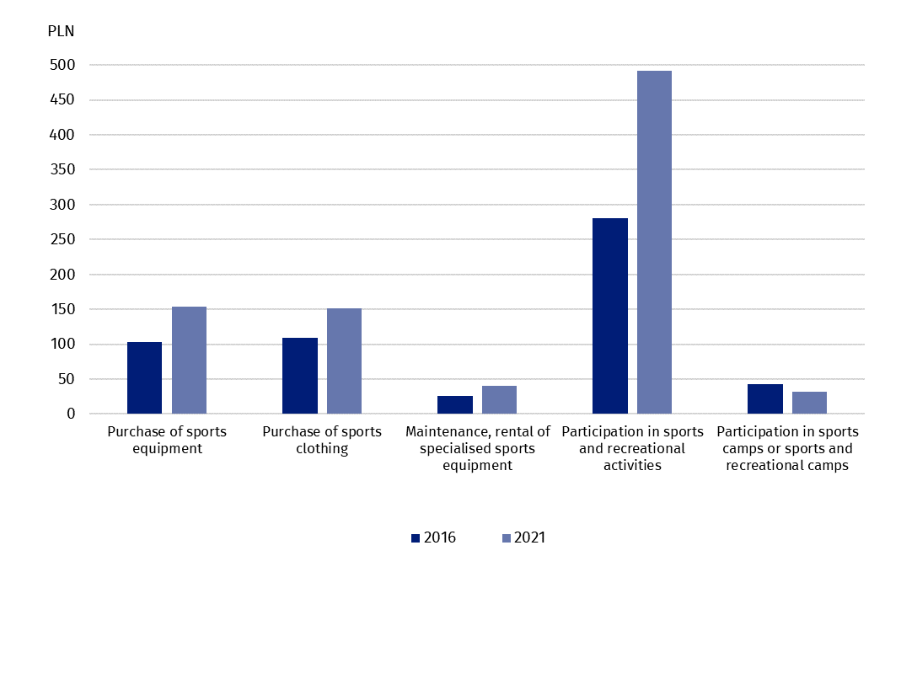

When quoting Statistics Poland data, please provide information: “Source of data: Statistics Poland”, and when publishing calculations made on data published by Statistics Poland, please provide information: “Own study based on Statistics Poland data”.
Prepared by:  Statistical Office in Rzeszów  Director Marek Cierpiał-Wolan  Phone: tel. (+48 17) 853 52 10 | Issued by:  The Spokesperson for the President  of Statistics Poland  Karolina Banaszek  Phone: (+48) 695 255 011
Press Office  Phone: (+48 22) 608 38 04  e-mail: obslugaprasowa@stat.gov.pl |   stat.gov.pl /en/

@StatPoland

@GlownyUrzadStatystyczny

gus_stat

glownyurzadstatystycznygus

glownyurzadstatystyczny
Related information
Participation in sports and physical recreation in 2016

Terms used in official statistics
Recreational activity
Sport

When asked about the motives for practising sport or physical recreation, the respondent could indicate up to two answers.
As the reason for not undertaking physical activity, age could be indicated by all surveyed household members, according to their subjective feeling.

