Price indices of sold production of industry in February 2023

According to preliminary data, the prices of sold production of industry in February 2023 decreased compared to January 2023 by 0.4% and compared to that recorded in the corresponding month of the previous year increased by 18.4%.
18.4%
the growth of producer prices in industry compared to February 2022

Table 1. Price indices of sold production of industry in January and February 2023

 | 01 2023 |  | 02 2023 |  |  | 01-02 2023
SPECIFICATION | 12 2022= 100 | corresponding period 2022=100 |  | 01 2023=100 | 12 2022=100 | 01-02 2022=100
TOTAL | 102.1* | 120.1* | 118.4 | 99.6 | 101.7 | 119.2
Mining and quarrying | 109.8* | 129.1* | 129.0 | 100.4 | 110.2 | 129.0
Manufacturing | 99.5* | 113.4* | 111.3 | 99.7 | 99.2 | 112.4
Electricity, gas, steam and air conditioning supply | 112.5* | 171.6* | 172.9 | 99.1 | 111.5 | 172.2
Water supply; sewerage, waste management and remediation activities | 101.9* | 106.1* | 106.0 | 100.6 | 102.5 | 106.1

* Data revised.

Prices changes of sold production of industry in February 2023 compared to January 2023
Among divisions of manufacturing in February this year in comparison with the previous month, the deepest prices drop was recorded in manufacture of coke and refined petroleum products, however the highest growth in manufacture of tobacco products
According to preliminary data, the prices of sold production of industry in February 2023 decreased by 0.4% compared to January 2023. The deepest prices drop was recorded in the section electricity, gas, steam and air conditioning supply by 0.9%. The prices were also lower than in January 2023 In the section manufacturing - by 0.3%. Among divisions of manufacturing the deepest prices decline was noticed in manufacture of coke and refined petroleum products (by 5.4%). The prices also decreased, among other things, in manufacture: of chemicals and chemical products (by 1.5%), of furniture (by 0.7%), of paper and paper products (by 0.5%), of products of wood, cork, straw and wicker as well as of metal products (by 0.2% each), of computer, electronic and optical products (by 0.1%). The prices of printing and reproduction of recorded media as well as of basic metals were at the similar level to that recorded last month. However, the prices higher than in January 2023 were, among other things, in manufacture: of beverages as well as of other non-metallic mineral products (by 0.1% each), of food products as well as of leather and related products as well as of machinery and equipment and also of motor vehicles, trailers and semi-trailers (by 0.2% each), of textiles as well as of other transport equipment (by 0.3% each), of rubber and plastic products (by 0.4%), of pharmaceutical products (by 0.5%), of wearing apparel (by 0.6%), of electrical equipment (by 0.8%), of tobacco products (by 1.3%). The prices in the section mining and quarrying increased by 0.4%, of which in mining of coal and lignite by 1.1%, with the prices drop in mining of metal ores by 0.6%. The prices the most increased in the section water supply; sewerage, waste management and remediation activities - by 0.6%.

Prices changes of sold production of industry in February 2023 compared to February 2022
Among divisions of manufacturing In February 2023 in comparison with the corresponding month of the previous year, the prices in manufacture of food products increased the most
In February 2023 the prices of sold production of industry compared to the corresponding month of the previous year increased by 18.4%. The prices were higher than in the previous year in all sections of the industry. The prices the most increased in the section electricity, gas, steam and air conditioning supply by 72.9%. The prices in the section mining and quarrying rose by 29.0%, of which in mining of coal and lignite by 50.5% and in mining of metal ores by 4.5%. The prices in manufacturing increased by 11.3%, of which the most in manufacture of food products (by 20.6%). The prices were also higher than in the year before in manufacture: of beverages (by 17.4%), of other non-metallic mineral products (by 17.1%), of paper and paper products (by 13.2%), of chemicals and chemical products (by 12.6%), of electrical equipment (by 12.5%), of tobacco products (by 12.2%), of products of wood, cork, straw and wicker (by 10.3%), of leather and related products (by 10.2%), of coke and refined petroleum products as well as of pharmaceutical products and of motor vehicles, trailers and semi-trailers (by 8.2% each). The prices increased also, among other things, in manufacture: of furniture (by 8.1%), of printing and reproduction of recorded media (by 7.9%), of machinery and equipment (by 7.4%), of other transport equipment (by 7.0%), of wearing apparel and of metal products (by 6.9% each), of rubber and plastic products (by 6.4%), of textiles (by 5.0%), of computer, electronic and optical products (by 4.8%) as well as of basic metals (by 4.1%). The prices in the section water supply; sewerage, waste management and remediation activities increased in annual terms by 6.0%.

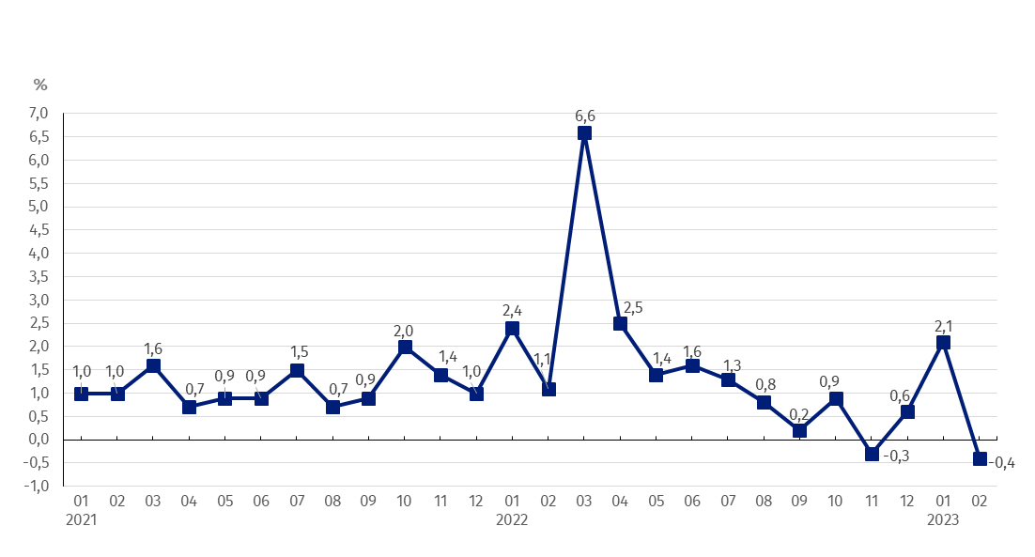
Chart 1. Prices changes of sold production of industry in 2021-2023 in relation to the previous period
In February 2023 in relation to January 2023 the prices drop of sold production of industry was recorded by 0.4%

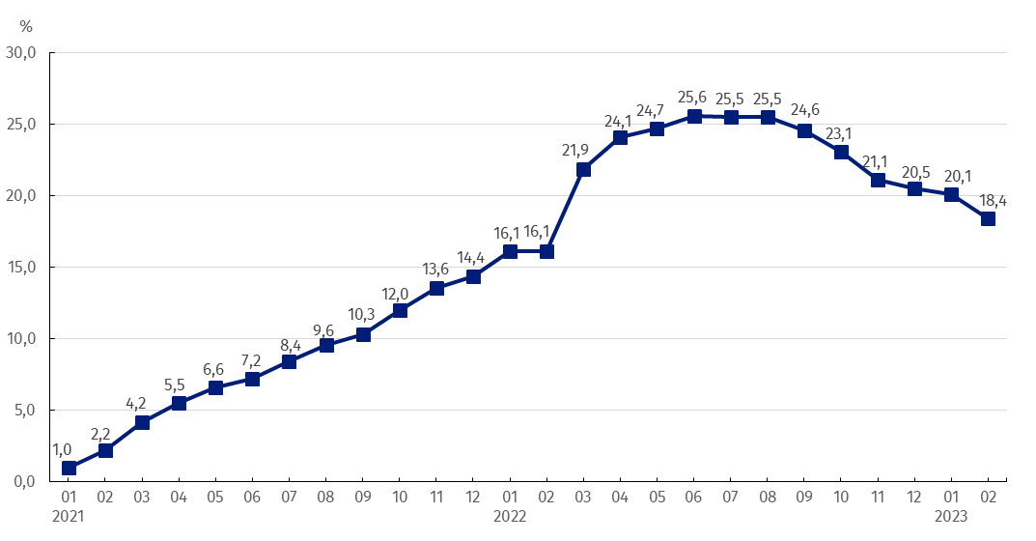
Chart 2. Prices changes of sold production of industry in 2021-2023 in relation to the same period of the previous year
In February 2023 the continued slowdown of dynamics of prices growth was recorded in annual terms

Chart 3. Prices changes of sold production of industry by sections NACE in 2021-2023 in relation to December 2020

In case of quoting Statistics Poland data, please provide information: “Source of data: Statistics Poland”, and in case of publishing calculations made on data published by Statistics Poland, please include the following disclaimer: “Own study based on figures from Statistics Poland”.

Prepared by:  The Trade and Services Department  Director Ewa Adach-Stankiewicz  Phone: (+48 22) 608 31 24 | Issued by:  The Spokesperson for the President  of Statistics Poland  Karolina Banaszek  Phone: (+48) 695 255 011
Press Office  Phone: (+48 22) 608 38 04  e-mail: obslugaprasowa@stat.gov.pl |   www.stat.gov.pl/en/

@StatPoland

@GlownyUrzadStatystyczny

gus_stat

glownyurzadstatystycznygus

glownyurzadstatystyczny
Related information
Statistical Bulletin
News Releases
Data available in databases
Analytical Platform - Knowledge Databases
Macroeconomic Data Bank
Prices indices (Topics: Prices, Trade)
Terms used inn official statistics
Price index of sold production of industry

