The situation of households in 2022 on the basis of results of the Household Budget Survey
In 2022, even though the income situation of households in nominal terms improved, in comparison with the previous year there was a decrease in income in real terms
In 2022 the financial situation of households, despite the increase in the average monthly available income, in real terms it worsened, which results from a high level of inflation. Households achieved both higher income and expenditure. The level of average monthly available income per capita in 2022 rounded to 1 PLN, amounted to PLN 2250 and was higher by 11.4% in nominal terms, but lower by 2.6% in real terms than the income in 2021. The average monthly expenditure per capita in households in 2022 amounted to PLN 1475 and was higher by 15.2% in nominal terms, and by 0.7% in real terms than expenditure in 2021. Expenditure on consumer goods and services amounted to PLN 1420 and was higher by 14.9% in nominal terms, and by 0.4% in real terms in comparison with 2021. After a 2-year period of an exceptionally low share of expenditure in available income, it increased from 63.4% in 2021 to 65.6% in 2022, but it still remains at a level significantly below the value from 2019.
2.6%
The decrease of the average monthly available income per capita in households in 2022 – in real terms

Income and expenditure
Households of self-employed outside farming had the highest average monthly available income (PLN 2540) and expenditure (PLN 1641) per capita
In 2022, there was still a relatively large diversity in average monthly income and expenditure between various socio-economic groups of households. Similarly to the previous years, the highest average monthly available income per capita in households (rounded to 1 PLN – PLN 2540) and average monthly expenditure per capita (rounded to 1 PLN – PLN 1641) were recorded in households of self-employed outside farming. In this group of households – in comparison with the average for the total of households in Poland – both income and expenditure were higher by 12.9% and 11.2% respectively (in 2021, by 19.7% and 12.7% respectively).
Similarly to the previous years, households of pensioners had the lowest average monthly available income per capita in 2022. Their average income per capita amounted to PLN 1809, which was by 19.6% lower than average for households in total (in 2021 – by 20.3%). The lowest average monthly expenditure per capita was noted in the households of farmers (PLN 1151) and it was by 22.0% lower than average for households in total (in 2021 – lower by 27.9%).

The highest share of expenditure in available income was observed in households of pensioners and the lowest in households of farmers

As in previous years, the highest share of expenditure in income (84.1%) and the lowest amount of average monthly excess of available income per capita over expenditure per capita
(PLN 288) was recorded in the households of pensioners. The lowest share of expenditure in income (49.4%) and the highest average excess of income over expenditure (PLN 1177), similarly to the previous year, was observed in the households of farmers.
In comparison with the previous year the share of expenditure in income for total households increased by 2.2 percentage points to 65.6%, which indicates a lower possibility of accumulating savings in comparison with the previous year, but still was on significantly lower level than in 2019 (the last before the COVID-19 pandemic).
The difference between average monthly available income indicator among socio-economic groups amounted to 32.5 percentage points (in 2021 – 40.0 percentage points), while the difference between average monthly expenditure indicator in these groups was 33.2 percentage points (in 2021 – 40.7 percentage points). Therefore, in the case of both indicators, there was a significant decrease in these differences in 2022.

In 2022, there was decline in average monthly available income per capita in real terms in total – by 2.6%. Decline in real terms occurred in all socio-economic groups of households, among which the highest income in real terms was recorded in the households of self-employed outside farming (by 7.6%), and the lowest – in the households of employees (by 1.3%).
Similarly to 2021, the highest share of income from the main source of income occurred in the households of retirees (84.5% against 84.1% in 2021) and the lowest in the households of self-employed outside farming (68.1% against 69.8% in 2021).
In the structure of the households’ total income, similarly to the previous years, income from hired work dominated (53.9%) as well as income from social security benefits (23.1%).
In 2022, in comparison with 2021, differences in the structure of the average monthly available income per capita in households ranged from -0.5 percentage points in the case of income from other social benefits to +1.1 percentage points for income from hired work.

The diversity of income per capita in households, measured by the Gini coefficient, after a period of decline in 2014-2017 and temporary stabilisation, increased in 2020 and 2021, and in 2022 decreased to the level of 0.314, almost equal to the value from 2020. Indices of the Gini coefficient for urban areas was very similar to the average noted in the country, although at a lower level of its value, while in the case of rural areas in 2022 the upward trend of the Gini coefficient from previous years continued.

Recorded in the years 2014-2017 significant decline in disparity in income per capita in households, measured by the Gini coefficient, in 2018 and 2019 was stopped. In 2020 and 2021, it increased, and in 2022 it decreased to the level from 2020
In 2022, the percentage of households with the income below PLN 2000 per capita decreased
In 2022, 41.3% of households had an average monthly available income per capita below PLN 2000 (50.9% in 2021), 47,5% of households had an income between PLN 2000 and PLN 4000 per capita (41.4% in 2021), 8.1% of households had an income from PLN 4000 to PLN 6000 per capita (5.5% in 2021), and PLN 6000 or more per capita had 3.1% of households (2.2% in 2021). In 2022, the percentage of households with an average monthly income of at least PLN 2000 per capita amounted to 58.7% (in 2021 – 49.1%).
In 2022, in comparison with the previous year, in real terms the average expenditure per capita increased by 0.7%. Taking into account all socio-economic groups of households, there was a real increase in average monthly expenditure per capita in comparison with 2021 in the group of farmers (increase by 5.8%), pensioners (by 3.1%) and employees (by 0.8%). In households of retirees, there was a real decrease in average monthly expenditure (by 1.3%), while expenditure in households of self-employed did not change in real terms.
In real terms – the average monthly expenditure per capita in households in 2022 increased by 0.7% in comparison with the previous year

Expenditure on food and non-alcoholic beverages, similarly to the previous years, had the highest share in the structure of expenditure for households in total – 26.7% (slightly higher in comparison with the previous year – by 0.2 percentage points). In individual socio-economic groups it ranged from 23.5% in households of self-employed outside farming to 32.1% in households of farmers.
Another important item in households expenditure was on housing, water, electricity, gas and other fuels. Its share in total expenditure was on average 19.0% and minimally increased in 2022 by 0.41 percentage points in comparison with the previous year. Among the socio-economic groups, the lowest share of expenditure on housing, water, electricity, gas and other fuels was recorded in the households of self-employed (16.2%) and the highest in the households of pensioners (25.0%).

In the case of the main groups of consumer goods and services, between 2021 and 2022, changes in the share in expenditure structure for households in total ranged from -0.4 percentage points (furnishings, household equipment and maintenance, and communication) to +0.6 percentage points (restaurants and hotels).

The average available income per capita in the group of the 20% of persons with the highest income (5th quintile group) amounted to PLN 4475 per capita, and it was 6.6 times higher (in 2021 – 6.3 times higher and amounted to PLN 4035) than the respective income of the 20% of persons with the lowest income (1st quintile group).
In the households of 20% of persons in the most favourable financial situation was accumulated 39.7% of income of entire surveyed population of households, while in the households of 20% of the persons in the worst situation
– 6.0%
In the households of 20% of persons in the most favourable income situation, there was accumulated 39.7% of income of entire surveyed population of households (in 2021 – 39.9%), while in the households of 20% of persons in the worst income situation – 6.0% (in 2021
– 6.3%).

The average monthly expenditure per capita in the 5th quintile group were 2.2 times higher than in the 1st quintile group (in 2021 – 2.1 times higher). The share of expenditure in available income in the highest quintile group amounted to 52.1% (in 2021 – 50.7%), and in the lowest – 159.0% (in 2021 – 149.5%). Over the last 5 years, the poorest households to an increasing extent were forced to use their savings, or loans, or credits.

The average monthly available income per capita in urban households was by 23.9% higher than in rural households
The average monthly expenditure per capita in urban households was by 28.5% higher than in rural households

The place of residence is another factor that substantially diversified dynamics and structure of income and expenditure of households.
The average monthly available income per capita in urban households was by 23.9% higher than in rural households (in 2021 by 28.3%), which resulted from the amount of income obtained by households, but were also connected with the larger number of persons living in rural households. Similar situation was observed in the case of expenditure of households. Average monthly expenditure per capita in urban households was by 28.5% higher than in rural households (in 2021 by 32.1%). Despite large differences in income and expenditure of households living in urban and rural areas, the distance between them is slowly decreasing.
In territorial terms the income higher than the national average appeared in the voivodships: Mazowieckie, Śląskie, Podlaskie, Zachodniopomorskie, Dolnośląskie, Łódzkie and Lubuskie. As in the previous year, definitely the highest average income per capita was in households in the Mazowieckie Voivodship – PLN 2686 (PLN 3106 in the Warsaw Capital Region and PLN 2055 in the remaining part of the Mazowieckie Voivodship, i.e. Mazowiecki Regional Region. This income was higher than the average national income per capita by 19.4% (higher than national average by 38.1% in the Warsaw Capital Region and lower by 8.6% in the remaining part of the Mazowieckie Voivodship). The lowest income obtained households in the Podkarpackie Voivodship (PLN 1829) – by 18.7% below the national average. The next voivodships with the lowest level of average monthly income per capita were voivodships: Opolskie (by 15.1% lower than the average for Poland), Świętokrzyskie (lower by 11.8%) and Pomorskie (lower by 10.2%).
The difference between the highest and the lowest average monthly income per capita in voivodships in relation to the national average compared with the previous year increased by 0.1 percentage points and amounted to 38.1 percentage points.

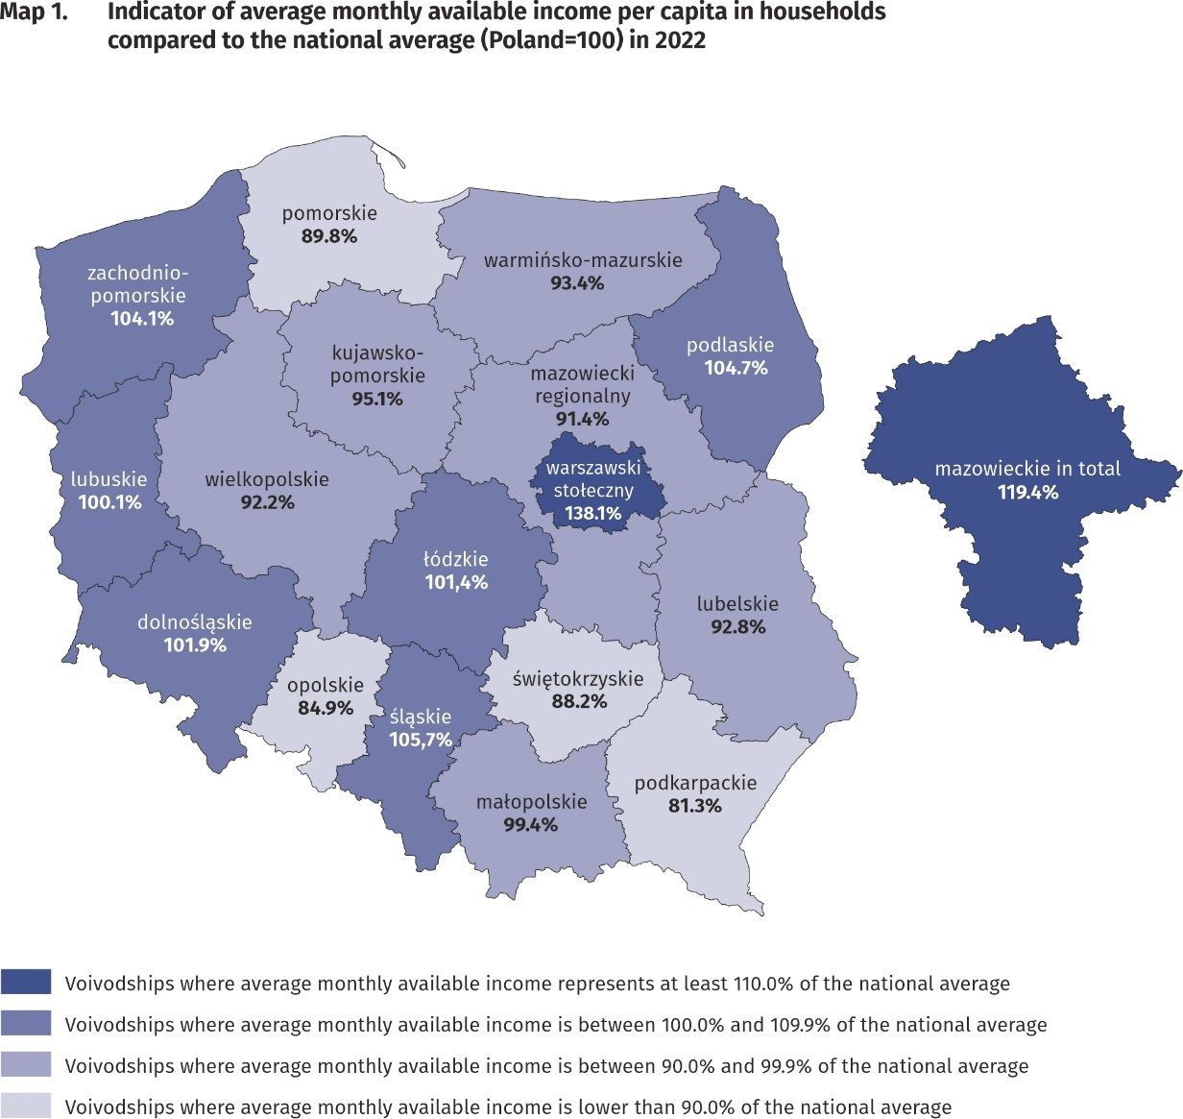
The highest average monthly available income per capita had households from the Mazowieckie Voivodship – PLN 2686 and the lowest
– household living in the Podkarpackie Voivodship –PLN 1829

In the case of expenditure, average monthly values above average for Poland in 2022 were recorded in voivodships: Mazowieckie, Dolnośląskie, Łódzkie, Opolskie, Pomorskie, Śląskie, Zachodniopomorskie and Kujawsko-Pomorskie. The highest average monthly expenditure per capita was noted in Mazowieckie voivodship – PLN 1673 (PLN 1902 in the Warsaw Capital Region and PLN 1329 in Mazowiecki Regional Region) and they were higher than the national average by 13.4% (higher by 28.9% in the Warsaw Capital Region and lower by 9.9% in the remaining part of the Mazowieckie Voivodship). The lowest average expenditure per capita occurred in the Podkarpackie Voivodship (PLN 1162) and in comparison with the average for the whole country was lower by 21.2%, subsequently in Małopolskie Voivodship (lower by 14.4%), Świętokrzyskie Voivodship (lower by 14.1%), Podlaskie Voivodship (lower by 12.9%) as well as Warmińsko-Mazurskie (lower by 10.6%).
The difference between the highest and the lowest average expenditure per capita in voivodships decreased by 4.5 percentage points in comparison with 2021 year and amounted to 34.6 percentage points.
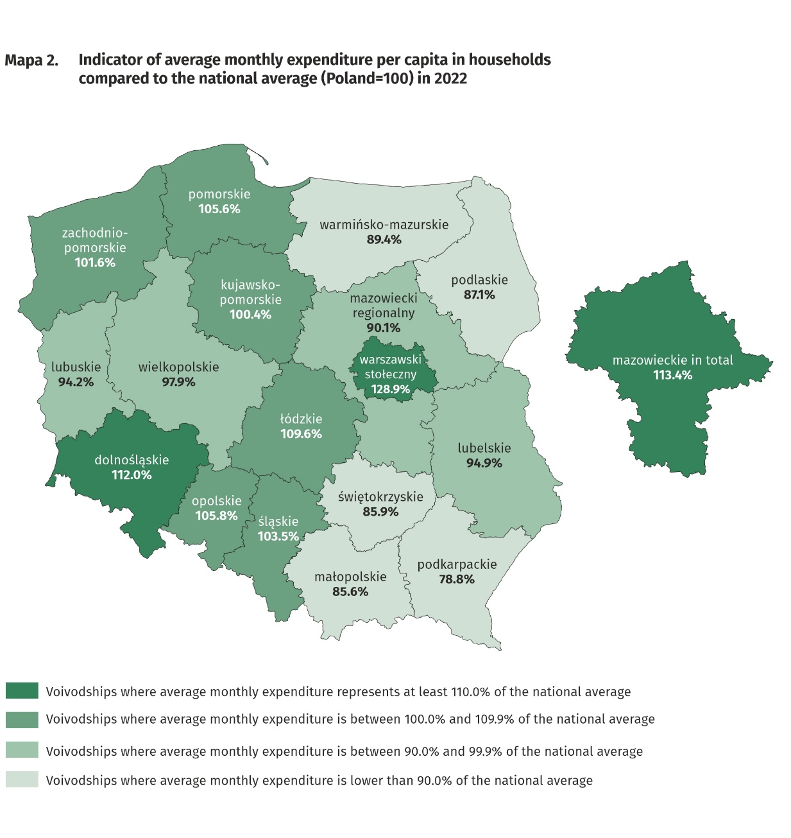
The highest average monthly expenditure per capita in households occurred in Mazowieckie Voivodship – PLN 1673 and the lowest – in Podkarpackie Voivodship – PLN 1162

Quantitative food consumption
In 2022, there was a decrease in consumption of the most basic foodstuffs, and particularly fish and seafood, butter and fruit
In 2022, there was a decrease in consumption of the majority of basic foodstuffs. The highest decline was recorded in: fish and seafood (by 11.1%), fruit (by 6.8%) and animal fats (by 5.4%, of which butter by 9.7%). The highest increase was noted in the case of pasta and pasta products (by 5.0%), vegetable fats (by 4.8%), as well as sugar and processed meat and other meat preparations (by 2.7% each). The decrease in the level of food consumption might be influenced by a 15.6% increase in expenditure on gastronomy in comparison to 2021 and an increase in the prices of food and non-alcoholic beverages.
The level of consumption of foodstuffs greatly depends on household income. As the wealth of households increases, so does the level of consumption of certain foodstuffs, such as bread and cereals, meat, vegetables, fruit, cheese and curd, sugar as well as mineral and spring water.

The level of food consumption is also affected by dietary habits, prices of foodstuffs and a place of residence. Households in rural areas compared with households in urban areas are characterised by a slightly different model of nutrition. In the rural areas there was
a higher consumption of bread and cereals, meat, potatoes and sugar, while in urban areas – vegetables (except potatoes), cheese and curd fruit as well as mineral and spring waters.
Negative phenomenon, both in urban and rural areas, is a decrease in the value of monthly consumption per capita of fruit (by 0.3 and 0.2 kg respectively) and vegetables (by 0.1 and 0.2 respectively).

The equipment of households with durable goods
In 2022, there was an increase in the number of households among others equipped with motorcycle, scooters, motorbikes, home theatre system and dishwasher
In 2022, the highest increase in the number of households equipped with durable goods occurred in the case of motorcycle, scooters, motorbikes (by 15.8%), home theatre system (by 8.8%) and dishwasher (by 8.5%), while the largest decrease occurred in the case of satellite or cable television equipment (drop by 5.7%) as well as equipment for reception, recording and reproduction of sound (drop by 5.3%).
In comparison with 2021, an increase in the number of households equipped with a dishwasher was recorded in all analysed socio-economic groups (the highest in the case of households of pensioners – by 20.2%). At the same time, in all socio-economic groups, there was a decrease in the number of households equipped with a device to receive satellite or cable television equipment (the largest concerned households of farmers – by 8.9%).
The level of household equipment with durable goods largely depends on their financial situation.
The richest households (5th quintile group) were much better equipped than the poorest households (1st quintile group). It should be emphasised, however, that the differences in the degree of equipment between 5th and 1st quintile groups decreased in comparison with 2021, the most in the case of passenger car – by 0.7. However, there was an increase in the difference in the degree of equipment with a dishwasher compared with the previous year - by 4.4 percentage points.

In terms of equipping with new generation devices, such as device with the access to the Internet, of which smartphone, there were slight differences in the degree of equipping with these devices between households in urban and rural areas (by 0.5 percentage points and by 2.6 percentage points in favour of rural areas respectively). A significantly higher percentage of rural than urban households owned a bicycle (by 23.9 percentage points), a passenger car (by 17.2 percentage points) or a motorcycle, scooters, motorbikes (by 6.4 percentage points). In comparison with 2021, there was a change in the level of equipment with new generation devices and in 2022, households in rural areas for the first time were better equipped with this type of equipment than urban residents.

In rural areas there was a higher percentage of households owning dishwasher, bicycle, passenger car or motorcycle, scooters, motorbikes, plasma or LCD TV set as well as device with access to the Internet, of which smartphone

Dwelling conditions
In 2022, the dwelling conditions of households improved slightly. The average household occupied a dwelling with a floor area of 86.2 m², which consisted of 3 rooms. The systematic increase in the average size of a dwelling has continued since 2013

The average household in 2022 occupied a dwelling with a floor area of 86.2 m² (in 2021 – 85.2 m²), which consisted of 3 rooms. There was an average of 29.4 m² of usable floor area and 1 room per capita in the household (in 2021 – 29.1 m² and 1 room).
The largest average usable floor area of dwellings was held by households of farmers
– 140.2 m², while the smallest by households of pensioners – 68.8 m². In comparison with 2021, the highest increase in the floor area of the dwellings occupied by households occurred in the households of farmers(by 6.4 m²), while the lowest increase – in households of employees (by 0.7 m²).
The largest usable floor area per capita was in the households of pensioners(41.2 m²) and retirees(40.4 m²), which is related to a smaller number of persons in the household, while the smallest usable floor area per capita – in the households of employees (25.8 m²).
The area of dwellings occupied by households was also differentiated according to the level of their income. In the case of the households with the highest income (5th quintile group) average occupied area was smaller (83.7 m²) than households with the lowest income (1st quintile group) – 91.2 m², however, their members had much greater floor area per capita (38.2 m² and 23.1 m² respectively).
The equipment of dwellings with technical and sanitary installations is systematically improving. Dwellings equipped with running water accounted for 99.9% of all households, with a flushing toilet – 99.1% and with a bathroom – 99.0%.
As in the previous years, the best equipped with technical and sanitary installations (except gas and central heating) were the dwellings of self-employed outside farming, and the worst – households of pensioners.
Households in urban areas were slightly better equipped with sanitary and technical installations than households in rural areas, except equipping with gas, which is related to the refusal to equip new multi-family buildings with gas installations. Among households in rural areas, changes in comparison with 2021 took place in the case of equipment with stoves (increase by 2.4 percentage points) and gas from a network (increase by 1.2 percentage points).

Households in urban areas were slightly better equipped with sanitary and technical installations (except gas) than households in rural areas
There is clear relationship between household’s income and the equipment of dwellings in sanitary and technical installations, excluding gas, which was used by the richest households the least (5th quintile group). The most significant difference in this area between 1st and 5th quintile group in favour of the richest households concerned the equipment with central heating (by 4.7 percentage points), bathroom (by 2.5 percentage points) and flushing toilet (by 1.9 percentage points). These differences remain on similar to 2021 level.

A subjective evaluation of the financial situation of households
The subjective evaluation of the financial situation of households worsened, however, still in all socio-economic groups (except households of pensioners), good or rather good assessments clearly prevailed over bad or rather bad
The subjective evaluation of the financial situation of households in 2022 worsened in all socio-economic groups, except farmers, among whom this evaluation slightly improved. However, still in all socio-economic groups (except households of pensioners), good or rather good assessments clearly prevailed over bad or rather bad. In 2022, there was a decrease in the percentage of households assessing their financial situation as good or rather good (49.9% of households in total compared with 53.3% in 2021) and increase in the percentage of households perceiving it as bad or rather bad (5.9% compared with 4.9% in 2021). Households of self-employed outside farming, similarly to the previous years, assessed their financial situation the most favourably (69.9% positive assessments compared with 75.8% in 2021), whereas households of pensioners assessed their situation the worst (21.2% positive assessments compared with 24.0% in 2021).

The subjective evaluation of the financial situation of households depends to a large extent on the place of residence of a household. Households in rural areas, similarly to the previous years, assessed their financial situation worse than urban residents, especially those from cities with a population of 500 thousand or more. In the case of households in cities with population of 500 thousand or more this evaluation worsened (60.6% of households in 2022 compared with 62.4% in 2021), similarly as in the case of households in rural areas (42.6% in 2022 compared with 49.9% in 2021).

Support granted by households to the inhabitants of Ukraine (in Poland and Ukraine)
Since 24th February 2022, households provided aid to inhabitants of covered by the war Ukraine (in Poland and Ukraine), and the scale of this assistance amounted from 70.3% of households in total in the first quarter to 23.0% in the fourth quarter of 2022
Since 24th February 2022, households in Poland provided aid to inhabitants of Ukraine covered by the war resulting from the Russian invasion. In individual quarters of 2022, the scale of assistance provided by households to residents of Ukraine decreased from 70.3% in the first quarter to 23.0% in the fourth quarter of 2022.

Among helping households, the dominant forms of support were in-kind donations and financial support (directly or through organizations). It is also worth noting that households provided assistance to refugees from Ukraine in Poland in finding a job, taking care of everyday matters or caring for relatives. Additionally households welcomed refugees from Ukraine to their house/apartment or provided them with a flat. Another declared kind of support was assistance in the area of border crossing points, reception points, accommodation facilities, aid centres or collection points for material donations as well as transport support.
The highest share of households granting support to Ukrainian inhabitants in all quarters of 2022 was among households of self-employed (from 81.1% in the first quarter to 26.3% in the fourth quarter) as well as in the households of employees (from 75.1% in the first quarter to 24.2% in the fourth quarter).

In the following quarters of 2022, among the households of self-employed was recorded the highest percentage of those providing support to residents of Ukraine (in Poland and Ukraine)

In the following quarters of 2022, households from 5th quintile group (covering 20% of the wealthiest persons) were the most engaged in the support to the inhabitants of Ukraine. In this quintile group the percentage of helping households ranged from 77.2% in the first quarter to 30.7% in the fourth quarter.

Households declaring support to the inhabitants of Ukraine were numerous in all the classes of locality. In all quarters the highest percentage of households that provided assistance was in the cities with 500 thousand or more residents – from 75.4% in the first quarter to 35.9% in the fourth quarter.

In all quarters of 2022, the highest percentage of households helping residents of Ukraine was in the cities with 500 thousand or more residents

It is worth of emphasizing, that in the first quarter of 2022, during first weeks after Russian full-scale invasion on Ukraine in 24th February, more than 70% of households granted support to the inhabitants of Ukraine escaping from war to Poland or staying on the territory of covered by war Ukraine. Despite the decline in the intensity of this assistance in the following quarters, in the fourth quarter of 2022 almost ¼ of households still granted such support.

In case of quoting Statistics Poland data, please provide information: “Source of data: Statistics Poland”, and in case of publishing calculations made on data published by Statistics Poland, please include the following disclaimer: “Own study based on figures from Statistics Poland”.

Prepared by:  Social Surveys Department  Director Piotr Łysoń  Office: tel. (+ 48 22) 449 40 27,  (+ 48 22) 608 31 22 | Issued by:  The Spokesperson for the President  of Statistics Poland  Karolina Banaszek  Phone: (+48) 695 255 011
Press Office  Phone: (+48 22) 608 38 04  e-mail: obslugaprasowa@stat.gov.pl |   stat.gov.pl/en/

@StatPoland

@GlownyUrzadStatystyczny

gus_stat

glownyurzadstatystycznygus

glownyurzadstatystyczny
Related information
Household Budget Survey in 2021
Support granted by households to the inhabitants of Ukraine in the first half of 2022 on the basis of results of the Household Budget Survey

Data available in databases
LOCAL DATA BANK private households
HBS - material conditions of population by socio-economic groups and household size
HBS - material conditions of population by class of locality
HBS - material conditions of population by voivodships

Terms used in official statistics
Household's budget
Disposable income
Household's available income
Private household
Net household's receipts
Net household's outgoings
Quantitative consumption of foodstuffs in households per person
Subjective evaluation of material situation
Housing conditions
Expenditures of a household
Household's equipment

Due to the introduction of a new classification of individual consumption by purpose in 2013, based on harmonized COICOP classification for all surveys of the European Statistical System, the results for 2010–2022 are presented in comparable conditions – each “expenditure” item from 2010–2012 was supplemented by the “life-insurance contributions” item.
The average monthly income indicator is equal to the quotient of the average monthly income per capita in the surveyed group by the average monthly income per capita for the whole Poland.
In 2022 the average number of persons in urban households was 2.23, while in rural households – 2.88.
This category includes devices that enable connection to the Internet, regardless of the type of device and type of Internet connection (e.g. desktop computer, laptop, tablet, TV set, smartphone).
Despite the smartphone was included in the category "Device with access to the Internet", the level of equipment with the smartphone is also presented as a separate category of device due to its universality and various uses.
The category of new generation equipment includes such durable goods as: device with access to the Internet (of which smartphone), plasma or LCD TV set, dishwasher and passenger car.
The average number of persons in 1st quintile group of households was 3.15, and in 5th quintile group – 1.99.
The category of stoves includes: central heating stoves for solid fuel, electric, gas, tiled stoves with electric heater, etc.
Concerns the provision of assistance due to warfare - regardless of its form and scope (covers both support provided in Poland and directed to persons remaining in Ukraine) at least once in the period from 24th February 2022 to the end of the first quarter or in the quarter, in which the household participated in the survey.

