Producer price indices for business services in the fourth quarter of 2022

In the fourth quarter of 2022, the producer prices for business services increased compared to the previous quarter by 1.1% and compared to the fourth quarter of 2021 by 8.0%.
101.1
Increase in producer prices for business services compared to the third quarter of 2022

Table 1. Producer price indices for business services in the fourth quarter of 2022
SPECIFICATION | 4 quarter 2022 |  | 1-4 quarter 2022
SPECIFICATION | 3 quarter 2022=100 | 4 quarter 2021=100 | 1-4 quater 2021=100
TOTAL | 101.1 | 108.0 | 106.9
Publishing activities | 102.6 | 112.3 | 110.4
Motion picture, video and television programme production, sound recording and music publishing activities | 101.8 | 107.8 | 104.6
Programming and broadcasting activities | 102.8 | 106.7 | 99.8
Computer programming, consultancy and related activities | 100.7 | 107.0 | 106.8
Information service activities | 102.3 | 110.4 | 107.2
Real estate activities | 100.4 | 106.0 | 105.8
Legal and accounting activities; management consultancy activities | 101.3 | 107.7 | 106.8
Architectural and engineering activities; technical testing and analysis | 100.4 | 106.2 | 105.0
Advertising and market research | 101.3 | 104.0 | 103.3
Other professional, scientific and technical activities | 100.7 | 106.0 | 106.3
Rental and leasing activities | 100.9 | 110.0 | 113.6

SPECIFICATION | 4 quarter 2022 |  | 1-4 quarter 2022
SPECIFICATION | 3 quarter 2022=100 | 4 quarter 2021=100 | 1-4 quarter 2021=100
Employment activities | 101.9 | 111.0 | 109.4
Travel agency, tour operator reservation service and related activities | 102.9 | 127.3 | 121.0
Security and investigation activities | 100.2 | 106.1 | 105.8
Services to buildings and landscape activities | 100.5 | 107.9 | 107.4
Office administrative, office support and other business support activities | 100.6 | 108.1 | 107.7

In the fourth quarter of 2022 there was an increase in prices in all surveyed kinds of business services compared to the previous quarter. The highest increase occurred in travel agency, tour operator reservation service and related activities, i.e. by 2.9%. Subsequently, the prices of programming and broadcasting activities rose by 2.8% (mainly due to the increase in the sales prices of television advertising time and space), in publishing activities – by 2.6% (among others an increase in the prices of publishing services of books, newspapers, journals and periodicals, and software) also in information service activities - by 2.3% (the significant increase in prices of data processing, hosting and related activities). The smallest growth (by 0.4%) was recorded in the prices of services related to real estate activities , and architectural and engineering activities; technical testing and analysis and security and investigation activities (by 0.2%).
In the 4th quarter of 2022, compared to the previous quarter, the highest price increase was recorded in travel agency, tour operator reservation service and related activities
Compared to the fourth quarter of 2021, the highest increase of prices occurred also in travel agency, tour operator reservation service and related activities (by 27.3%). Subsequently, the increase was recorded in the prices of publishing activities (by 12.3%), and employment activities (by 11.0%). The lowest increase was recorded in the prices of advertising and market research (by 4.0%).

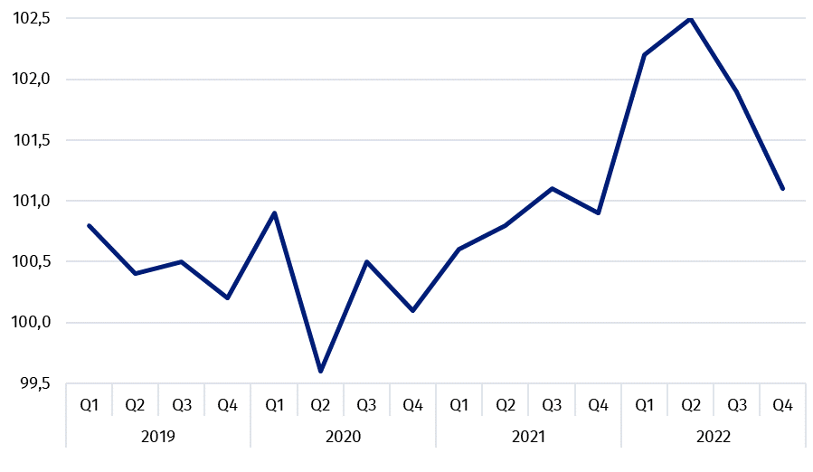
Chart 1. Producer price changes of business services in 2019-2022 (the previous quarter = 100)

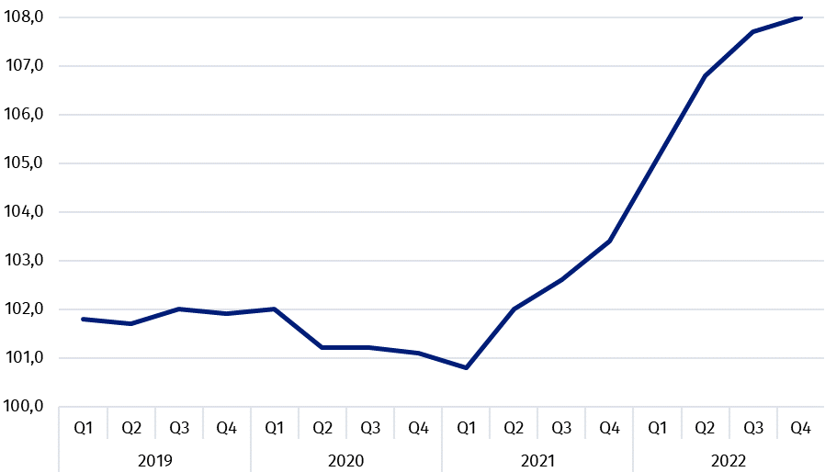
Chart 2. Producer price changes of business services in 2019-2022 (corresponding period of the previous year = 100)

In case of quoting Statistics Poland data, please provide information: “Source of data: Statistics Poland”, and in case of publishing calculations made on data published by Statistics Poland, please include the following disclaimer: “Own study based on figures from Statistics Poland”.

Prepared by:  Trade and Services Department  Director Ewa Adach-Stankiewicz  Phone: (+48 22) 608 31 24 | Issued by:  The Spokesperson for the President  of Statistics Poland  Karolina Banaszek  Phone: (+48) 695 255 011
Press Office  Phone: (+48 22) 608 38 04  e-mail: obslugaprasowa@stat.gov.pl |   www.stat.gov.pl/en/

@StatPoland

@GlownyUrzadStatystyczny

gus_stat

glownyurzadstatystycznygus

glownyurzadstatystyczny
Related information
News releases

Prices in the national economy

Data available in databases
Analytical Platform - Knowledge Databases
Prices indices (Topics: Prices, Trade)

Terms used inn official statistics
Producer price indices for business services

