Index numbers of sold production of industry in January 2023^{a)}
In January 2023, sold production of industry was by 2.6% higher than in January 2022, when an increase was recorded by 18.0% as compared to the corresponding period of of the previous year, whereas in comparison with Dedember 2022, it decreased by 2.5%.
2.6%
Increase in sold production of industry as compared to January 2022

After seasonal adjustment, an increase in sold industrial production in January 2023 amounted to 0.3% per year

After eliminating the seasonal factors, in January 2023 sold production of industry reached the level higher by 0.3% than in the corresponding month of 2022 and by 1.3% lower as compared to December 2022.
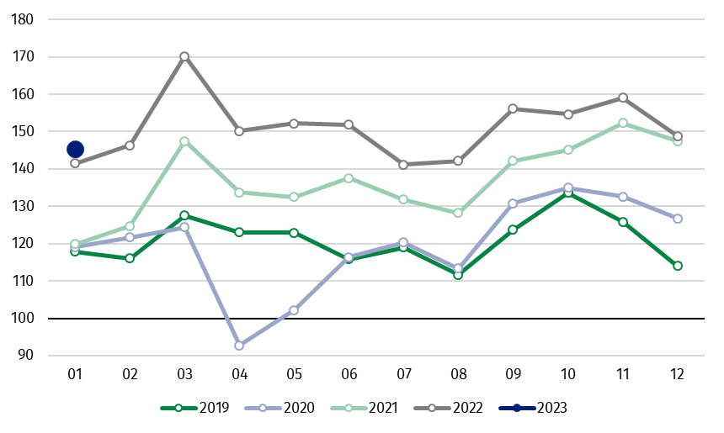
Chart 1. Sold production of industry (average monthly level in 2015=100)

In January 2023, among the main industrial groupings there was an increase per year in the production of capital goods by 10.8% and non-durable consumer goods – by 8.0%. A decrease was observed in production of durable consumer goods – by 6.2% and intermediate goods – by 0.4%. Production of energy remained at the same level.

^{a)} Reported data; comprise enterprises with 10 or more persons employed.

Table 1. Index numbers of sold production of industry ^{a)} (constant prices)
SPECIFICATION | 12 2022 | 01 2023 | 12 2022 | 01 2023 | 12 2022 | 01 2023
SPECIFICATION | previous month =100 |  | previous year =100 |  | monthly average  of 2015 =100
INDUSTRY | 93.6 | 97.5 | 101.0 | 102.6 | 148.8* | 145.2
Mining and quarrying | 90.5 | 106.7 | 93.0* | 103.9 | 86.1* | 91.9
Manufacturing | 92.0 | 95.3 | 103.5* | 102.8 | 150.1* | 143.1
Electricity, gas, steam and air conditioning supply | 109.3* | 120.2 | 82.8* | 101.7 | 162.4* | 195.2
Water supply; sewerage waste management and remediation activities | 105.1* | 86.5 | 101.8 | 97.8 | 157.4* | 136.2

^{a)} Data including final information on production and prices in December and reported data in January.
* Data revised.
Share of production value of industry divisions, which saw an increase in comparison to January 2022, stood at 69.9%

According to the preliminary data, in January 2023 as compared to January 2022, an increase in sold production (in constant prices) was reported in 21 (out of 34) industry divisions, among others, in manufacture of electrical equipment – by 31.5%, manufacture of motor vehicles, trailers and semi-trailers – by 14.7%, manufacture of machinery and equipment – by 11.7%, manufacture of food products – by 5.6%, manufacture of metal products – by 5.2%,
manufacture of rubber and plastic products – by 3.7%.
A decrease in sold production of industry, as compared to January 2022, was recorded in 13 divisions, among others, in manufacture of chemicals and chemical products – by 20.4%,
manufacture of basic metals – by 18.8%, manufacture of products of wood, cork, straw and wicker – by 7.6%, manufacture of computer, electronic and optical products – by 7.2%, manufacture of paper and paper products – by 5.5%.

Chart 2. Index numbers of sold production of industry by selected NACE divisions (constant prices;
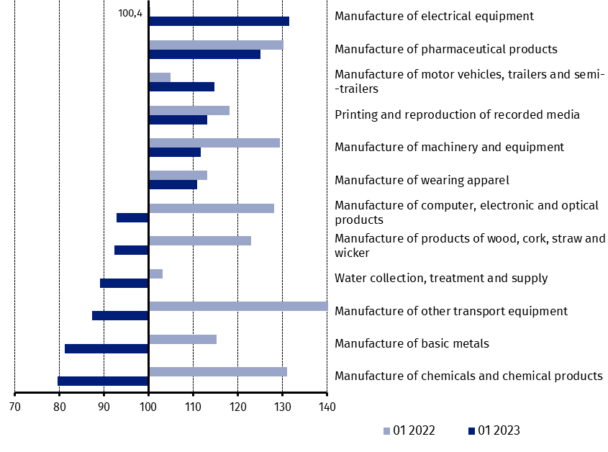
previous year =100)
As compared to December 2022, a decrease in sold production (in constant prices) in January 2023 was recorded in 16 industry divisions, among others, in repair and installation of machinery and equipment – by 60.6%, in manufacture of other transport equipment – by 24.8%, manufacture of machinery and equipment – by 17.7%, manufacture of food products – by 6.9%, manufacture of motor vehicles, trailers and semi-trailers – by 5.8%.
An increase in sold production of industry, as compared to December 2022, was recorded in 18 divisions, among others, in electricity, gas, steam and air conditioning supply – by 20.2%, in manufacture of basic metals – by 18.8%, manufacture of products of wood, cork, straw and wicker – by 17.2%, manufacture of paper and paper products – by 9.1%, manufacture of rubber and plastic products – by 7.3%.

Chart 3. Index numbers of sold production of industry by selected NACE divisions (constant prices;
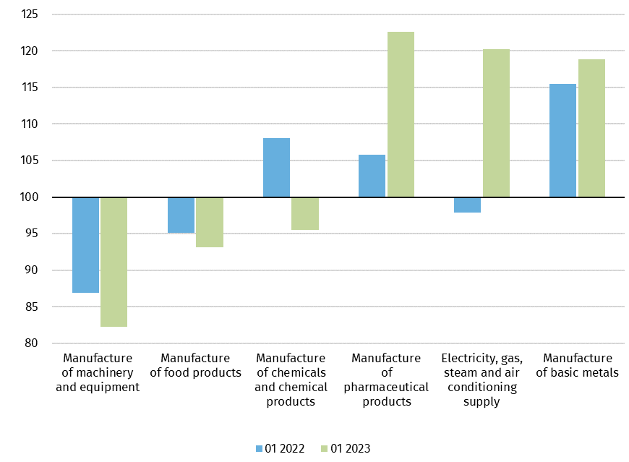
previous month =100)

In case of quoting Statistics Poland data, please provide information: “Source of data: Statistics Poland”, and in case of publishing calculations made on data published by Statistics Poland, please include the following disclaimer: “Own study based on figures from Statistics Poland”
Prepared by:  Enterprises Department  Director Katarzyna Walkowska  Phone: (+48 22) 608 31 25 | Issued by:  The Spokesperson for the President  of Statistics Poland  Karolina Banaszek  Phone: (+48) 695 255 011
Press Office  Phone: (+48 22) 608 38 04  e-mail: obslugaprasowa@stat.gov.pl |   www.stat.gov.pl/en/

@StatPoland

@GlownyUrzadStatystyczny

gus_stat

glownyurzadstatystycznygus

glownyurzadstatystyczny

Related information
Statistical Bulletin
Socio-economic situation of the country

Data available in databases
Knowledge Database - Industrial Production
Macroeconomic Data Bank
Macroeconomic indicators
Local Data Bank

Terms used in official statistics
Sold production of industry
Seasonally un-adjustedindex of sold production of industry
Seasonally adjustedindex of sold production of industry
Production of capital goods
Production of non-durable consumer goods
Production of durable consumer goods
Production of intermediate goods
Production of goods related to energy

