Index numbers of sold production of industry in March 2023^{a)}
In March 2023, sold production of industry was by 2.9% lower than in March 2022, when an increase was recorded by 15.4% as compared to the corresponding period of the previous year, whereas in comparison with February 2023, it increased by 14.1%. In the period January-March of 2023, sold production of industry was by 0.6% lower than in the corresponding period of 2022, which saw an increase by 16.0% as compared to the corresponding period of 2021.
2.9%
Decrease in sold production of industry as compared to March 2022

After seasonal adjustment, a decrease in sold industrial production in March 2023 amounted to 2.5% per year

After eliminating the seasonal factors, in March 2023 sold production of industry reached the level lower by 2.5% than in the corresponding month of 2022 and by 1.0% lower as compared to February 2023.
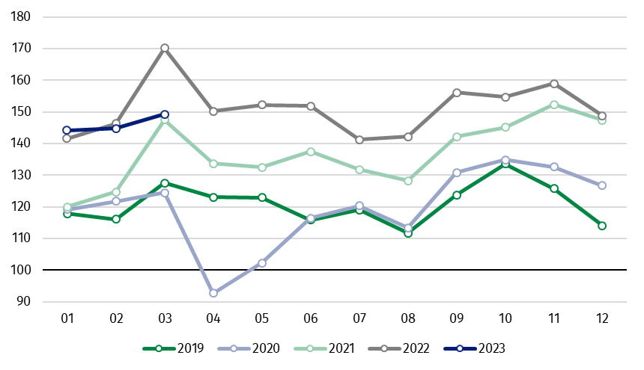
Chart 1. Sold production of industry (average monthly level in 2015=100)

In March 2023, among the main industrial groupings there was a significant decrease per year in the production of energy – by 20.7%, while a smaller drop in the production of durable consumer goods – by 9.0% and intermediate goods – by 8.5%. An increase was observed in the production of capital goods – by 20.7% and a slight growth in non-durable consumer goods – by 1.0%.

^{a)} Reported data; comprise enterprises with 10 or more persons employed.

Table 1. Index numbers of sold production of industry ^{a)} (constant prices)
SPECIFICATION | 2023
SPECIFICATION | 02 | 03 | 02 | 03 | 01-03 | 02 | 03
SPECIFICATION | previous month =100 |  | previous year =100 |  |  | monthly average  of 2015 =100
INDUSTRY | 100.6* | 114.1 | 99.0* | 97.1 | 99.4 | 144.8* | 165.2
Mining and quarrying | 102.1* | 109.0 | 103.5 | 92.8 | 98.3 | 92.9* | 101.3
Manufacturing | 100.9* | 115.8 | 99.2* | 99.6 | 100.8 | 144.5* | 167.4
Electricity, gas, steam and air conditioning supply | 96.8* | 101.0 | 95.8* | 78.2 | 88.9 | 174.7* | 176.4
Water supply; sewerage waste management and remediation activities | 101.8* | 108.9 | 99.2* | 96.6 | 96.7 | 137.1* | 149.3
^{a)} Data including final information on production and prices in February and reported data in March.
* Data revised.
Share of production value of industry divisions, which saw a decrease in comparison to March 2022, stood at 71.1%

According to the preliminary data, in March 2023 as compared to March 2022, a decrease in sold production (in constant prices) was reported in 20 (out of 34) industry divisions, among others, in manufacture of products of wood, cork, straw and wicker – by 22.0%, in electricity, gas, steam and air conditioning supply – by 21.8%, in manufacture of chemicals and chemical products – by 21.2%, manufacture of basic metals – by 19.8%, in mining of coal and lignite – by 16.6%, in manufacture of other non-metallic mineral products – by 13.9%, manufacture of paper and paper products – by 12.2%, manufacture of furniture – by 8.9%, manufacture of metal products – by 7.1%.
An increase in sold production of industry, as compared to March 2022, was recorded in 13 divisions, among others, in manufacture of motor vehicles, trailers and semi-trailers – by 36.5%, manufacture of electrical equipment – by 20.3%, manufacture of other transport equipment – by 16.8%, manufacture of machinery and equipment – by 16.0%, in repair and installation of machinery and equipment – by 12.6%.

Chart 2. Index numbers of sold production of industry by selected NACE divisions (constant prices;
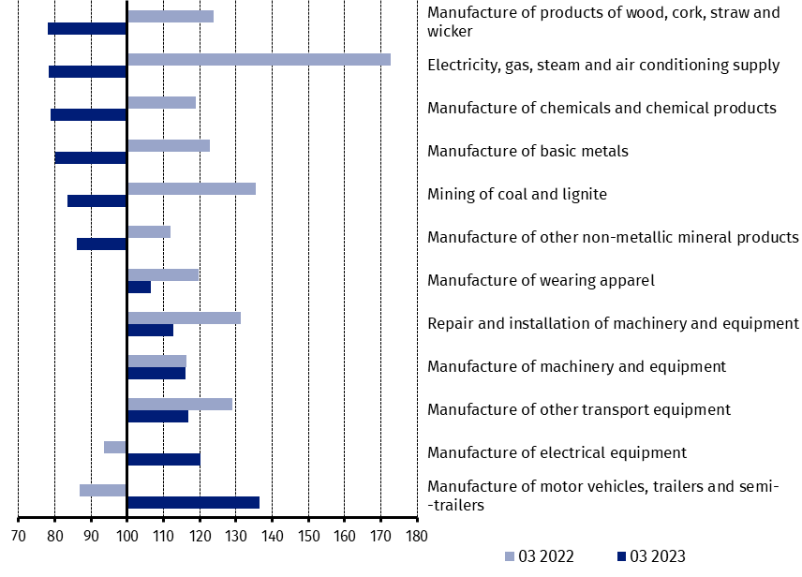
previous year =100)
As compared to February 2023, an increase in sold production (in constant prices) in March 2023 was recorded in all industry divisions, among others, in manufacture of beverages – by 44.9%, manufacture of other transport equipment – by 40.5%, in repair and installation of machinery and equipment – by 33.1%, in manufacture of other non-metallic mineral products – by 26.5%, manufacture of machinery and equipment – by 21.1%, manufacture of basic metals – by 19.2%, manufacture of motor vehicles, trailers and semi-trailers – by 17.2%, manufacture of food products – by 16.7%.

Chart 3. Index numbers of sold production of industry by selected NACE divisions (constant prices;
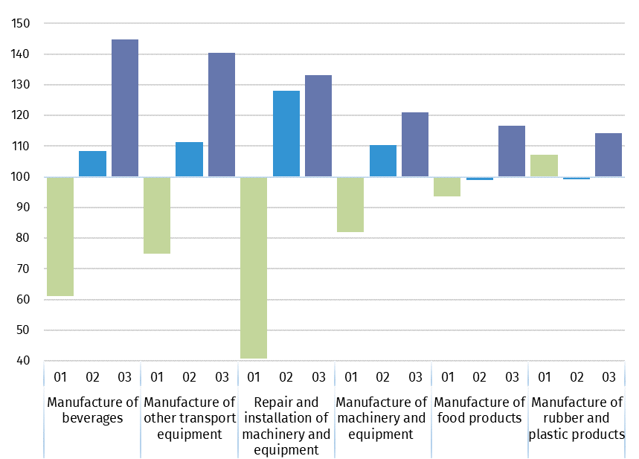
previous month =100)

In case of quoting Statistics Poland data, please provide information: “Source of data: Statistics Poland”, and in case of publishing calculations made on data published by Statistics Poland, please include the following disclaimer: “Own study based on figures from Statistics Poland”
Prepared by:  Enterprises Department  Director Katarzyna Walkowska  Phone: (+48 22) 608 31 25 | Issued by:  The Spokesperson for the President  of Statistics Poland  Karolina Banaszek  Phone: (+48) 695 255 011
Press Office  Phone: (+48 22) 608 38 04  e-mail: obslugaprasowa@stat.gov.pl |   www.stat.gov.pl/en/

@StatPoland

@GlownyUrzadStatystyczny

gus_stat

glownyurzadstatystycznygus

glownyurzadstatystyczny

Related information
Statistical Bulletin
Socio-economic situation of the country

Data available in databases
Knowledge Database - Industrial Production
Macroeconomic Data Bank
Macroeconomic indicators
Local Data Bank

Terms used in official statistics
Sold production of industry
Seasonally un-adjustedindex of sold production of industry
Seasonally adjustedindex of sold production of industry
Production of capital goods
Production of non-durable consumer goods
Production of durable consumer goods
Production of intermediate goods
Production of goods related to energy

