Index numbers of sold production of industry in May 2023^{a)}
In May 2023, sold production of industry was by 3.2% lower than in May 2022, when an increase was recorded by 14.9% as compared to the corresponding period of the previous year, whereas in comparison with April 2023, it increased by 4.4%. In the period January-May of 2023, sold production of industry was by 1.8% lower than in the corresponding period of 2022, which saw an increase by 14.5% as compared to the corresponding period of 2021.
3.2%
Decrease in sold production of industry as compared to May 2022

After seasonal adjustment, a decrease in sold industrial production in May 2023 amounted to 2.4% per year

After eliminating the seasonal factors, in May 2023 sold production of industry reached the level lower by 2.4% than in the corresponding month of 2022 and by 1.0% lower as compared to April 2023.
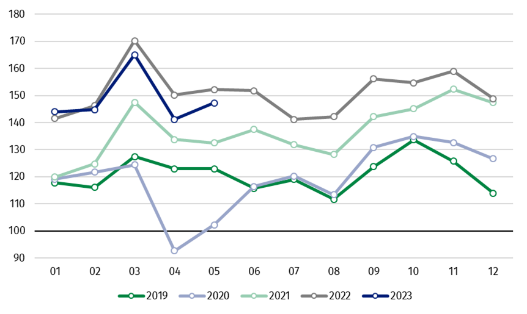
Chart 1. Sold production of industry (average monthly level in 2015=100)

In May 2023, among the main industrial groupings there was a significant decrease per year in the production of durable consumer goods – by 11.8%, energy – by 11.6%, intermediate goods – by 8.5%. An increase was observed in the production of capital goods – by 9.1% and non-durable consumer goods – by 1.0%.

^{a)} Reported data; comprise enterprises with 10 or more persons employed.

Table 1. Index numbers of sold production of industry ^{a)} (constant prices)
SPECIFICATION | 2023
SPECIFICATION | 04 | 05 | 04 | 05 | 01-05 | 04 | 05
SPECIFICATION | previous month =100 |  | previous year =100 |  |  | monthly average  of 2015 =100
INDUSTRY | 85.6* | 104.4 | 94.0* | 96.8 | 98.2 | 141.2* | 147.3
Mining and quarrying | 85.5 | 101.3 | 88.3 | 88.8 | 94.2 | 86.4 | 87.5
Manufacturing | 86.2* | 105.7 | 94.6* | 97.3 | 99.4 | 144.3* | 152.5
Electricity, gas, steam and air conditioning supply | 76.4* | 89.3 | 88.2* | 93.5 | 87.3 | 132.4* | 118.2
Water supply; sewerage waste management and remediation activities | 97.8* | 105.1 | 96.2 | 97.6 | 97.7 | 146.1* | 153.5
^{a)} Data including final information on production and prices in April and reported data in May.
* Data revised.
Share of production value of industry divisions, which saw a decrease in comparison to May 2022, stood at 56.0%

According to the preliminary data, in May 2023 as compared to May 2022, a decrease in sold production (in constant prices) was reported in 21 (out of 34) industry divisions, among others, in manufacture of products of wood, cork, straw and wicker – by 22.5%, manufacture of chemicals and chemical products – by 20.7%, mining of coal and lignite – by 19.7%, in manufacture of other non-metallic mineral products – by 15.7%, manufacture of basic metals – by 14.8%, manufacture of paper and paper products – by 13.5%, manufacture of furniture – by 12.5%, in electricity, gas, steam and air conditioning supply – by 6.5%, in manufacture of rubber and plastic products – by 5.3%.
An increase in sold production of industry, as compared to May 2022, was recorded in 13 divisions, among others, in repair and installation of machinery and equipment – by 36.2%, in manufacture of electrical equipment – by 14.5%, manufacture of motor vehicles, trailers and semi-trailers – by 11.7%, manufacture of machinery and equipment – by 4.0%.

Chart 2. Index numbers of sold production of industry by selected NACE divisions (constant
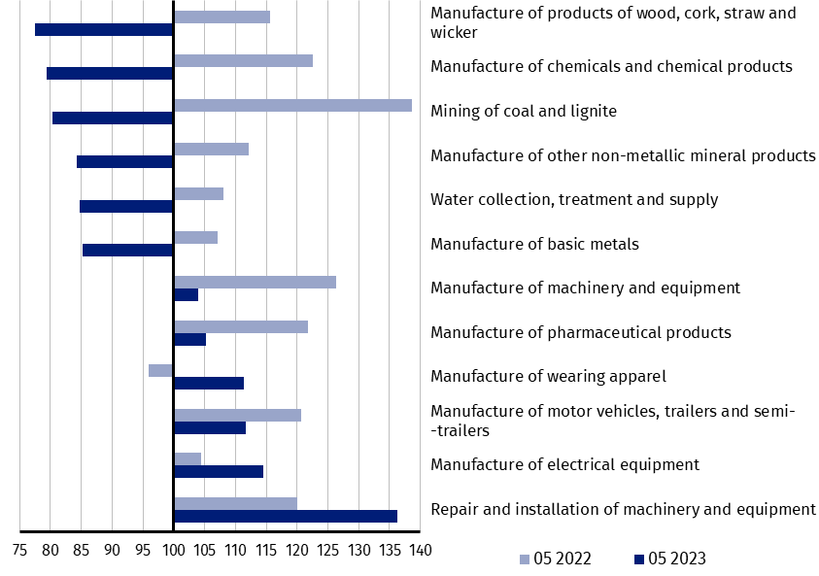
prices; previous year =100)
As compared to April 2023, an increase in sold production (in constant prices) in May 2023 was recorded in 27 (out of 34) industry divisions, among others, in manufacture of beverages – by 13.8%, manufacture of electrical equipment – by 10.0%, manufacture of food products – by 8.7%, manufacture of other non-metallic mineral products – by 8.6%, manufacture of rubber and plastic products – by 7.6%, in repair and installation of machinery and equipment – by 7.5%.
A decrease in sold production of industry, as compared to April 2023, was recorded in 7 divisions, among others, in electricity, gas, steam and air conditioning supply – by 10.7%,
in manufacture of basic metals – by 1.8%.

Chart 3. Index numbers of sold production of industry by selected NACE divisions (constant
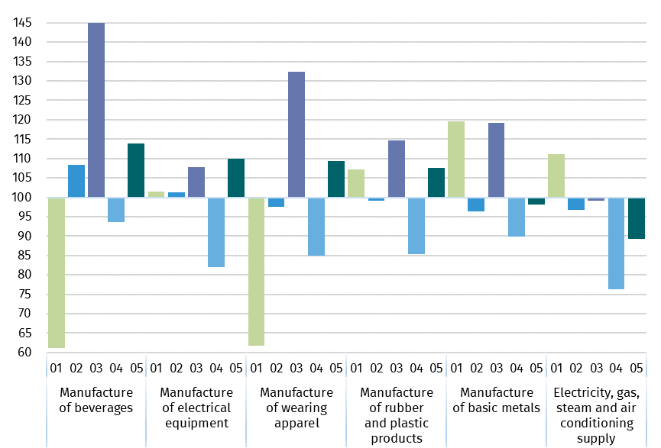
prices; previous month =100)

In case of quoting Statistics Poland data, please provide information: “Source of data: Statistics Poland”, and in case of publishing calculations made on data published by Statistics Poland, please include the following disclaimer: “Own study based on figures from Statistics Poland”
Prepared by:  Enterprises Department  Director Katarzyna Walkowska  Phone: (+48 22) 608 31 25 | Issued by:  The Spokesperson for the President  of Statistics Poland  Karolina Banaszek  Phone: (+48) 695 255 011
Press Office  Phone: (+48 22) 608 38 04  e-mail: obslugaprasowa@stat.gov.pl |   www.stat.gov.pl/en/

@StatPoland

@GlownyUrzadStatystyczny

gus_stat

glownyurzadstatystycznygus

glownyurzadstatystyczny

Related information
Statistical Bulletin
Socio-economic situation of the country

Data available in databases
Knowledge Database - Industrial Production
Macroeconomic Data Bank
Macroeconomic indicators
Local Data Bank

Terms used in official statistics
Sold production of industry
Seasonally un-adjustedindex of sold production of industry
Seasonally adjustedindex of sold production of industry
Production of capital goods
Production of non-durable consumer goods
Production of durable consumer goods
Production of intermediate goods
Production of goods related to energy

