Index numbers of sold production of industry in June 2023^{a)}
In June 2023, sold production of industry was by 1.4% lower than in June 2022, when an increase was recorded by 10.4% as compared to the corresponding period of the previous year, whereas in comparison with May 2023, it increased by 1.2%. In the period January-June of 2023, sold production of industry was by 1.7% lower than in the corresponding period of 2022, which saw an increase by 13.6% as compared to the corresponding period of 2021.
1.4%
Decrease in sold production of industry as compared to June 2022

After seasonal adjustment, a decrease in sold industrial production in June 2023 amounted to 0.8% per year

After eliminating the seasonal factors, in June 2023 sold production of industry reached the level lower by 0.8% than in the corresponding month of 2022 and by 0.4% higher as compared to May 2023.
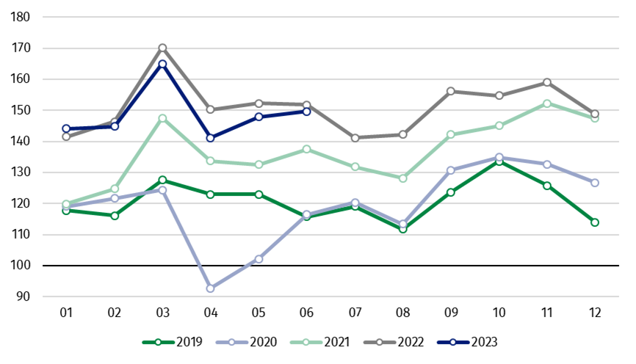
Chart 1. Sold production of industry (average monthly level in 2015=100)

In June 2023, among the main industrial groupings there was a decrease per year in the production of energy – by 10.9%, durable consumer goods – by 9.9%, intermediate goods – by 5.8% and slightly the production of non-durable consumer goods – by 0.3%. An increase was observed in the production of capital goods – by 11.0%.

^{a)} Reported data; comprise enterprises with 10 or more persons employed.

Table 1. Index numbers of sold production of industry ^{a)} (constant prices)
SPECIFICATION | 2023
SPECIFICATION | 05 | 06 | 05 | 06 | 01-06 | 05 | 06
SPECIFICATION | previous month =100 |  | previous year =100 |  |  | monthly average  of 2015 =100
INDUSTRY | 104.8* | 101.2 | 97.2* | 98.6 | 98.3 | 147.9* | 149.7
Mining and quarrying | 101.2* | 105.3 | 88.7* | 86.9 | 91.3 | 87.5 | 92.1
Manufacturing | 106.2* | 101.7 | 97.7* | 99.3 | 99.6 | 153.3* | 155.8
Electricity, gas, steam and air conditioning supply | 88.4* | 93.2 | 92.6* | 93.4 | 87.3 | 117.1* | 109.1
Water supply; sewerage waste management and remediation activities | 105.3* | 103.0 | 97.8* | 99.0 | 98.4 | 153.8* | 158.4
^{a)} Data including final information on production and prices in May and reported data in June.
* Data revised.
Share of production value of industry divisions, which saw a decrease in comparison to June 2022, stood at 72.1%

According to the preliminary data, in June 2023 as compared to June 2022, a decrease in sold production (in constant prices) was reported in 22 (out of 34) industry divisions, among others, in mining of coal and lignite – by 31.6%, in manufacture of chemicals and chemical products – by 20.4%, manufacture of products of wood, cork, straw and wicker – by 17.8%, manufacture of basic metals – by 12.9%, manufacture of paper and paper products – by 11.9%, manufacture of furniture – by 10.7%, manufacture of other non-metallic mineral products – by 10.6%, in electricity, gas, steam and air conditioning supply – by 6.6%.
An increase in sold production of industry, as compared to June 2022, was recorded in 12 divisions, among others, in manufacture of motor vehicles, trailers and semi-trailers – by 19.7%, manufacture of electrical equipment – by 9.7%, manufacture of machinery and equipment – by 7.4%, in repair and installation of machinery and equipment – by 7.1%, in manufacture of computer, electronic and optical products – by 3.0%.

Chart 2. Index numbers of sold production of industry by selected NACE divisions (constant
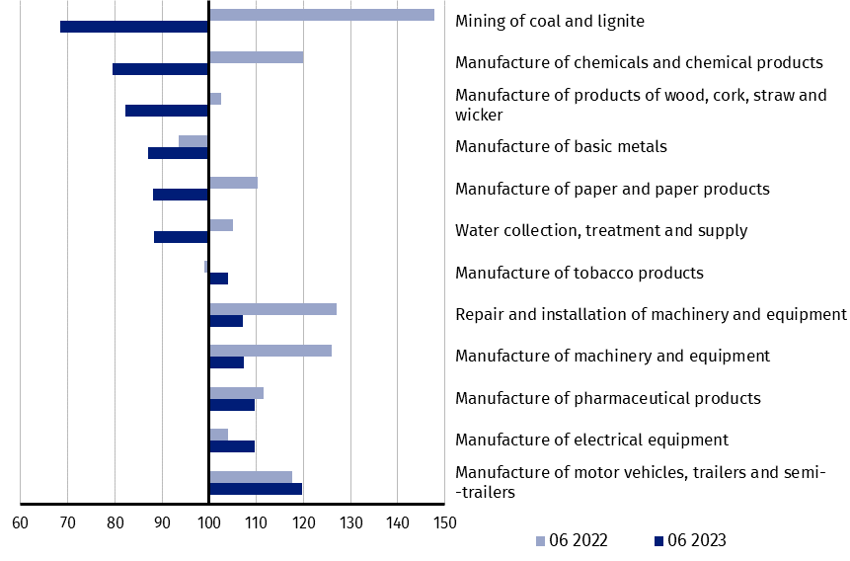
prices; previous year =100)
As compared to May 2023, an increase in sold production (in constant prices) in June 2023 was recorded in 22 (out of 34) industry divisions, among others, in repair and installation of machinery and equipment – by 17.4%, in manufacture of beverages – by 10.7%, manufacture of machinery and equipment – by 9.7%, manufacture of motor vehicles, trailers and semi-trailers – by 7.5%.
A decrease in sold production of industry, as compared to May 2023, was recorded in 12 divisions, among others, in mining of coal and lignite – by 9.5%, in manufacture of basic metals – by 8.9%, in electricity, gas, steam and air conditioning supply – by 6.8%, in manufacture of computer, electronic and optical products – by 3.9%, manufacture of chemicals and chemical products – by 2.8%, manufacture of furniture – by 2.3%.

Chart 3. Index numbers of sold production of industry by selected NACE divisions (constant
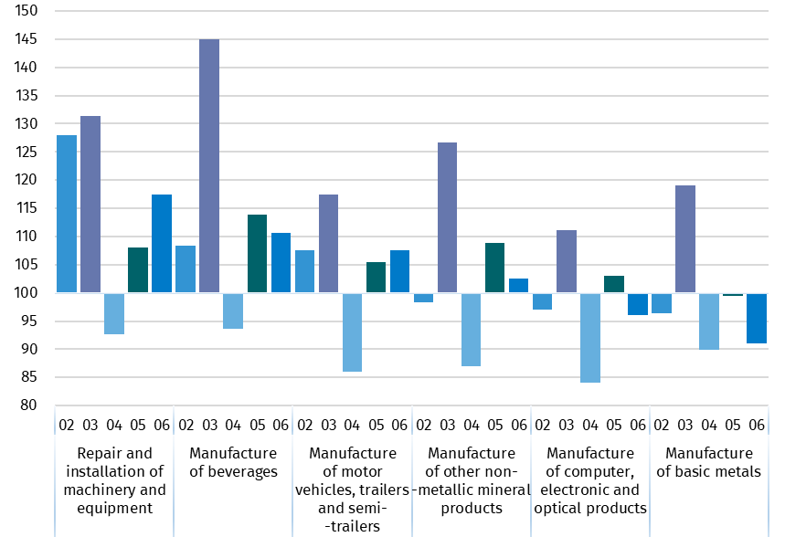
prices; previous month =100)

In case of quoting Statistics Poland data, please provide information: “Source of data: Statistics Poland”, and in case of publishing calculations made on data published by Statistics Poland, please include the following disclaimer: “Own study based on figures from Statistics Poland”
Prepared by:  Enterprises Department  Director Katarzyna Walkowska  Phone: (+48 22) 608 31 25 | Issued by:  The Spokesperson for the President  of Statistics Poland  Karolina Banaszek  Phone: (+48) 695 255 011
Press Office  Phone: (+48 22) 608 38 04  e-mail: obslugaprasowa@stat.gov.pl |   www.stat.gov.pl/en/

@StatPoland

@GlownyUrzadStatystyczny

gus_stat

glownyurzadstatystycznygus

glownyurzadstatystyczny

Related information
Statistical Bulletin
Socio-economic situation of the country

Data available in databases
Knowledge Database - Industrial Production
Macroeconomic Data Bank
Macroeconomic indicators
Local Data Bank

Terms used in official statistics
Sold production of industry
Seasonally un-adjustedindex of sold production of industry
Seasonally adjustedindex of sold production of industry
Production of capital goods
Production of non-durable consumer goods
Production of durable consumer goods
Production of intermediate goods
Production of goods related to energy

